

**MINISTRY OF EDUCATION AND TRAINING**

**FPT UNIVERSITY**

Capstone Project Document

**Bakery Management Application that manages the business of a bakery, only product for schools**

|  |  |
| --- | --- |
| **Group 1** | |
| **Group members** | Huỳnh Hữu Trường Giang – SE60894  Ông Tấn Mạnh – SE61045  Nguyễn Quốc Vương – SE60907  Lê Anh Khoa – SE60864 – Dropped out |
| **Supervisor** | Ngô Đăng Hà An |
| **Ext. Supervisor** | N/A |
| **Capstone Project Code** | BMA |

- Ho Chi Minh City, 05 December 2015 -

This page is intentionally left blank

Table of Contents

Table of Contents 3

List of Tables 7

List of Figures 9

Definitions, Acronyms, and Abbreviations 13

A. Introduction 14

1. Project Information 14

2. Introduction 14

3. Current Situation 14

4. Problem Definition 14

5. Proposed Solution 15

5.1. Feature functions 15

5.2. Advantages and disadvantages 15

6. Functional Requirements 15

7. Roles and Responsibility 16

B. Software Project Management Plan 17

1. Problem Definition 17

1.1. Name of this Capstone Project 17

1.2. Problem Abstract 17

1.3. Project Overview 17

2. Project organization 20

2.1. Software Process Model 20

2.2. Roles and responsibilities 21

2.3. Tools and Techniques 22

3. Project Management Plan 22

3.1. Tasks 22

3.2. Task sheet 24

3.3. All Meeting Minutes 24

4. Coding Convention 25

C. Software Requirement Specification 26

1. User Requirement Specification 26

1.1. Guest requirement 26

1.2. Customer requirement 26

1.3. Staff requirement 26

1.4. Manager requirement 27

2. System Requirement Specification 28

2.1. External Interface Requirement 28

2.2. System Overview Use Case 28

2.3. List of Use Case 30

3. Software System Attribute 128

3.1. Usability 128

3.2. Reliability 129

3.3. Availability 129

3.4. Security 129

3.5. Maintainability 129

3.6. Portability 129

3.7. Performance 129

4. Conceptual Diagram 130

D. Software Design Description 132

1. Design Overview 132

2. System Architecture Design 133

2.1. Web Application architecture description 133

3. Component Diagram 134

4. Detailed Description 135

4.1. Class Diagram 135

4.2. Class Diagram Explanation 138

4.3. Interactive Diagram 150

5. User Interface Design 207

5.1 User Login 207

5.2 Order A Product 208

5.3 Add to cart a product 208

5.4 Check cart 209

5.5 View information in cart 210

5.6 Confirm order 211

5.7 Add customer information to order 211

5.8 View order list 212

5.9 Staff add product to order 213

5.10 Add customer to order 214

5.11 Check out with new customer 215

5.12 View input bill list 216

5.13 Add new input bill 217

5.14 View input material list 218

5.15 View input material detail 219

5.16 Add new input material 220

5.17 Review income by time 221

5.18 Review income weekly detail 223

5.19 VAT Tax Declaration – Appendix 1 224

6. Database Design 226

6.1 Entity relationship diagram 226

6.2 Entity Dictionary 228

7. Algorithms 240

7.1 Order State 240

E. 番５のレポート。システムの展開とテスト 242

1. はじめに 242

1.1 概要 242

1.2 テストアプローチ 242

2. データベース関係ダイアグラム 242

2.1 ウェブアプリケーション物理的なダイアグラム 242

2.2 ウェブアプリケーションデータ辞書 244

3. パフォーマンス対策 261

3.1 製品検索、メンバーのパフォーマンス 261

3.2 送り状リストが展示されるパフォーマンス 261

3.3 収入統計など展示されるパフォーマンス 261

4. テスト計画 261

4.1 テストする機能 261

4.2 テストされない機能 262

5. システムテストのテストケース 262

5.1 ウェブシステムのテストケース 262

F. 番６のレポート。ソフトウェアユーザーズマニュアル 304

1. インストレーションガイド 304

1.1. サーパ側の環境を設定 304

1.2. サーパ側で展開 304

1.3. クライアント側の環境の設定 308

2. ユーザーガイド 309

2.1. ログイン 309

2.2. 製品を注文すること 310

2.3. カートに製品を追加すること 310

2.4. かーとをチェックすること 311

2.5. カーとの精細 312

2.6. 送り状を確認すること 313

2.7. 送り状に顧客の情報を充実すること 313

2.8. 送り状のリストを見ること 314

2.9. 「人員」送り状を造ること 315

2.10. 送り状に顧客を追加すること 316

2.11. 新い顧客の口座で送り状をチェックアウト 317

2.12. 入力法案 リスク 318

2.13. 新入力法案を造ること 319

2.14. 入力原料 リスクを見る 320

2.15. 入力原料 の精細を見ること 321

2.16. 新入力原料を造ること 322

G. Appendix 324

List of Tables

Table 1: Definitions, Acronyms, and Abbreviations 13

Table 2: Roles and Responsibility 16

Table 3: Hardware requirement for Web Server 20

Table 4: Hardware requirement for Web Server 20

Table 5 : Software requirement 20

Table 6: Roles and responsibilities 21

Table 7: Tools and Techniques 22

Table 8: Use case UG01 - <Guest> Login 32

Table 9: Use case UG02 - <Guest> Search product 33

Table 10: Use case UG03 - <Guest> View product detail 34

Table 11: Use case UG04 - <Guest> Make order 37

Table 12: Use case UA01 - <Authenticated user> Logout 38

Table 13: Use case UA02 - < Authenticated user> Search product 39

Table 14: Use case UA03 - < Authenticated user> View product detail 41

Table 15: Use case UA04 - <Authenticated user> Change personal information 42

Table 16: Use case UA05 - <Authenticated user> Change password 44

Table 17: Use case UA06 - <Authenticated user> Reset password 47

Table 18: Use case C01 - <System> Get notification 49

Table 18: Use case UC01 - <Customer> Make Order 52

Table 19: Use case UC02 - <Customer> Edit order 55

Table 20: Use case UC03 - <Customer> View order detail 56

Table 21: Use case UC04 - <Customer> Cancel Order 57

Table 22: Use case UC05 - <Customer> Confirm order 59

Table 23: Use case US01- <Staff> Edit order 64

Table 24: Use case US01- <Staff> Edit order 67

Table 25: Use case US03- <Staff> View order detail 68

Table 26: Use case US04- <Staff> Approve order 71

Table 27: Use case US05 - <Staff> Change order state 73

Table 28: Use case US06 - <Staff> Export bill 75

Table 29: Use case US07 - <Staff> Cancel order 77

Table 30: Use case US08- <Staff> Export more material for order 78

Table 31: Use case US09 - <Staff> Add input material 80

Table 32: Use case US10 - <Staff> Edit input material 82

Table 33: Use case US11 - <Staff> Change input material state 84

Table 34: Use case US12 - <Staff> Add input bill 86

Table 35: Use case US13 - <Staff> Edit input bill 88

Table 36: Use case US14 - <Staff> Change material status 89

Table 37: Use case US15 - <Staff> Add material 91

Table 38: Use case US16 - <Staff> Edit material 92

Table 39: Use case US17 - <Staff> Add product 96

Table 40: Use case US18 - <Staff> Edit product 99

Table 41: Use case US19 - <Staff> Change product status 100

Table 42: Use case UM01 - <Manager> Edit store information 104

Table 43: Use case UM02 - <Manager> Edit store config 108

Table 44: Use case UM03 - <Manager> Add new staff 110

Table 45: Use case UM04 - <Manager> Change staff status 111

Table 46: Use case UM05 - <Manager> Change customer status 112

Table 47: Use case UM06 - <Manager> Change customer account to loyal 113

Table 48: Use case UM07 - <Manager> Add new supplier 115

Table 49: Use case UM08 - <Manager> Add new supplier 117

Table 50: Use case UM09 - <Manager> Change supplier status 118

Table 51: Use case UM10 - <Manager> Update VAT tax rate 119

Table 52: Use case UM11 - <Manager> Update Excise tax rate 121

Table 53: Use case UM12 - <Manager> Review income by time 122

Table 54: Use case UM13 - <Manager> Review income by product 124

Table 55: Use case UM14 - <Manager> Review revenue by customer 125

Table 56: Use case UM15 - <Manager> Create VAT Tax Declaration 127

Table 57: Use case UM16 - <Manager> Create Excise Tax Declaration 128

Table 58: Component Dictionary 135

Table 59 Class dictionary 137

Table 60 : Entity dictionary 228

Table 61 : Detail data dictionary 240

Table 62: Contract State Dictionary 241

Table 62 : ウェブデータ•ディクショナリ 244

Table 64: ウェブ属性データディクショナリ 261

テーブル64: ログインポップアップ 309

テーブル 65:　製品を注文する 310

テーブル 66: カートに製品を追加する 311

テーブル 67: かーとをチェックすること 311

テーブル 68: カートの精細 312

テーブル 69: 送り状を確認すること 313

テーブル 70: 送り状に顧客の情報を充実すること 314

テーブル 71: 送り状のリストを見ること 315

テーブル 72: 「人員」送り状を造ること 315

テーブル 73: 送り状に顧客を追加すること 316

テーブル 74: 新顧客の口座で送り状をチェックアウト 318

テーブル 75:入力法案 リスク 318

テーブル 76: 新入力法案を造ること 319

テーブル 77: 入力原料リスク 320

テーブル 78:入力原料の精細を見ること 321

テーブル 79:入力原料を造ること 323

List of Figures

Figure 1: Modified Waterfall Development Model 21

Figure 2: System Overview Use Case 29

Figure 3: <Guest> Overview Use Case 30

Figure 4:< Guest> Login 30

Figure 5: <Guest> Search product 32

Figure 6: <Guest> View product detail 33

Figure 7: <Guest> Make order 34

Figure 8: <Authenticated user> Overview Use Case 37

Figure 9: <Authenticated user> Logout 37

Figure 10: <Authenticated user> Search product 38

Figure 11: < Authenticated user> View product detail 40

Figure 12: <Authenticated user> Change personal information 41

Figure 13: <Authenticated user> Change password 43

Figure 14: <Authenticated user> Reset password 45

Figure 15 <System> Overview Use Case 47

Figure 16: <System> Get notification 47

Figure 15 <Customer> Overview Use Case 50

Figure 16: <Customer> Make Order 50

Figure 17: <Customer> Edit Order 53

Figure 18: <Customer> View order detail 55

Figure 19: <Customer> Cancel Order 56

Figure 20: <Customer> Confirm Order 58

Figure 21: <Staff> Overview Use Case 60

Figure 22: <Staff> Add Order 61

Figure 23: <Staff> Edit Order 65

Figure 24: <Staff> View order detail 67

Figure 25: <Staff> Approve order 68

Figure 26: <Staff> Change order state 72

Figure 27: <Staff> Export bill 74

Figure 28: <Staff> Cancel order 75

Figure 29 <Staff> Export more material for order 77

Figure 30: <Staff> Add input material 78

Figure 31: < Staff> Edit input material 80

Figure 32: <Staff> Discard input material 82

Figure 33: <Staff> Add input bill 84

Figure 34: <Staff> Edit input bill 86

Figure 35: <Staff> Change material status 88

Figure 36: <Staff> Add material 89

Figure 37: <Staff> Edit material 91

Figure 38: <Staff> Add product 93

Figure 39: <Customer> Edit product 96

Figure 40: <Staff> Change product status 99

Figure 41: <Manager> Manager Overview Usecase 101

Figure 42: <Manager> Edit store information 102

Figure 43: <Manager>Edit store config 104

Figure 44: <Manager> Add new staff 108

Figure 45: <Manager> Change staff status 110

Figure 46: <Manager> Change customer status 111

Figure 47: <Manager> Change customer account to loyal 112

Figure 48: <Manager> Add new supplier 113

Figure 49 <Manager> Edit supplier information 115

Figure 50: <Manager> Change supplier status 117

Figure 51: <Manager> Update VAT tax rate 118

Figure 52: <Manager> Update Excise tax rate 120

Figure 53: <Manager> Review income by time 121

Figure 54: <Manager> Review income by product 123

Figure 55: <Manager> Review revenue by customer 124

Figure 56: <Manager> Create VAT Tax Declaration 126

Figure 57: <Manager> Create Excise Tax Declaration 127

Figure 58: Conceptual Diagram 130

Figure 59: System architecture design 133

Figure 60 : Component Diagram 134

Figure 61 : Sequence diagram - <Guest> Make order 151

Figure 62 : Sequence diagram - <Authenticated User> Change password 152

Figure 62 : Sequence diagram - <Authenticated User> Change personal information 153

Figure 62 : Sequence diagram - <Authenticated User> Reset password 154

Figure 62 : Sequence diagram - <Authenticated User> Search product 155

Figure 62 : Sequence diagram - <Authenticated User> View product detail 156

Figure 62 : Sequence diagram - <System> Get notification 157

Figure 62 : Sequence diagram - <Customer> Make order 158

Figure 63 : Sequence diagram - <Customer> Confirm order 159

Figure 64 : Sequence diagram - <Customer> Cancel order 161

Figure 65 : Sequence diagram - <Customer> Edit order 163

Figure 66 : Sequence diagram - <Staff> Approve order 165

Figure 67 : Sequence diagram - <Staff> Add order 165

Figure 68 : Sequence diagram - <Staff> Cancel order 167

Figure 69 : Sequence diagram - <Staff> Edit order 168

Figure 70 : Sequence diagram - <Staff> Change order status 170

Figure 71 : Sequence diagram - <Staff> Export Bill 170

Figure 72 : Sequence diagram - <Staff> Export More Material For Order 171

Figure 73 : Sequence diagram - <Staff> 4.3.1.3.8. Add input material 173

Figure 74 : Sequence diagram - <Staff> Edit input material 174

Figure 75 : Sequence diagram - <Staff> Discard input material 175

Figure 76 : Sequence diagram - <Staff> Add input bill 177

Figure 77 : Sequence diagram - <Staff> Edit input bill 178

Figure 78 : Sequence diagram - <Staff> Change material status 179

Figure 79 : Sequence diagram - <Staff> Add material 181

Figure 80 : Sequence diagram - <Staff> Edit material 182

Figure 81 : Sequence diagram - <Staff> Add product 184

Figure 82 : Sequence diagram - <Staff> Edt product 185

Figure 83 : Sequence diagram - <Staff> Change product status 186

Figure 84 : Sequence diagram - <Manager> Edit store information 187

Figure 85 : Sequence diagram - <Manager> Edit store config 188

Figure 86 : Sequence diagram - <Manager> Add new staff 190

Figure 87 : Sequence diagram - <Manager> Change staff status 190

Figure 88 : Sequence diagram - <Manager> Change customer status 191

Figure 89 : Sequence diagram - <Manager> Change customer account to loyal 192

Figure 90 : Sequence diagram - <Manager> Add new supplier 193

Figure 91 : Sequence diagram - <Manager> Edit supplier information 194

Figure 92 : Sequence diagram - <Manager> Change supplier status 195

Figure 93 : Sequence diagram - <Manager> Update VAT Tax Rate 196

Figure 94 : Sequence diagram - <Manager> Update Excise Tax Rate 197

Figure 95 : Sequence diagram - <Manager> Review income by time 199

Figure 96 : Sequence diagram - <Manager> Review income by product 201

Figure 97 : Sequence diagram - <Manager> Review revenue by customer 203

Figure 98 : Sequence diagram - <Manager> Create VAT Tax Declaration 205

Figure 99 : Sequence diagram - <Manager> Create Excise Tax Declaration 206

Figure 100: Login popup 207

Figure 101: Order Product 208

Figure 102: Add to cart a product 208

Figure 103: Check cart 209

Figure 104: View information in cart 210

Figure 105: Confirm order 211

Figure 106: Add customer information to order 212

Figure 107: View order list 212

Figure 108: Staff add product to order 213

Figure 109: Add customer to order 214

Figure 110: Check out with new customer 215

Figure 111: View input bill list 216

Figure 112: Add new input bill 217

Figure 113: Input material list 218

Figure 114: View input material detail 219

Figure 115: Add new input material 220

Figure 116: Review income by time 221

Figure 117: Review income weekly detail 223

Figure 118: VAT Tax Declaration – Appendix 1 224

Figure 119 : Entity relationship diagram 227

Figure 120: Order State Chart 240

Figure 121: ウェブサイトアプリケーション物理的なダイアグラム 243

Figure 128: 「ゲスト」製品を注文すること 263

Figure 129: 「顧客」製品を注文すること 263

Figure 130: 「人員」送り状を造ること 264

Figure 130: 「人員」送り状を造ること 264

Figure 132: 「人員」送り状の状態を変化すること 265

Figure 133: 「人員」入力原料を付加すること 265

Figure 134: 「人員」入力原料を捨てること 266

Figure 135: 「人員」新製品を造る前に、この製品の原料が無能にすること 266

Figure 135: 「人員」新製品を造ったら、この製品の原料が無能にすること 266

Figure 135: 「人員」注文することが終了する前に、この注文の製品が無能にすること 267

図面122: ログインポップアップ 309

図面 123:製品を注文すること 310

図面 124: カートに製品を追加すること 311

図面 125: かーとをチェックすること 311

図面 126: カートの精細 312

図面 127: 送り状を確認すること 313

図面 128: 送り状に顧客の情報を充実すること 314

図面 129: 送り状のリストを見ること 314

図面 130: 「人員」送り状を造ること 315

図面 131: 送り状に顧客を追加すること 316

図面 132: 新顧客の口座で送り状をチェックアウト 317

図面 133: 入力法案 リスク 318

図面 134: 新入力法案を造ること 319

図面 135: 入力原料 リスク 320

図面 136:入力原料 の精細を見ること 321

図面 137: 新入力原料を造ること 322

Definitions, Acronyms, and Abbreviations

|  |  |
| --- | --- |
| Name | Definition |
| BMA | Bakery Management Application |

Table 1: Definitions, Acronyms, and Abbreviations

# Introduction

## Project Information

* Project name: **Bakery Management Application**
* Project Code: **BMA**
* Product Type: **Website Application**
* Start Date: **September 7th, 2015**
* End Date: **December 17th,2016**

## Introduction

In this document, we introduce a system to help the bakery which delivery products for schools with high quantity. Due to the inconvenience of the current process like high dependency on phone contact, communication skills..., we develop a website application for the ease of use for both sides.

Bakery Management Application (or BMA for short) can help schools (or customers) track their orders better instead of relying on phone contact. Customers can also browse their desired products easier using the proposing system. The bakery owner can also use our system to increase their management process.

This document also describes our working process in 14 weeks that includes our designs, workflows as well as a how-to-use guide for our system.

## Current Situation

In order to keep a fresh stock of breads and bakery products every day, schools have to go to the bakery and order manually or by phone. They have to constantly check for their order status by contacting the bakery staff. Once the order is ready for delivery, the staff also has to call customers to confirm delivery date and time. The owner spends time to manage the business include materials, bills, orders... and create tax declaration. Besides it is difficult to see the overview of the store.

## Problem Definition

Below are disadvantages of current situation:

* **Difficult when a school want to order:** Customer must go to the store directly to order or order by phone.
* **Hard for change/cancel (a) product(s) in ordered order(s):** Customer must go to the bakery directly or make a call to change or cancel so that it takes a lot of time.
* **Manual management of income:** The bakery owner usually manages revenue, expenses and income by writing in paper or using business softwares (such as Microsoft Excel). These are unprofessional, time-comsuming, difficult to check and find out when there is a mistake.
* **Manual making the tax declaration:** When the bakery owner wants to make the VAT tax declaration, he/she have to collect the bills and making the declaration manual. So, it takes too much time and sometimes can make a mistake.

## Proposed Solution

Our proposed solution is to build a Bakery Management Web Application named “BMA system” to support bakery manager manage the business of a bakery which delivery products for schools with high quantity.

### Feature functions

* + **Manage information of customers**: Staff can make the new account for corresponding with new customer. Manager manages the customer’s accounts.
  + **Manage information of staffs**: Manager can make the new account for satff and manages the staff’s accounts.
  + **Manage information of products**: Staff can manage the products of the bakery include the material for each product.
  + **Manage number of input materials**: Staff can manage the input materials of the bakery.
  + **Manage number of orders**: Users can make the new order online by account provided by the bakery or the staff will add the new order. The customer can view the status of the orders. The staff can manage the orders of the bakey.
  + **Statistic functions**: The system will provide the review the income weekly, monthly, yearly; the income by type of products and the revenue per customer.
  + **Create tax declaration**: The system will support make the VAT Tax and Excise Tax declaration and export XML file which can use in HTKK 3.3.4 of Ministry of Finance.

### Advantages and disadvantages

* Advantages:
  + Reduce the manual paperwork about the tax so that help the bakery owner save time and increase the accuracy.
  + Without going to the bakery, customers can browse the products.
  + Have convinient way for the customer making and tracking their orders.
  + Have a general view of the business: The bakery can have the general view of business through the statistics so that the bakery can have the timely solution.
* Disadvantages:
  + Applying the tax policy in real business is complicated.
  + Because of large quantity of product in order, the staff has to contact to customer by phone call every approve order.

## Functional Requirements

Function requirements of the system are listed as below:

* **Store Information Management:**
  + Edit store information
* **Product Management:**
  + Add/Edit/Change Status/Search/View products.
* **Input material Management**
  + Add/Edit input material.
  + Discard input material.
  + Staff will receive notifications when there are not enough materials to meet customer order.
* **Notfications:** The system will show the notification when:
* To staff:
  + The material is below standard quantity
  + The new order is created
* To customer:
  + The order is changed state.
  + The order is edited by staff.
* **Customer Account Management**
  + Create/Change status of customer account.
* **Order Management**
  + Add/Edit/Cancel/Approve order
  + Change order’s state
  + View the state of the orders
* **Bill Management**
  + Add/Export/Edit bill.
* **Tax Management**
  + Change the VAT and Excise tax create
  + Create VAT and Excise Tax Declaration
* **Statistic**
  + Review income weekly, monthly, year.
  + Review income by product.
  + Review revenue by customers.
* **Staff account Management**
  + Create/Change status of staff account

## Roles and Responsibility

|  |  |  |  |  |
| --- | --- | --- | --- | --- |
| No | Full Name | Role | Position | Contact |
| 1 | Ngô Đăng Hà An | Project Manager | Supervisor | anndh@fpt.edu.vn |
| 2 | Huỳnh Hữu Trường Giang | Developer | Leader | gianghhtse60894@fpt.edu.vn |
| 3 | Ông Tấn Mạnh | Developer | Member | manhotse61045@fpt.edu.vn |
| 4 | Nguyễn Quốc Vương | Developer | Member | vuongnqse60907@fpt.edu.vn |
| 5 | Lê Anh Khoa – Dropped out | Developer | Member | khoalase60864@fpt.edu.vn |

Table 2: Roles and Responsibility

# Software Project Management Plan

## Problem Definition

### Name of this Capstone Project

* **Official name**: Bakery Management Application that manages the business of a bakery, only product for schools
* **Vietnamese name**: Ứng dụng quản lý cửa hàng cung cấp bánh ngọt cho các trường học
* **Abbreviation**: BMA

### Problem Abstract

Nowadays when the canteens or food holes in the schools want to order the bakery the high quantity of cakes, for the first time, they often go to the bakery to choose the cakes, order with the quantity. For the next time, customer can order directly or by the phone. On the other hand, when the manager of the bakery wants to control the business; work out the total of revenue, tax manually.

We provide a web application to help the customer’s order the cake with high quantity, track the order easily. Moreover the web application also helps the bakery manage the customer, product, input material, order. In addition, this application also helps the bakery manage input and output bills; review the income by time, by type of goods, the revenue per customer and review VAT tax monthly and excise tax yearly.

### Project Overview

#### Current Situation

Below are the problems encountered in this project:

* **Server crash:** The web application runs on the server. So if server crash, the web application cannot run.
* **Absence of team members:** team members can get sick or unexpected problems.
* **Shortage of technology knowledge**

#### The Proposed System

According the requirement of the bakery manager, we build a web application, which can provide the way for the customer’s order the product online and the bakery can control the business easily.

##### Website

* For guests:
  + Guests can view and search products in store.
  + Guests can order the products online.
  + Guests will receive an account from staff when the first guest’s order is approved.
* For customers:
  + Customers can order the products online.
  + Customers can view their order state.
  + Customers can edit/cancel their orders.
  + Customers can edit their information,
  + Customers can confirm order when the order is edited by staff.
* For staffs:
  + Staffs can manage products (add, edit, change status). In addition, they can add, edit materials to products.
  + Staffs can manage input materials (add, edit), discard input material.
  + Staffs can add bill, edit, export bill.
  + Staffs can create account for customer (when the first customer’s order is approved), change status of customer account.
  + Staffs can change order state, add/edit customer’s order, approve order.
  + Staffs can manage product materials (add, edit, change status).
* For manager:
  + Manager can create VAT, excise tax declaration and edit the tax rate.
  + Manager can view statistic (income by time, product;revenue by customer).
  + Manager can edit store information.
  + Manager can manage staff account (create, change status)
  + Manager can manager customer account (change status, change to loyal)
  + Manager can manager supplier (create, edit, change status)
* Notfications: The system will show the notification when:
  + - To staff:
      * The material is below standard quantity
      * The new order is created
    - To customer:
      * The order is changed state.
      * The order is edited by staff.

#### Boundaries of the System

* Every bakery store that needs to manage their store easier can deploy this system.
* Customer is school’s canteen or food holes.
* The language of this system is Vietnamese
* The complete product includes:
  + Order system for guests and customers.
  + Manage system for staffs and manager.

#### Future Plans

* Support export financial report.
* Provide the financial management.
* Provide the personnel management.
* Provide promotion functions

#### Development Environment

##### Hardware requirement

For web server:

|  |  |  |
| --- | --- | --- |
| Hardware | Minimum Requirements | Recommended |
| Network Bandwidth | 4 Mbps | 8 Mbps |
| Operating System | Window Server 2008 | Window Server 2008 |
| Computer Processor | Intel® Xeon Dual Core® 1.4GHz (4MB Cache) | Intel® Xeon® Quad Core (8M Cache, 2.40 GHz) |
| Computer Memory | 2GB RAM | 4GB or more |
| Hard disk | 40GB | 80GB |

Table 3: Hardware requirement for Web Server

For web development:

|  |  |  |
| --- | --- | --- |
| Hardware | Minimum Requirements | Recommended |
| Internet Connection | 512 Kbps | 8 Mbps |
| Operating System | Window Vista, 7, 8 | Window 7, 8 |
| Computer Processor | 1 GHz | Intel® Core™ i5 CPU 2.53 GHz |
| Computer Memory | 2GB RAM | 4GB or more |

Table 4: Hardware requirement for Web Server

##### Software requirement

|  |  |
| --- | --- |
| Software | Name / Version |
| Operating system | Windows 7 or above |
| Modeling tool | StarUML version 2.5.0 |
| IDE | Microsoft Visual Studio 2013 Ultimate |
| DBMS | SQL Server 2008 R2 Developer |
| Source control | Github 3.0.5 |
| Web browser | Chrome 42 or above |

Table 5 : Software requirement

## Project organization

### Software Process Model

This project is developed under modified waterfall model (Shashimi). We choose this model because the following reasons:

* Due to the timeline of capstone project, this project lasts 4 months, a short project.
* The requirements of the project are well-defined and well-understood by all team members.
* During the process of the capstone project, the team have to submit reports corresponding with the deliverables in each phase.

Requirement

Design and Architecture

Development and Coding

QA and Testing

Maintenance

Figure 1: Modified Waterfall Development Model

For more information about modified waterfall development model: <http://www.waterfall-model.com/sashimi-waterfall-model/>

### Roles and responsibilities

|  |  |  |  |
| --- | --- | --- | --- |
| No | Full name | Role in Group | Responsibilities |
| 1 | Ngô Đăng Hà An | Supervisor / Project Manager | - Clarify user requirement  - Give out technical support and business analysis  - Track development process  - Review document and product |
| 2 | Huỳnh Hữu Trường Giang | Team leader, BA, Developer, Tester | - Track process  - Plan project, distribute tasks  - Requirement analysis  - Design database  - Prepare documents  - Design GUI  - Code  - Test  - Deploy product |
| 3 | Ông Tấn Mạnh | Team Member, BA, Developer, Tester | - Analysis requirements  - Design database  - Prepare documents  - Design GUI  - Code  - Test |
| 4 | Nguyễn Quốc Vương | Team Member, BA, Developer, Tester | - Analysis requirements  - Design database  - Prepare documents  - Design GUI  - Code  - Test |

Table 6: Roles and responsibilities

### Tools and Techniques

|  |  |
| --- | --- |
| Tool / Technique | Name / version |
| Frontend | HTML5, CSS3, JavaScript, jQuery, Bootstrap, SignalR |
| Backend | ASP.NET MVC 5 |
| Web server | IIS 8 |
| Development tool | Microsoft Visual Studio 2013 Ultimate |
| DBMS | MSSQL Server 2008 R2 Developer |
| Source control | Github 3.0.5 |
| Modeling tool | StarUML 2.5.0 |
| Document tool | Microsoft Word 2013 |

Table 7: Tools and Techniques

## Project Management Plan

### Tasks

Below are all the major tasks that need to be performed sequentially during the development of the system.

#### Task 1: Initiating

|  |  |
| --- | --- |
| Task name | Initiating |
| Description | - Get requirements about the business of the bakery.  - Research how to calculate the taxes include VAT and excise tax.  - Offer team’s solution, declare its pros and cons, introduce some core function of the new system. |
| Deliverables | Report No.1 Introduction |
| Resource needed | 20 man-days |
| Dependencies and constraints | N/A |
| Risk | - Missing requirement.  - Project’s scope can be unclear.  - Lack of member share and understand.  - Lack of work force |

#### Task 2: Planning

|  |  |
| --- | --- |
| Task name | Planning |
| Description | - Review team’s solution, verify project’s scope and determine project organization  - Create project management plan |
| Deliverables | Report No.2 Software Project Management Plan |
| Resource needed | 16 man-days |
| Dependencies and constraints | - Base on Report No.1 Introduction.  - Planned project must be completed in 14 weeks |
| Risk | - Lack of experience  - Plan may not fit yet |

#### Task 3: Specifying requirements

|  |  |
| --- | --- |
| Task name | Specifying requirements |
| Description | Identify and clarify software requirements. |
| Deliverables | Report No. 3 Software Requirement Specification |
| Resource needed | 20 man-days |
| Dependencies and constraints | Base on Report No.2 Software Project Management Plan. |
| Risk | - Misunderstood or unclear system’s requirement  - Lack of practical experience |

#### Task 4: Designing database

|  |  |
| --- | --- |
| Task name | Designing database |
| Description | Design database in conceptual, logical and physical |
| Deliverables | Physical database and SQL script. |
| Resource needed | 12 man-days |
| Dependencies and constraints | Base on Report No. 3 Software Requirement Specification |
| Risk | Lack of practical experience leading to unreasonable database design |

#### Task 5: Create Software Design Description

|  |  |
| --- | --- |
| Task name | Create Software Design Description |
| Description | Decide software architect and clarify software detail design. |
| Deliverables | Report No. 4 Software Design Description |
| Resource needed | 40 man-days |
| Dependencies and constraints | Base on Report No. 3 Software Requirement Specification and designed database |
| Risk | Lack of practical experience leading to unreasonable software design |

#### Task 6: Implementing

|  |  |
| --- | --- |
| Task name | Implementing |
| Description | Implements all functions of system. |
| Deliverables | Software package. |
| Resource needed | 80 man-days |
| Dependencies and constraints | - Base on Software Requirement Specification and Software Design Description.  - Coding try to follow coding convention. |
| Risk | - Member does not perform unit test.  - Lack of practical experience |

#### Task 7: Testing

|  |  |
| --- | --- |
| Task name | Testing |
| Description | - Create test plan  - Perform integration test and system test. |
| Deliverables | Report No. 5 System Implementation & Test |
| Resource needed | 40 man-days |
| Dependencies and constraints | Implementation is finished |
| Risk | - Lack of testing experience leading to lack of test cases.  - Not enough time for performing test. |

#### Task 8: Creating User’s Manual

|  |  |
| --- | --- |
| Task name | Creating User’s Manual |
| Description | Create the user’s manuals to instruct users using system. |
| Deliverables | Report No.6 Software User’s Manual |
| Resource needed | 12 man-days |
| Dependencies and constraints | Testing is finished |
| Risk | User’s manual may be difficult for user to understand and confuse. |

### Task sheet

Refer to “Task sheet” folder.

### All Meeting Minutes

Refer to “Meeting minutes” folder.

## Coding Convention

This project follows “C# coding conventions”.

* Naming Convention :
  + - For variable’s name, use camel case. Example: lstProduct, isAdmin…
    - For function name, class name, use pascal case. Example: GetNotifications, SearchProduct…
* Layout Convention :
  + - Use the default Code Editor Settings (smart indenting, four-character indents, tabs saved as spaces).
    - Write only one statement/declaration per line.
    - If continuation lines are not indented automatically, indent them one tab stop (four spaces).
    - Add at least one blank line between method definitions and property definitions.
    - Use parentheses to make clauses in an expression apparent
* Commenting Convention :
  + - Place the comment on a separate line, not at the end of a line of code.
    - Begin comment text with an uppercase letter.
    - End comment text with a period.
    - Insert one space between the comment delimiter (//) and the comment text.
* Language Guidelines :

<https://msdn.microsoft.com/en-us/library/vstudio/ff926074.aspx>

# Software Requirement Specification

## User Requirement Specification

### Guest requirement

Guest is a person who does not have access the system. Guest can use some functions in the system. To use all functions, guest must login. These are some functions guest can use:

* Login
* Search product
* View product detail
* Make order

### Customer requirement

Customer is guest who can login to the system by his/her account and uses service of system. The customer can use some following functions:

* Logout
* Search product
* View product detail
* View personal information
* Change password
* Make order
* Edit order (before staff approve)
* View order detail
* Cancel order (before staff approve)
* Edit personal information
* Confirm order
* Get notification when:
  + Staff changes order status
  + Staff edit customer’s order status

### Staff requirement

Staff is the person who works directly with system to manage customer, product, order and bill. Staff can use some following functions:

* Logout
* Search product
* View product detail
* View personal information
* Change password
* Edit personal information
* Manage Order includes
  + Add order
  + Edit order
  + View order detail
  + Approve order
  + Change order state
* Get notification when:
  + There is a new order
  + The product quantity is under standard quantity
* Manage product includes:
  + Add new product
  + Add material to product
  + Edit product
* Manage material includes:
  + Add material
  + Edit material
  + Change material status
* Manage bill includes:
  + Add input bill
  + Edit input bill
  + Export bill
* Manage input material includes:
  + Add input material
  + Edit input material
  + Change input material status

### Manager requirement

Manager is the person who manages the system and reviews the business statistic. Manager can use some following functions:

* Logout
* Search product
* View product detail
* View personal information
* Change password
* Change product status
* Create VAT tax declaration
* Create Excise tax declaration
* Update VAT tax rate
* Update Excise tax rate
* Review income by time
* Review income by product
* Review revenue by customer
* Edit store information
* Manage staff includes:
  + Create staff account
  + Change staff account status
* Manage customer includes:
  + Change customer account status
  + Change customer account to loyal
* Manage supplier includes:
  + Add supplier
  + Edit supplier
  + Change supplier status

## System Requirement Specification

### External Interface Requirement

#### User interface

* General requirement for graphics user interface is the GUI should be simple, clear, intuitive, and reminiscent.
* The user interface uses Vietnamese language.
* The user interface uses consistent palette of colors between the text and the background.
* The user interface displays best on 1024x768-screen size.

#### Hardware Interface

* N/A

#### Software Interface

* Web application: work with Google Chrome (version 42 or above)

#### Communication Protocol

* Use HTTP protocol 1.1 for communication between the web browser and the web server.

### System Overview Use Case

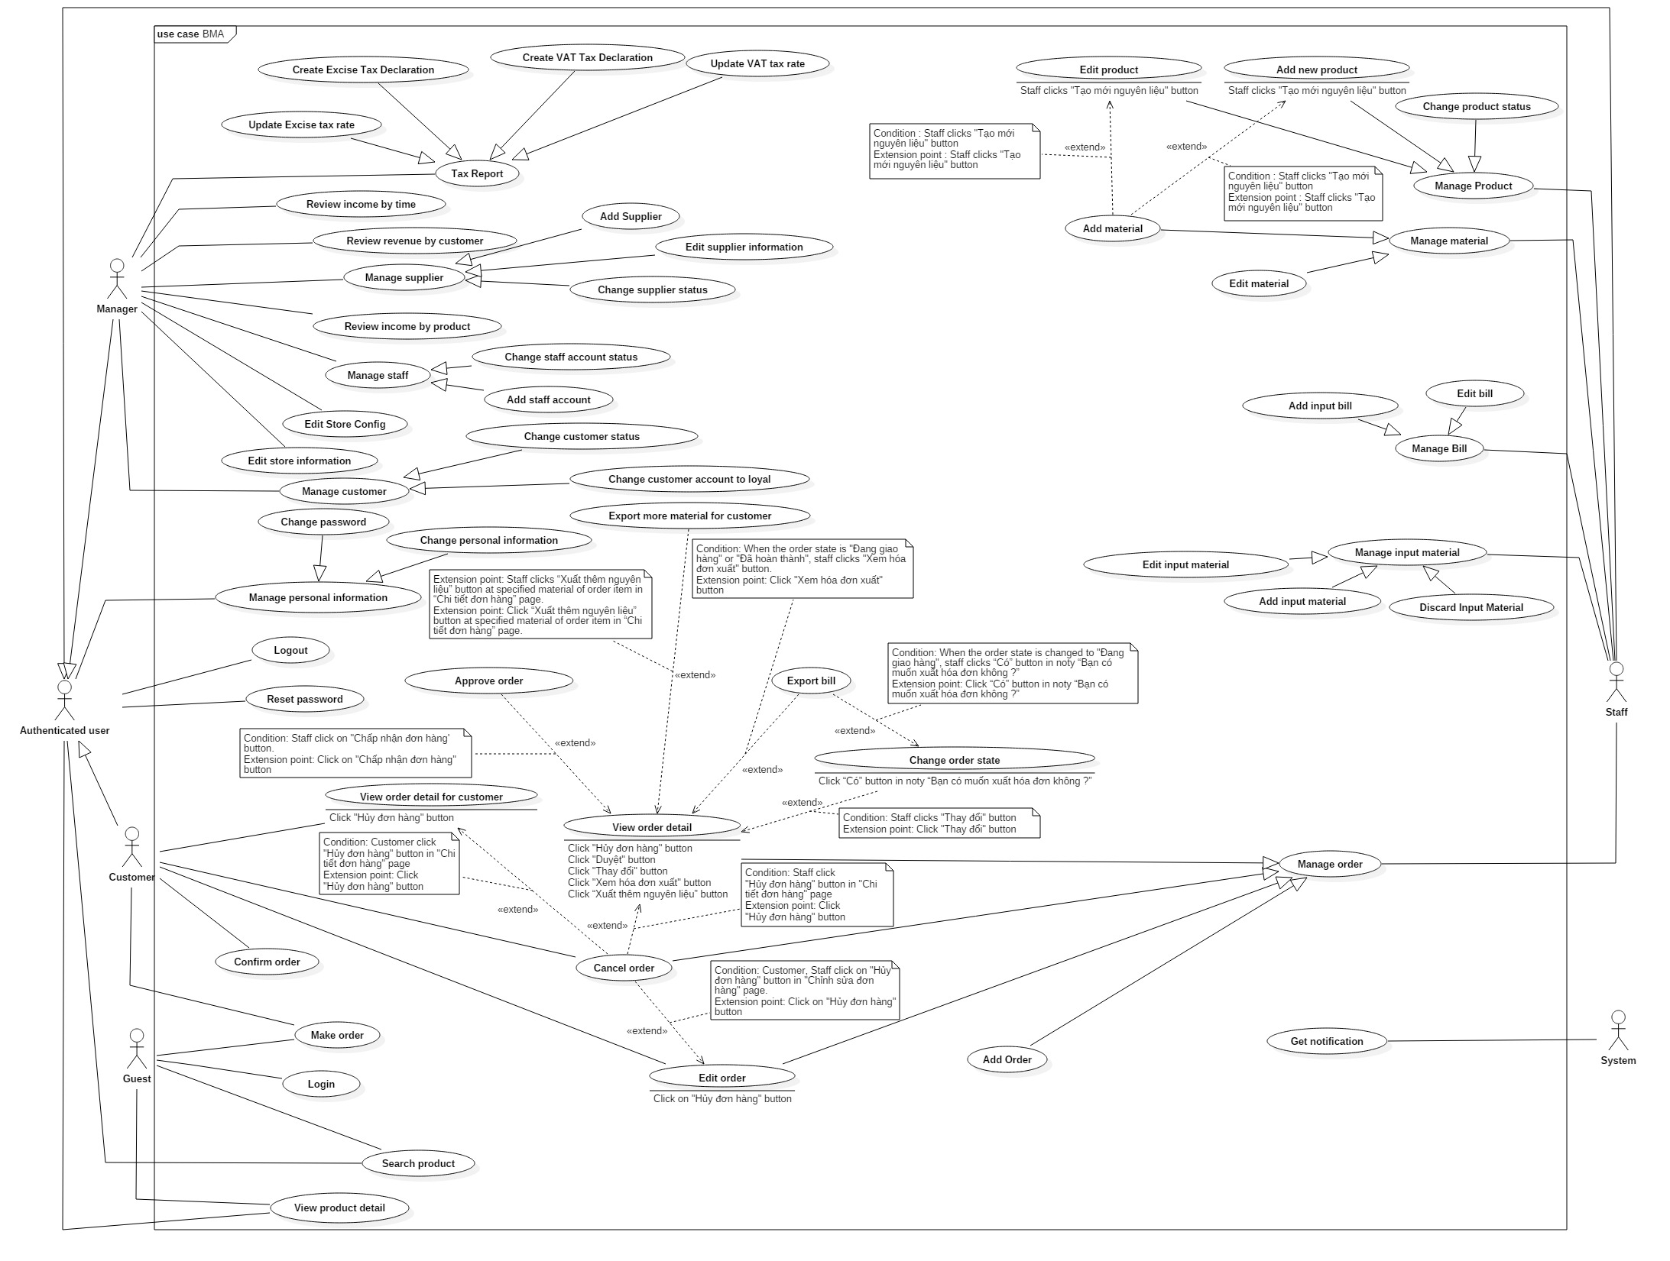

Figure 2: System Overview Use Case

### List of Use Case

#### <Guest> Overview Use Case

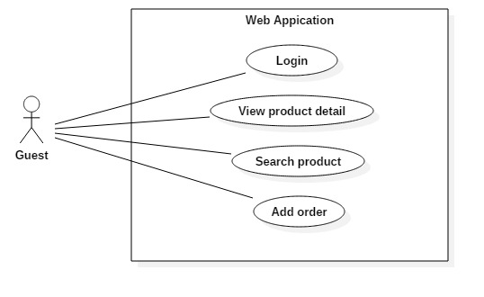

Figure 3: <Guest> Overview Use Case

##### <Guest> Login

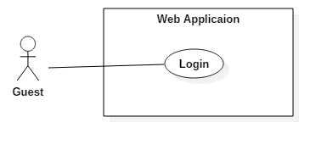

Figure 4:< Guest> Login

|  |  |  |  |
| --- | --- | --- | --- |
| USE CASE – UG01 | | | |
| Use Case No. | UG01 | **Use Case Version** | 2.0 |
| Use Case Name | Login | | |
| Author | MạnhOT | | |
| Date | 27/09/2015 | **Priority** | Normal |
| Actor:   * Guest   Summary:   * This use case allows guest to log in the system.   Goal:   * Guest can log in the system.   Triggers:   * Guest sends the login command.   Preconditions:   * N/A   Post Conditions:   * Success: Guest login the system. * Fail: Show error message.   Main Success Scenario:   |  |  |  | | --- | --- | --- | | Step | Actor Action | System Response | | 1 | Guest click “Đăng nhập” button. | System show popup requires identity information :   * Tài khoản: free text input, required, max length 32 * Mật khẩu: free text input, required, length 6 – 32 | | 2 | Guest inputs information. |  | | 3 | Guest sends command to login to system | Guest will be logged-in system with their specific role  [Exception 1]  [Exception 2]  [Exception 3]  [Exception 4]  [Exception 5] |   Alternative Scenario: N/A  Exceptions:   |  |  |  | | --- | --- | --- | | No | Actor Action | System Response | | 1 | Guest missed to input “Tài khoản” field | System show error message “Tài khoản không được đế trống” | | 2 | Guest missed to input “Mật khẩu” field | System show error message “Mật khẩu không được đế trống” | | 3 | Guest inputed wrong format “Mật khẩu” field | System shows error message “Mật khẩu không được ít hơn 6 kí tự” | | 4 | Guest inputed wrong account or password | System shows error message “Tài khoản hoặc mật khẩu không đúng” | | 5 | Account is deactivated. | System shows error message “Tài khoản đã bị khóa, vui lòng liên hệ quản lý để biết thêm chi tiết”. |   Relationships: N/A  Business Rules:   * Only active account can login into server. * After login to system, guest will been redirected to specific view based on their role on the system: staff or customer. * If role is “Customer”, the system will display to Customer view. * If role is “Staff” or “Manager”, the system will display to Staff Dashboard view. | | | |

Table 8: Use case UG01 - <Guest> Login

##### <Guest> Search product

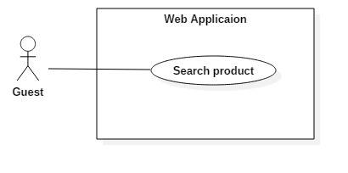

Figure 5: <Guest> Search product

|  |  |  |  |
| --- | --- | --- | --- |
| USE CASE – UG02 | | | |
| Use Case No. | UG02 | **Use Case Version** | 2.0 |
| Use Case Name | Search product | | |
| Author | MạnhOT | | |
| Date | 27/09/2015 | **Priority** | Normal |
| Actor:   * Guest   Summary:   * This use case allows guest to search product.   Goal:   * Guest can search products by name.   Triggers:   * Guest enters a keyword to search product name.   Preconditions:   * Guest goes to “Sản phẩm” page   Post Conditions:   * Success: A list of products which have name agreed with keyword will be displayed. * Fail: List of products which have name agreed with keyword hadn’t been display.   Main Success Scenario:   |  |  |  | | --- | --- | --- | | Step | Actor Action | System Response | | 1 | Guest enters keyword and click “Tìm kiếm” button on webpage (or press “Enter” button on keyboard)  [Alternative 1] | Display list of matched products’ name with this keyword.  [Exception 1] |   Alternative Scenario:   |  |  |  | | --- | --- | --- | | No | Actor Action | System Response | | 1 | Guest doesn’t enter keyword and click “Tìm kiếm” button on webpage (or press “Enter” button on keyboard) | Display all products |   Exceptions:   |  |  |  | | --- | --- | --- | | No | Actor Action | System Response | | 1 | Guest enters keyword which do not match any product. | Show message “Không có sản phẩm thỏa yêu cầu”. |   Relationships: N/A  Business Rules:   * Do not display unmatched product(s) with keyword had been entered. * Each product includes name, price, “Chi tiết” button for viewing the information of this product and “Thêm vào giỏ hàng” button for guest can order. | | | |

Table 9: Use case UG02 - <Guest> Search product

##### <Guest> View product detail

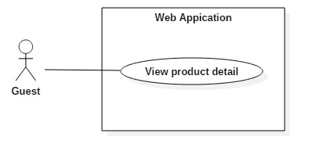

Figure 6: <Guest> View product detail

|  |  |  |  |
| --- | --- | --- | --- |
| USE CASE – UG03 | | | |
| Use Case No. | UG03 | **Use Case Version** | 2.0 |
| Use Case Name | View product detail | | |
| Author | MạnhOT | | |
| Date | 27/09/2015 | **Priority** | Normal |
| Actor:   * Guest   Summary:   * This use case allows guest to view product detail.   Goal:   * Guest can view product detail.   Triggers:   * Guest clicks “Chi tiết” button   Preconditions:   * Guest goes to “Sản phẩm” page   Post Conditions:   * Success: Display all of information of selected product. * Fail: Show error message   Main Success Scenario:   |  |  |  | | --- | --- | --- | | Step | Actor Action | System Response | | 1 | Guest click “Chi tiết” button | Redirect to selected product’s information page; display all of information of this product.  [Exception 1] |   Alternative Scenario: N/A  Exceptions:   |  |  |  | | --- | --- | --- | | No | Actor Action | System Response | | 1 | Guest try to retrieve a product’s information page but not exist in database | Redirect to an exception page |   Relationships: N/A  Business Rules:   * Redirect correctly to information page of selected product. | | | |

Table 10: Use case UG03 - <Guest> View product detail

##### <Guest> Make order

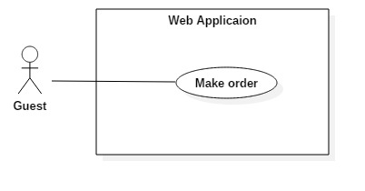

Figure 7: <Guest> Make order

|  |  |  |  |
| --- | --- | --- | --- |
| USE CASE – UG04 | | | |
| Use Case No. | UG04 | **Use Case Version** | 2.0 |
| Use Case Name | Make order | | |
| Author | MạnhOT | | |
| Date | 27/09/2015 | **Priority** | Normal |
| Actor:   * Guest   Summary:   * This use case allows guest to order product(s).   Goal:   * Guest can order product(s).   Triggers:   * Guest clicks “Mua hàng” in “Sản phẩm” page * Guest clicks “Mua hàng” in specified product information page   Preconditions:   * Guest is in “Sản phẩm” page * The product list has at least one product.   Post Conditions:   * Success: Order success and waiting for staff approve. * Fail: Show error message.   Main Success Scenario:   |  |  |  | | --- | --- | --- | | Step | Actor Action | System Response | | 1 | Guest clicks “Mua hàng” button at “Sản phẩm” page  [Alternative 1] | Display a pop-up for entering quantity of selected product. | | 2 | Guest clicks on “Thêm vào giỏ hàng” button | System will add this product and quantity to customer’s cart. | | 3 | Previous step 1 to order more |  | | 4 | Guest clicks on “Thanh toán” button to view all ordered products | Redirect to “Giỏ hàng” page and display list of all ordered products. | | 5 | Guest can change quantity of products in order in quantity textbox and click “Cập nhật giỏ hàng”  [Alternative 2]  [Alternative 3]  [Alternative 4] | System will change quantity of this product and update total price of this order. | | 6 | Guest clicks “Đặt hàng” button | Redirect to “Xác nhận đơn hàng” page and display all information about order  [Exception 1]  [Exception 2] | | 7 | Guest clicks “Xác nhận” button | Redirect to “Nhập thông tin” page with required field to get guest information:   * Name: free text input, required, length 3 –50 * Phone number: free text input, required, length 3 –15 * Email: free text input, length 3 – 250 * Address: free text input, required, length 5-250   [Exception 3] | | 8 | Guest clicks “Hoàn tất” button | Show message order products successfully.  [Exception 4] |   Alternative Scenario:   |  |  |  | | --- | --- | --- | | No | Actor Action | System Response | | 1 | Guest wants to search product. | Display list of products which have name matched with keyword had been enter. | | 2 | Guest wants to delete a product from cart, click “Recycle Bin” icon | System will delete this product out of cart | | 3 | Guest wants to delete cart, he/she can click “Hủy đơn hàng” button | All products of cart will be removed and return to product page. | | 4 | Guest wants to continue to order another product, guest will click “Tiếp tục mua sắm” button | Redirect to “Sản phẩm” page |   Exceptions:   |  |  |  | | --- | --- | --- | | No | Actor Action | System Response | | 1 | Total number of products in cart smaller than specific number | Show a message to notify that “Số lượng sản phẩm không được dưới ‘Minimum quantity’” | | 2 | Total number of products in cart more than 10000 | Show a message to notify that “Số lượng sản phẩm không được trên 10000” | | 3 | Customer clicks “Đặt hàng” but the order has the specified product which has status “Ngừng sản xuất”. | Show message “Xin lỗi quý khách đơn hàng có sản phẩm đã ngừng sản xuất. Quý khách vui lòng gỡ khỏi giỏ hàng.” | | 4 | Email and phone number have existed | Show a message to notify that “Email và số điện thoại đã tồn tại, nếu đã có tài khoản xin vui lòng đăng nhập.” |   Relationships: N/A  Business Rules:   * Minimum quantity is prescribed by Manager. * After orders are submitted, the status will be "Chờ xử lý". * All products in cart must have status “Đang sản xuất”. | | | |

Table 11: Use case UG04 - <Guest> Make order

#### <Authenticated user> Overview Use Case

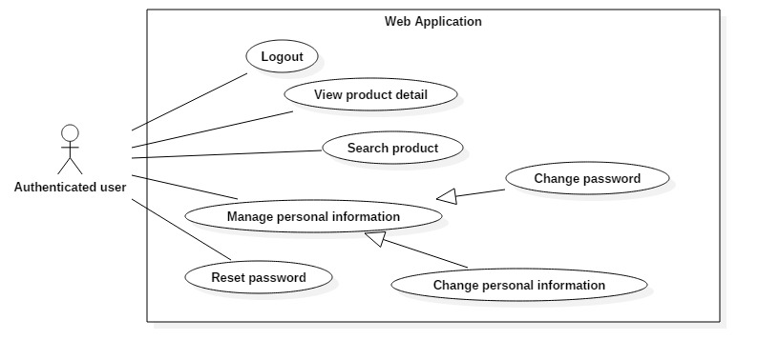

Figure 8: <Authenticated user> Overview Use Case

##### <Authenticated User> Logout

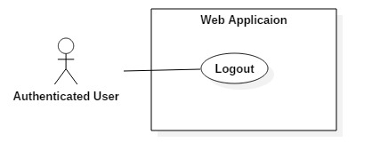

Figure 9: <Authenticated user> Logout

|  |  |  |  |
| --- | --- | --- | --- |
| USE CASE – UA01 | | | |
| Use Case No. | UA01 | **Use Case Version** | 2.0 |
| Use Case Name | Log out | | |
| Author | MạnhOT | | |
| Date | 27/09/2015 | **Priority** | Medium |
| Actor:   * Authenticated user (include Customer, Staff and Manager)   Summary:   * This use case allows authenticated user to log out of the system.   Goal:   * Authenticated user can log out the system.   Triggers:   * Authenticated User clicks on “Đăng xuất” button.   Preconditions:   * User logged in the system. * This account status is “Đang hoạt động”   Post Conditions:   * Success: User logs out the system. * Fail: Do nothing.   Main Success Scenario:   |  |  |  | | --- | --- | --- | | Step | Actor Action | System Response | | 1 | User sends logout command. | Clear session and log user out of the system. Redirect in “Trang chủ” page with “Guest” rule. |   Alternative Scenario: N/A  Exceptions: N/A  Relationships: N/A  Business Rules:   * N/A | | | |

Table 12: Use case UA01 - <Authenticated user> Logout

##### <Authenticated user> Search product

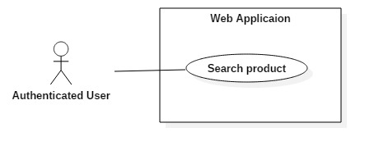

Figure 10: <Authenticated user> Search product

|  |  |  |  |
| --- | --- | --- | --- |
| USE CASE – UA02 | | | |
| Use Case No. | UA02 | **Use Case Version** | 2.0 |
| Use Case Name | Search product | | |
| Author | MạnhOT | | |
| Date | 27/09/2015 | **Priority** | Normal |
| Actor:   * Authenticated user (include Customer, Staff and Manager)   Summary:   * This use case allows authenticated user to search products.   Goal:   * Authenticated user can search products by name.   Triggers:   * Authenticated user enters a keyword to search product name.   Preconditions:   * Logged-in as customer, staff or manager * Authenticated user goes to “Sản phẩm” page   Post Conditions:   * Success: A list of products which have name agreed with keyword will be displayed. * Fail: List of products which have name agreed with keyword hadn’t been display.   Main Success Scenario:   |  |  |  | | --- | --- | --- | | Step | Actor Action | System Response | | 1 | Guest enters keyword and click “Tìm kiếm” button on webpage (or press “Enter” button on keyboard)  [Alternative 1] | Display list of matched product name with this keyword.  [Exception 1] |   Alternative Scenario:   |  |  |  | | --- | --- | --- | | No | Actor Action | System Response | | 1 | Guest doesn’t enter keyword and click “Tìm kiếm” button on webpage (or press “Enter” button on keyboard) | Display all products |   Exceptions:   |  |  |  | | --- | --- | --- | | No | Actor Action | System Response | | 1 | Guest enters keyword which do not match any product. | Show message “Không có sản phẩm thỏa yêu cầu”. |   Relationships: N/A  Business Rules:   * Do not display unmatched product(s) with keyword had been entered. * Each product includes name, price, “Xem thông tin” button for viewing all of information of this product. | | | |

Table 13: Use case UA02 - < Authenticated user> Search product

##### < Authenticated user > View product detail

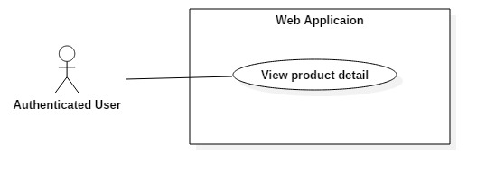

Figure 11: < Authenticated user> View product detail

|  |  |  |  |
| --- | --- | --- | --- |
| USE CASE – UA03 | | | |
| Use Case No. | UA03 | **Use Case Version** | 2.0 |
| Use Case Name | View product detail | | |
| Author | MạnhOT | | |
| Date | 27/09/2015 | **Priority** | Normal |
| Actor:   * Authenticated user (include Customer, Staff and Manager)   Summary:   * This use case allows guest to view product detail.   Goal:   * Authenticated user can view product detail.   Triggers:   * Authenticated user click “Xem thông tin” button   Preconditions:   * Logged-in as customer, staff or manager * Authenticated user goes to “Sản phẩm” page   Post Conditions:   * Success: Display all of information of selected product. * Fail: Show message   Main Success Scenario:   |  |  |  | | --- | --- | --- | | Step | Actor Action | System Response | | 1 | Authenticated userclicks “Chi tiết” button | Redirect to selected product’s information page; display all of information of this product.  [Exception 1] |   Alternative Scenario: N/A  Exceptions:   |  |  |  | | --- | --- | --- | | No | Actor Action | System Response | | 1 | Guest tries to connect to a product’s information page but not exist in database | Redirect to an exception page |   Relationships: N/A  Business Rules:   * Redirect correctly information page of selected product. | | | |

Table 14: Use case UA03 - < Authenticated user> View product detail

##### < Authenticated user > Change personal information

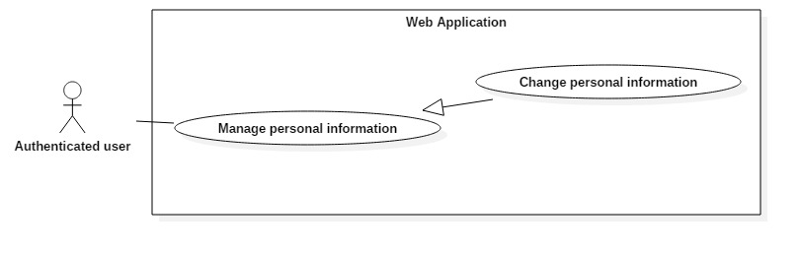

Figure 12: <Authenticated user> Change personal information

|  |  |  |  |
| --- | --- | --- | --- |
| USE CASE – UA01 | | | |
| Use Case No. | UA04 | **Use Case Version** | 2.0 |
| Use Case Name | Change personal information | | |
| Author | MạnhOT | | |
| Date | 27/09/2015 | **Priority** | Medium |
| Actor:   * Authenticated user (include Customer, Staff and Manager)   Summary:   * This use case allows authenticated user to change he/she’s personal information   Goal:   * Authenticated user can change their personal information.   Triggers:   * Authenticated User clicks on “Thay đổi thông tin cá nhân” at Quản lý thông tinh page   Preconditions:   * User logged in the system. * This account status is “Đang hoạt động”   Post Conditions:   * Success: Authenticate user’s information will be updated. * Fail: Show error message.   Main Success Scenario:   |  |  |  | | --- | --- | --- | | Step | Actor Action | System Response | | 1 | User clicks on “Thay đổi thông tin cá nhân” | System require information :   * “Họ tên”: textbox, required, max length 50 * “Địa chỉ”: textbox, required, max length 250 * “Email”: textbox, max length 250 * “Mã số thuế”: textbox, max length 13, number only * “Số điện thoại”: textbox, max length 12???, number only | | 2 | User inputs information |  | | 3 | User clicks on “Thay đổi” button to send change information command | Show message change persornal information successful  [Exception 1, 2, 3, 4, 5, 6] |   Alternative Scenario: N/A  Exceptions:   |  |  |  | | --- | --- | --- | | No | Actor Action | System Response | | 1 | User missed to input “Họ tên” field | Show error message : “Họ tên không được để trống” | | 2 | User missed to input “Địa chỉ” field | Show error message : “Địa chỉ không được để trống” | | 3 | User missed to input “Số điện thoại” field | Show error message : “Số điện thoại không được để trống” | | 4 | User missed to input “Email” field | Show error message : “Email không được để trống” | | 5 | User inputed wrong format at “Email” field | Show error message : “Email không đúng định dạng – example@gmail.com” | | 6 | User missed to input “Mã số thuế” field | Show error message : “Mã số thuế không được để trống” |   Relationships: N/A  Business Rules:   * Format input text :   + “Họ tên”: textbox, required, max length 50   + “Địa chỉ”: textbox, required, max length 250   + “Email”: textbox, max length 250   + “Mã số thuế”: textbox, max length 13, number only   + “Số điện thoại”: textbox, max length 12???, number only | | | |

Table 15: Use case UA04 - <Authenticated user> Change personal information

##### < Authenticated user > Change password

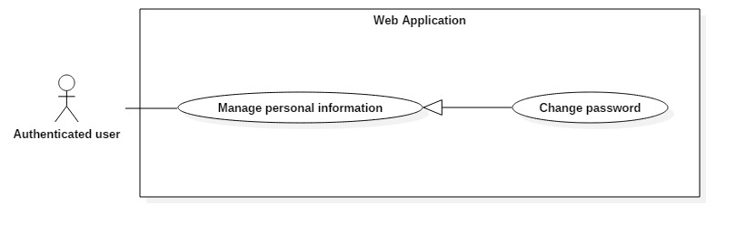

Figure 13: <Authenticated user> Change password

|  |  |  |  |
| --- | --- | --- | --- |
| USE CASE – UA05 | | | |
| Use Case No. | UA05 | **Use Case Version** | 2.0 |
| Use Case Name | Change password | | |
| Author | MạnhOT | | |
| Date | 27/09/2015 | **Priority** | Medium |
| Actor:   * Authenticated user (include Customer, Staff and Manager)   Summary:   * This use case allows authenticated user to change he/she’s password   Goal:   * Authenticated user can change their password.   Triggers:   * Authenticated User clicks on “Thay đổi mật khẩu” at Quản lý thông tin page   Preconditions:   * User logged in the system. * This account status is “Đang hoạt động”   Post Conditions:   * Success: Authenticate user’s password will be changed. * Fail: Show error message.   Main Success Scenario:   |  |  |  | | --- | --- | --- | | Step | Actor Action | System Response | | 1 | User clicks on “Thay đổi mật khẩu” | System require information :   * “Mật khẩu cũ”: textbox, required, max length 32 * “Mật khẩu mới”: textbox, required, max length 32 * “Xác nhận lại”: textbox, max length 32 | | 2 | User inputs information |  | | 3 | User clicks on “Thay đổi” button to send change password command | Show message change password successful  [Exception 1, 2, 3, 4, 5] |   Alternative Scenario: N/A  Exceptions:   |  |  |  | | --- | --- | --- | | No | Actor Action | System Response | | 1 | User missed to input “Mật khẩu cũ” field or “Mật khẩu mới” field or “Mật khẩu cũ” field | Show error message : “Mật khẩu không được để trống” | | 2 | Inputted “Mật khẩu cũ” field or “Mật khẩu mới” field or “Xác nhận lại” field have length less than 6 | Show error message : “Mật khẩu không được ít hơn 6 kí tự” | | 3 | Inputted “Mật khẩu cũ” field not same as this user’s password in database | Show error message : “Mật khẩu không đúng, vui lòng thử lại” | | 4 | Inputted “Mật khẩu cũ” field and “Mật khẩu mới” field are the same | Show error message : “Mật khẩu cũ và mật khẩu mới giống nhau, vui lòng thử lại” | | 5 | Inputted “Mật khẩu mới” field and “Xác nhận lại” field aren’t the same | Show error message : “Mật khẩu mới và mật khẩu xác nhận không trùng khớp” |   Relationships: N/A  Business Rules:   * After change password, user have to login to system by new password * New password will be encrypted before save into database * Format input text :   + Mật khẩu cũ”: textbox, required, max length 32   + “Mật khẩu mới”: textbox, required, max length 32   + “Xác nhận lại”: textbox, max length 32 | | | |

Table 16: Use case UA05 - <Authenticated user> Change password

##### <Authenticated user> Reset password

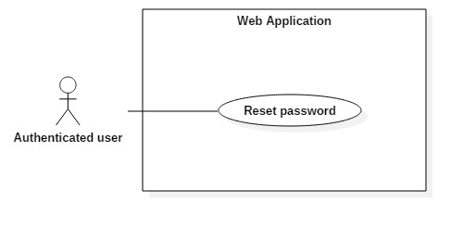

Figure 14: <Authenticated user> Reset password

|  |  |  |  |
| --- | --- | --- | --- |
| USE CASE – UA01 | | | |
| Use Case No. | UA06 | **Use Case Version** | 2.0 |
| Use Case Name | Reset password | | |
| Author | MạnhOT | | |
| Date | 27/09/2015 | **Priority** | Medium |
| Actor:   * Authenticated user (include Customer, Staff and Manager)   Summary:   * This use case allows authenticated user reset password   Goal:   * Authenticated user can change password without current password   Triggers:   * Authenticated User clicks on “Quên mật khẩu” at Login popup   Preconditions:   * User account exist in the system   Post Conditions:   * Success: Authenticate user’s password will be changed. * Fail: Show error message.   Main Success Scenario:   |  |  |  | | --- | --- | --- | | Step | Actor Action | System Response | | 1 | User clicks on “Quên mật khẩu” at login popup | System require information :   * “Tài khoản”: textbox, required, max length 32 | | 2 | User inputs information |  | | 3 | User clicks on “Hoàn tất” button | Show message request create password successful  [Exception 1]  [Exception 2]  [Exception 3] | | 4 | User checks email and click on “Tạo mới mật khẩu” link | Redirect to “Tạo mật khẩu mới” page, require information :   * “Mật khẩu mới” : textbox, required, max length 32 * “Xác nhận lại”: textbox, required, max length 32   [Expcetion 4] | | 5 | User inputs information |  | | 6 | User clicks on “Hoàn tất” button to send create new password command | Show message create new password successful  [Exception 5]  [Exception 6]  [Exception 7]  [Exception 8] |   Alternative Scenario: N/A  Exceptions:   |  |  |  | | --- | --- | --- | | No | Actor Action | System Response | | 1 | User missed to input “Tài khoản” field | Show error message : “Vui lòng nhập tên tài khoản” | | 2 | User inputted account that not existed | Show error message : “Tài khoản này không tồn tại trong hệ thống, vui lòng thử lại” | | 3 | System take too long time to send email to this user | Redirect to error page | | 4 | Users click “Tạo mới mật khẩu” link after 24 hours since he/she sent request to create a password | Show error message: “Đã quá 24 tiếng kể từ khi chúng tôi gởi mail xác nhận. Vui lòng gởi yêu cầu khác” | | 5 | User miss to input “Mật khẩu mới” field | Show error message: “Vui lòng nhập mật khẩu mới” | | 6 | User miss to input “Xác nhận lại” field | Show error message: “Vui lòng xác nhận lại mật khẩu mới” | | 7 | Inputted “Mật khẩu mới” field or “Xác nhận lại” field have length less than 6 | Show error message: “Mật khẩu khong được ít hơn 6 kí tự” | | 8 | Inputted “Mật khẩu mới” field and “Xác nhận lại” field aren’t the same | Show error message: “Mật khẩu và mật khẩu xác nhận không giống nhau, vui lòng thử lại” |   Relationships: N/A  Business Rules:   * User can change password within 24 hours since he/she sent request to create new password, if over 24 hours, he/she have to send another request * Format input text :   + “Tài khoản”: textbox, required, max length 32 | | | |

Table 17: Use case UA06 - <Authenticated user> Reset password

#### <System> Overview Use Case

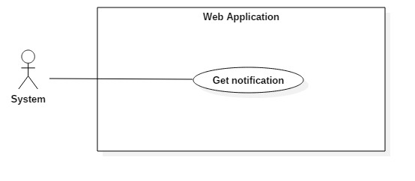

Figure 15 <System> Overview Use Case

##### <System> Get notifcation



Figure 16: <System> Get notification

|  |  |  |  |
| --- | --- | --- | --- |
| USE CASE – US12 | | | |
| Use Case No. | US12 | **Use Case Version** | 2.0 |
| Use Case Name | Get notification | | |
| Author | MạnhOT | | |
| Date | 02/10/2015 | **Priority** | Normal |
| Actor:   * System   Summary:   * This use case allows customer, staff, manager receive notification   Goal:   * Customer or (Staff and Manager) receive notification   Triggers:   * Guest clicks “Hoàn tất” at “Nhập thông tin” page to make new order * Customer clicks “Xác nhận” at “Xác nhận đơn hàng” page to make new order * Staff clicks “Duyệt” to confirm customer/guest order at “Chi tiết đơn hàng” page * Staff clicks “Đồng ý” at “Hủy nguyên liệu” popup * Staff clicks “Cập nhật” at “Chỉnh sửa đơn hàng” page * Staff clicks “Đồng ý” at “Thay đổi trạng thái đơn hàng” popup   Preconditions:   * User must login into the system * This account status is “Đang hoạt động”   Post Conditions:   * Success: Customer or (Staff and Manager) receive notification * Fail: Show error message.   Main Success Scenario:   |  |  |  | | --- | --- | --- | | Step | Actor Action | System Response | | 1 | Customer clicks “Xác nhận” or Guest clicks “Hoàn tất” at “Nhập thông tin” page at “Xác nhận đơn hàng” page to make new order  [Alternative 1, 2, 3, 4] | System shows notifcation to Staff and Manager : “Có một đơn hàng vừa được thêm mới”  [Exception 1] |   Alternative Scenario:   |  |  |  | | --- | --- | --- | | No | Actor Action | System Response | | 1 | Staff clicks “Duyệt” to confirm customer/guest order at “Chi tiết đơn hàng” page | System shows notifcation to Staff and Manager : “Có nguyên liệu số lượng quá thấp, vui lòng kiểm tra”  [Exception 5] | | 2 | Staff clicks “Đồng ý” at “Hủy nguyên liệu” popup | System shows notifcation to Staff and Manager : “Có nguyên liệu số lượng quá thấp, vui lòng kiểm tra”  [Exception 2] | | 3 | Staff clicks “Cập nhật” at “Chỉnh sửa đơn hàng” page | System shows notifcation to Customer whose orders were modified : “Có một đơn hàng vừa được thay đổi trạng thái”  [Exception 3] | | 4 | Staff clicks “Đồng ý” at “Thay đổi trạng thái đơn hàng” popup | System shows notifcation to Customer whose orders were modified : “Có một đơn hàng vừa được thay đổi trạng thái”  [Exception 4] |   Exceptions:   |  |  |  | | --- | --- | --- | | No | Actor Action | System Response | | 1 | Customer or Guest fail to make order | No notification to staff, manager | | 2 | Staff fail to discard input material | No notification to staff, manager | | 3 | Staff fail to edit customer’s order | No notification to staff, manager | | 4 | Staff fail to change customer’s order status | No notification to staff, manager | | 5 | Staff fail to confirm customer’s/guest’s order | No notification to staff, manager |   Relationships: N/A  Business Rules:   * Notify will be displayed until user click on it. * Numbers of notity will be increased as new notifications and undisplay only user click to check. | | | |

Table 18: Use case C01 - <System> Get notification

#### <Customer> Overview Use Case

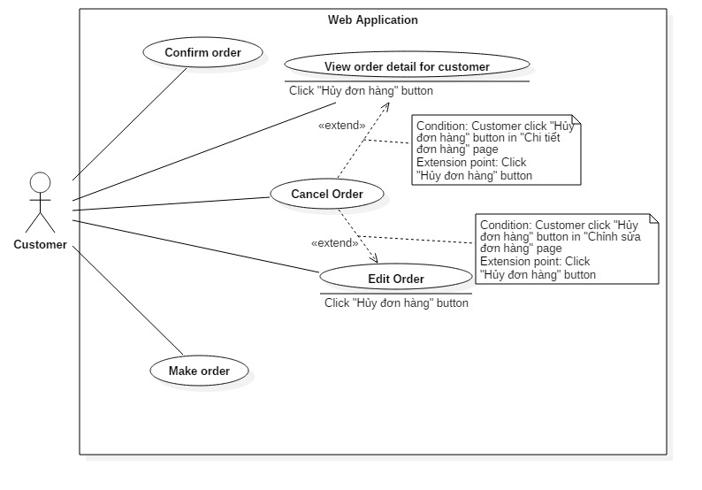

Figure 17 <Customer> Overview Use Case

##### <Customer> Make order

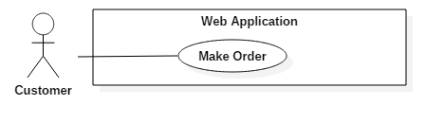

Figure 18: <Customer> Make Order

|  |  |  |  |
| --- | --- | --- | --- |
| USE CASE – C01 | | | |
| Use Case No. | UC01 | **Use Case Version** | 2.0 |
| Use Case Name | Make Order | | |
| Author | MạnhOT | | |
| Date | 01/10/2015 | **Priority** | Normal |
| Actor:   * Customer   Summary:   * This use case allows customer to order products.   Goal:   * Customer can order products.   Triggers:   * Customer click “Mua hàng” in “Sản phẩm” page. * Customer click “Mua hàng” in specified “Chi tiết sản phẩm” page.   Preconditions:   * User must login into the system with role “Customer”. * This account status is “Đang hoạt động”. * The product list has at least one product.   Post Conditions:   * Success: Order success and waiting for staff approve. * Fail: Show error message.   Main Success Scenario:   |  |  |  | | --- | --- | --- | | Step | Actor Action | System Response | | 1 | Customer clicks “Mua hàng” button in “Sản phẩm” page.  [Alternative 1] | Display a pop-up for entering quantity of the selected product. | | 2 | Customer clicks “Thêm vào giỏ hàng” button. | System will add this product and quantity to customer’s cart. | | 3 | Previous step 1 to order more |  | | 4 | Customer clicks “Thanh toán” button to view all ordered products. | Redirect to “Giỏ hàng” page and display list of all ordered products. | | 5 | Customer changes the number in quantity textbox and clicks “Cập nhật giỏ hàng” to change the quantity of specified product  [Alternative 2]  [Alternative 3]  [Alternative 4] | System will change quantity of this product and update total price of this order. | | 6 | Customer click “Đặt hàng” | Redirect to “Xác nhận đơn hàng” page and display all information about order  [Exception 1]  [Exception 2] | | 7 | Customer clicks on “Xác nhận” button | Show message order products successfully.  [Exception 3] |   Alternative Scenario:   |  |  |  | | --- | --- | --- | | No | Actor Action | System Response | | 1 | Customer enters keyword at search box and clicks “Tìm kiếm” button. | Display list of product matched with keyword has been enter. | | 2 | Customer clicks “Recycle Bin” icon on specified product to remove this product from cart. | System will remove this product from cart. | | 3 | Customer clicks “Tiếp tục mua sắm” button to continue order another product. | Redirect to “Sản phẩm” page | | 4 | Customer clicks “Hủy đơn hàng” button to delete cart. | All products of cart will be removed and return to product page. |   Exceptions:   |  |  |  | | --- | --- | --- | | No | Actor Action | System Response | | 1 | Total number of products in cart smaller than specific number | Show a message to notify that “Số lượng sản phẩm không được dưới ‘Minimum quantity’” | | 2 | Total number of products in cart more than 10000 | Show a message to notify that “Số lượng sản phẩm không được trên 10000” | | 3 | Customer clicks “Đặt hàng” but the order has the specified product which has status “Ngừng sản xuất”. | Show message “Xin lỗi quý khách sản phẩm X đã ngừng sản xuất. Quý khách vui lòng gỡ khỏi giỏ hàng.” |   Relationships: N/A  Business Rules:   * Minimum quantity is prescribed by Manager. * All products in cart must have status “Đang sản xuất”. * After order is submitted, the order status will be "Chờ xác nhận". | | | |

Table 19: Use case UC01 - <Customer> Make Order

##### <Customer> Edit order

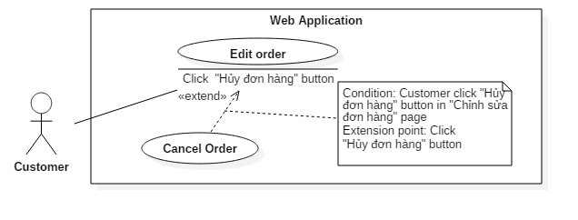

Figure 19: <Customer> Edit Order

|  |  |  |  |
| --- | --- | --- | --- |
| USE CASE – UC02 | | | |
| Use Case No. | UC02 | **Use Case Version** | 2.0 |
| Use Case Name | Edit Order | | |
| Author | MạnhOT | | |
| Date | 01/10/2015 | **Priority** | Normal |
| Actor:   * Customer   Summary:   * This use case allows customer to edit the order.   Goal:   * Customer can change quantity for selected products, add/delete products in order.   Triggers:   * Customer clicks on “Chỉnh sửa” button at “Quản lý đơn hàng” page.   Preconditions:   * User must login into the system with role “Customer”. * This customer account status is “Đang hoạt động”. * Customer has at least one order. * The order status is “Chờ xử lý”.   Post Conditions:   * Success: Order is edited. * Fail: Show error message.   Main Success Scenario:   |  |  |  | | --- | --- | --- | | Step | Actor Action | System Response | | 1 | Customer clicks “Chỉnh sửa” button | Redirect to “Giỏ hàng” page and display list of all products of that order.  [Exception 1] | | 2 | Customer changes the number in quantity textbox and clicks “Cập nhật giỏ hàng” to change the quantity of specified product.  [Alternative 1]  [Alternative 2] | System will change quantity of this product and update total price of this order. | | 3 | Customer clicks “Chỉnh sửa đơn hàng” button. | Redirect to “Xác nhận đơn hàng” page and display all information about order  [Exception 2]  [Exception 3] | | 4 | Customer clicks on “Xác nhận” button | Show message edit order products successfully.  [Exception 4] |   Alternative Scenario:   |  |  |  | | --- | --- | --- | | No | Actor Action | System Response | | 1 | Customer clicks “Recycle Bin” icon on specified product to remove this product from cart. | System will remove this product from cart. | | 2 | Customer clicks “Tiếp tục mua sắm” button to order new product. | Redirect to “Sản phẩm” page |   Exceptions:   |  |  |  | | --- | --- | --- | | No | Actor Action | System Response | | 1 | Customer try to retrieve a order’s information not exist in database or connect to a order’s information doesn’t belong to he/she | Redirect to an exception page | | 2 | Total number of products in cart smaller than specific number | Show a message to notify that “Số lượng sản phẩm không được dưới ‘Minimum quantity’”. | | 3 | Total number of products in cart more than 10000 | Show a message to notify that “Số lượng sản phẩm không được trên 10000” | | 4 | Customer clicks “Đặt hàng” but the order has the specified product which has status “Ngừng sản xuất”. | Show message “Xin lỗi quý khách sản phẩm X đã ngừng sản xuất. Quý khách vui lòng gỡ khỏi giỏ hàng.” |   Relationships: extended by “Cancel order” (Click “Hủy đơn hàng” button)  Business Rules:   * System paging page when the number of products larger than 10. * The information is loaded from the system correctly. * Cannot edit when order’s status isn’t “Chờ xử lý”. * Minimum quantity is prescribed by Manager. * All products in cart must have status “Đang sản xuất”. | | | |

Table 20: Use case UC02 - <Customer> Edit order

##### <Customer> View order detail

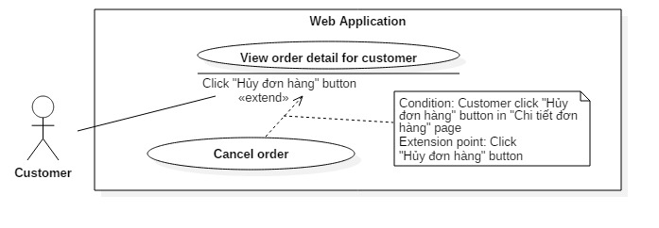

Figure 20: <Customer> View order detail

|  |  |  |  |
| --- | --- | --- | --- |
| USE CASE – UC03 | | | |
| Use Case No. | UC03 | **Use Case Version** | 2.0 |
| Use Case Name | View order detail | | |
| Author | MạnhOT | | |
| Date | 01/10/2015 | **Priority** | Normal |
| Actor:   * Customer   Summary:   * This use case allows customer to view order detail   Goal:   * Customer can review the own order detail.   Triggers:   * Customer goes to “Danh sách đơn hàng” page.   Preconditions:   * User must login into the system with role “Customer”. * This customer account status is “Đang hoạt động”. * Customer have at least one order.   Post Conditions:   * Success: View the detail of the specific order. * Fail: Show error message.   Main Success Scenario:   |  |  |  | | --- | --- | --- | | Step | Actor Action | System Response | | 1 | Customer clicks “Chi tiết” button at specific order. | Redirect to “Chi tiết đơn hàng” page. |   Alternative Scenario: N/A  Exceptions:   |  |  |  | | --- | --- | --- | | No | Actor Action | System Response | | 1 | Customer try to retrieve a order’s information not exist in database or connect to a order’s information doesn’t belong to he/she | Redirect to an exception page |   Relationships: extended by “Cancel order” (Click “Hủy đơn hàng” button)  Business Rules:   * The information is loaded from the system correctly. | | | |

Table 21: Use case UC03 - <Customer> View order detail

##### <Customer> Cancel order

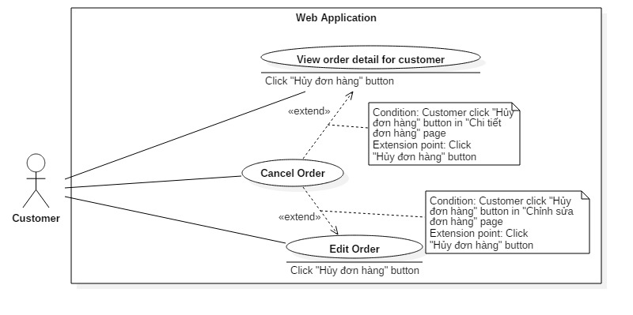

Figure 21: <Customer> Cancel Order

|  |  |  |  |
| --- | --- | --- | --- |
| USE CASE – UC04 | | | |
| Use Case No. | UC04 | **Use Case Version** | 2.0 |
| Use Case Name | Cancel Order | | |
| Author | MạnhOT | | |
| Date | 02/10/2015 | **Priority** | Normal |
| Actor:   * Customer   Summary:   * This use case allows customer to cancel the order.   Goal:   * Customer can remove specific order   Triggers:   * Customer clicks “Hủy” at “Quản lý đơn hàng” page. * Customer clicks “Hủy đơn hàng” at “Chi tiết đơn hàng” page of specified order.   Preconditions:   * User must login into the system with role “Customer”. * This account status is “Đang hoạt động”. * Customer have at least one order which status is not “Đã hoàn thành”   Post Conditions:   * Success: Cancel specific order. * Fail: Show error message.   Main Success Scenario:   |  |  |  | | --- | --- | --- | | Step | Actor Action | System Response | | 1 | Customer click “Hủy” button of the order have status is “Chờ xử lý”  [Alternative 1] | System will show popup to display the notification “Quý khách thực sự muốn hủy đơn hàng này?” to confirm the cancellation. | | 2 | Customer click “Đồng ý” button  [Alternative 2] | Show the message “Hủy đơn hàng thành công”. |   Alternative Scenario:   |  |  |  | | --- | --- | --- | | No | Actor Action | System Response | | 1 | Customer click “Hủy” button of the order have status is “Chờ xác nhận” or “Đã Duyệt” or “Đang sản xuất” or “Đang giao hàng | System will show popup to display the notification “Nếu quý khách hủy đơn hàng thì sẽ bị mất tiền cọc. Quý khách có muốn hủy đơn hàng này không?” to confirm the cancellation. | | 2 | Customer clicks “Đóng” button. | Close popup |   Exceptions: N/A  Relationships: extend for “View order detail” (Click “Hủy” button), “Edit order” (Click “Hủy đơn hàng” button).  Business Rules:   * That order will be removed out of database if that order status is “Chờ xử lý” * Cannot cancel order if order status is “Đã hoàn thành”, “Đã hủy” * Order status will become to “Đã hủy” if order status before cancel is “Chờ xác nhận” or “Đã duyệt” or “Đang sản xuất” or “Đang giao hàng”. * Depend on the cancellation from the bakery or the customer, there is the return of deposit. * If the cancellation happens at “Đã duyệt”, “Chở xác nhận”, the materal will be returned to the store. * If the cancellation happens at “Chở xử lý” the order will be removed from system. | | | |

Table 22: Use case UC04 - <Customer> Cancel Order

##### <Customer> Confirm order

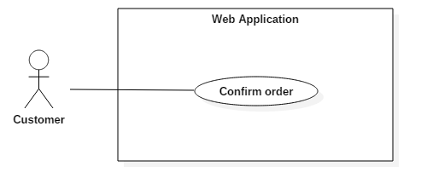

Figure 22: <Customer> Confirm Order

|  |  |  |  |
| --- | --- | --- | --- |
| USE CASE – UC05 | | | |
| Use Case No. | UC05 | **Use Case Version** | 2.0 |
| Use Case Name | Confirm Order | | |
| Author | MạnhOT | | |
| Date | 01/10/2015 | **Priority** | Normal |
| Actor:   * Customer   Summary:   * This use case allows customer to confirm order.   Goal:   * Customer can confirm their order when that order is edited by staff.   Triggers:   * Customer goes to “Danh sách đơn hàng xác nhận” page.   Preconditions:   * That order has status “Chờ xác nhận”. * Customer have at one order has status “Chờ xác nhận” * User must login into the system with role “Customer”. * This account status is “Đang hoạt động”.   Post Conditions:   * Success: Order status become to “Đã duyệt”. * Fail: Show error message.   Main Success Scenario:   |  |  |  | | --- | --- | --- | | Step | Actor Action | System Response | | 1 | Customer clicks “Xác nhận” button at specific order | Redirect to “Xác nhận đơn hàng” page, display orders before, after edited | | 2 | Customer clicks “Xác nhận” button.  [Alternative 1]  [Alternative 2] | Order’s status will changed from “Chờ xác nhận” to “Đã duyệt” |   Alternative Scenario:   |  |  |  | | --- | --- | --- | | No | Actor Action | System Response | | 1 | Customer click “Hủy đơn hàng”. | Order before staff edit (Chờ xử lý) will be deleted  Order after staff edit (Chờ xác nhận) will be changed status to “Đã hủy” | | 2 | Customer click “Hủy thay đổi” | Order’s status will changed from “Chờ xác nhận” to “Chờ xử lý” |   Exceptions: N/A  Relationships: N/A  Business Rules:   * The information is loaded from the system correctly. * Customer cannot edit when order’s status is “Chờ xác nhận”. * If customer clicks “Hủy đơn hàng” button, all input material provided to that order will be return. * If customer clicks “Hủy thay đổi” button, all change will be rollback to before staff edit. * When customer clicks “Xác nhận”, the older version of order is deleted | | | |

Table 23: Use case UC05 - <Customer> Confirm order

#### <Staff> Overview Use Case

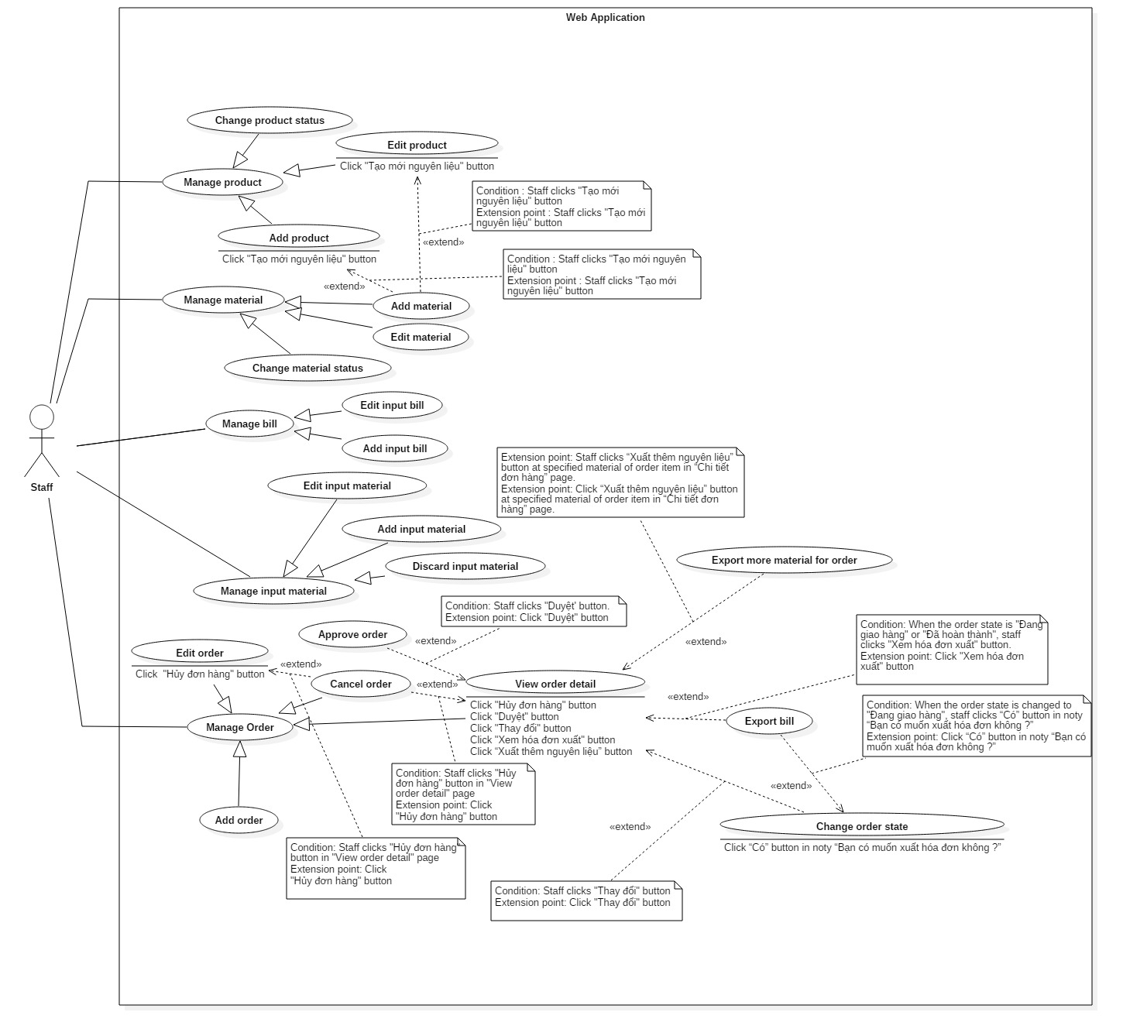

Figure 23: <Staff> Overview Use Case

##### <Staff> Add order

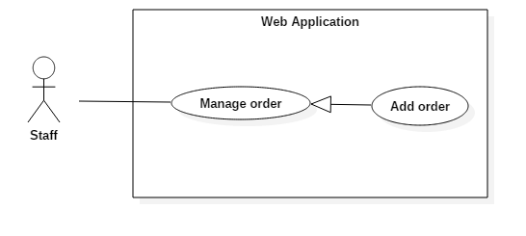

Figure 24: <Staff> Add Order

|  |  |  |  |
| --- | --- | --- | --- |
| USE CASE – US01 | | | |
| Use Case No. | US01 | **Use Case Version** | 2.0 |
| Use Case Name | Add order | | |
| Author | GiangHHT | | |
| Date | 02/10/2015 | **Priority** | Normal |
| Actor:   * Staff   Summary:   * This use case allows staff to add order for guest or customer.   Goal:   * Staff can add order for guest or customer’s suggestion   Triggers:   * Staff clicks “Tạo mới đơn hàng” at left side bar. * Staff clicks “Tạo mới đơn hàng” button at Order list page.   Preconditions:   * User must login into the system with role “Staff” with status “Đang hoạt động”.   Post Conditions:   * Success: Add new order for guest or customer * Fail: Show error message.   Main Success Scenario:   |  |  |  | | --- | --- | --- | | Step | Actor Action | System Response | | 1 | Staff clicks “Tạo mới đơn hàng” button at left side bar. | System shows “Chọn sản phẩm” page displaying all products of system | | 2 | Staff clicks “Thêm sản phẩm” button. | System shows the popup for staff chooses the product. | | 3 | Back to step 2 to add more product. |  | | 4 | Staff inputs price and quantity for selected products; click “Tiếp tục” button.  [Alternative 1,2] | System redirects to “Thông tin khách hàng” page.  [Exception 1,2] | | 6 | Staff chooses “Chọn khách hàng” button  [Alternative 3] | System shows the list of customer with name, address, phone. | | 7 | Staff chooses the customer and clicks “Chọn” button.  [Alternative 2,4] | System redirects to “Xác nhận” page.  [Exception 3] | | 8 | When there is enough material, staff clicks “Duyệt” button.  [Alternative 2,5,6,7] | System shows message order has been added successfully and redirect to “Danh sách đơn hàng” page.  [Exception ] |   Alternative Scenario:   |  |  |  | | --- | --- | --- | | No | Actor Action | System Response | | 1 | Staff clicks “Hủy chọn” button to remove a product from cart. | System will remove this product from the cart. | | 2 | Staff clicks “Hủy đơn hàng” button to delete cart. | All products of cart will be removed and navigate to “Danh sách đơn hàng” page. | | 3 | Staff chooses “Thêm khách hàng” button, inputs customer information and clicks “Đồng ý” | System require information :   * “Tên khách hàng”: textbox, required, max length 50. * “Tên đăng nhập”: textbox, required, max length 50. * “Email”: textbox (format xxx@xxx.xxx), required, max length 250. * “Địa chỉ”: textbox, required, max length 250. * “Mã số thuế”: textbox (number only), required, length 10-13. * “Số điện thoại”: textbox (number only), required, length 10-11.   [Exception 4,5,6,7,8,9,10,11,12,13,14,  15,16,17,18,19,20,21] | | 4 | Staff clicks “Quay lại” button at “Thông tin khách hàng” page. | System redirects to “Chọn sản phẩm” page. | | 5 | Staff clicks “Quay lại” button at ““Xác nhận” page. | System redirects to “Thông tin khách hàng” page. | | 6 | Staff clicks “Chọn sản phẩm” button at ““Xác nhận” page. | System redirects to “Chọn sản phẩm” page. | | 7 | When there is not enough material, staff clicks at “Nhập nguyên liệu đầu vào”. | System redirects to “Thêm hóa đơn đầu vào” page. |   Exceptions:   |  |  |  | | --- | --- | --- | | No | Actor Action | System Response | | 1 | There are no products in order when staff clicks “Tiếp tục” button. | Show a message to notify that “Vui lòng có một sản phẩm có số lượng lớn hơn 0” | | 2 | The quantity of all products less than min quantity in system when staff clicks “Tiếp tục” button. | Show a message to notify that “Số lượng sản phẩm phải lớn hơn [số lượng tối thiệu].” | | 3 | Staff does not choose any customer. | Show a message to notify that “Vui lòng chọn một khách hàng.” | | 4 | Staff missed to input “Tên khách hàng” field. | Show error message “Tên khách hàng không được trống”. | | 5 | Staff inputs too long string in “Tên khách hàng” textbox | Show error message “Tên khách hàng không được quá 50 kí tự.” | | 6 | Staff missed to input “Tên đăng nhập” field. | Show error message “Tên đăng nhập không được trống.” | | 7 | Staff inputs too long string in “Tên đăng nhập” textbox | Show error message “Tên đăng nhập không được quá 50 kí tự.” | | 8 | Staff inputs the username is existed in system | Show error message “Tên đăng nhập này đã có trong hệ thống.” | | 9 | Staff missed to input “Email” field. | Show error message “Email không được trống”. | | 10 | Staff inputs too long string in “Email” textbox | Show error message “Email không được quá 50 kí tự.” | | 11 | Staff enters wrong format in “Email” textbox | Show error message “Hãy nhập email đúng định dạng.” | | 12 | Staff inputs the email is existed in system | Show error message “Email này đã có trong hệ thống.” | | 13 | Staff missed to input “Địa chỉ” field. | Show error message “Địa chỉ không được trống”. | | 14 | Staff inputs too long string in “Địa chỉ” textbox | Show error message “Địa chỉ không được quá 250 kí tự.”. | | 15 | Staff inputs the address is existed in system | Show error message “Địa chỉ này đã có trong hệ thống.”. | | 16 | Staff missed to input “Mã số thuế” field. | Show error message “Mã số thuế không được để trống”. | | 17 | Staff enters wrong format in “Mã số thuế” textbox | Show error message “Hãy nhập mã số thuế đúng.”. | | 18 | Staff inputs the tax code is existed in system | Show error message “Mã số thuế này đã có trong hệ thống.”. | | 19 | Staff missed to input “Số điện thoại” field. | Show error message “Số điện thoại không được để trống”. | | 20 | Staff enters wrong format in “Số điện thoại” textbox | Show error message “Hãy nhập số điện thoại đúng.”. | | 21 | Staff inputs the phone number is existed in system | Show error message “Số điện thoại này đã có trong hệ thống.”. |   Relationships: N/A  Business Rules:   * Total number of products in cart must be more than the specific number * After Staff orders are submitted, the status will be "Đã duyệt". * Apply discount by amount in the system * “Tên đăng nhập”, “Email”, “Địa chỉ”, “Mã số thuế”, “Số điện thoại” must not be existed in system. * Format input text :   + “Họ tên”: max length 50   + “Tên đăng nhập”: max length 50   + “Email”: format [xxx@xxx.](mailto:xxx@xxx.)xxx, max length 250.   + “Địa chỉ”: max length 5-250.   + “Mã số thuế”: number only, length 10, 13   + “Số điện thoại”: number only, length 10-11 | | | |

Table 24: Use case US01- <Staff> Edit order

##### <Staff> Edit order

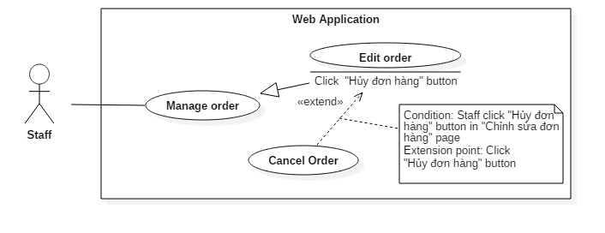

Figure 25: <Staff> Edit Order

|  |  |  |  |
| --- | --- | --- | --- |
| USE CASE – US02 | | | |
| Use Case No. | US02 | **Use Case Version** | 2.0 |
| Use Case Name | Edit order | | |
| Author | GiangHHT | | |
| Date | 02/10/2015 | **Priority** | Normal |
| Actor:   * Staff   Summary:   * This use case allows staff to edit customer’s order   Goal:   * Staff can edit customer’s order   Triggers:   * Staff click “Sửa” button at “Danh sách đơn hàng” page   Preconditions:   * User must login into the system with role “Staff”. * This staff account status is “Đang hoạt động” * The order status is “Chờ xử lý”.   Post Conditions:   * Success: The order status is changed into “Chờ xác nhận”. * Fail: Show error message.   Main Success Scenario:   |  |  |  | | --- | --- | --- | | Step | Actor Action | System Response | | 1 | Staff clicks “Sửa” button “Chi tiết đơn hàng” page of specific order. | System shows all products of that order. | | 2 | Staff clicks “Thêm sản phẩm” button  [Alternative 1]  [Alternative 2] | System shows the popup which has   * “Tên sản phẩm”: Dropdown list, required * “Số lượng”: textbox (number only), required | | 3 | Staff clicks on “Cập nhật” button | System shows the popup for input the deposit.  [Exception 1,2,3,4,5] | | 4 | Staff inputs the deposit and clicks “Đồng ý” button.  [Alternative 3] | Show message “Đã chỉnh sửa đơn hàng thành công. Chờ khách hàng xác nhận” |   Alternative Scenario:   |  |  |  | | --- | --- | --- | | No | Actor Action | System Response | | 1 | Staff clicks “Hủy” button to remove a specific product from cart. | System will remove this product from cart. | | 2 | Staff changes the number in textbox to change quantity of selected product | System will change quantity of this product and update total price of this order immediately. | | 3 | Staff clicks “Hủy” button. | Close the popup. |   Exceptions:   |  |  |  | | --- | --- | --- | | No | Actor Action | System Response | | 1 | Staff clicks on “Cập nhật” button when cart has nothing. | Show a message to notify that “Khách hàng cần phải có ít nhất một sản phẩm trong giỏ hàng để thực hiện việc đặt hàng.” | | 2 | Staff clicks on “Hoàn tất” button when order’s status is approved | Show the error message “Đơn hàng đã được chấp nhận, không thể sửa”. | | 3 | Staff enters character into quantity textbox. | Show a message to notify that “Không được nhập kí tự chữ vào ô này.” | | 4 | Total price of specific cart smaller than specific number | Show a message to notify that “Số lượng sản phẩm quá ít.” | | 5 | Staff clicks “Duyệt” button at “Chi tiết đơn hàng” page but the material in storage is not enough for this order. | System shows message “Nguyên liệu trong kho không đủ để sản xuất đơn hàng này.” |   Relationships: extended by Cancel order (Click “Hủy đơn hàng” button)  Business Rules:   * The information is loaded from the system correctly. * Pagination must be displayed if number of products larger than 10. * The order status is changed into “Chờ xác nhận” if and only if there are enough material for this order. * After the order status is changed into “Chờ xác nhận”, the order can not be edited. * After the order status is changed into “Chờ xác nhận”, the input material for this order is defined. | | | |

Table 25: Use case US01- <Staff> Edit order

##### <Staff> View order detail

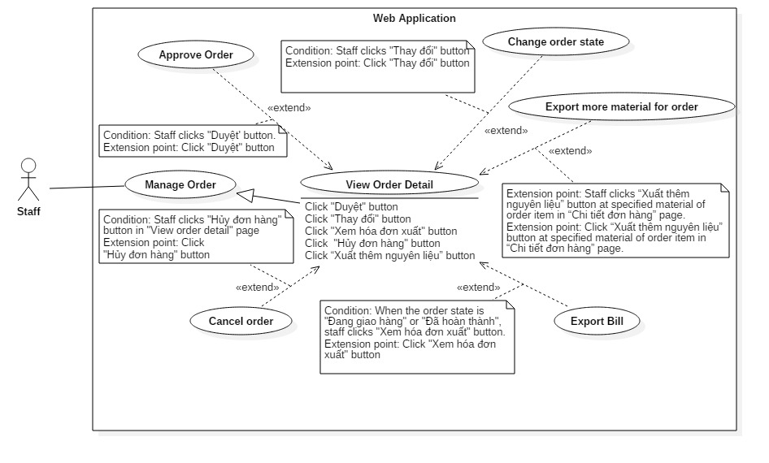

Figure 26: <Staff> View order detail

|  |  |  |  |
| --- | --- | --- | --- |
| USE CASE – US03 | | | |
| Use Case No. | US03 | **Use Case Version** | 2.0 |
| Use Case Name | View order detail | | |
| Author | GiangHHT | | |
| Date | 02/10/2015 | **Priority** | Normal |
| Actor:   * Staff   Summary:   * This use case allows staff to view order detail   Goal:   * Staff can view the detail of specific order   Triggers:   * Staff click “Chi tiết” link at “Danh sách đơn hàng” page   Preconditions:   * User must login into the system with role “Staff” * This staff account status is “Đang hoạt động”. * System has at least one order.   Post Conditions:   * Success: Staff view customer’s order detail * Fail: Show error message.   Main Success Scenario:   |  |  |  | | --- | --- | --- | | Step | Actor Action | System Response | | 1 | Staff clicks **“**Chi tiết**”** button at specific order | Redirect to “Chi tiết đơn hàng” page. |   Alternative Scenario: N/A  Exceptions: N/A  Relationships: Extend change order state, approve order, cancel order  Business Rules:   * The information is loaded from the system correctly. * Pagination must be displayed if number of products larger than 10. * If the order status is “Đã duyệt” or “Đang sản xuất” or “Đang giao hàng” or “Đã hoàn thành” the system will shows “Thời gian duyệt” with label. * If the order status is “Đang giao hàng” or “Đã hoàn thành” the system will shows “Ngày giao hàng” with label. | | | |

Table 26: Use case US03- <Staff> View order detail

##### <Staff> Approve order

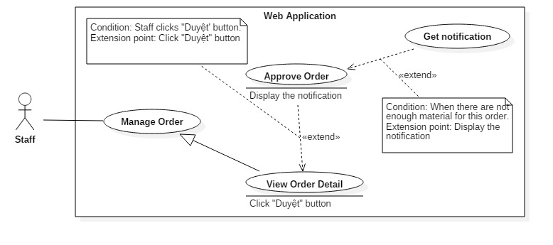

Figure 27: <Staff> Approve order

|  |  |  |  |
| --- | --- | --- | --- |
| USE CASE – US04 | | | |
| Use Case No. | US04 | **Use Case Version** | 2.0 |
| Use Case Name | Approve order | | |
| Author | GiangHHT | | |
| Date | 02/10/2015 | **Priority** | Normal |
| Actor:   * Staff   Summary:   * This use case allows staff approve order   Goal:   * Staff can approve customer’s order   Triggers:   * Staff clicks “Duyệt” button at “Chi tiết đơn hàng” page.   Preconditions:   * User must login into the system with role Staff with status “Đang hoạt động”. * That order status is “Chờ xác nhận”. * The order is enough material.   Post Conditions:   * Success: Staff approve customer’s order * Fail: Show error message.   Main Success Scenario:   |  |  |  | | --- | --- | --- | | Step | Actor Action | System Response | | 1 | Staff clicks “Duyệt” button for customer’s order at “Chi tiết đơn hàng” page  [Alternative 1] | System shows the popup for input the deposit amount and delivery time. | | 2 | Staff inputs deposit, delivery date and clicks “Đồng ý” button.  [Alternative 2] | The system show “Duyệt đơn hàng thành công” message and redirect to “Danh sách đơn hàng” page.  [Exception 1,2,3] |   Alternative Scenario:   |  |  |  | | --- | --- | --- | | No | Actor Action | System Response | | 1 | Staff clicks “Duyệt” button for customer’s order at “Chi tiết đơn hàng” page.  Staff inputs all field and clicks “Đồng ý” button. | System shows the popup for input the deposit amount, delivery time and:   * “Tên khách hàng”: textbox, required, max length 50. * “Tên đăng nhập”: textbox, required, max length 50. * “Email”: textbox (format xxx@xxx.xxx), required, max length 250. * “Địa chỉ”: textbox, required, max length 250. * “Mã số thuế”: textbox (number only), required, length 10-13. * “Số điện thoại”: textbox (number only), required, length 10-11.   The system show “Duyệt đơn hàng thành công” message and redirect to “Danh sách đơn hàng” page.  [Exception 1,2,3,4,5,6,7,8,9,10,11,12,13,  14,15,16,17,18,19,20,21] | | 2 | If the order for VIP customer, staff can choose input deposit or not. | System shows the popup with check box for input deposit or not. |   Exceptions:   |  |  |  | | --- | --- | --- | | No | Actor Action | System Response | | 1 | If this is the order for normal customer, staff inputs the deposit under material cost. | System show warning message “Tiền cọc phải lớn hơn [Material Cost]”. | | 2 | Staff clicks “Chấp nhận đơn hàng” at “Chi tiết đơn hàng” page when order’ status is not “Chờ xác nhận” | System show message “Đơn hàng này đã được xác nhận” | | 3 | Staff clicks “Chấp nhận đơn hàng” when customer is editing the same order. | System show message “Đơn hàng này đang được khách hàng chỉnh sửa.” | | 4 | Staff missed to input “Tên khách hàng” field. | Show error message “Tên khách hàng không được trống”. | | 5 | Staff inputs too long string in “Tên khách hàng” textbox | Show error message “Tên khách hàng không được quá 50 kí tự.” | | 6 | Staff missed to input “Tên đăng nhập” field. | Show error message “Tên đăng nhập không được trống.” | | 7 | Staff inputs too long string in “Tên đăng nhập” textbox | Show error message “Tên đăng nhập không được quá 50 kí tự.” | | 8 | Staff inputs the username is existed in system | Show error message “Tên đăng nhập này đã có trong hệ thống.” | | 9 | Staff missed to input “Email” field. | Show error message “Email không được trống”. | | 10 | Staff inputs too long string in “Email” textbox | Show error message “Email không được quá 50 kí tự.” | | 11 | Staff enters wrong format in “Email” textbox | Show error message “Hãy nhập email đúng định dạng.” | | 12 | Staff inputs the email is existed in system | Show error message “Email này đã có trong hệ thống.” | | 13 | Staff missed to input “Địa chỉ” field. | Show error message “Địa chỉ không được trống”. | | 14 | Staff inputs too long string in “Địa chỉ” textbox | Show error message “Địa chỉ không được quá 250 kí tự.”. | | 15 | Staff inputs the address is existed in system | Show error message “Địa chỉ này đã có trong hệ thống.”. | | 16 | Staff missed to input “Mã số thuế” field. | Show error message “Mã số thuế không được để trống”. | | 17 | Staff enters wrong format in “Mã số thuế” textbox | Show error message “Hãy nhập mã số thuế đúng.”. | | 18 | Staff inputs the tax code is existed in system | Show error message “Mã số thuế này đã có trong hệ thống.”. | | 19 | Staff missed to input “Số điện thoại” field. | Show error message “Số điện thoại không được để trống”. | | 20 | Staff enters wrong format in “Số điện thoại” textbox | Show error message “Hãy nhập số điện thoại đúng.”. | | 21 | Staff inputs the phone number is existed in system | Show error message “Số điện thoại này đã có trong hệ thống.”. |   Relationships: Extended by “Get notification”  Business Rules:   * The order state is changed from “Chờ xác nhận” to “Duyệt”. * The normal customer and guest must have deposit. The VIP customer don’t need have the deposit. * The deposit amount must over the around to thoundsand of material cost. * “Tên đăng nhập”, “Email”, “Địa chỉ”, “Mã số thuế”, “Số điện thoại” must not be existed in system. * Staff can not approve order when customer is editing this order. | | | |

Table 27: Use case US04- <Staff> Approve order

##### <Staff> Change order state

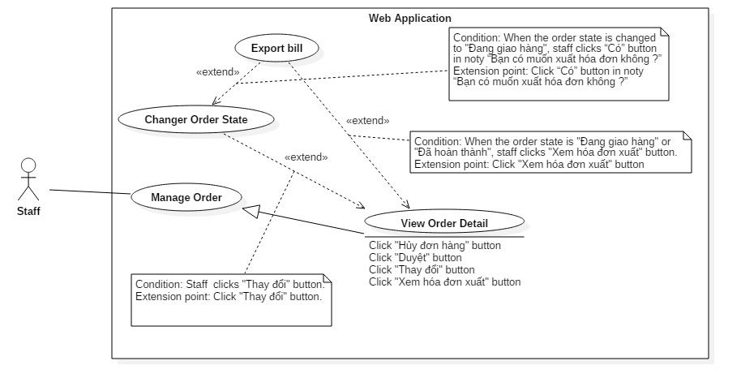

Figure 28: <Staff> Change order state

|  |  |  |  |
| --- | --- | --- | --- |
| USE CASE – US05 | | | |
| Use Case No. | US05 | **Use Case Version** | 2.0 |
| Use Case Name | Change order state | | |
| Author | GiangHHT | | |
| Date | 02/10/2015 | **Priority** | Normal |
| Actor:   * Staff   Summary:   * This use case allows staff to change order state.   Goal:   * Staff can change order state of specific customer’s order from “Đã duyệt” to “Đang sản xuất” or from “Đang sản xuất” to “Đang giao hàng” or from “Đang giao hàng” to “Đã hoàn thành”.   Triggers:   * Staff clicks “Thay đổi” button at “Chi tiết đơn hàng” page   Preconditions:   * User must login into the system with role “Staff”. * The staff account status is “Đang hoạt động”. * The order status is “Đã duyệt” or “Đang sản xuất” or “Đang giao hàng”.   Post Conditions:   * Success: Staff change the order status. * Fail: Show error message.   Main Success Scenario:   |  |  |  | | --- | --- | --- | | Step | Actor Action | System Response | | 1 | Staff clicks “Thay đổi” button.  [Alternative 1]  [Alternative 2] | When the order status is “Đã duyệt”, the order status will be changed into “Đang sản xuất”.  [Exception 1] |   Alternative Scenario:   |  |  |  | | --- | --- | --- | | No | Actor Action | System Response | | 1 | Staff clicks “Thay đổi” button. | When the order status is “Đang sản xuất”, the order status will be changed into “Đang giao hàng”. | | 2 | Staff clicks “Thay đổi” button. | When the order status is “Đang giao hàng”, the order status will be changed into “Đã hoàn thành” and the “Xuất hóa đơn” button is displayed |   Exceptions:   |  |  |  | | --- | --- | --- | | No | Actor Action | System Response | | 1 | Staff clicks “Thay đổi” button but the order is canceled by customer. | Show error message “Đơn hàng đã bị hủy bởi khách hàng” |   Relationships: extend from “View order detail”(Click on “Thay đổi” button); extended by “Export Bill” (Click on “Có” button in noty “Bạn có muốn xuất hóa đơn không ?”)  Business Rules:   * The order state will be updated. * The next change state of “Đã được xác nhận” is “Đang sản xuất”. The next change state of “Đang sản xuất” is “Đang giao hàng”. The next change state of “Đang giao hàng” is “Hoàn thành”. * Cannot change the state when the order state is “Hủy” and “Đã hoàn thành”. | | | |

Table 28: Use case US05 - <Staff> Change order state

##### <Staff> Export bill



Figure 29: <Staff> Export bill

|  |  |  |  |
| --- | --- | --- | --- |
| USE CASE – US06 | | | |
| Use Case No. | US06 | **Use Case Version** | 2.0 |
| Use Case Name | Export bill | | |
| Author | GiangHHT | | |
| Date | 02/10/2015 | **Priority** | Normal |
| Actor:   * Staff   Summary:   * This use case allows staff export bill   Goal:   * Staff can export bill for customer’s order   Triggers:   * Staff clicks “Xem hóa đơn xuất” button at “Chi tiết đơn hàng” page. * Staff clicks “Có” button in noty “Bạn có muốn xuất hóa đơn không ?”.   Preconditions:   * User must login into the system with role Staff * This account status is “Đang hoạt động” * Order’s status is “Đang giao hàng” ,”Đã hoàn thành”.   Post Conditions:   * Success: Staff view customer’s order detail * Fail: Show error message.   Main Success Scenario:   |  |  |  | | --- | --- | --- | | Step | Actor Action | System Response | | 1 | Staff clicks **“**Xem hóa đơn xuất**”** button.  [Alternative 1] | System shows the bill in new tab.  [Exception 1] |   Alternative Scenario:   |  |  |  | | --- | --- | --- | | No | Actor Action | System Response | | 1 | Staff clicks “Có” button in noty “Bạn có muốn xuất hóa đơn không ?” | System shows the bill in new tab. |   Exceptions:   |  |  |  | | --- | --- | --- | | No | Actor Action | System Response | | 1 | Staff click **“**Xuất hóa đơn**”** button when order’s status not “Đã hoàn thành” or “Đang giao hàng”. | System show message “Không thể xuất hóa đơn.” |   Relationships: extend from “Change order state” (Click “Có” button in noty “Bạn có muốn xuất hóa đơn không ?”), extend from “View order detail (Click “Xem hóa đơn xuất” button)  Business Rules:   * Bill will print all information of that order. | | | |

Table 29: Use case US06 - <Staff> Export bill

##### <Staff> Cancel order

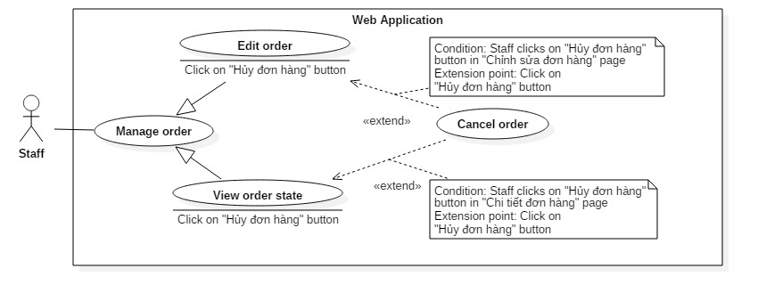

Figure 30: <Staff> Cancel order

|  |  |  |  |
| --- | --- | --- | --- |
| USE CASE – US07 | | | |
| Use Case No. | US07 | **Use Case Version** | 2.0 |
| Use Case Name | Cancel order | | |
| Author | GiangHHT | | |
| Date | 02/10/2015 | **Priority** | Normal |
| Actor:   * Staff   Summary:   * This use case allows staff to cancel the order.   Goal:   * Staff can cancel customer’s order   Triggers:   * Staff clicks “Hủy” button at “Chi tiết đơn hàng” page. * Staff clicks “Hủy” button at “Chỉnh sửa đơn hàng” page. * Staff clicks “Hủy” link at “Danh sách đơn hàng” page   Preconditions:   * User must login into the system with role “Staff”. * This account status is “Đang hoạt động”. * The order status must not be “Đã hoàn thành” or “Hủy”.   Post Conditions:   * Success: Staff cancel the order * Fail: Show error message.   Main Success Scenario:   |  |  |  | | --- | --- | --- | | Step | Actor Action | System Response | | 1 | Staff clicks “Hủy” button. | System will show the popup to confirm the cancellation include the textbox for input the return of the deposit. | | 2 | Staff clicks “Đồng ý” button  [Alternative 1] | That order will be removed and return to “Chi tiết đơn hàng” page.  [Exception 1] |   Alternative Scenario:   |  |  |  | | --- | --- | --- | | No | Actor Action | System Response | | 1 | Staff clicks “Hủy” button | Close the popup. |   Exceptions:   |  |  |  | | --- | --- | --- | | No | Actor Action | System Response | | 1 | Database connection error | Show error message “Đã có lỗi xảy ra trong quá trình thực hiện, vui lòng thử lại sau!” |   Relationships: extend from Edit order (Click on “Hủy” button), View order state (Click on “Hủy” button).  Business Rules:   * That order will be removed out of database if that order status is “Chờ xử lý”. * Cannot cancel order if order status is “Đã hoàn thành” or “Hủy”. * The cancellation happens “Chở xác nhận”, “Đang sản xuất”, “Đang giao hàng”, the order state will become “Hủy”. * Depend on the cancellation from the bakery or the customer, there is the return of deposit. * If the cancellation happens at “Đã duyệt”, “Chở xác nhận”, the materal will be returned to the store. * If the cancellation happens at “Chở xử lý” the order will be removed from system. | | | |

Table 30: Use case US07 - <Staff> Cancel order

##### <Staff> Export More Material for Order

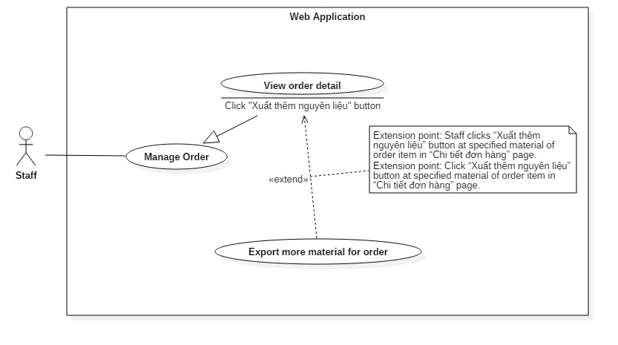

Figure 31 <Staff> Export more material for order

|  |  |  |  |
| --- | --- | --- | --- |
| USE CASE – US08 | | | |
| Use Case No. | US08 | **Use Case Version** | 2.0 |
| Use Case Name | Export more material for order | | |
| Author | GiangHHT | | |
| Date | 02/10/2015 | **Priority** | Normal |
| Actor:   * Staff   Summary:   * This use case allows staff export more material for order   Goal:   * Staff can approve customer’s order   Triggers:   * Staff clicks “Xuất thêm nguyên liệu” button at specified material of order item in “Chi tiết đơn hàng” page.   Preconditions:   * User must login into the system with role Staff with status “Đang hoạt động”. * That order status is “Đã duyệt” or “Đang sản xuất”.   Post Conditions:   * Success: Staff exports more material for order. * Fail: Show error message.   Main Success Scenario:   |  |  |  | | --- | --- | --- | | Step | Actor Action | System Response | | 1 | Staff clicks “Xuất thêm nguyên liệu” button at specified material of order item in “Chi tiết đơn hàng” page.  [Alternative 1] | System shows the popup for input the export quantity.  [Exception 1]. | | 2 | Staff inputs export quantity and clicks “Xuất” button. | The system show “Xuất nguyên liệu thành công” message and reload page. |   Alternative Scenario: N/A  Exceptions:   |  |  |  | | --- | --- | --- | | No | Actor Action | System Response | | 1 | If the export quantity is more than the current quantity of this material in storage. | System show warning message “Không thể xuất nguyên liệu lớn hơn [Current Quantity]”. |   Relationships: Extend from by “View order detail”  Business Rules:   * The export quantity is less than the current quantity of this material in storage. | | | |

Table 31: Use case US08- <Staff> Export more material for order

##### <Staff> Add input material

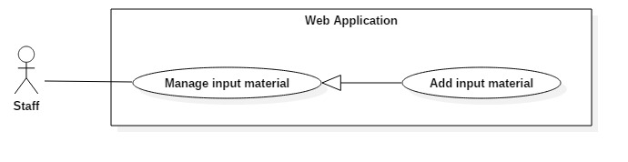

Figure 32: <Staff> Add input material

|  |  |  |  |
| --- | --- | --- | --- |
| USE CASE – US09 | | | |
| Use Case No. | US09 | **Use Case Version** | 2.0 |
| Use Case Name | Add input material | | |
| Author | VuongNQ | | |
| Date | 02/10/2015 | **Priority** | Normal |
| Actor:   * Staff   Summary:   * This use case allows staff to add input materials   Goal:   * Staff can add input materials   Triggers:   * Staff clicks “Thêm nguyên liệu đầu vào” button at “Danh sách nguyên liệu đầu vào” page * Staff clicks “Thêm nguyên liệu đầu vào” at “Nguyên liệu đầu vào” tab in menu bar of manage page.   Preconditions:   * User must login into the system with role “Staff” * This staff account’s status is “Đang hoạt động”   Post Conditions:   * Success: Staff add input material * Fail: Show error message.   Main Success Scenario:   |  |  |  | | --- | --- | --- | | Step | Actor Action | System Response | | 1 | Staff clicks “Thêm nguyên liệu đầu vào” at “Nguyên liệu đầu vào” tab in menu bar of manage page.  [Alternative 1] | System require information :   * “Tên nguyên liệu đầu vào”: selected popup, required * “Số lượng”: textbox (number only), required * “Tổng giá (VNĐ)”: textbox (number only), required * “Đơn giá (VNĐ)”: textbox, readonly, auto render by “Tổng giá (VNĐ)” field and “Số lượng” field * “Ngày nhập kho”: textbox (format dd/MM/yyyy), required * “Ngày hết hạn”: textbox (format dd/MM/yyyy), required * “Ghi chú”: textbox, max length 500 * “Thuộc hóa đơn”: selected popup, required | | 2 | Staff inputs information |  | | 3 | Staff sends command to add input material | System shows success message: “”  [Exception 1, 2, 3, 4, 5, 6, 7, 8, 9, 10] |   Alternative Scenario: N/A  Exceptions:   |  |  |  | | --- | --- | --- | | No | Actor Action | System Response | | 1 | Staff missed to input “Tên nguyên liệu đầu vào” field | Show error message: “Tên nguyên liệu đầu vào không được trống” | | 2 | Staff missed to input “Số lượng” field | Show error message: “Số lượng nguyên liệu đầu vào không được trống.” | | 3 | Staff missed to input “Tổng giá” field | Show error message: “Tổng giá nguyên liệu đầu vào không được trống.” | | 4 | Staff missed to input “Thuộc hóa đơn” field | Show error message: “Hóa đơn nhập không được trống” | | 5 | Staff inputted wrong format of “Số lượng” field | Show message error: “Số lượng nguyên liệu đầu vào phải là số.” | | 6 | Staff inputted wrong format of “Tổng giá” field | Show message error: “Tổng giá nguyên liệu đầu vào phải là số.” | | 7 | Import quantity is large than 99,999,999 unit | Show error message: “Số lượng nguyên liệu đầu vào không được lớn hơn 99,999,999 đơn vị” | | 8 | Input material price is less than 1,000 VNĐ | Show error message: “Tổng giá nguyên liệu đầu vào không được nhỏ hơn 1,000 VNĐ.” | | 9 | Input material price is large than 999,999,999 VNĐ | Show error message: “Tổng giá nguyên liệu đầu vào không được lớn hơn 999,999,999 VNĐ.” | | 10 | Input material price is less than import quantity | Show error message: “Số lượng nguyên liệu nhập vào không được lớn hơn tổng giá nguyên liệu.” |   Relationships: extended by Add supplier  Business Rules:   * Input material code is automatic initialized by the system. * Do not allow staff add a new input material when that input material with specified input bill had been existed in database * Format input text :   + “Số lượng” : number only   + “Giá” : number only   + “Ngày nhập” : format dd/MM/yyyy   + “Ngày hết hạn”: format dd/MM/yyyy, expire date cannot before input date | | | |

Table 32: Use case US09 - <Staff> Add input material

##### <Staff> Edit input material

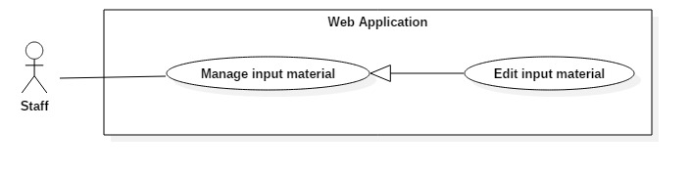

Figure 33: < Staff> Edit input material

|  |  |  |  |
| --- | --- | --- | --- |
| USE CASE – US10 | | | |
| Use Case No. | US10 | **Use Case Version** | 2.0 |
| Use Case Name | Edit input material | | |
| Author | VuongNQ | | |
| Date | 02/10/2015 | **Priority** | Normal |
| Actor:   * Staff   Summary:   * This use case allows staff to edit input material   Goal:   * Staff edit input material information   Triggers:   * Staff click “Sửa” button at “Danh sách nguyên liệu đầu vào” page * Staff click “Chỉnh sửa” button at input material detail page   Preconditions:   * User must login into the system with role Staff * This staff account status is “Đang hoạt động”   Post Conditions:   * Success: Staff edit input material successful. * Fail: Show error message.   Main Success Scenario:   |  |  |  | | --- | --- | --- | | Step | Actor Action | System Response | | 1 | Staff clicks **“**Chỉnh sửa**”** at “Nguyên liệu đầu vào” page | Staff can edit information :   * “Tên nguyên liệu đầu vào”: selected popup, required * “Số lượng”: textbox (number only), required * “Tổng giá (VNĐ)”: textbox (number only), required * “Đơn giá (VNĐ)”: textbox, readonly, auto render by “Tổng giá (VNĐ)” field and “Số lượng” field * “Ngày nhập kho”: textbox (format dd/MM/yyyy), required * “Ngày hết hạn”: textbox (format dd/MM/yyyy), required * “Ghi chú”: textbox, max length 500 * “Thuộc hóa đơn”: selected popup, required | | 2 | Staff changes information |  | | 3 | Staff sends command to edit input material | System shows message input material has been edit successfully.  [Exception 1, 2, 3, 4, 5, 6, 7, 8, 9,10,11] |   Alternative Scenario: N/A  Exceptions:   |  |  |  | | --- | --- | --- | | No | Actor Action | System Response | | 1 | Staff missed to input “Tên nguyên liệu đầu vào” field | Show error message: “Tên nguyên liệu đầu vào không được trống” | | 2 | Staff missed to input “Số lượng” field | Show error message: “Số lượng nguyên liệu đầu vào không được trống.” | | 3 | Staff missed to input “Tổng giá” field | Show error message: “Tổng giá nguyên liệu đầu vào không được trống.” | | 4 | Staff missed to input “Thuộc hóa đơn” field | Show error message: “Hóa đơn nhập không được trống” | | 5 | Staff inputted wrong format of “Số lượng” field | Show message error: “Số lượng nguyên liệu đầu vào phải là số.” | | 6 | Staff inputted wrong format of “Tổng giá” field | Show message error: “Tổng giá nguyên liệu đầu vào phải là số.” | | 7 | Import quantity is large than 99,999,999 unit | Show error message: “Số lượng nguyên liệu đầu vào không được lớn hơn 99,999,999 đơn vị” | | 8 | Input material price is less than 1,000 VNĐ | Show error message: “Tổng giá nguyên liệu đầu vào không được nhỏ hơn 1,000 VNĐ.” | | 9 | Input material price is large than 999,999,999 VNĐ | Show error message: “Tổng giá nguyên liệu đầu vào không được lớn hơn 999,999,999 VNĐ.” | | 10 | Input material price is less than import quantity | Show error message: “Số lượng nguyên liệu nhập vào không được lớn hơn tổng giá nguyên liệu.” | | 11 | Staff changes input material id in url bar but this id is not existed in database | Redirect to input material index |   Relationships: N/A  Business Rules:   * Input material code is automatic initialized by the system. * Do not allow staff add a new input material when that input material with specified input bill had been existed in database * Format input text :   + “Số lượng” : number only   + “Giá” : number only   + “Ngày nhập” : format dd/MM/yyyy   + “Ngày hết hạn”: format dd/MM/yyyy, expire date cannot before input date | | | |

Table 33: Use case US10 - <Staff> Edit input material

##### <Staff> Discard input material

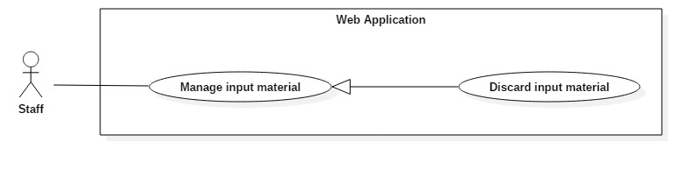

Figure 34: <Staff> Discard input material

|  |  |  |  |
| --- | --- | --- | --- |
| USE CASE – US11 | | | |
| Use Case No. | US11 | **Use Case Version** | 2.0 |
| Use Case Name | Discard input material | | |
| Author | VuongNQ | | |
| Date | 02/10/2015 | **Priority** | Normal |
| Actor:   * Staff   Summary:   * This use case allows staff to discard input material   Goal:   * Staff can discard input material   Triggers:   * Staff click “Hủy nguyên liệu” button in “Danh sách nguyên liệu” page * Staff click “Hủy nguyên liệu” button in specific input material page.   Preconditions:   * User must login into the system with role Staff * This staff account status is “Đang hoạt động”   Post Conditions:   * Success: Discard input material * Fail: Show error message.   Main Success Scenario:   |  |  |  | | --- | --- | --- | | Step | Actor Action | System Response | | 1 | Staff click “Hủy nguyên liệu” button | System show popup and require information :   * “Số lượng hủy”: Number only, required * “Ghi chú”: textbox, required | | 2 | Staff inputs information |  | | 3 | Staff click “Xác nhận” button  [Alternative 1] | Discard input material and update remain product material |   Alternative Scenario:   |  |  |  | | --- | --- | --- | | No | Actor Action | System Response | | 1 | Customer click “Hủy” button | Close the popup. |   Exceptions:   |  |  |  | | --- | --- | --- | | No | Actor Action | System Response | | 1 | Staff missed to input “Số lượng hủy” field | Show error message: “Số lượng hủy không được trống” | | 2 | Staff missed to input “Ghi chú” field | Show error message: “Ghi chú không được trống” | | 3 | Discard quantity less than 0 | Show error message: “Số lượng hủy không được nhỏ hơn 0” | | 4 | Discard quantity large than remain quantity | Show error message: “Số lượng hủy không được lớn hơn số lượng tồn kho” |   Relationships: N/A  Business Rules:   * Discard input material and update remain product material * Discard quantity does not large than remain quantity | | | |

Table 34: Use case US11 - <Staff> Change input material state

##### <Staff> Add input bill

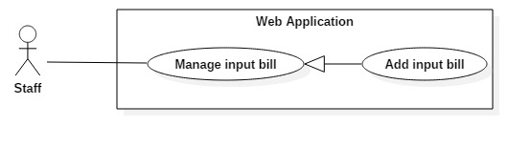

Figure 35: <Staff> Add input bill

|  |  |  |  |
| --- | --- | --- | --- |
| USE CASE – US12 | | | |
| Use Case No. | US12 | **Use Case Version** | 2.0 |
| Use Case Name | Add input bill | | |
| Author | VuongNQ | | |
| Date | 02/10/2015 | **Priority** | Normal |
| Actor:   * Staff   Summary:   * This use case allows staff to add input bill   Goal:   * Staff can add input bill   Triggers:   * Staff clicks “Tạo mới hóa đơn” at “Hóa đơn” tab in menu bar of manage page. * Staff clicks “Tạo mới hóa đơn” at “Danh sách hóa đơn” page   Preconditions:   * User must login into the system with role Staff * This staff account status is “Đang hoạt động”   Post Conditions:   * Success: Staff edit input bill successful * Fail: Show error message.   Main Success Scenario:   |  |  |  | | --- | --- | --- | | Step | Actor Action | System Response | | 1 | Staff click **“**Thêm mới**”** at **“**Hóa đơn**”** page | System require information :  “Nhà cung cấp”: Selected popup, required   * “Chi phí (Chưa thuế)”: textbox (number only), required, form 1,000 – 999,999,999 VNĐ * Thuế VAT: textbox (readonly), auto render by “Chi phí(Chưa thuế)” * “Ngày nhập”: textbox (format dd/MM/yyyy), required * “Mẫu hóa đơn số”: textbox, required * “Mã số”: textbox, required * “Hình hóa đơn gốc”: browse image (type .jpg, max 1MB) | | 2 | Staff input information |  | | 3 | Staff sends command to add input bill | System shows message input bill has been add successfully.  [Exception 1, 2, 3, 4, 5, 6, 7, 8, 9] |   Alternative Scenario: N/A  Exceptions:   |  |  |  | | --- | --- | --- | | No | Actor Action | System Response | | 1 | Staff missed to input “Nhà cung cấp” field | Show error message: “Nhà cung cấp không được trống” | | 2 | Staff missed to input “Chi phí (Chưa thuế)” field | Show error message: “Chi phí (Chưa thuế) không được trống” | | 3 | Staff missed to input “Mẫu hóa đơn số” field | Show error message: “Mẫu hóa đơn không được trống” | | 4 | Staff missed to input “Mã số” field | Show error message: “Mã số hóa đơn không được trống” | | 5 | Staff missed to input “Hình ảnh cho hóa đơn” field | Show error message: “Vui lòng chọn hình ảnh cho hóa đơn” | | 6 | Staff enter wrong “Chi phí (Chưa thuế)” format (less than 1,000 VNĐ) | Show error message: “Chi phí (Chưa thuế) ít nhất là 1,000 VNĐ.” | | 7 | Staff enter wrong “Chi phí (Chưa thuế)” format (more than 999,999,999 VNĐ) | Show error message: “Chi phí (Chưa thuế) không được lớn hơn 999,999,999 VNĐ.” | | 8 | Staff chooses input bill image wrong format image | Show error message: “Định dạng hình ảnh không đúng.” | | 9 | Staff chooses input bill image size large than 1MB | Show error message: “Kích thước hình ảnh quá lớn” |   Relationships:  Business Rules:   * Input material code is automatic initialized by the system. * Format input text :   + “Tổng giá hóa đơn đầu vào”: number only   + “Mã hóa đơn”: type XddMMyyyy (with “X” is “Supplier Id”, yyyy is year, MM is month, dd is day).   + “Hình hóa đơn gốc”: only image type, max is 1MB   + “Chi phí (Chưa tính VAT)”: number only   + “Thuế VAT”: by multiplying “Chi phí” and “VAT tax rate” | | | |

Table 35: Use case US12 - <Staff> Add input bill

##### <Staff> Edit input bill

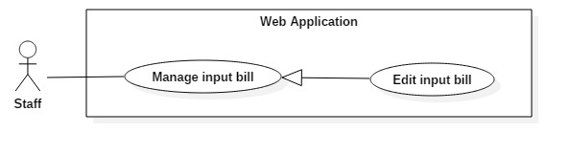

Figure 36: <Staff> Edit input bill

|  |  |  |  |
| --- | --- | --- | --- |
| USE CASE – US13 | | | |
| Use Case No. | US13 | **Use Case Version** | 2.0 |
| Use Case Name | Edit input bill | | |
| Author | VuongNQ | | |
| Date | 02/10/2015 | **Priority** | Normal |
| Actor:   * Staff   Summary:   * This use case allows staff to edit input bill   Goal:   * Staff edit input bill information   Triggers:   * Staff click “Sửa” button at “Danh sách hóa đơn” page * Staff click “Chỉnh sửa” button at specific input bill detail page   Preconditions:   * User must login into the system with role Staff * This staff account status is “Đang hoạt động”   Post Conditions:   * Success: Staff edit input bill successful. * Fail: Show error message.   Main Success Scenario:   |  |  |  | | --- | --- | --- | | Step | Actor Action | System Response | | 1 | Staff click “Sửa” button at “Danh sách hóa đơn” page | System require information :  “Nhà cung cấp”: Selected popup, required   * “Chi phí (Chưa thuế)”: textbox (number only), required, from 1,000 to 999,999,999 VNĐ * Thuế VAT: textbox (number only), auto render * “Ngày nhập”: textbox (format dd/MM/yyyy), required * “Mẫu hóa đơn số”: textbox, required * “Mã số”: textbox, required   “Hình hóa đơn gốc”: browse image (type .jpg, max 1MB) | | 2 | Staff changes information |  | | 3 | Staff sends command to edit input bill | System shows message input bill has been edit successfully.  [Exception 1, 2, 3, 4, 5, 6, 7, 8, 9,10] |   Alternative Scenario: N/A  Exceptions:   |  |  |  | | --- | --- | --- | | No | Actor Action | System Response | | 1 | Staff missed to input “Nhà cung cấp” field | Show error message: “Nhà cung cấp không được trống” | | 2 | Staff missed to input “Chi phí (Chưa thuế)” field | Show error message: “Chi phí (Chưa thuế) không được trống” | | 3 | Staff missed to input “Mẫu hóa đơn số” field | Show error message: “Mẫu hóa đơn không được trống” | | 4 | Staff missed to input “Mã số” field | Show error message: “Mã số hóa đơn không được trống” | | 5 | Staff missed to input “Hình ảnh cho hóa đơn” field | Show error message: “Vui lòng chọn hình ảnh cho hóa đơn” | | 6 | Staff enter wrong “Chi phí (Chưa thuế)” format (less than 1,000 VNĐ) | Show error message: “Chi phí (Chưa thuế) ít nhất là 1,000 VNĐ.” | | 7 | Staff enter wrong “Chi phí (Chưa thuế)” format (more than 999,999,999 VNĐ) | Show error message: “Chi phí (Chưa thuế) không được lớn hơn 999,999,999 VNĐ.” | | 8 | Staff chooses input bill image wrong format image | Show error message: “Định dạng hình ảnh không đúng.” | | 9 | Staff chooses input bill image size large than 1MB | Show error message: “Kích thước hình ảnh quá lớn” | | 10 | Staff changes input bill id in url bar but this id is not exist in database | Redirect to input bill index |   Relationships: N/A  Business Rules:   * Input material code is automatic initialized by the system. * Format input text :   + “Tổng giá hóa đơn đầu vào”: number only   + “Mã hóa đơn”: type XddMMyyyy (with “X” is “Supplier Id”, yyyy is year, MM is month, dd is day).   + “Hình hóa đơn gốc”: only show image type .jpg, max is 1MB   + “Chi phí (Chưa tính VAT)”: number only   + “Thuế VAT”: by multiplying “Chi phí” and “VAT tax rate” | | | |

Table 36: Use case US13 - <Staff> Edit input bill

##### <Staff> Change material status

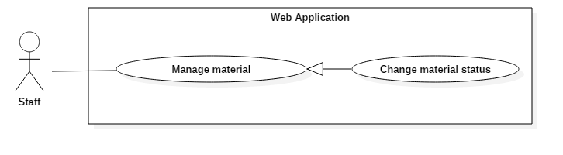

Figure 37: <Staff> Change material status

|  |  |  |  |
| --- | --- | --- | --- |
| USE CASE – US14 | | | |
| Use Case No. | US14 | **Use Case Version** | 2.0 |
| Use Case Name | Change material status | | |
| Author | ManhOT | | |
| Date | 02/10/2015 | **Priority** | Normal |
| Actor:   * Staff   Summary:   * This use case allows staff to to change material status   Goal:   * Staff can change material status   Triggers:   * Staff clicks “Đổi trạng thái” button in specific material information page. * Staff clicks “Thay đổi trạng thái” button in “Danh sách nguyên liệu” page   Preconditions:   * User must login into the system with role Staff * This staff account status is “Đang hoạt động”   Post Conditions:   * Success: Change material status success * Fail: Show error message.   Main Success Scenario:   |  |  |  | | --- | --- | --- | | Step | Actor Action | System Response | | 1 | Staff clicks “Thay đổi trạng thái” button | System shows the popup with 2 choices: “Sử dụng”, “Ngừng sử dụng”. | | 2 | Staff chooses status |  | | 3 | Staff clicks “Đồng ý” button  [Alternative 1] | System will change new status of this material and close the popup. |   Alternative Scenario:   |  |  |  | | --- | --- | --- | | No | Actor Action | System Response | | 1 | Staff click “Hủy” button | Close the popup |   Exceptions:   |  |  |  | | --- | --- | --- | | No | Actor Action | System Response | | 1 | Staff chooses “Ngừng sử dụng” and click “Đồng ý” button when this product’s status is “Không còn sử dụng” | System show error message : Nguyên liệu hiện đã có trạng thái Không còn sử dụng. | | 2 | Staff chooses “Sử dụng” and click “Đồng ý” button when this product’s status is “Đang sử dụng” | System show error message : Nguyên liệu đã có trạng thái Đang sử dụng |   Relationships: N/A  Business Rules:   * The new status will be saved into the system * If material’s status be changed to “Không còn sử dụng”, staff can’t add input material for that material. | | | |

Table 37: Use case US14 - <Staff> Change material status

##### <Staff> Add material

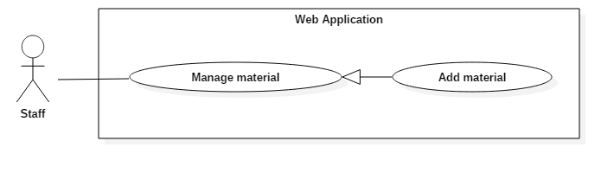

Figure 38: <Staff> Add material

|  |  |  |  |
| --- | --- | --- | --- |
| USE CASE – US15 | | | |
| Use Case No. | US15 | **Use Case Version** | 2.0 |
| Use Case Name | Add material | | |
| Author | ManhOT | | |
| Date | 02/10/2015 | **Priority** | Normal |
| Actor:   * Staff   Summary:   * This use case allows staff to to add new material   Goal:   * Staff can add new material   Triggers:   * Staff clicks “Thêm nguyên liệu mới” button at “Danh sách nguyên liệu” page * Staff clicks “Tạo mới nguyên liệu” at “Nguyên liệu” tab in menu bar of manage page.   Preconditions:   * User must login into the system with role Staff * This account status is “Đang hoạt động”   Post Conditions:   * Success: Staff add new material successful, that material will display at “Danh sách nguyên liệu” page * Fail: Show error message.   Main Success Scenario:   |  |  |  | | --- | --- | --- | | Step | Actor Action | System Response | | 1 | Staff clicks “Thêm nguyên liệu mới” button at “Danh sách nguyên liệu” page | System require information :  -“Tên nguyên liệu”: textbox, max length 100, required   * “Đơn vị tính”: textbox, required, max length 20 * “Số lượng tối thiểu”: textbox, required, max length 10, number only | | 2 | Staff inputs information |  | | 3 | Staff sends command to add new material | System shows message new material has been added successfully.  [Exception 1, 2, 3, 4,5] |   Alternative Scenario: N/A  Exceptions:   |  |  |  | | --- | --- | --- | | Step | Actor Action | System Response | | 1 | Staff missed to input “Tên nguyên liệu” field | Show error message: “Tên nguyên liệu không được để trống” | | 2 | Staff missed to input “Đơn vị tính” field | Show error message: “Đơn vị tính không được để trống” | | 3 | Staff inputted wrong format of “Tên nguyên liệu” field | Show error message: “Tên nguyên liệu phải có độ dài từ 2 đến 100 kí tự” | | 4 | Staff inputted wrong format of “Đơn vị tính” field | Show error message: “Đơn vị tính của nguyên liệu phải có độ dài từ 2 đến 20 kí tự” | | 5 | Staff missed to input “Số lượng tối thiểu” field | Show error message: “Số lượng tối thiểu không được để trống” |   Relationships: N/A  Business Rules:   * Pagination must be displayed if number of products larger than 10. * Cannot add material which existed in database. * New material status is “Đang sử dụng”. * Format input text :   + “Tên nguyên liệu”: textbox, max length 100, required   + “Đơn vị tính”: textbox, required, max length 20   + “Số lượng tối thiểu” textbox, maxleng 10, required, numberonly | | | |

Table 38: Use case US15 - <Staff> Add material

##### <Staff> Edit material

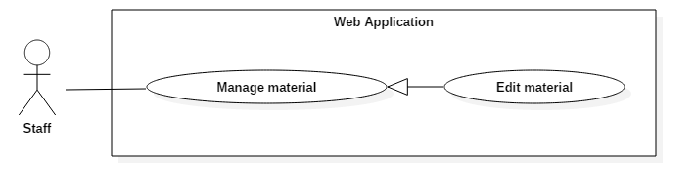

Figure 39: <Staff> Edit material

|  |  |  |  |
| --- | --- | --- | --- |
| USE CASE – US16 | | | |
| Use Case No. | US16 | **Use Case Version** | 2.0 |
| Use Case Name | Edit material | | |
| Author | ManhOT | | |
| Date | 02/10/2015 | **Priority** | Normal |
| Actor:   * Staff   Summary:   * This use case allows staff to edit material   Goal:   * Staff edit material information   Triggers:   * Staff clicks “Chỉnh sửa” button at “Danh sách nguyên liệu” page   Preconditions:   * User must login into the system with role Staff * This staff account status is “Đang hoạt động”   Post Conditions:   * Success: Staff edit material successful. * Fail: Show error message.   Main Success Scenario:   |  |  |  | | --- | --- | --- | | Step | Actor Action | System Response | | 1 | Staff clicks **“**Chỉnh **s**ửa**”** button | System require information :   * “Tên nguyên liệu”: textbox, max length 100, required * “Đơn vị tính”: textbox, required, max length 50 * “Số lượng tối thiểu”: textbox, required, max length 10, number only | | 2 | Staff inputs information |  | | 3 | Staff clicks “Cập nhật” button | System shows message material has been edit successfully.  [Exception 1, 2, 3, 4,5] |   Alternative Scenario: N/A  Exceptions:   |  |  |  | | --- | --- | --- | | No | Actor Action | System Response | | 1 | “Tên nguyên liệu” field is null | Show error message: “Tên nguyên liệu không được để trống” | | 2 | “Đơn vị tính” field is null | Show error message: “Đơn vị tính không được để trống” | | 3 | Staff inputted wrong format of “Tên nguyên liệu” field | Show error message: “Tên nguyên liệu phải có độ dài từ 2 đến 100 kí tự” | | 4 | Staff inputted wrong format of “Đơn vị tính” field | Show error message: “Đơn vị tính của nguyên liệu phải có độ dài từ 2 đến 20 kí tự” | | 5 | Staff missed to input “Số lượng tối thiểu” field | Show error message: “Số lượng tối thiểu không được để trống” |   Relationships: N/A  Business Rules:   * Cannot edit material name duplicate which material name (Status is “Đang sử dụng”) existed in database * Pagination must be displayed if number of products larger than 10. * Format input text :   + “Tên nguyên liệu”: textbox, max length 100, required   + “Đơn vị tính”: textbox, required, max length 20   + “Số lượng tối thiểu” textbox, maxleng 10, required, numberonly | | | |

Table 39: Use case US16 - <Staff> Edit material

##### <Staff> Add product

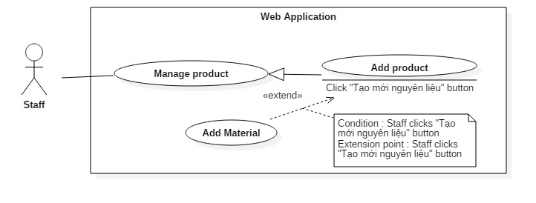

Figure 40: <Staff> Add product

|  |  |  |  |
| --- | --- | --- | --- |
| USE CASE – US17 | | | |
| Use Case No. | US17 | **Use Case Version** | 2.0 |
| Use Case Name | Add product | | |
| Author | ManhOT | | |
| Date | 02/10/2015 | **Priority** | Normal |
| Actor:   * Staff   Summary:   * This use case allows staff to add new product   Goal:   * Staff can add new product   Triggers:   * Staff clicks “Thêm sản phẩm mới” button at “Danh sách sản phẩm” page * Staff clicks “Thêm sản phẩm mới” link at “Sản phẩm” tab in menu bar of manage page.   Preconditions:   * User must login into the system with role Staff * This staff account status is “Đang hoạt động”   Post Conditions:   * Success: Staff add new product successful, that product will display at “Danh sách sản phẩm” page * Fail: Show error message.   Main Success Scenario:   |  |  |  | | --- | --- | --- | | Step | Actor Action | System Response | | 1 | Staff clicks “Thêm sản phẩm mới” button. | System require information :  -“Tên sản phẩm”: textbox, required, max length 100   * “Đơn vị tính”: textbox, required, max length 20 * “Trọng lượng”: textbox, required, from 100-2000 gram * “Mô tả sản phẩm”: textbox, max length 500 * “Ghi chú”: textbox, max length 500 * Image: browse image (type .jpg, png, jpeg. Max size: 1MB) * “Đơn giá”: textbox (number only), required, from 1000-‘Max Price’(VNĐ) * “Loại bánh” : Dropdown list * “Nguyên liệu cho sản phẩm” : Select popup | | 2 | Staff inputs information |  | | 3 | Staff clicks “Thêm nguyên liệu” button | System shows list material | | 4 | Staff select materials and click “Chọn” button | System shows list material have been chosen by Staff | | 5 | Staff change material’s quantity  [Alternative 1] |  | | 6 | Staff clicks “Thêm mới” button | System shows message new product has been added successfully.  [Exception 1, 2, 3, 4, 5, 6, 7, 8, 9, 10, 11, 12, 13, 14, 15, 16 , 17] |   Alternative Scenario:   |  |  |  | | --- | --- | --- | | No | Actor Action | System Response | | 1 | Staff click “Hủy” button at specific material | System will remove that material out of list materials |   Exceptions:   |  |  |  | | --- | --- | --- | | No | Actor Action | System Response | | 1 | Staff missed to input “Tên sản phẩm” field | Show error message: “Tên sản phẩm không được để trống”. | | 2 | Staff missed to input “Đơn vị tính” field | Show error message: “Đơn vị tính của sản phẩm không được để trống”. | | 3 | Staff missed to input “Trọng lượng” field | Show error message: “Trọng lượng của sản phẩm không được để trống”. | | 4 | Staff missed to input “Đơn giá” field | Show error message: “Giá gốc của sản phẩm không được để trống”. | | 5 | Staff missed to input “Mã sản phẩm” field | Show error message: “Mã sản phẩm không được để trống”. | | 6 | Staff inputted wrong format of “Tên sản phẩm” field | Show error message: “Tên sản phẩm phải có độ dài tối đa 100 kí tự” | | 7 | Staff inputted wrong format of “Đơn vị tính” field | Show error message: “Đơn vị tính của sản phẩm phải có độ dài từ 2-20 kí tự” | | 8 | Staff inputted product’s weight too small | Show error message: “Trọng lượng của sản phẩm phải lớn hơn hoặc bằng 100 gam” | | 9 | Staff inputted product’s weight too large | Show error message: “Trọng lượng của sản phẩm phải nhỏ hơn 2000 gam” | | 10 | Staff inputted product’s price too small | Show error message: “Giá sản phẩm phải lớn hơn hoặc bằng 1000 đồng” | | 11 | Staff inputted product’s price too large | Show error message: “Giá sản phẩm không được lớn hơn ‘Max Price’” | | 12 | Staff didn’t add material to product | Show error message: “Vui lòng thêm nguyên liệu cho sản phẩm” | | 13 | Material’s quantity is null | Show error message : “Số lượng nguyên liệu không được trống” | | 14 | Material’s quantity not more than 0 | Show error message : “Số lượng nguyên liệu phải lớn hơn 0” | | 15 | Staff didn’t choose image | Show error message : “Vui lòng thêm nguyên liệu cho sản phẩm” | | 16 | Staff chose image that have size larger than 1MB | Show error message : “Kích thước hình ảnh quá lớn” | | 17 | Staff chose file that isn’t image file | Show error message : “Xin chọn tệp hình ảnh (đuôi “.png”, “.jpg”, “.jpeg”,… |   Relationships: extended by “Add material” (Click “Tạo mới nguyên liệu” button)  Business Rules:   * Product code(Mã sản phẩm) is automatic initialized by the system. * Max Price is prescribed by Manager. * Cannot add product which existed in database * Format input text :   + “Tên sản phẩm”: max length 100   + “Đơn vị tính”: max length 50   + “Trọng lượng”: Number only, from 100-2000 (gram)   + “Mô tả sản phẩm”: textbox, max length 500   + “Ghi chú”: textbox, max length 500   + Image: browse image (type .jpg, max 1MB)   + “Giá gốc”: textbox (number only), from 1000-‘Max Price’ (VNĐ)   + “Loại bánh” : Dropdown list | | | |

Table 40: Use case US17 - <Staff> Add product

##### <Staff> Edit product

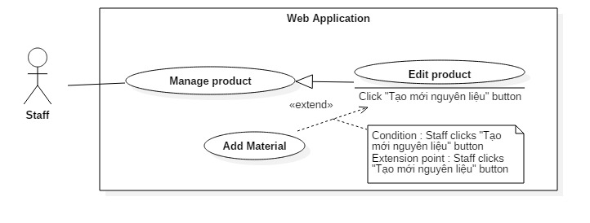

Figure 41: <Customer> Edit product

|  |  |  |  |
| --- | --- | --- | --- |
| USE CASE – US18 | | | |
| Use Case No. | US18 | **Use Case Version** | 2.0 |
| Use Case Name | Edit product | | |
| Author | ManhOT | | |
| Date | 02/10/2015 | **Priority** | Normal |
| Actor:   * Staff   Summary:   * This use case allows staff to edit product   Goal:   * Staff can edit product   Triggers:   * Staff clicks “Sửa” button at “danh sách sản phẩm” page   Preconditions:   * User must login into the system with role Staff * This staff account status is “Đang hoạt động”   Post Conditions:   * Success: Staff edit product successful * Fail: Show error message.   Main Success Scenario:   |  |  |  | | --- | --- | --- | | Step | Actor Action | System Response | | 1 | Staff click **“**Sửa sản phẩm**”** at **“**Quản lý sản phẩm**”** page | System require information :  -“Tên sản phẩm”: free textbox, max length 100   * “Đơn vị tính”: textbox, required, max length 20 * “Trọng lượng”: textbox, required, from 100-1000 gram * “Mô tả sản phẩm”: textbox, max length 500 * “Ghi chú”: textbox, max length 500 * Image: browse image (type .jpg, max 1MB) * “Giá gốc”: textbox (number only), required, from 1000-100000(VNĐ) * “Loại bánh” : Dropdown list * “Nguyên liệu cho sản phẩm” : Select popup | | 2 | Staff inputs information |  | | 3 | Staff clicks “Thêm nguyên liệu” button | System shows list material | | 4 | Staff select materials and click “Chọn” button | System shows list material have been chosen by Staff | | 5 | Staff change material’s quantity  [Alternative 1] |  | | 6 | Staff clicks “Cập nhật” button | System shows message new product has been added successfully.  [Exception 1, 2, 3, 4, 5, 6, 7, 8, 9, 10, 11, 12, 13, 14, 15, 16 , 17] |   Alternative Scenario:   |  |  |  | | --- | --- | --- | | No | Actor Action | System Response | | 1 | Staff click “Hủy” button at specific material | System will remove that material out of list materials |   Exceptions:   |  |  |  | | --- | --- | --- | | No | Actor Action | System Response | | 1 | Staff missed to input “Tên sản phẩm” field | Show error message: “Tên sản phẩm không được để trống”. | | 2 | Staff missed to input “Đơn vị tính” field | Show error message: “Đơn vị tính của sản phẩm không được để trống”. | | 3 | Staff missed to input “Trọng lượng” field | Show error message: “Trọng lượng của sản phẩm không được để trống”. | | 4 | Staff missed to input “Đơn giá” field | Show error message: “Giá gốc của sản phẩm không được để trống”. | | 5 | Staff missed to input “Mã sản phẩm” field | Show error message: “Mã sản phẩm không được để trống”. | | 6 | Staff inputted wrong format of “Tên sản phẩm” field | Show error message: “Tên sản phẩm phải có độ dài tối đa 100 kí tự” | | 7 | Staff inputted wrong format of “Đơn vị tính” field | Show error message: “Đơn vị tính của sản phẩm phải có độ dài từ 2-20 kí tự” | | 8 | Staff inputted product’s weight too small | Show error message: “Trọng lượng của sản phẩm phải lớn hơn hoặc bằng 100 gam” | | 9 | Staff inputted product’s weight too large | Show error message: “Trọng lượng của sản phẩm phải nhỏ hơn 2000 gam” | | 10 | Staff inputted product’s price too small | Show error message: “Giá sản phẩm phải lớn hơn hoặc bằng 1000 đồng” | | 11 | Staff inputted product’s price too large | Show error message: “Giá sản phẩm không được lớn hơn ‘Max Price’” | | 12 | Staff didn’t add material to product | Show error message: “Vui lòng thêm nguyên liệu cho sản phẩm” | | 13 | Material’s quantity is null | Show error message : “Số lượng nguyên liệu không được trống” | | 14 | Material’s quantity not more than 0 | Show error message : “Số lượng nguyên liệu phải lớn hơn 0” | | 15 | Staff didn’t choose image | Show error message : “Vui lòng thêm nguyên liệu cho sản phẩm” | | 16 | Staff chose image that have size larger than 1MB | Show error message : “Kích thước hình ảnh quá lớn” | | 17 | Staff chose file that isn’t image file | Show error message : “Xin chọn tệp hình ảnh (đuôi “.png”, “.jpg”, “.jpeg”,… |   Relationships: extended by Add material(Click “Thêm nguyên liệu” button)  Business Rules:   * Product code(Mã sản phẩm) is automatic initialized and changed by the system. * Max Price is prescribed by Manager. * Cannot edit product name duplicate which product name (Status is “Đang sử dụng”) existed in database * Format input text :   + “Tên sản phẩm”: max length 100   + “Đơn vị tính”: max length 50   + “Trọng lượng”: Number only, from 100-2000 (gram)   + “Mô tả sản phẩm”: textbox, max length 500   + “Ghi chú”: textbox, max length 500   + Image: browse image (type .jpg, max 1MB)   + “Giá gốc”: textbox (number only), from 1000-‘Max Price’ (VNĐ)   + “Loại bánh” : Dropdown list | | | |

Table 41: Use case US18 - <Staff> Edit product

##### <Staff> Change product status

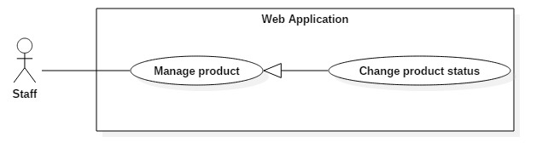

Figure 42: <Staff> Change product status

|  |  |  |  |
| --- | --- | --- | --- |
| USE CASE – US19 | | | |
| Use Case No. | US19 | **Use Case Version** | 2.0 |
| Use Case Name | Change product status | | |
| Author | ManhOT | | |
| Date | 02/10/2015 | **Priority** | Normal |
| Actor:   * Staff   Summary:   * This use case allows staff to to change product status   Goal:   * Staff can change product status   Triggers:   * Staff clicks “Đổi trạng thái” button in specific material information page. * Staff clicks “Thay đổi trạng thái” button in “Danh sách nguyên liệu” page   Preconditions:   * User must login into the system with role Staff * This staff account status is “Đang hoạt động”   Post Conditions:   * Success: Change product status success. * Fail: Show error message.   Main Success Scenario:   |  |  |  | | --- | --- | --- | | Step | Actor Action | System Response | | 1 | Staff clicks “Đổi trạng thái” button | System shows the popup with 2 choices: “Sử dụng”, “Ngừng sử dụng”. | | 2 | Staff chooses status |  | | 3 | Staff clicks “Đồng ý” button  [Alternative 1] | System will change new status of this material and close the popup.  [Exception 1]  [Exception 2] |   Alternative Scenario:   |  |  |  | | --- | --- | --- | | No | Actor Action | System Response | | 1 | Staff click “Ngừng sử dụng” button | Close the popup |   Exceptions:   |  |  |  | | --- | --- | --- | | No | Actor Action | System Response | | 1 | Staff chooses “Ngừng sử dụng” and click “Đồng ý” button when this product’s status is “Không còn sử dụng” | System show error message : Sản phẩm hiện đã có trạng thái Không còn sử dụng. | | 2 | Staff chooses “Sử dụng” and click “Đồng ý” button when this product’s status is “Đang sử dụng” | System show error message : Sản phẩm đã có trạng thái Đang sử dụng |   Relationships: N/A  Business Rules:   * The new status will be saved into the system * If product’s status be changed to “Không còn sử dụng”, that product will not be displayed at product list at customer page. | | | |

Table 42: Use case US19 - <Staff> Change product status

#### <Manager> Overview Use Case

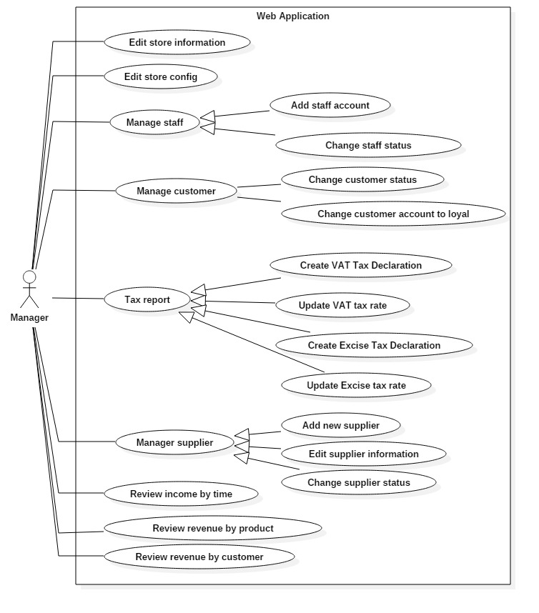

Figure 43: <Manager> Manager Overview Usecase

##### <Manager> Edit store information

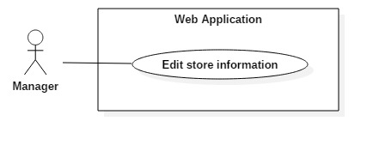

Figure 44: <Manager> Edit store information

|  |  |  |  |
| --- | --- | --- | --- |
| USE CASE – M01 | | | |
| Use Case No. | UM01 | **Use Case Version** | 2.0 |
| Use Case Name | Edit store information | | |
| Author | ManhOT | | |
| Date | 27/09/2015 | **Priority** | Normal |
| Actor:   * Manager   Summary:   * This use case allows manager to edit the store information.   Goal:   * The store information is edited.   Triggers:   * The manager send the edit store information command.   Preconditions:   * User must have role “Manager”. * Manager go to “Thông tin cửa hàng” page.   Post Conditions:   * Success: The store information is edited. * Fail: Show error message.   Main Success Scenario:   |  |  |  | | --- | --- | --- | | Step | Actor Action | System Response | | 1 | Manager clicks “Thay đổi thông tin cửa hàng” button at “Thông tin cửa hàng” page | Edit store information is shown with following labels and fields:   * Tên cửa hàng: text input with the letter from Vietnamese alphabet and number, required, length 3 – 200. * Tên chủ sở hữu: text input with the letter from Vietnamese alphabet, required, length 3 – 200. * Email : textbox (format xxx@xxx.xxx), required, max 250. * Địa chỉ: text input with the letter from Vietnamese alphabet and number, required, length 10 – 250. * Tỉnh thành: text input with the letter from Vietnamese alphabet and number, required, length 3 – 100. * Quận: text input with the letter from Vietnamese alphabet and number, required, length 1 – 30. * Số điện thoại: have at least one phone number which each phone number is text input with number, length 8 – 15. * Fax : text input with number. * Mã số thuế: text input with number, required, length 10 – 13. * Logo Image: browse image (type .jpg, png, jpeg. Max size: 1MB) | | 2 | Manager fills out the form. |  | | 3 | Manager sends command to edit to system | The data is edited in the system.  Show message store infor has been edited successfully.  [Exception 1, 2, 3, 4, 5, 6, 7, 8, 9, 10, 11, 12, 13, 14, 15, 16] |   Alternative Scenario: N/A  Exceptions:   |  |  |  | | --- | --- | --- | | No | Actor Action | System Response | | 1 | Staff missed to input “Tên cửa hàng” field | Show error message: “Tên cửa hàng không được để trống”. | | 2 | Staff missed to input “Tên chủ sở hữu” field | Show error message: “Tên chủ sở hữu không được để trống”. | | 3 | Staff missed to input “Email” field | Show error message: “Email không được để trống”. | | 4 | Staff missed to input “Địa chỉ” field | Show error message: “Giá gốc của sản phẩm không được để trống”. | | 5 | Staff missed to input “Tỉnh thành” field | Show error message: “Tỉnh thành không được để trống”. | | 6 | Staff missed to input “Quận” field | Show error message: “Quận không được để trống”. | | 7 | Staff missed to input “Số điện thoại” field | Show error message: “Số điện thoại không được để trống”. | | 8 | Staff missed to input “Mã số thuế” field | Show error message: “Mã số thuế không được để trống”. | | 9 | Staff inputted wrong format of “Tên cửa hàng” field | Show error message: “Tên cửa hàng phải có độ dài từ 3 đến 200 ký tự” | | 10 | Staff inputted wrong format of “Tên chủ sở hữu” field | Show error message: “Tên chủ sở hữu phải có độ dài từ 3 đến 200 ký tự” | | 11 | Staff inputted wrong format of “Email” field | Show error message: “Email không đúng định dạng – example@gmail.com” | | 12 | Staff inputted wrong format of “Địa chỉ” field | Show error message: “Địa chỉ phải từ 10 đến 250 ký tự” | | 13 | Staff inputted wrong format of “Tỉnh thành” field | Show error message: “Tỉnh thành phải từ 3 đến 100 ký tự.” | | 14 | Staff inputted wrong format of “Quận” field | Show error message : “Quận phải từ 1 đến 30 ký tự” | | 15 | Staff inputted wrong format of “Số điện thoại” field | Show error message : “Số điện thoại có độ dài từ 8 đến 15 ký tự” | | 16 | Staff inputted wrong format of “Mã số thuế” field | Show error message : “Mã số thuế có độ dài từ 10 đến 13 ký tự” |   Relationships: N/A  Business Rules:   * After editing, the basic information of the store will be updated in the system. * Logo Image will be displayed at customer page. | | | |

Table 43: Use case UM01 - <Manager> Edit store information

##### <Manager> Edit store config

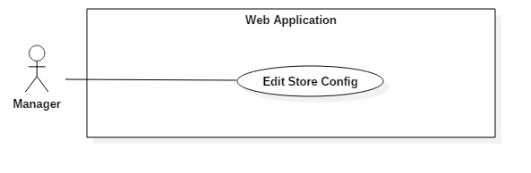

Figure 45: <Manager>Edit store config

|  |  |  |  |
| --- | --- | --- | --- |
| USE CASE – M02 | | | |
| Use Case No. | UM02 | **Use Case Version** | 2.0 |
| Use Case Name | Edit store config | | |
| Author | ManhOT | | |
| Date | 27/09/2015 | **Priority** | Normal |
| Actor:   * Manager   Summary:   * This use case allows manager to edit system configuration (Min quantity, max price, category, discount by quantity).   Goal:   * The store config is edited.   Triggers:   * The manager send the edit store config command.   Preconditions:   * User must have role “Manager”. * Manager go to “Cấu hình hệ thống” page.   Post Conditions:   * Success: The store config is edited. * Fail: Show error message.   Main Success Scenario:   |  |  |  | | --- | --- | --- | | Step | Actor Action | System Response | | 1 | Manager clicks “Thay đổi” at “Giảm giá theo số lượng” box at “Cấu hình hệ thống” page  [Alternative 1]  [Alternative 2]  [Alternative 3] | Enable edit store config (Discount by quantity) include :   * “Thực hiện giảm giá theo số lượng” : dropdown list * Table with 3 columns:   + “Từ” : number only, max length 5   + “Đến” : number only, max length 5   + “Tỉ lệ giảm”: number only, max length 3 | | 2 | Manager fills out the form.  [Alternative 4]  [Alternative 5] |  | | 3 | Manager clicks “Xác nhận” button to sends command edit to system | The data is edited in the system.  Show message store config has been edited successfully.  [Exception 1, 2, 3, 4, 5, 6, 7, 8, 9, 10, 11, 12, 13, 14, 15] |   Alternative Scenario:   |  |  |  | | --- | --- | --- | | No | Actor Action | System Response | | 1 | Manager clicks “Thay đổi” at “Số lượng sản phẩm tối thiểu trong đơn hàng” box at “Cấu hình hệ thống” page | Enable edit store config (Min quantity) with field :   * “Số lượng sản phẩm tối thiểu” : number only, max length 5 | | 2 | Manager clicks “Thay đổi” at “Đơn giá tối đa cho một sản phẩm” box at “Cấu hình hệ thống” page | Enable edit store config (Max price) with field :   * “Đơn giá tối đa cho sản phẩm” : number only, max length 10 | | 3 | Manager clicks “Thay đổi” at “Loại bánh” box at “Cấu hình hệ thống” page | Enable edit store config (Product category) table with field :  “Tên loại bánh” : textbox, max length 50 | | 4 | Change value at dropdown list |  | | 5 | Manager clicks “Hủy thay đổi” | Disable edit store config and rollback to old value. |   Exceptions:   |  |  |  | | --- | --- | --- | | No | Actor Action | System Response | | 1 | Manager missed to input “Từ” field when clicks “Xác nhận” button at “Giảm giá theo số lượng” box | Show error message: “Số lượng không được để trống”. | | 2 | Manager missed to input “Đến” field when clicks “Xác nhận” button at “Giảm giá theo số lượng” box | Show error message: “Số lượng không được để trống”. | | 3 | Manager missed to input “Tỉ lệ giảm” field when clicks “Xác nhận” button at “Giảm giá theo số lượng” box | Show error message: “Tỉ lệ giảm không được để trống”. | | 4 | Manager clicks “Xác nhận” button at “Giảm giá theo số lượng” box when “Từ” field of first row is not 0 | Show error message: “Số lượng ‘từ’ ở hàng đầu tiên không được khác 0”. | | 5 | Manager clicks “Xác nhận” button at “Giảm giá theo số lượng” box when “Từ” field of any row not equal “Đến” field of previous row plus 1 | Show error message: “Tỉnh thành không được để trống”. | | 6 | Manager clicks “Xác nhận” button at “Giảm giá theo số lượng” box when “Từ” field larger than “Đến” of that row | Show error message: “Trong một hàng, số lượng ‘từ’ không được lớn hơn số lượng ‘đến”. | | 7 | Manager clicks “Xác nhận” button at “Giảm giá theo số lượng” box when “Tỉ lệ giảm” field of any row smaller than “Tỉ lệ giảm” field of next row. | Show error message: “Tỉ lệ giảm hàng sau không được nhỏ hơn hàng trước”. | | 8 | Manager clicks “Xác nhận” button at “Giảm giá theo số lượng” box when “Tỉ lệ giảm” field of last row larger than 100 | Show error message: “Tỉ lệ giảm tối đa là 100%”. | | 9 | Manager missed to input “Số lượng sản phẩm tối thiểu” field when clicks “Xác nhận” button at “Số lượng sản phẩm tối thiểu” box | Show error message: “Số lượng không được để trống” | | 10 | Manager clicks “Xác nhận” button at “Số lượng sản phẩm tối thiểu” box when “Số lượng sản phẩm tối thiểu” field larger than 5000 | Show error message: “Số lượng không được lớn hơn 5000” | | 11 | Manager missed to input “Đơn giá tối đa cho sản phẩm” field when clicks “Xác nhận” button at “Đơn giá tối đa cho sản phẩm” box | Show error message: “Gía tối đa không được để trống” | | 12 | Manager clicks “Xác nhận” button at “Đơn giá tối đa cho sản phẩm” box when system has product that price large than manager inputted | Show error message: “Tồn tại sản phẩm hiện đang có giá lớn hơn giá tối đa bạn vừa nhập, vui lòng thử lại” | | 13 | Manager clicks “Hủy” button at “Loại bánh” box when system has product using that category | Show error message: “Loại bánh này đang được sử dụng, vui lòng thay đổi và thử lại” | | 14 | Manager add category which existed in system | Show error message : “Đã tồn tại loại bánh cùng tên, vui lòng thử lại” | | 15 | Manager missed to input “Tên loại bánh” field when clicks “Xác nhận” button at “Loại bánh” box | Show error message : “Loại bánh không được để trống” | | 16 | Manager clicks “Xác nhận” button at “Loại bánh” box when that input duplicate with another product’s category | Show error message : “Có loại bánh trùng tên nhau, vui lòng thử lại” |   Relationships: N/A  Business Rules:   * If manager change “Min quantity”, user can make new order if and only if total quantity of that order larger than new “Min quantity”. * If manager change “Max price”, staff can edit or add new product if and only if product standard price smaller than new “Max Price”. * If manager change category, any change will be displayed at customer page. * If manager set “Discount by quantity” to false, any new order will not be discounted | | | |

Table 44: Use case UM02 - <Manager> Edit store config

##### <Manager> Add new staff

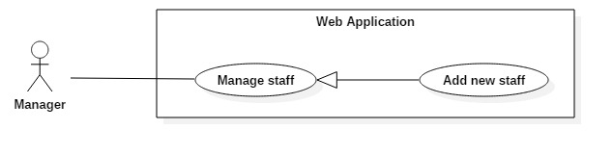

Figure 46: <Manager> Add new staff

|  |  |  |  |
| --- | --- | --- | --- |
| USE CASE – UM03 | | | |
| Use Case No. | UM03 | **Use Case Version** | 2.0 |
| Use Case Name | Add new staff | | |
| Author | VuongNQ | | |
| Date | 27/09/2015 | **Priority** | Normal |
| Actor:   * Manager   Summary:   * This use case allows manager to add new staff account.   Goal:   * Manager can create new staff account.   Triggers:   * The manager clicks “Tạo tài khoản nhân viên” tab in menu bar of manage page. * The manager clicks “Thêm nhân viên mới” button at staff index page.   Preconditions:   * User must have role “Manager”.   Post Conditions:   * Success: New staff account will created. * Fail: Show error message.   Main Success Scenario:   |  |  |  | | --- | --- | --- | | Step | Actor Action | System Response | | 1 | Manager goes to add staff page. | System requires information to staff:   * “Tên nhân viên”: textbox, require, max length 50 * “Tên tài khoản”: textbox, require, max length 50 * “Số điện thoại”: textbox (number only), require, from 10-11 number character * “E-mail”: textbox, email format [example@gmail.com](mailto:example@gmail.com) * “Địa chỉ”: text field, max length 200 | | 2 | Manager inputs information. |  | | 3 | Manager sends command to add new staff account. | System shows success message.  [Exception 1, 2, 3, 4, 5, 6, 7] |   Alternative Scenario: N/A  Exceptions:   |  |  |  | | --- | --- | --- | | Step | Actor Action | System Response | | 1 | Missing “Tên nhân viên” fields | System shows error messgage: “Tên nhân viên không được trống”. | | 2 | Missing “Tên tài khoản” fields | System shows error messgage: “Tên tài khoản của nhân viên không được trống”. | | 3 | Missing “Số điện thoại” fields | System shows error messgage: “Số điện thoại của không được trống”. | | 4 | Missing “E-mail” fields | System shows error messgage: “Địa chỉ E-mail của nhân viên không được trống.” | | 5 | Missing “Địa chỉ” fields | System shows error messgage: “Địa chỉ của nhân viên không được trống.” | | 6 | Wrong format of “Số điện thoại” fields | System shows error messgage: “Hãy nhập số điện thoại đúng”. | | 7 | Wrong format of “E-mail” fields | System shows error messgage: “Hãy nhập email đúng định dạng”. |   Relationships: N/A  Business Rules:   * Staff’s email does not duplicated with other email in system. * Password will be random with six characters and send to email to registered staff’s mail. * The new created staff account is in the state “Active”. | | | |

Table 45: Use case UM03 - <Manager> Add new staff

##### <Manager> Change staff status

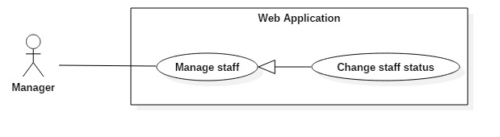

Figure 47: <Manager> Change staff status

|  |  |  |  |
| --- | --- | --- | --- |
| USE CASE – UM04 | | | |
| Use Case No. | UM04 | **Use Case Version** | 2.0 |
| Use Case Name | Change staff status | | |
| Author | VuongNQ | | |
| Date | 27/09/2015 | **Priority** | Normal |
| Actor:   * Manager   Summary:   * This use case allows manager to update the status of a staff account.   Goal:   * Update new status of staff’s account to database.   Triggers:   * The manager clicks “Thay đổi trạng thái” button at staff list page. * The manager clicks “Thay đổi trạng thái” button in specific staff detail page.   Preconditions:   * User must have role “Manager”.   Post Conditions:   * Success: The selected staff account will change state: from active to de-active or reverse. * Fail: Show error message, no changes in database.   Main Success Scenario:   |  |  |  | | --- | --- | --- | | Step | Actor Action | System Response | | 1 | Manager click on “Danh sách nhân viên” tab in menu bar. | Navigate to “Danh sách nhân viên” page. | | 2 | Manager clicks “Thay đổi trạng thái” button | System will display a confirm popup to change staff status.  [Exception 1] |   Alternative Scenario: N/A  Exceptions:   |  |  |  | | --- | --- | --- | | Step | Actor Action | System Response | | 1 | Connection with database fail | Show error message “Đã có lỗi xảy ra, vui lòng thử lại.” |   Relationships: N/A  Business Rules:   * Active staff account: an account that can log in into the system and use all functions of staff account. * De-active staff account: an account that cannot log in into the system with role staff. | | | |

Table 46: Use case UM04 - <Manager> Change staff status

##### <Manager> Change customer status

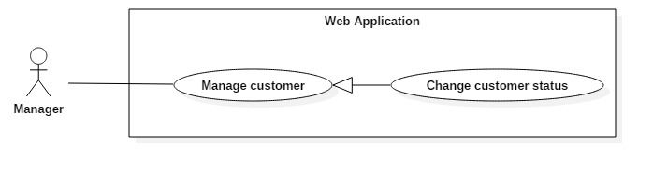

Figure 48: <Manager> Change customer status

|  |  |  |  |
| --- | --- | --- | --- |
| USE CASE – UM05 | | | |
| Use Case No. | UM05 | **Use Case Version** | 2.0 |
| Use Case Name | Change customer status | | |
| Author | VuongNQ | | |
| Date | 27/09/2015 | **Priority** | Normal |
| Actor:   * Manager   Summary:   * This use case allows manager to update the status of a customer account.   Goal:   * Update new status of customer’s account in database.   Triggers:   * The manager clicks “Thay đổi trạng thái” button at customer list page. * The manager clicks “Thay đổi trạng thái” button in specific customer detail page.   Preconditions:   * User must have role “Manager”.   Post Conditions:   * Success: The selected customer account will change state: from active to de-active or reverse. * Fail: Show error message, no changes in database.   Main Success Scenario:   |  |  |  | | --- | --- | --- | | Step | Actor Action | System Response | | 1 | Manager click on “Danh sách khách hàng” tab in menu bar. | Navigate to “Danh sách khách hàng” page. | | 2 | Manager clicks “Thay đổi trạng thái” button | System will display a confirm popup to change staff status.  [Exception 1] |   Alternative Scenario: N/A  Exceptions:   |  |  |  | | --- | --- | --- | | Step | Actor Action | System Response | | 1 | Connection with database fail | Show error message “Đã có lỗi xảy ra, vui lòng thử lại.” |   Relationships: N/A  Business Rules:   * Active customer account: an account that can log in into the system and use all functions of customer account. * De-active customer account: an account that cannot log in into the system. | | | |

Table 47: Use case UM05 - <Manager> Change customer status

##### <Manager> Change customer account to loyal

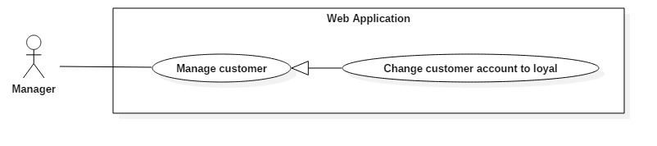

Figure 49: <Manager> Change customer account to loyal

|  |  |  |  |
| --- | --- | --- | --- |
| USE CASE – UM06 | | | |
| Use Case No. | UM06 | **Use Case Version** | 2.0 |
| Use Case Name | Change customer account to loyal | | |
| Author | VuongNQ | | |
| Date | 27/09/2015 | **Priority** | Normal |
| Actor:   * Manager   Summary:   * This use case allows manager to update the status of a customer account to loyal.   Goal:   * Update loyal status of customer in database.   Triggers:   * The manager clicks “Khách hàng thân thiết” button at staff list page. * The manager clicks “Khách hàng thân thiết” button in specific customer detail page.   Preconditions:   * User must have role “Manager”.   Post Conditions:   * Success: The selected customer account will change state: from loyal to regular or reverse. * Fail: Show error message, no changes in database.   Main Success Scenario:   |  |  |  | | --- | --- | --- | | Step | Actor Action | System Response | | 1 | Manager click on “Danh sách khách hàng” tab in menu bar. | Navigate to “Danh sách khách hàng” page. | | 2 | Manager clicks “Khách hàng thân thiết” button | System will display a confirm popup to change loyal customer.  [Exception 1] |   Alternative Scenario: N/A  Exceptions:   |  |  |  | | --- | --- | --- | | Step | Actor Action | System Response | | 1 | A staff want to execute this function | Show error message “Đã có lỗi xảy ra, vui lòng thử lại.” |   Relationships: N/A  Business Rules:   * Loyal customer account: when staff approves or creates order for loyal customer account, staff can select to receive deposit or not. * De-active staff account: when staff approves or creates order for loyal customer account, staff must select to receive deposit with minimum is equal to material cost. | | | |

Table 48: Use case UM06 - <Manager> Change customer account to loyal

##### <Manager> Add new supplier

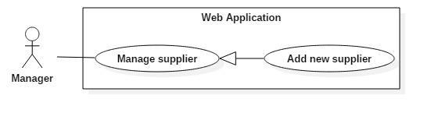

Figure 50: <Manager> Add new supplier

|  |  |  |  |
| --- | --- | --- | --- |
| USE CASE – UM07 | | | |
| Use Case No. | UM07 | **Use Case Version** | 2.0 |
| Use Case Name | Add new supplier | | |
| Author | VuongNQ | | |
| Date | 27/09/2015 | **Priority** | Normal |
| Actor:   * Manager   Summary:   * This use case allows manager to add new supplier.   Goal:   * Manager can create new supplier.   Triggers:   * The manager clicks “Thêm nhà cung cấp mới” tab in menu bar of manage page. * The manager clicks “Thêm nhà cung cấp mới” button at supplier index page.   Preconditions:   * User must have role “Manager”.   Post Conditions:   * Success: New supplier will created. * Fail: Show error message.   Main Success Scenario:   |  |  |  | | --- | --- | --- | | Step | Actor Action | System Response | | 1 | Manager goes to add supplier page. | System requires information to supplier:   * “Nhà cung cấp”: textbox, require, max length 50 * “Địa chỉ”: textbox, require, max length 200 * “Số điện thoại”: textbox (number only), require, 10 – 12 number * “E-mail”: textbox, email format [example@gmail.com](mailto:example@gmail.com) * “Mã số thuế”: textbox (number only), require, 10 – 13 number | | 2 | Manager inputs information. |  | | 3 | Manager sends command to add new staff account. | System shows success message.  [Exception 1, 2, 3, 4, 5, 6, 7, 8] |   Alternative Scenario: N/A  Exceptions:   |  |  |  | | --- | --- | --- | | Step | Actor Action | System Response | | 1 | Missing “Nhà cung cấp” fields | System shows error messgage: “Tên nhà cung cấp không được trống”. | | 2 | Missing “Địa chỉ” fields | System shows error messgage: “Địa chỉ nhà cung cấp không được trống”. | | 3 | Missing “Số điện thoại” fields | System shows error messgage: “Số điện thoại nhà cung cấp không được trống”. | | 4 | Missing “E-mail” fields | System shows error messgage: “Email nhà cung cấp không được trống.” | | 5 | Missing “Mã số thuế” fields | System shows error messgage: “Mã số thuế nhà cung cấp không được trống.” | | 6 | Wrong format of “Số điện thoại” fields | System shows error messgage: “Hãy nhập số điện thoại đúng”. | | 7 | Wrong format of “E-mail” fields | System shows error messgage: “Hãy nhập email đúng định dạng”. | | 8 | Wrong format of “Mã số thuế” fields | System shows error messgage: “Hãy nhập mã số thuế đúng.” |   Relationships: N/A  Business Rules:   * All information of new supplier does not existed in database. * The new created supplier is in the state “Active”. | | | |

Table 49: Use case UM07 - <Manager> Add new supplier

##### <Manager> Edit supplier informaion

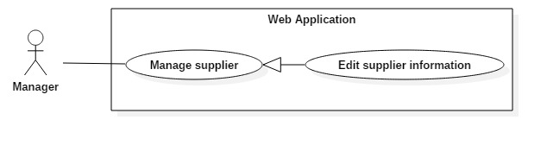

Figure 51 <Manager> Edit supplier information

|  |  |  |  |
| --- | --- | --- | --- |
| USE CASE – UM08 | | | |
| Use Case No. | UM08 | **Use Case Version** | 2.0 |
| Use Case Name | Edit supplier information | | |
| Author | VuongNQ | | |
| Date | 27/09/2015 | **Priority** | Normal |
| Actor:   * Manager   Summary:   * This use case allows manager to edit supplier information.   Goal:   * Manager can edit supplier’s information   Triggers:   * The manager clicks “Sửa” button at supplier index page. * The manager clicks “Chỉnh sửa” button at specific supplier detail page.   Preconditions:   * User must have role “Manager”.   Post Conditions:   * Success: Edit supplier information successful. * Fail: Show error message.   Main Success Scenario:   |  |  |  | | --- | --- | --- | | Step | Actor Action | System Response | | 1 | Manager goes to edit staff page. | Manager can edit supplier information:   * “Nhà cung cấp”: textbox, require, max length 50 * “Địa chỉ”: textbox, require, max length 200 * “Số điện thoại”: textbox (number only), require, 10 – 12 number * “E-mail”: textbox, email format [example@gmail.com](mailto:example@gmail.com) * “Mã số thuế”: textbox (number only), require, 10 – 13 number | | 2 | Manager edits information. |  | | 3 | Manager sends command to add new staff account. | System shows success message.  [Exception 1, 2, 3, 4, 5, 6, 7, 8, 9] |   Alternative Scenario: N/A  Exceptions:   |  |  |  | | --- | --- | --- | | Step | Actor Action | System Response | | 1 | Missing “Nhà cung cấp” fields | System shows error messgage: “Tên nhà cung cấp không được trống”. | | 2 | Missing “Địa chỉ” fields | System shows error messgage: “Địa chỉ nhà cung cấp không được trống”. | | 3 | Missing “Số điện thoại” fields | System shows error messgage: “Số điện thoại nhà cung cấp không được trống”. | | 4 | Missing “E-mail” fields | System shows error messgage: “Email nhà cung cấp không được trống.” | | 5 | Missing “Mã số thuế” fields | System shows error messgage: “Mã số thuế nhà cung cấp không được trống.” | | 6 | Wrong format of “Số điện thoại” fields | System shows error messgage: “Hãy nhập số điện thoại đúng”. | | 7 | Wrong format of “E-mail” fields | System shows error messgage: “Hãy nhập email đúng định dạng”. | | 8 | Wrong format of “Mã số thuế” fields | System shows error messgage: “Hãy nhập mã số thuế đúng.” | | 9 | Staff changes supplier id in url bar but this id is not existed in database | Redirect to supplier index page |   Relationships: N/A  Business Rules:   * All information of new supplier does not existed in database. * The new created supplier is in the state “Active”. | | | |

Table 50: Use case UM08 - <Manager> Add new supplier

##### <Manager> Change supplier status

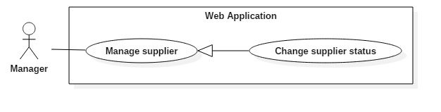

Figure 52: <Manager> Change supplier status

|  |  |  |  |
| --- | --- | --- | --- |
| USE CASE – UM09 | | | |
| Use Case No. | UM09 | **Use Case Version** | 2.0 |
| Use Case Name | Change supplier status | | |
| Author | VuongNQ | | |
| Date | 27/09/2015 | **Priority** | Normal |
| Actor:   * Manager   Summary:   * This use case allows manager to change supplier status.   Goal:   * Update new status of supplier’s account in database.   Triggers:   * The manager clicks “Thay đổi trạng thái” button at supplier list page. * The manager clicks “Thay đổi trạng thái” button in specific supplier detail page.   Preconditions:   * User must have role “Manager”.   Post Conditions:   * Success: The selected supplier account will change state: from active to de-active or reverse. * Fail: Show error message, no changes in database.   Main Success Scenario:   |  |  |  | | --- | --- | --- | | No | Actor Action | System Response | | 1 | Manager click on “Danh sách nhà cung cấp” tab in menu bar. | Navigate to “Danh sách nhà cung cấp” page. | | 2 | Manager clicks “Thay đổi trạng thái” button | System will display a confirm popup to change staff status.  [Exception 1] |   Alternative Scenario: N/A  Exceptions:   |  |  |  | | --- | --- | --- | | No | Actor Action | System Response | | 1 | Connection with database fail | Show error message “Đã có lỗi xảy ra, vui lòng thử lại.” |   Relationships: N/A  Business Rules:   * Supplier with active status: When staff adds new input bill, he/she can select this supplier. * Supplier with de-active status: Donot display when staff adds new input bill | | | |

Table 51: Use case UM09 - <Manager> Change supplier status

##### <Manager> Update VAT tax rate

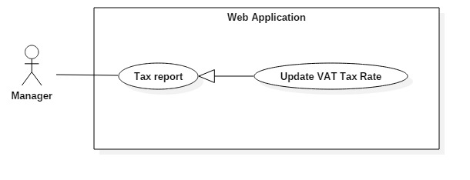

Figure 53: <Manager> Update VAT tax rate

|  |  |  |  |
| --- | --- | --- | --- |
| USE CASE – UM10 | | | |
| Use Case No. | UM10 | **Use Case Version** | 2.0 |
| Use Case Name | Update VAT tax rate | | |
| Author | GiangHHT | | |
| Date | 27/09/2015 | **Priority** | Normal |
| Actor:   * Manager   Summary:   * This use case allows manager to update the VAT tax rate.   Goal:   * The new VAT tax rate is added to database.   Triggers:   * Click “Thay đổi” button in “Thuế giá trị gia tăng (VAT)” group in “Báo cáo thuế” page.   Preconditions:   * User must have role “Manager”.   Post Conditions:   * Success: The new VAT tax rate is updated. * Fail: Show error message, no changes in database.   Main Success Scenario:   |  |  |  | | --- | --- | --- | | Step | Actor Action | System Response | | 1 | Manager click on “Thay đổi” button in “Thuế giá trị gia tăng (VAT) group. | Show pop-up “Thay đổi tỉ xuất thuế VAT” pop-up with:   * Tax rate: text input with number, required, value from 1 to 20. * Apply time: date time in the future with format dd/MM/yyyy, required. * Two buttons:   + “Hủy” button   + “Thay đổi” button | | 2 | Manager input new tax rate and click “Thay đổi”. | The new VAT tax rate will be added.  [Exception 1] |   Alternative Scenario:   |  |  |  | | --- | --- | --- | | No | Actor Action | System Response | | 1 | Manager choose one option button and click “Hủy”. | The new VAT tax rate will not be added. |   Exceptions:   |  |  |  | | --- | --- | --- | | No | Actor Action | System Response | | 1 | Database connection error | Show error message “Đã có lỗi xảy ra trong quá trình thực hiện, vui lòng thử lại sau!” |   Relationships:  Business Rules:   * The VAT tax rate is defined by law. * All the bill will be applied the tax rate from the apply time. * If adding a bill in the pass, it must be right with the corresponding period. | | | |

Table 52: Use case UM10 - <Manager> Update VAT tax rate

##### <Manager> Update Excise tax rate

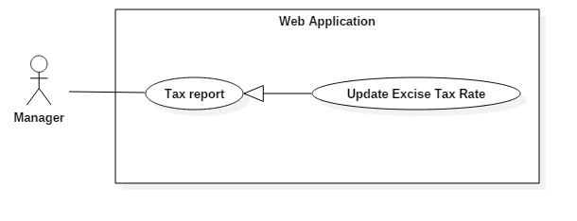

Figure 54: <Manager> Update Excise tax rate

|  |  |  |  |
| --- | --- | --- | --- |
| USE CASE – UM11 | | | |
| Use Case No. | UM11 | **Use Case Version** | 2.0 |
| Use Case Name | Update Excise tax rate | | |
| Author | GiangHHT | | |
| Date | 27/09/2015 | **Priority** | Normal |
| Actor:   * Manager   Summary:   * This use case allows manager to update the Excise tax rate.   Goal:   * The new Excise tax rate is updated to database.   Triggers:   * Click “Thay đổi” button in “Thuế thu nhập doanh nghiệp (TNDN)” group in “Báo cáo thuế” page.   Preconditions:   * User must have role “Manager”.   Post Conditions:   * Success: The new Excise tax rate is added. * Fail: Show error message, no changes in database.   Main Success Scenario:   |  |  |  | | --- | --- | --- | | Step | Actor Action | System Response | | 1 | Manager click on “Thay đổi” button in “Thuế thu nhập doanh nghiệp (TNDN)” group. | Show pop-up “Thay đổi tỉ xuất thuế TNDN” pop-up with:   * Tax rate: text input with number, required, value from 1 to 50. * Apply time: year in the future yyyy, required. * Two buttons:   + “Hủy” button   + “Thay đổi” button | | 2 | Manager choose one option button and click “Thay đổi”. | The new Excise tax rate will be updated.  [Exception 1] |   Alternative Scenario:   |  |  |  | | --- | --- | --- | | No | Actor Action | System Response | | 1 | Manager choose one option button and click “Hủy”. | The new Excise tax rate will not be updated. |   Exceptions:   |  |  |  | | --- | --- | --- | | No | Actor Action | System Response | | 1 | Database connection error | Show error message “Đã có lỗi xảy ra trong quá trình thực hiện, vui lòng thử lại sau!” |   Relationships:  Business Rules:   * The Excise tax rate is defined by law. * All the Excise tax declaration will be applied the tax rate from the apply time. | | | |

Table 53: Use case UM11 - <Manager> Update Excise tax rate

##### <Manager> Review income by time

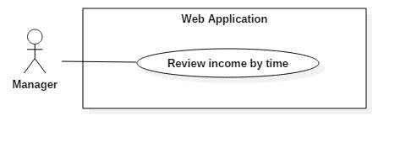

Figure 55: <Manager> Review income by time

|  |  |  |  |
| --- | --- | --- | --- |
| USE CASE – UM12 | | | |
| Use Case No. | UM12 | **Use Case Version** | 2.0 |
| Use Case Name | Review income by time | | |
| Author | GiangHHT | | |
| Date | 27/09/2015 | **Priority** | Normal |
| Actor:   * Manager   Summary:   * This use case allows manager to review income by time.   Goal:   * Show in the income by time.   Triggers:   * Click “Thu nhập theo thời gian” menu item from left side bar.   Preconditions:   * User must have role “Manager”.   Post Conditions:   * Success: The review income by time is displayed. * Fail: Show error message.   Main Success Scenario:   |  |  |  | | --- | --- | --- | | Step | Actor Action | System Response | | 1 | Manager chooses type of time to review in drop-down list in “Thống kê theo”. | Show the drop-down list with three options “Tuần”, “Tháng”, “Năm”. | | 2 | Manager chooses the from time and to time to review depending on the choice of type of time. | Show calendar pop-up. | | 3 | Manager clicks “Thống kê” button. | Show the graph with the value of the income, revenue, expense during the time choice.  [Exception 1] | | 4 | Manager selects specific period and click “Chi tiết” button. | Show review income by time detail.  [Exception 1] |   Alternative Scenario: N/A  Exceptions:   |  |  |  | | --- | --- | --- | | Step | Actor Action | System Response | | 1 | Database connection error | Show error message “Đã có lỗi xảy ra trong quá trình thực hiện, vui lòng thử lại sau!” |   Relationships: N/A  Business Rules:   * The weekly income does not include the other expenses. * The monthly, yearly income includes the other expenses. | | | |

Table 54: Use case UM12 - <Manager> Review income by time

##### <Manager> Review income by product

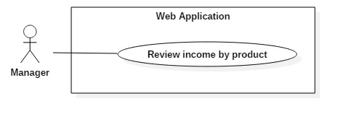

Figure 56: <Manager> Review income by product

|  |  |  |  |
| --- | --- | --- | --- |
| USE CASE – UM13 | | | |
| Use Case No. | UM13 | **Use Case Version** | 2.0 |
| Use Case Name | Review income by product | | |
| Author | GiangHHT | | |
| Date | 27/09/2015 | **Priority** | Normal |
| Actor:   * Manager   Summary:   * This use case allows manager to review income by product.   Goal:   * Show in the income by product.   Triggers:   * Click “Thu nhập theo sản phẩm” menu item from left side bar.   Preconditions:   * User must have role “Manager”.   Post Conditions:   * Success: The review income by product is displayed. * Fail: Show error message.   Main Success Scenario:   |  |  |  | | --- | --- | --- | | Step | Actor Action | System Response | | 1 | Manager chooses type of time to review in drop-down list in “Thống kê theo”. | Show the drop-down list with three options “Tuần”, “Tháng”, “Năm”. | | 2 | Manager chooses the from time and to time to review depending on the choice of type of time. | Show calendar pop-up. | | 3 | Manager clicks on “Thống kê” button. | Show the graph with the value of the revenue of the products in top ten.  [Alternative 1]  [Exception 1] | | 4 | Manager selects specific product and click “Chi tiết” button. | Show review income detail of this product.  [Exception 1] |   Alternative Scenario:   |  |  |  | | --- | --- | --- | | Step | Actor Action | System Response | | 1 | Manager clicks “Xem toàn bộ” button. | Show all products with income. |   Exceptions:   |  |  |  | | --- | --- | --- | | Step | Actor Action | System Response | | 1 | Database connection error | Show error message “Đã có lỗi xảy ra trong quá trình thực hiện, vui lòng thử lại sau!” |   Relationships: N/A  Business Rules:   * The income by product is calculated on the order have state “Đã hoàn thành” within the time chosen. | | | |

Table 55: Use case UM13 - <Manager> Review income by product

##### <Manager> Review revenue by customer

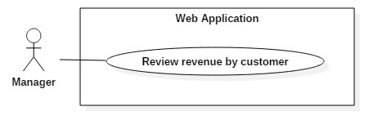

Figure 57: <Manager> Review revenue by customer

|  |  |  |  |
| --- | --- | --- | --- |
| USE CASE – UM14 | | | |
| Use Case No. | UM14 | **Use Case Version** | 2.0 |
| Use Case Name | Review revenue by customer | | |
| Author | GiangHHT | | |
| Date | 27/09/2015 | **Priority** | Normal |
| Actor:   * Manager   Summary:   * This use case allows manager to review revenue by customer.   Goal:   * Show the revenue by customer.   Triggers:   * Click “Doanh thu theo khách hàng” menu item from left side bar.   Preconditions:   * User must have role “Manager”.   Post Conditions:   * Success: The review revenue by customer is displayed. * Fail: Show error message.   Main Success Scenario:   |  |  |  | | --- | --- | --- | | Step | Actor Action | System Response | | 1 | Manager chooses type of time to review in drop-down list in “Thống kê theo”. | Show the drop-down list with three options “Tuần”, “Tháng”, “Năm”. | | 2 | Manager chooses the from time and to time to review depending on the choice of type of time. | Show calendar pop-up. | | 3 | Manager clicks “Thống kê” button. | Show the graph with the value of the revenue of the customers in top ten.  [Alternative 1]  [Exception 1] | | 4 | Manager selects specific customer and click “Chi tiết” button. | Show review revenue detail of this customer.  [Exception 1] |   Alternative Scenario:   |  |  |  | | --- | --- | --- | | Step | Actor Action | System Response | | 1 | Manager clicks “Xem toàn bộ” button. | Show all customer with revenue. |   Exceptions:   |  |  |  | | --- | --- | --- | | Step | Actor Action | System Response | | 1 | Database connection error | Show error message “Đã có lỗi xảy ra trong quá trình thực hiện, vui lòng thử lại sau!” |   Relationships: N/A  Business Rules:   * The revenue by customer is calculated on the order have state “Đã hoàn thành”, “Đã hủy” within the time chosen. | | | |

Table 56: Use case UM14 - <Manager> Review revenue by customer

##### <Manager> Create VAT Tax Declaration

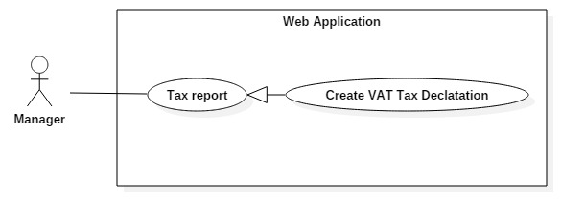

Figure 58: <Manager> Create VAT Tax Declaration

|  |  |  |  |
| --- | --- | --- | --- |
| USE CASE – UM15 | | | |
| Use Case No. | UM15 | **Use Case Version** | 2.0 |
| Use Case Name | Create VAT Tax Declaration | | |
| Author | GiangHHT | | |
| Date | 27/09/2015 | **Priority** | Normal |
| Actor:   * Manager   Summary:   * This use case allows manager to create VAT Tax Declaration.   Goal:   * Show in the tax by time.   Triggers:   * Click “Kê khai” button at “Báo cáo thuế” page.   Preconditions:   * User must have role “Manager”.   Post Conditions:   * Success: The VAT tax declaration is created. * Fail: Show error message.   Main Success Scenario:   |  |  |  | | --- | --- | --- | | Step | Actor Action | System Response | | 1 | Manager selects quarter, year and clicks “Kê khai” button to create VAT Tax Declaration | Show VAT Tax Declaration Form. | | 2 | Manager inputs into VAT Tax Declaration Form and click “Lưu” button.  [Alternative 1] | Show success message.  [Exception 1] |   Alternative Scenario:   |  |  |  | | --- | --- | --- | | No | Actor Action | System Response | | 1 | Manager clicks “Xuất XML” button to export XML file that can import to “HTKK 3.3.4” software | Export XML file. |   Exceptions:   |  |  |  | | --- | --- | --- | | No | Actor Action | System Response | | 1 | Database connection error | Show error message “Đã có lỗi xảy ra trong quá trình thực hiện, vui lòng thử lại sau!” |   Relationships:  Business Rules:   * The output bills in the selected time will be inserted into “Hàng hóa, dịch vụ chịu thuế suất thuế GTGT 10%” in “PL 01-1GTGT”. * The input bills in the selected time will be inserted into “1. Hàng hoá, dịch vụ dùng riêng cho SXKD chịu thuế GTGT và sử dụng cho các hoạt động cung cấp hàng hoá, dịch vụ không kê khai, nộp thuế GTGT đủ điều kiện khấu trừ thuế” in “PL 01-2GTGT”. * Other field will operate as “TT 119/2014/TT-BTC”. | | | |

Table 57: Use case UM15 - <Manager> Create VAT Tax Declaration

##### <Manager> Create Excise Tax Declaration

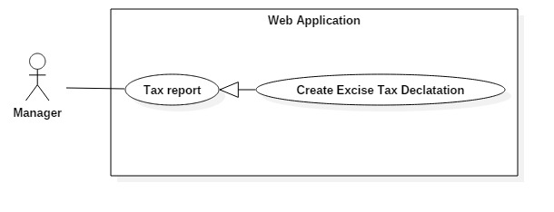

Figure 59: <Manager> Create Excise Tax Declaration

|  |  |  |  |
| --- | --- | --- | --- |
| USE CASE – UM16 | | | |
| Use Case No. | UM16 | **Use Case Version** | 2.0 |
| Use Case Name | Create Excise Tax Declaration | | |
| Author | GiangHHT | | |
| Date | 27/09/2015 | **Priority** | Normal |
| Actor:   * Manager   Summary:   * This use case allows manager to create excise tax declaration.   Goal:   * Show in the tax by time.   Triggers:   * Click “Kê khai” button at “Báo cáo thuế” page.   Preconditions:   * User must have role “Manager”.   Post Conditions:   * Success: The Excise tax declaration is created. * Fail: Show error message.   Main Success Scenario:   |  |  |  | | --- | --- | --- | | Step | Actor Action | System Response | | 1 | Manager selects year and clicks “Kê khai” button to create Excise Tax Declaration | Show Excise Tax Declaration Form. | | 2 | Manager inputs into Excise Tax Declaration Form and click “Lưu” button.  [Alternative 1] | Show success message.  [Exception 1] |   Alternative Scenario:   |  |  |  | | --- | --- | --- | | No | Actor Action | System Response | | 1 | Manager clicks “Xuất XML” button to export XML file that can import to “HTKK 3.3.4” software | Export XML file. |   Exceptions:   |  |  |  | | --- | --- | --- | | No | Actor Action | System Response | | 1 | Database connection error | Show error message “Đã có lỗi xảy ra trong quá trình thực hiện, vui lòng thử lại sau!” |   Relationships:  Business Rules:   * The field will operate as “TT 151/2014/TT-BTC”. | | | |

Table 58: Use case UM16 - <Manager> Create Excise Tax Declaration

## Software System Attribute

### Usability

#### Graphic User Interface

* All the texts, labels and notifications must be written in Vietnamese.

#### Usability

* Manager, staff should need less than 2 days of training to be productive with the system.
* The system is easy to use for customer without training.

#### Installation

* The system must be easy to deploy. The bakery can deploy successfully and learn how to configure, maintain the system within two days of training.
* If there are any problems, the bakery can contact the support for help.

### Reliability

* The system must have less than 3 days downtime per one year.

### Availability

* N/A

### Security

* Privacy: Each role of user has a specific permission to interact with system.  
  System always checks the authorization and authentication before doing anything.
* Password is encrypted and save in database.

### Maintainability

* The system is divided into separated modules.

### Portability

* The system can be deployed into many type of servers those have IIS8.
* Manager, staff, customers and guests can use application on Google Chrome version 42 or above.

### Performance

* Requests from web application are responded in less than 5 seconds at 4 Mbps bandwidth speed and 1GHz Proccessing Speed of CPU.

## Conceptual Diagram

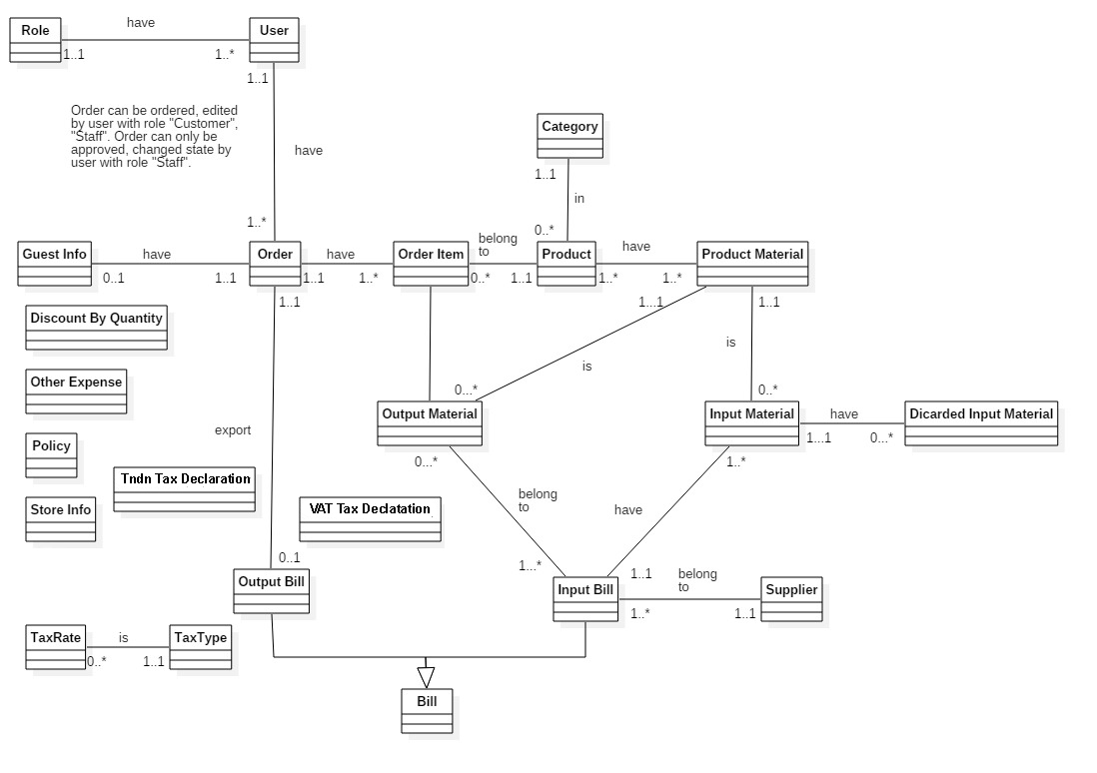

Figure 60: Conceptual Diagram

**Data Dictionary**

|  |  |
| --- | --- |
| Entity Data dictionary: describe all content of all entities | |
| Entity Name | **Description** |
| User | Abstract entity describes a user in system |
| Role | Describe role user in system |
| Order | Contain the order information. |
| Guest info | Contain guest information who have ordered the first time |
| Output bill | Contain output bill information |
| Input bill | Contain input bill information |
| Bill | Abstract entity describes a bill in system |
| Supplier | Contain supplier information. |
| Input material | Contain input material information |
| Output material | Contain total materials spend for order |
| Discard input material | Contain discard input material information |
| Order item | Contain order item information |
| Tax rate | Contain tax rate information |
| Tax type | Contain tax type information |
| Product | Contain product information |
| Category | Describe category of product |
| Product material | Contain product material information |
| Discount by quantity | Contain discount by quantity |
| Other expense | Contain other expense of store |
| Policy | Contain all of store configurations |
| Store info | Contain all of store information |
| VAT Tax declaration | Contain all of VAT tax declaration |
| Tndn Tax declaration | Contain all of Excise tax declaration |

# Software Design Description

## Design Overview

* This document describes the technical and user interface design of BMA system. It includes the architectural design, the detailed design of common functions and business functions and the design of database model.
* The architectural design describes the overall architecture of the system and the architecture of each main component and subsystem.
* The detailed design describes static and dynamic structure for each component and functions. It includes class diagrams, class explanations and sequence diagrams for each use cases.
* The database design describes the relationships between entities and details of each entity.
* Document overview:
  + Section 2: Give an overall description of the system architecture design.
  + Section 3: Give component diagrams that describe the connection and integration of the system.
  + Section 4: Give the detail design description, which includes class diagram, class explanation, and sequence diagram to details the application functions.
  + Section 5: Describe screen design
  + Section 6: Describe a fully attributed ERD.
  + Section 7: Describe algorithm.

## System Architecture Design

|  |
| --- |
| HTTP Request (1)    Database  Web browser  Object Relational Mapping  (ORM)  (5)  **Annotation**  Call / Send  Dependency  Query / Update  HTTP Response (6)  (4)  (3)  View Model  Entity Framework 6.0  ADO.NET Data Provider  Select (2)  URL Routing  View  Business  Model  Controller |

Figure 61: System architecture design

### Web Application architecture description

The system is developed from MVC architecture style and customized with passive model to adapt to MVC5 and Entity Framework 6.0 (EF6) technologies.

* **Model** is the part of the application that acts like a data transfer object between the system and database (POCO). Models is generated by mapping the database table (ORM) by EF6.
* **View** is the part of the application that handles the display of data. The views are created from the model data or view model data. The creation of View is under control of Controller.
* **Controller** is the part of the application that acts like event handler to handle the user interaction. Typically controller reads data from the request and calls appropriate Business’s method then selects view to generate.
* **Business** is the part of the application that do business processing to solve domain problems.
* **View Model** is the part of the application that acts like value object (VO). Typically view model contains model instances and is passed to view by controller.

## Component Diagram

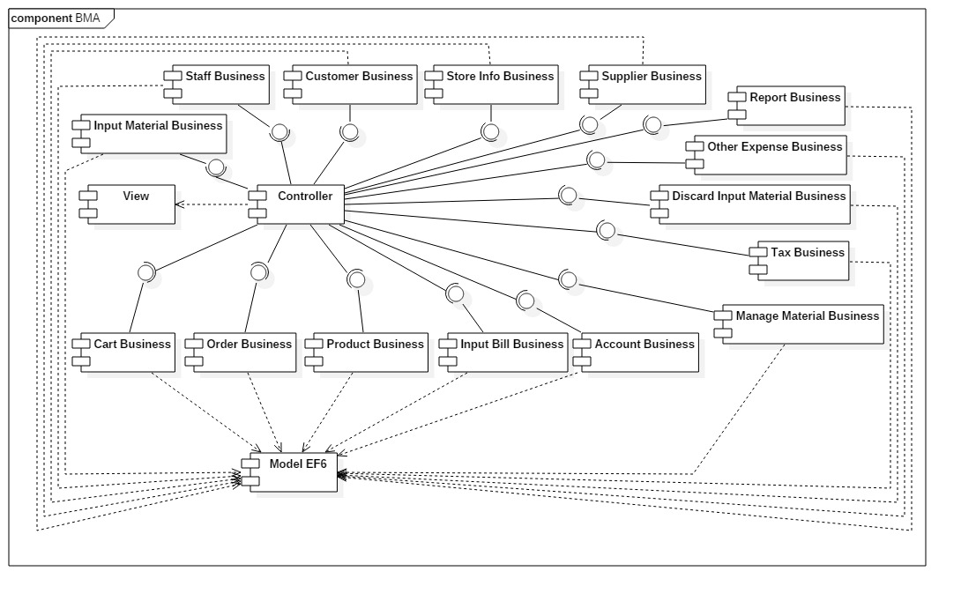

Figure 62 : Component Diagram

|  |  |
| --- | --- |
| Component Dictionary: Describes components | |
| View | Content all views of the system |
| Controller | Content all controllers of the system |
| Model EF6 | Entity Framework 6.0 mapping models |
| Cart Business | Business logic making the order for guest and customer |
| Order Business | Business logic processing the manage the order. |
| Product Business | Business logic processing of products |
| Input Bill Business | Business logic processing of input bill |
| Manage Material Business | Business logic processing of product material |
| Tax Business | Business logic processing of tax |
| Input Material Business | Business logic processing of input material |
| DiscardInputMaterialBusiness | Business logic processing of discarding input material |
| Other Expense Business | Business logic processing of other expense business |
| ReportBusiness | Business logic processing of statistic |
| Staff Business | Business logic processing of staff |
| Customer Business | Business logic processing of customer |
| Store Info Business | Business logic processing of store info |
| Supplier Business | Business logic processing of supplier |

Table 59: Component Dictionary

## Detailed Description

### Class Diagram

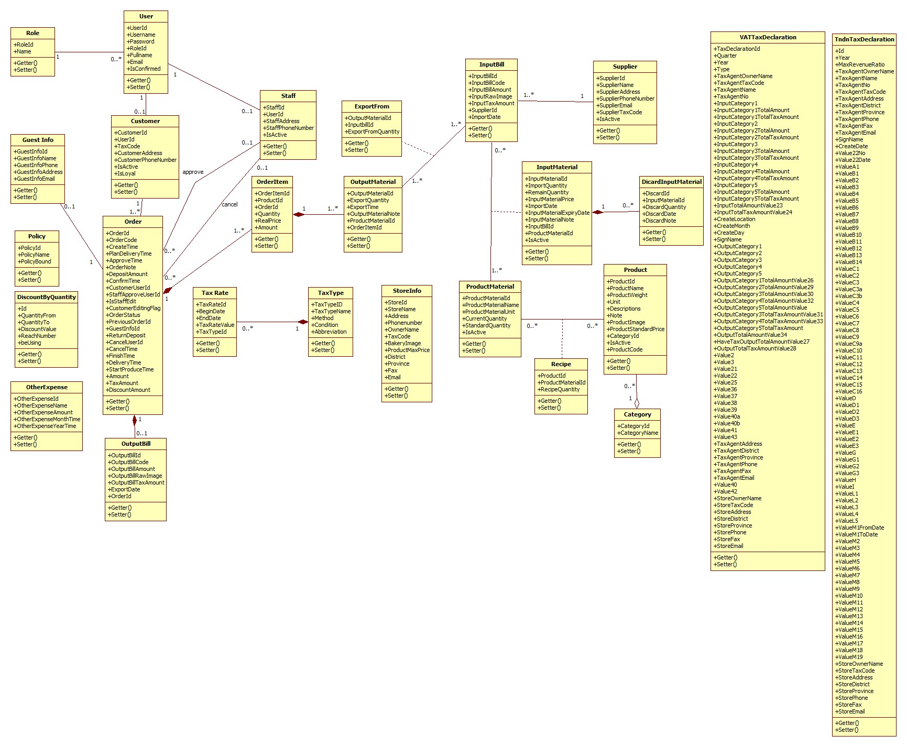

Figure 1 Class Diagram

|  |  |  |
| --- | --- | --- |
| Class dictionary: Describe Class | | |
| Class Name | **Mapping column with Conceptual diagram** | **Description** |
| Discount By Quantity | Discount By Quantity | Describe all discounts by quantity in the system |
| Other Expense | Other Expense | Describe all other expenses in the system |
| StoreInfo | StoreInfo | Describe all information of store in the system |
| Policy | Policy | Describe all policies in the system |
| Role | Role | Describe all roles in the system |
| User | User | Describe all users in the system |
| Customer | User | Describe all customers in the system |
| Staff | User | Describe all staffs in the system |
| Guest Info | Guest Info | Describe all guest information in the system |
| Orders | Orders | Describe all orders in the system |
| Output Bill | Output Bill | Describe all output bills in the system |
| Order Item | Order Item | Describe all order items of an order in the system |
| Category | Category | Describe all categories in the system |
| Product | Product | Describe all products in the system |
| Supplier | Supplier | Describe all suppliers in the system |
| Input Bill | Input Bill | Describe all input bills in the system |
| Discarded Input Material | Discarded Input Material | Describe all discard information of an input material in the system |
| Input Material | Input Material | Describe all input materials in the system |
| Export From | N/A | Describe all relationship information between output material and input bill |
| Product Material | Product Material | Describe all product materials in the system |
| Output Material | Output Material | Describe all output materials of an order item in the system |
| Recipe | N/A | Describe all of materials of each product in the system |
| Tax Rate | Tax Rate | Describe all tax rates in the system |
| Tax Type | Tax Type | Describe all tax types in the system |
| VAT Tax Declaration | VAT Tax Declaration | Describe all information in VAT tax declaration |
| Tndn Tax Declaration | Tndn Tax Declaration | Describe all information in Excise tax declaration |

Table 60 Class dictionary

### Class Diagram Explanation

#### Discount by Quantity

|  |  |  |  |
| --- | --- | --- | --- |
| Attribute | Description | Type | Visibility |
| Id (PK) | Unique identifier of discount by quantity | interger | Private |
| QuantityFrom | Min quantity to get discount | interger | Private |
| QuantityTo | Max quantity to get discount | interger | Private |
| DiscountValue | Discount value | interger | Private |
| beUsing | Identifier for discount or not | interger | Private |

#### Other Expense

|  |  |  |  |
| --- | --- | --- | --- |
| Attribute | Description | Type | Visibility |
| OtherExpenseId (PK) | Unique identifier of other expense | interger | Private |
| OtherExpenseName | Other expense name | string | Private |
| OtherExpenseAmount | Other expense amount | interger | Private |
| OtherExpenseMonthTime | Other expense month | interger | Private |
| OtherExpenseYearTime | Other expense year | interger | Private |
| Type | Type of other expense | interger | Private |

#### StoreInfo

|  |  |  |  |
| --- | --- | --- | --- |
| Attribute | Description | Type | Visibility |
| StoreId (PK) | Unique identifier of store information | interger | Private |
| StoreName | Name of the store | string | Private |
| Address | Store address (include No, Street name) | string | Private |
| Phonenumber | Store phone number | string | Private |
| OwnerName | Store owner name | string | Private |
| TaxCode | Store tax code | string | Private |
| BakeryImage | Link of bakery’s logo | string | Private |
| District | Store address’s district | string | Private |
| Province | Store address’s province | string | Private |
| Fax | Store fax number | string | Private |
| Email | Store email | string | Private |

#### Policy

|  |  |  |  |
| --- | --- | --- | --- |
| Attribute | Description | Type | Visibility |
| PolicyId (PK) | Unique identifier of policy | interger | Private |
| PolicyName | Name of policy | string | Private |
| PolicyBound |  | interger | Private |

#### Role

|  |  |  |  |
| --- | --- | --- | --- |
| Attribute | Description | Type | Visibility |
| RoleId (PK) | Unique identifier of role | interger | Private |
| Name | Role name | string | Private |

#### User

|  |  |  |  |
| --- | --- | --- | --- |
| Attribute | Description | Type | Visibility |
| UserId (PK) | Unique identifier of user | interger | Private |
| Username | User name in the system | string | Private |
| Password | User’s password | string | Private |
| RoleId (FK) | Foreign key, role identifier | interger | Private |
| Fullname | User’s fullname | string | Private |
| Email | User’s email | string | Private |
| IsConfirmed | Check the account is used or not | bool | Private |
| UserId (PK) | Unique identifier of user | interger | Private |

#### Customer

|  |  |  |  |
| --- | --- | --- | --- |
| Attribute | Description | Type | Visibility |
| CustomerId (PK) | Unique identifier of customer | interger | Private |
| UserId (FK) | Foreign key, user identifier | interger | Private |
| TaxCode | Customer’s tax code | string | Private |
| CustomerAddress | Customer’s address | string | Private |
| CustomerPhoneNumber | Customer’s phone number | string | Private |
| IsActive | Customer’s staus | bool | Private |
| IsLoyal | Identifier for loyal customer | bool | Private |

#### Staff

|  |  |  |  |
| --- | --- | --- | --- |
| Attribute | Description | Type | Visibility |
| StaffId (PK) | Unique identifier of staff | interger | Private |
| UserId (FK) | Foreign key, user identifier | interger | Private |
| StaffAddress | Staff’s address | string | Private |
| StaffPhoneNumber | Staff’s phone number | string | Private |
| IsActive | Staff’s status | bool | Private |

#### Guest Info

|  |  |  |  |
| --- | --- | --- | --- |
| Attribute | Description | Type | Visibility |
| GuestInfoId (PK) | Unique identifier for guest information | interger | Private |
| GuestInfoName | Guest’s name | string | Private |
| GuestInfoPhone | Guest’s phone | string | Private |
| GuestInfoAddress | Guest’s address | string | Private |
| GuestInfoEmail | Guest’s email | string | Private |

#### Orders

|  |  |  |  |
| --- | --- | --- | --- |
| Attribute | Description | Type | Visibility |
| OrderId (PK) | Unique identifier for order | interger | Private |
| OrderCode | Order code | string | Private |
| CreateTime | Order create time | datetime | Private |
| PlanDeliveryTime | Order plan delivery time | datetime | Private |
| ApproveTime | Order approve time | datetime | Private |
| OrderNote | Order note | string | Private |
| DepositAmount | Deposit amount | interger | Private |
| ConfirmTime | Order confirm time | datetime | Private |
| CustomerUserId (FK) | Foreign key, customer user identifier | interger | Private |
| StaffApproveUserId (FK) | Foreign key, approved staff user identifier | interger | Private |
| IsStaffEdit | Check order staff edit or not | bool | Private |
| CustomerEditingFlag | Check order customer edit or not | bool | Private |
| OrderStatus | Order status | interger | Private |
| PreviousOrderId (FK) | The previous version of order before staff edit | interger | Private |
| GuestInfoId (FK) | Foreign key, guest identifier | interger | Private |
| ReturnDeposit | Return deposit when order is canceled | interger | Private |
| CancelUserId (FK) | Foreign key, canceled customer user identifier | interger | Private |
| CancelTime | Order’s cancel time | datetime | Private |
| FinishTime | Order’s finish time | datetime | Private |
| DeliveryTime | Order’s delivery time | datetime | Private |
| StartProduceTime | Order’s start producing time | datetime | Private |
| Amount | Order’s total amount | interger | Private |
| TaxAmount | Order’s total tax amount | interger | Private |
| DiscountAmount | Order’s discount amount | interger | Private |

#### Output Bill

|  |  |  |  |
| --- | --- | --- | --- |
| Attribute | Description | Type | Visibility |
| OutputBillId (PK) | Unique identifier for output bill | interger | Private |
| OutputBillCode | Output bill code | string | Private |
| OutputBillAmount | Output bill amount | float | Private |
| OutputBillRawImage | Output bill raw image | string | Private |
| OutputBillTaxAmount | Output bill tax amount | float | Private |
| ExportDate | Export date | date | Private |
| OrderId (FK) | Foreign key, Order identifier | interger | Private |

#### Order Item

|  |  |  |  |
| --- | --- | --- | --- |
| Attribute | Description | Type | Visibility |
| OrderItemId (PK) | Unique identifier for order item | interger | Private |
| ProductId (FK) | Foreign key, product identifier | interger | Private |
| OrderId (FK) | Foreign key, order identifier | interger | Private |
| Quantity | Order item’s quantity | interger | Private |
| RealPrice | Order item’s real price | interger | Private |
| Amount | Order item’s total amount | interger | Private |

#### Category

|  |  |  |  |
| --- | --- | --- | --- |
| Attribute | Description | Type | Visibility |
| CategoryId (PK) | Unique identifier for category | interger | Private |
| CategoryName | Category name | string | Private |

#### Product

|  |  |  |  |
| --- | --- | --- | --- |
| Attribute | Description | Type | Visibility |
| ProductId (PK) | Unique identifier for product | interger | Private |
| ProductName | Product’s name | string | Private |
| ProductWeight | Product’s weight | float | Private |
| Unit | Product’s unit | string | Private |
| Descriptions | Product’s description | string | Private |
| Note | Product’s note | string | Private |
| ProductImage | Product’s image | string | Private |
| ProductStandardPrice | Product’s standard price | interger | Private |
| CategoryId (FK) | Foreign key, category identifier | interger | Private |
| IsActive | Product’s status | bool | Private |
| ProductCode | Product’s code | string | Private |

#### Supplier

|  |  |  |  |
| --- | --- | --- | --- |
| Attribute | Description | Type | Visibility |
| SupplierId (PK) | Unique identifier for supplier | interger | Private |
| SupplierName | Supplier’s name | string | Private |
| SupplierAddress | Supplier’s address | string | Private |
| SupplierPhoneNumber | Supplier’s phone number | string | Private |
| SupplierEmail | Supplier’s email | string | Private |
| SupplierTaxCode | Supplier’s tax code | string | Private |
| IsActive | Supplier’s status | bool | Private |

#### Input Bill

|  |  |  |  |
| --- | --- | --- | --- |
| Attribute | Description | Type | Visibility |
| InputBillId (PK) | Unique identifier for input bill | interger | Private |
| InputBillCode | Input bill’s code | string | Private |
| InputBillAmount | Input bill’s amount | float | Private |
| InputRawImage | Input bill’s raw image | string | Private |
| InputTaxAmount | Input bill’s tax amount | float | Private |
| SupplierId (FK) | Foreign key, supplier identifier | interger | Private |
| ImportDate | Import date | date | Private |

#### Discarded Input Material

|  |  |  |  |
| --- | --- | --- | --- |
| Attribute | Description | Type | Visibility |
| DiscardId (PK) | Unique identifier for discard input material | interger | Private |
| InputMaterialId (FK) | Foreign key, input material identifier | interger | Private |
| DiscardQuantity | Discard quantity | interger | Private |
| DiscardDate | Discard Date | date | Private |
| DiscardNote | Discard’s Note | string | Private |

#### Input Material

|  |  |  |  |
| --- | --- | --- | --- |
| Attribute | Description | Type | Visibility |
| InputMaterialId (PK) | Unique identifier for input material | interger | Private |
| ImportQuantity | Import quantity | interger | Private |
| RemainQuantity | Remain quantity | interger | Private |
| InputMaterialPrice | Input material price per unit | float | Private |
| ImportDate | Import Date | date | Private |
| InputMaterialExpiryDate | Expiry Date | date | Private |
| InputMaterialNote | Input material’s nore | string | Private |
| InputBillId (FK) | Foreign key, input bill identifier | interger | Private |
| ProductMaterialId (FK) | Foreign key, product material identifier | interger | Private |

#### Export From

|  |  |  |  |
| --- | --- | --- | --- |
| Attribute | Description | Type | Visibility |
| OutputMaterialId (PK,FK) | One member of composite primary keyForeign key, output material identifier | interger | Private |
| InputbillId (PK,FK) | One member of composite primary keyForeign key, input bill identifier | interger | Private |
| ExportFromQuantity | Export quantity | interger | Private |

#### Product Material

|  |  |  |  |
| --- | --- | --- | --- |
| Attribute | Description | Type | Visibility |
| ProductMaterialId (PK) | Unique identifier for product material | interger | Private |
| ProductMaterialName | Product material’s name | string | Private |
| ProductMaterialUnit | Product material’s unit | string | Private |
| CurrentQuantity | Current quantity | interger | Private |
| StandardQuantity | Standard quantity | interger | Private |
| IsActive | Product material’s status | interger | Private |

#### Output Material

|  |  |  |  |
| --- | --- | --- | --- |
| Attribute | Description | Type | Visibility |
| OutputMaterialId (PK) | Unique identifier for output material | interger | Private |
| ExportQuantity | Export quantity | interger | Private |
| ExportTime | Export time | datetime | Private |
| OutputMaterialNote | Output material’s note | string | Private |
| ProductMaterialId (FK) | Foreign key, product material identifier | interger | Private |
| OrderItemId (FK) | Foreign key, order item identifier | interger | Private |

#### Recipe

|  |  |  |  |
| --- | --- | --- | --- |
| Attribute | Description | Type | Visibility |
| ProductId (PK,FK) | One member of composite primary keyForeign key, product identifier | interger | Private |
| ProductMaterialId (PK,FK) | One member of composite primary keyForeign key, product material identifier | interger | Private |
| RecipeQuantity | Quantity | float | Private |

#### Tax Rate

|  |  |  |  |
| --- | --- | --- | --- |
| Attribute | Description | Type | Visibility |
| TaxRateId (PK) | Unique identifier for tax rate | interger | Private |
| BeginDate | Valid begin date | date | Private |
| EndDate | Valid end date | date | Private |
| TaxRateValue | Tax rate value | interger | Private |
| TaxTypeId (FK) | Foreign key, tax type identifier | interger | Private |

#### Tax Type

|  |  |  |  |
| --- | --- | --- | --- |
| Attribute | Description | Type | Visibility |
| TaxTypeID (PK) | Unique identifier for tax type | interger | Private |
| TaxTypeName | Tax type’s name | string | Private |
| Abbreviation | Short name of tax type | string | Private |

#### VAT Tax Declaration

|  |  |  |  |
| --- | --- | --- | --- |
| Attribute | Description | Type | Visibility |
| TaxDeclarationId | Unique identifier for VAT Tax Declaration | interger | Private |
| Quarter | VAT Tax Declaration’s quarter | interger | Private |
| Year | VAT Tax Declaration’s year | interger | Private |
| Type | VAT Tax Declaration’s type | interger | Private |
| TaxAgentOwnerName | Tax agent owner name | string | Private |
| TaxAgentTaxCode | Tax agent tax code | string | Private |
| TaxAgentName | Tax agent name | string | Private |
| TaxAgentNo | Tax agent certificate number | string | Private |
| InputCategory1 | Category 1 in appendix 1 tax declaration | string | Private |
| InputCategory1TotalAmount | Category 1 in appendix 1 tax declaration total amount | interger | Private |
| InputCategory1TotalTaxAmount | Category 1 in appendix 1 tax declaration total tax amount | interger | Private |
| InputCategory2 | Category 2 in appendix 1 tax declaration | string | Private |
| InputCategory2TotalAmount | Category 2 in appendix 1 tax declaration total amount | interger | Private |
| InputCategory2TotalTaxAmount | Category 2 in appendix 1 tax declaration total tax amount | interger | Private |
| InputCategory3 | Category 3 in appendix 1 tax declaration | string | Private |
| InputCategory3TotalAmount | Category 3 in appendix 1 tax declaration total amount | interger | Private |
| InputCategory3TotalTaxAmount | Category 3 in appendix 1 tax declaration total tax amount | interger | Private |
| InputTotalAmountValue23 | Total value in appendix 1 | interger | Private |
| InputTotalTaxAmountValue24 | Total tax value in appendix 1 | interger | Private |
| CreateLocation | Create Location | string | Private |
| CreateDate | Create Date | date | Private |
| SignName | Sign name | string | Private |
| OutputCategory1 | Category 1 in appendix 2 tax declaration | string | Private |
| OutputCategory2 | Category 2 in appendix 2 tax declaration | string | Private |
| OutputCategory3 | Category 3 in appendix 2 tax declaration | string | Private |
| OutputCategory4 | Category 4 in appendix 2 tax declaration | string | Private |
| OutputCategory1TotalAmountValue26 | Category 1 in appendix 2 tax declaration Total Amount | interger | Private |
| OutputCategory2TotalAmountValue29 | Category 2 in appendix 2 tax declaration Total Amount | interger | Private |
| OutputCategory3TotalAmountValue30 | Category 3 in appendix 2 tax declaration Total Amount | interger | Private |
| OutputCategory4TotalAmountValue32 | Category 4 in appendix 2 tax declaration Total Amount | interger | Private |
| OutputCategory3TotalTaxAmountValue31 | Category 3 in appendix 2 tax declaration Total Tax Amount | interger | Private |
| OutputCategory4TotalTaxAmountValue33 | Category 4 in appendix 2 tax declaration Total Tax Amount | interger | Private |
| OutputTotalAmountValue34 | Total value in appendix 2 | interger | Private |
| HaveTaxOutputTotalAmountValue27 | Total value which have tax in appendix 2 | interger | Private |
| OutputTotalTaxAmountValue28 | Total tax value in appendix 2 | interger | Private |
| Value2 | Value 2 in VAT tax declaration | bool | Private |
| Value3 | Value3 in VAT tax declaration | interger | Private |
| Value21 | Value 21 in VAT tax declaration | bool | Private |
| Value22 | Value 22 in VAT tax declaration | interger | Private |
| Value25 | Value 25 in VAT tax declaration | interger | Private |
| Value36 | Value 36 in VAT tax declaration | interger | Private |
| Value37 | Value 37 in VAT tax declaration | interger | Private |
| Value38 | Value 38 in VAT tax declaration | interger | Private |
| Value39 | Value 39 in VAT tax declaration | interger | Private |
| Value40a | Value 40a in VAT tax declaration | interger | Private |
| Value40b | Value 40b in VAT tax declaration | interger | Private |
| Value41 | Value 41 in VAT tax declaration | interger | Private |
| Value43 | Value 43 in VAT tax declaration | interger | Private |
| TaxAgentAddress | Tax agent address | string | Private |
| TaxAgentDistrict | Tax agent district | string | Private |
| TaxAgentProvince | Tax Agent Province | string | Private |
| TaxAgentPhone | Tax Agent Phone | string | Private |
| TaxAgentFax | Tax Agent Fax | string | Private |
| TaxAgentEmail | Tax Agent Email | string | Private |
| Value40 | Value 40 in VAT tax declaration | interger | Private |
| Value42 | Value 42 in VAT tax declaration | interger | Private |
| StoreOwnerName | Store owner name | string | Private |
| StoreTaxCode | Store tax code | string | Private |
| StoreAddress | Store address | string | Private |
| StoreDistrict | Store district | string | Private |
| StoreProvince | Store province | string | Private |
| StorePhone | Store phone | string | Private |
| StoreFax | Store fax | string | Private |
| StoreEmail | Store email | string | Private |

#### Tndn Tax Declaration

|  |  |  |  |
| --- | --- | --- | --- |
| Attribute | Description | Type | Visibility |
| Id | Unique identifier for Excise tax declaration | interger | Private |
| Year | Excise tax declaration’s year | interger | Private |
| MaxRevenueRatio | Max Revenue Ratio | interger | Private |
| TaxAgentOwnerName | Tax agent owner name | string | Private |
| TaxAgentName | Tax agent name | string | Private |
| TaxAgentNo | Tax agent certificate number | string | Private |
| TaxAgentTaxCode | Tax agent tax code | string | Private |
| TaxAgentAddress | Tax agent address | string | Private |
| TaxAgentDistrict | Tax agent district | string | Private |
| TaxAgentProvince | Tax Agent Province | string | Private |
| TaxAgentPhone | Tax Agent Phone | string | Private |
| TaxAgentFax | Tax Agent Fax | string | Private |
| TaxAgentEmail | Tax Agent Email | string | Private |
| SignName | Sign name | string | Private |
| CreateDate | Create Date | date | Private |
| Value22No | Value 22 No | interger | Private |
| Value22Date | Value 22 Date | date | Private |
| ValueA1 | Value A1 in tax declaration | interger | Private |
| ValueB1 | Value B1 in tax declaration | interger | Private |
| ValueB2 | Value B2 in tax declaration | interger | Private |
| ValueB3 | Value B3 in tax declaration | interger | Private |
| ValueB4 | Value B4 in tax declaration | interger | Private |
| ValueB5 | Value B5 in tax declaration | interger | Private |
| ValueB6 | Value B6 in tax declaration | interger | Private |
| ValueB7 | Value B7 in tax declaration | interger | Private |
| ValueB8 | Value B8 in tax declaration | interger | Private |
| ValueB9 | Value B9 in tax declaration | interger | Private |
| ValueB10 | Value B10 in tax declaration | interger | Private |
| ValueB11 | Value B11 in tax declaration | interger | Private |
| ValueB12 | Value B12 in tax declaration | interger | Private |
| ValueB13 | Value B13 in tax declaration | interger | Private |
| ValueB14 | Value B14 in tax declaration | interger | Private |
| ValueC1 | Value C1 in tax declaration | interger | Private |
| ValueC2 | Value C2 in tax declaration | interger | Private |
| ValueC3 | Value C3 in tax declaration | interger | Private |
| ValueC3a | Value C3a in tax declaration | interger | Private |
| ValueC3b | Value C3b in tax declaration | interger | Private |
| ValueC4 | Value C4 in tax declaration | interger | Private |
| ValueC5 | Value C5 in tax declaration | interger | Private |
| ValueC6 | Value C6 in tax declaration | interger | Private |
| ValueC7 | Value C7 in tax declaration | interger | Private |
| ValueC8 | Value C8 in tax declaration | interger | Private |
| ValueC9 | Value C9 in tax declaration | interger | Private |
| ValueC9a | Value C9a in tax declaration | interger | Private |
| ValueC10 | Value C10 in tax declaration | interger | Private |
| ValueC11 | Value C11 in tax declaration | interger | Private |
| ValueC12 | Value C12 in tax declaration | interger | Private |
| ValueC13 | Value C13 in tax declaration | interger | Private |
| ValueC14 | Value C14 in tax declaration | interger | Private |
| ValueC15 | Value C15 in tax declaration | interger | Private |
| ValueC16 | Value C16 in tax declaration | interger | Private |
| ValueD | Value D in tax declaration | interger | Private |
| ValueD1 | Value D1 in tax declaration | interger | Private |
| ValueD2 | Value D2 in tax declaration | interger | Private |
| ValueD3 | Value D3 in tax declaration | interger | Private |
| ValueE | Value E in tax declaration | interger | Private |
| ValueE1 | Value E1 in tax declaration | interger | Private |
| ValueE2 | Value E2 in tax declaration | interger | Private |
| ValueE3 | Value E3 in tax declaration | interger | Private |
| ValueG | Value G in tax declaration | interger | Private |
| ValueG1 | Value G1 in tax declaration | interger | Private |
| ValueG2 | Value G2 in tax declaration | interger | Private |
| ValueG3 | Value G3 in tax declaration | interger | Private |
| ValueH | Value H in tax declaration | interger | Private |
| ValueI | Value I in tax declaration | interger | Private |
| ValueL1 | Value L1 in tax declaration | interger | Private |
| ValueL2 | Value L2 in tax declaration | interger | Private |
| ValueL3 | Value L3 in tax declaration | interger | Private |
| ValueL4 | Value L4 in tax declaration | interger | Private |
| ValueL5 | Value L5 in tax declaration | interger | Private |
| ValueM1FromDate | Value M1 From Date in tax declaration | date | Private |
| ValueM1ToDate | Value M1 To Date in tax declaration | date | Private |
| Value M2 | Value M2 in tax declaration | interger | Private |
| Value1 | Value1 in appendix | interger | Private |
| Value2 | Value 2 in appendix | interger | Private |
| Value3 | Value 3 in appendix | interger | Private |
| Value4 | Value 4 in appendix | interger | Private |
| Value5 | Value 5 in appendix | interger | Private |
| Value6 | Value 6 in appendix | interger | Private |
| Value7 | Value 7 in appendix | interger | Private |
| Value8 | Value 8 in appendix | interger | Private |
| Value9 | Value 9 in appendix | interger | Private |
| Value10 | Value 10 in appendix | interger | Private |
| Value11 | Value 11 in appendix | interger | Private |
| Value12 | Value 12 in appendix | interger | Private |
| Value13 | Value 13 in appendix | interger | Private |
| Value14 | Value 14 in appendix | interger | Private |
| Value15 | Value 15 in appendix | interger | Private |
| Value16 | Value 16 in appendix | interger | Private |
| Value17 | Value 17 in appendix | interger | Private |
| Value18 | Value 18 in appendix | interger | Private |
| Value19 | Value 19 in appendix | interger | Private |
| StoreOwnerName | Store owner name | string | Private |
| StoreTaxCode | Store tax code | string | Private |
| StoreAddress | Store address | string | Private |
| StoreDistrict | Store district | string | Private |
| StoreProvince | Store province | string | Private |
| StorePhone | Store phone | string | Private |
| StoreFax | Store fax | string | Private |
| StoreEmail | Store email | string | Private |

### Interactive Diagram

#### Web Application

##### Guest

###### Make order

**Summary**: This diagram shows the process of guest making new order

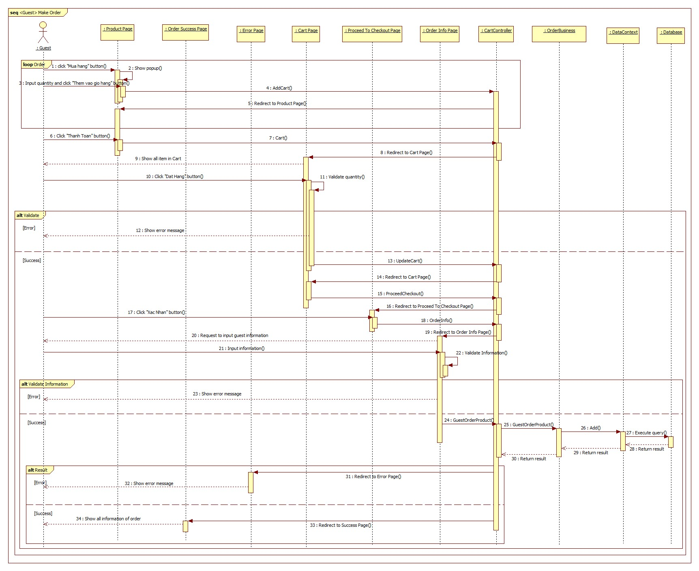

Figure 63 : Sequence diagram - <Guest> Make order

##### Authenticated User

###### Change password

**Summary**: This diagram shows process of change password

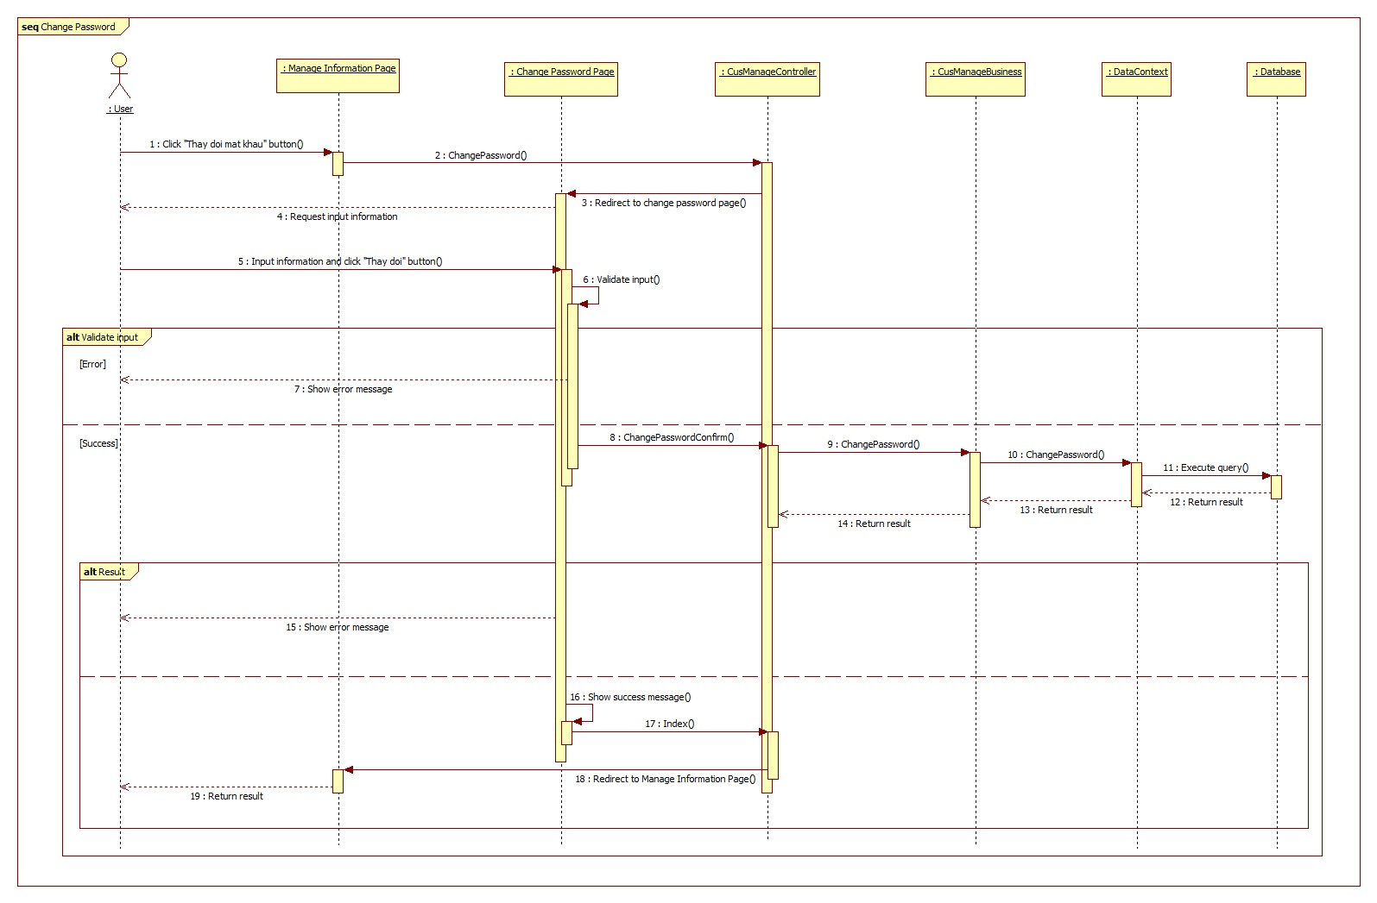

Figure 64 : Sequence diagram - <Authenticated User> Change password

###### Change personal information

**Summary**: This diagram shows process of change personal information

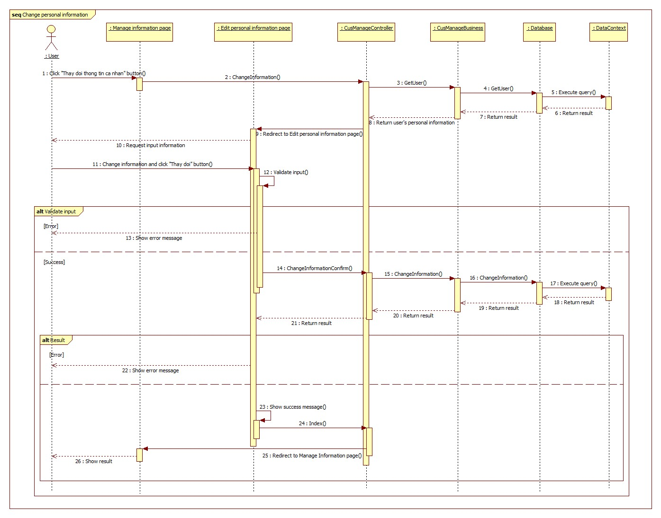

Figure 65 : Sequence diagram - <Authenticated User> Change personal information

###### Reset password

**Summary**: This diagram shows process of reset password

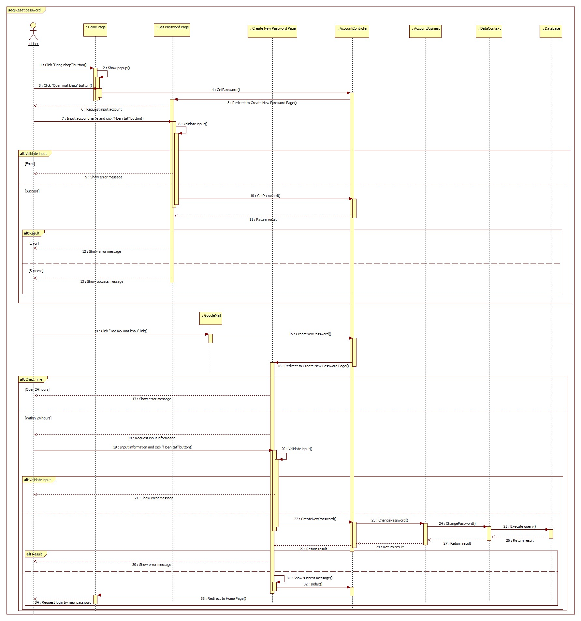

Figure 66 : Sequence diagram - <Authenticated User> Reset password

###### Search product

**Summary**: This diagram shows process of search product

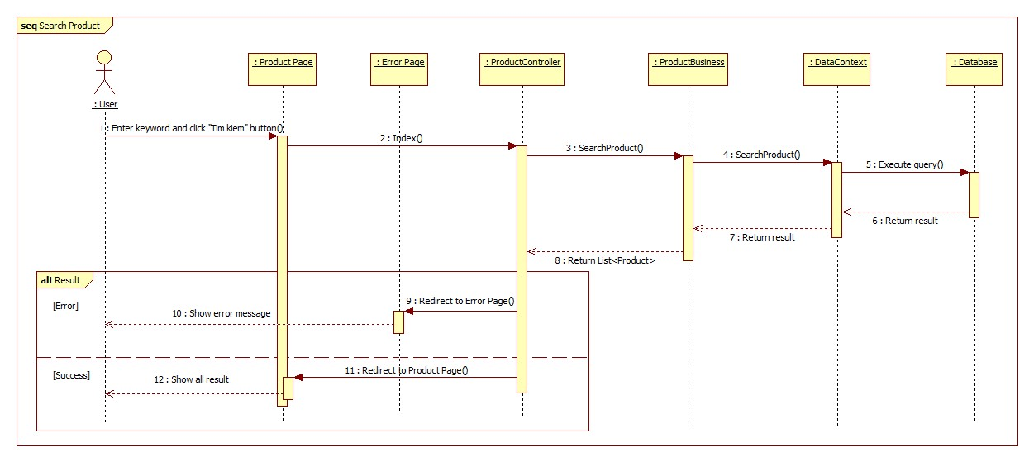

Figure 67 : Sequence diagram - <Authenticated User> Search product

###### View product detail

**Summary**: This diagram shows process of view product detail

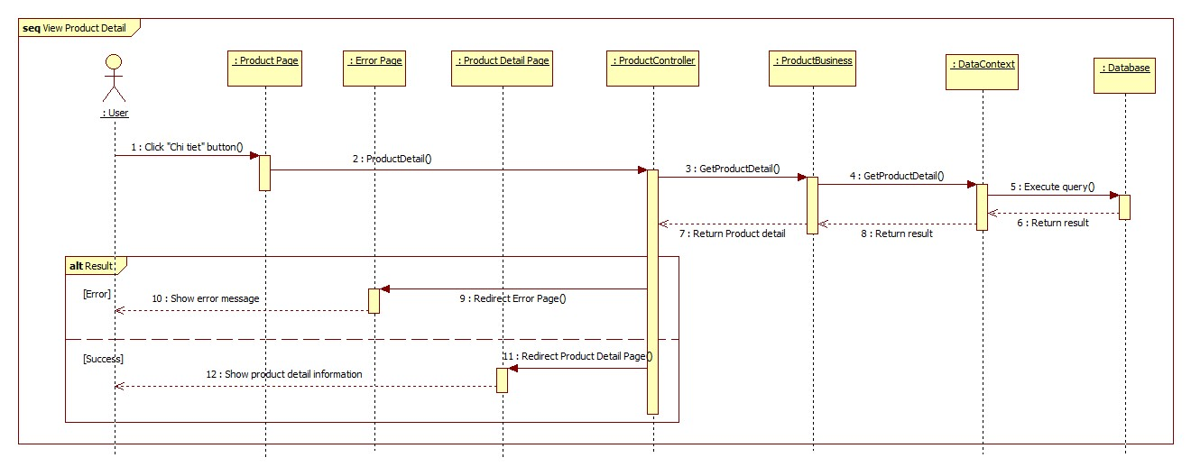

Figure 68 : Sequence diagram - <Authenticated User> View product detail

##### System

###### Get notification

**Summary**: This diagram shows process of get notification

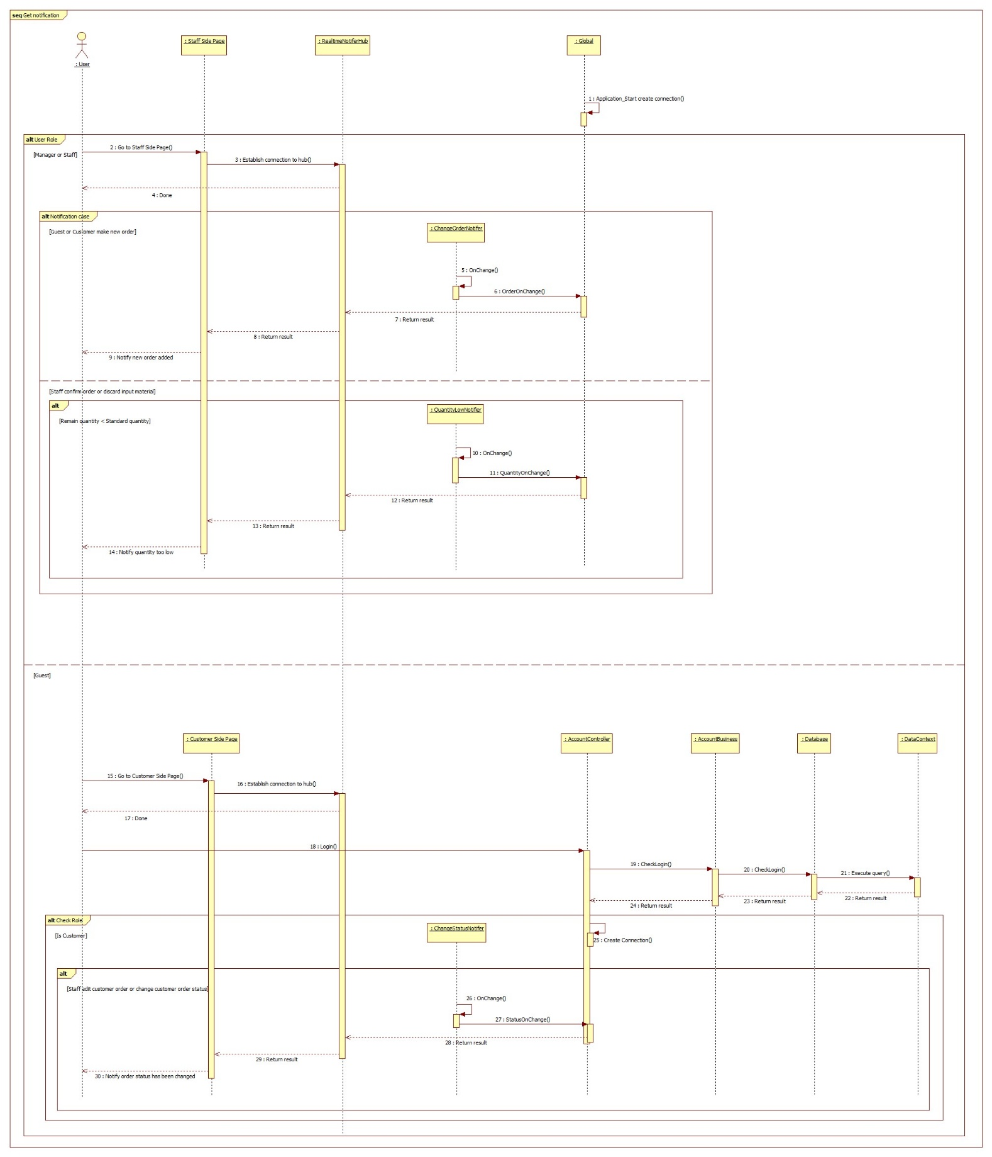

Figure 69 : Sequence diagram - <System> Get notification

##### Customer

###### Make order

**Summary**: This diagram shows process of customer making new order

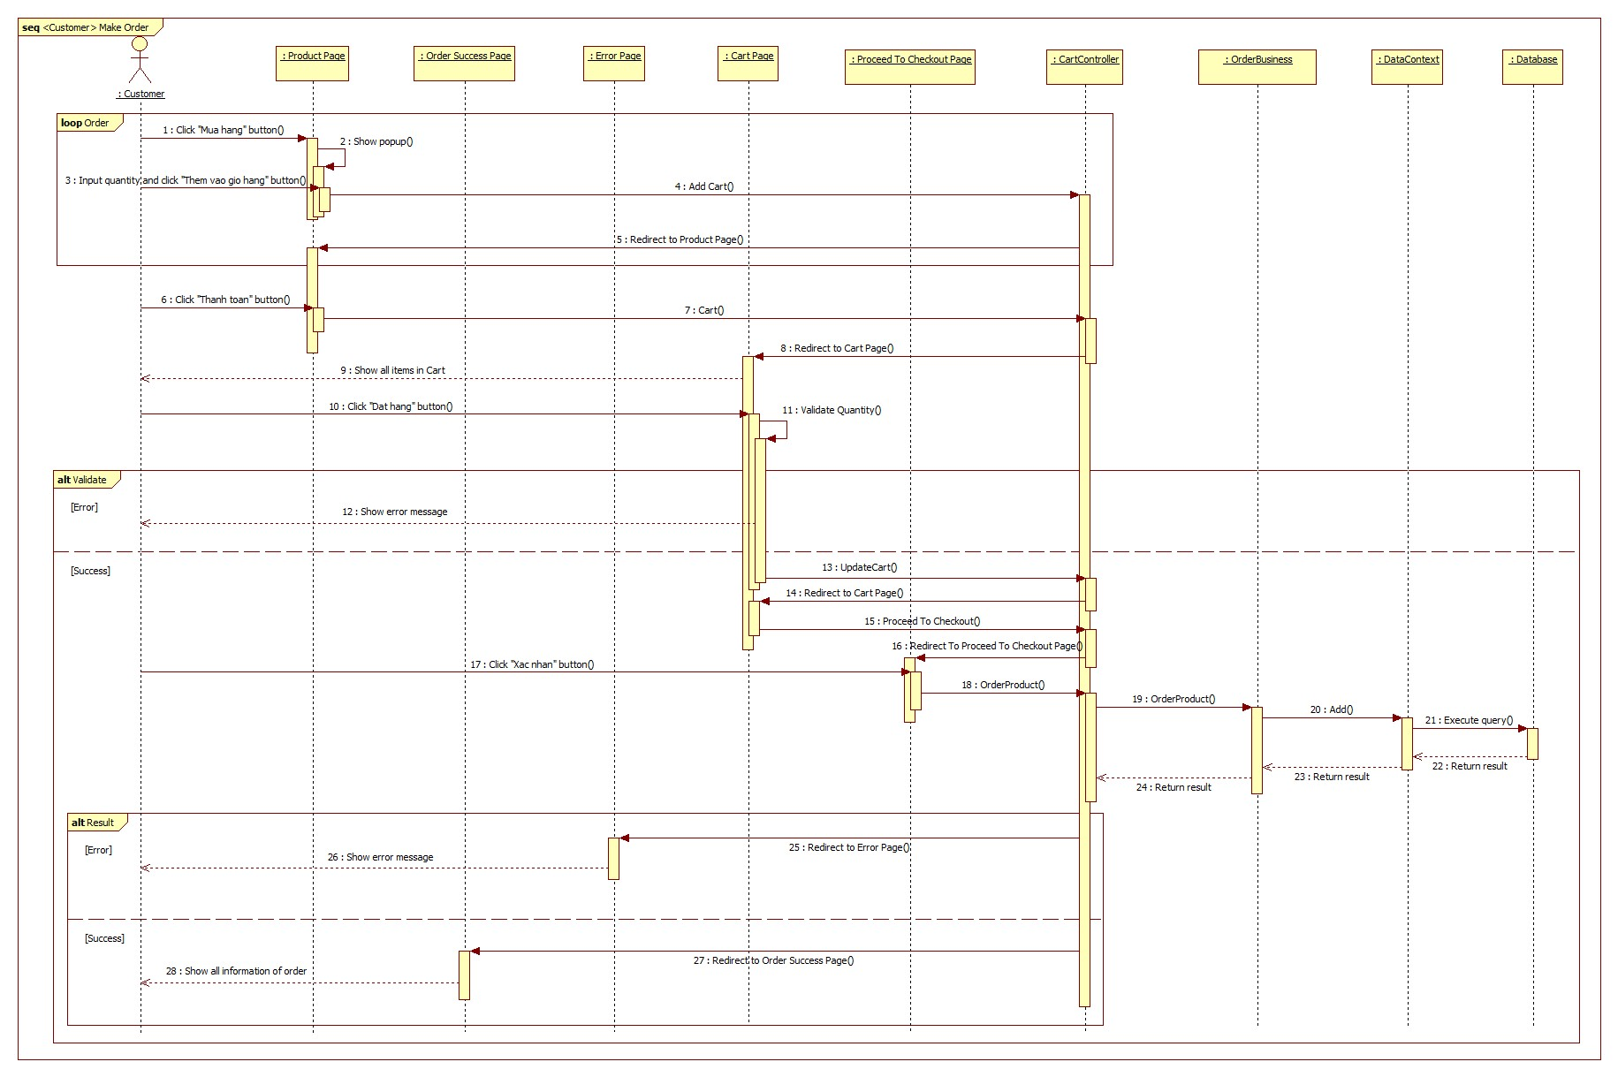

Figure 70 : Sequence diagram - <Customer> Make order

###### Confirm order

**Summary**: This diagram shows process of customer confirming the order that edited by staff

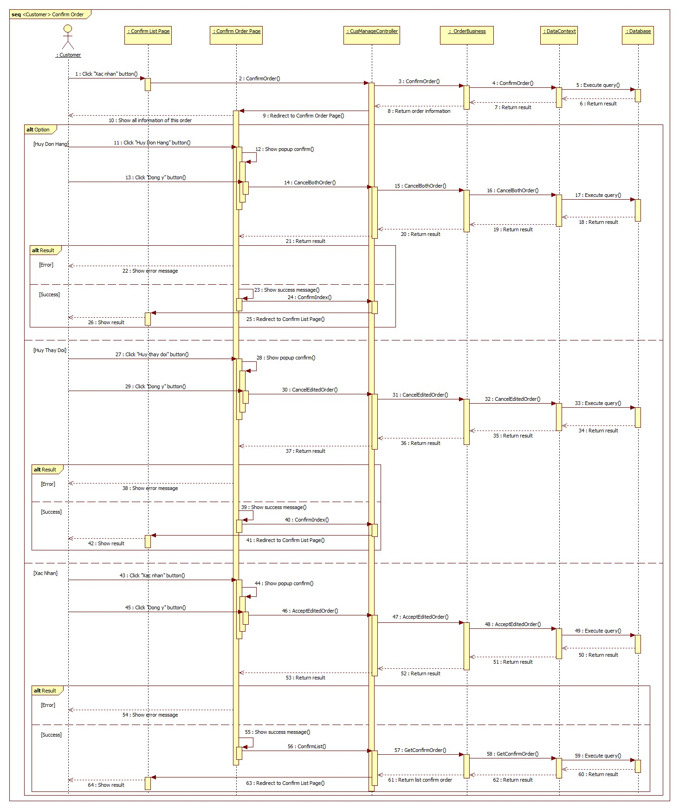

Figure 71 : Sequence diagram - <Customer> Confirm order

###### Cancel order

**Summary**: This diagram shows process of customer cancelling the order.

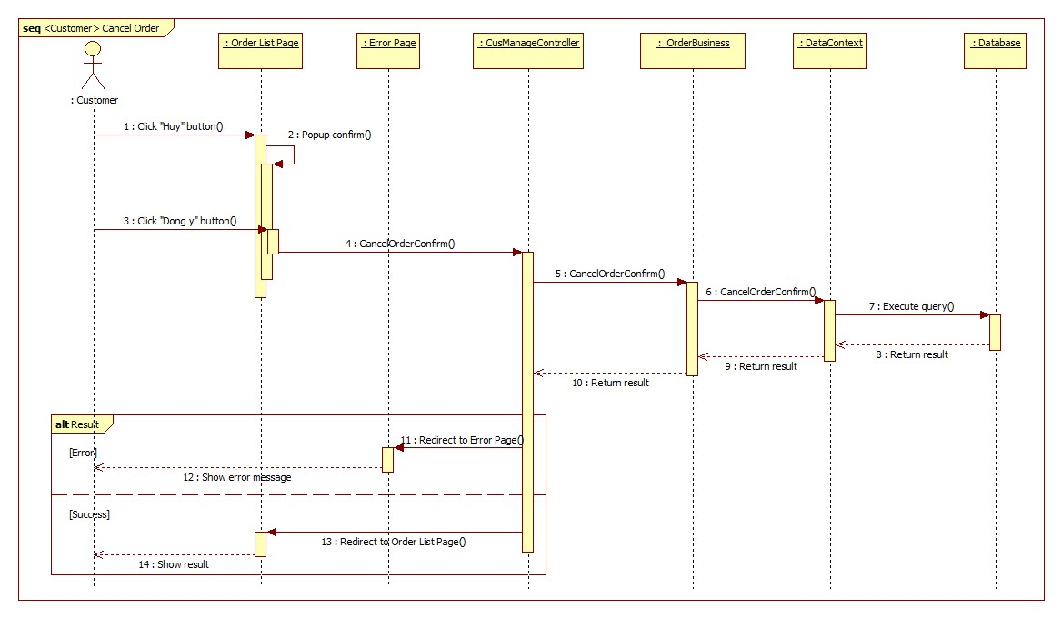

Figure 72 : Sequence diagram - <Customer> Cancel order

###### Edit order

Summary: this diagram shows process of customer editing the order.

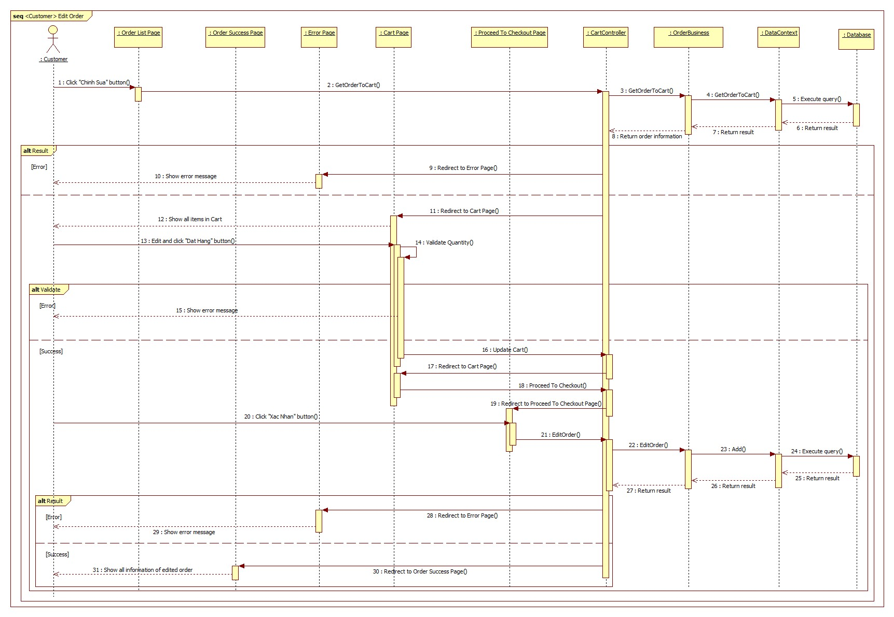

Figure 73 : Sequence diagram - <Customer> Edit order

##### Staff

###### Approve order

**Summary**: This diagram shows process of staff approving the order

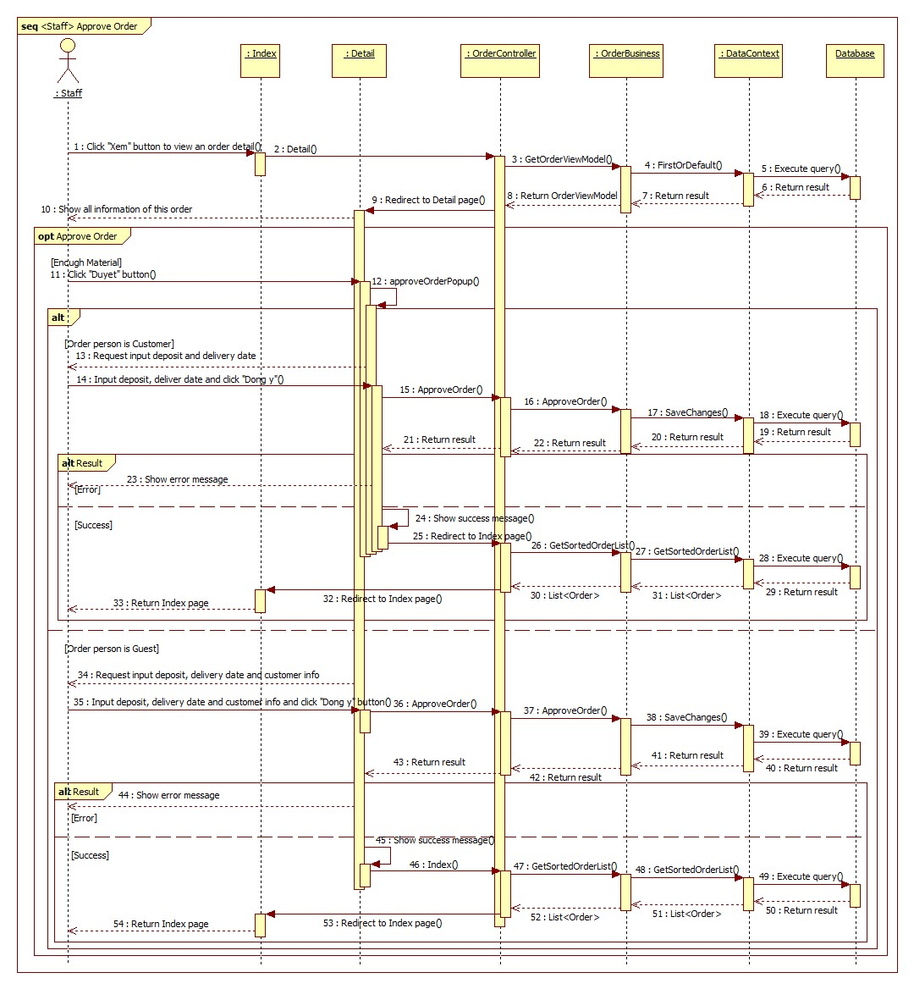

Figure 74 : Sequence diagram - <Staff> Approve order

###### Add order

**Summary**: This diagram shows process of staff adding new order.

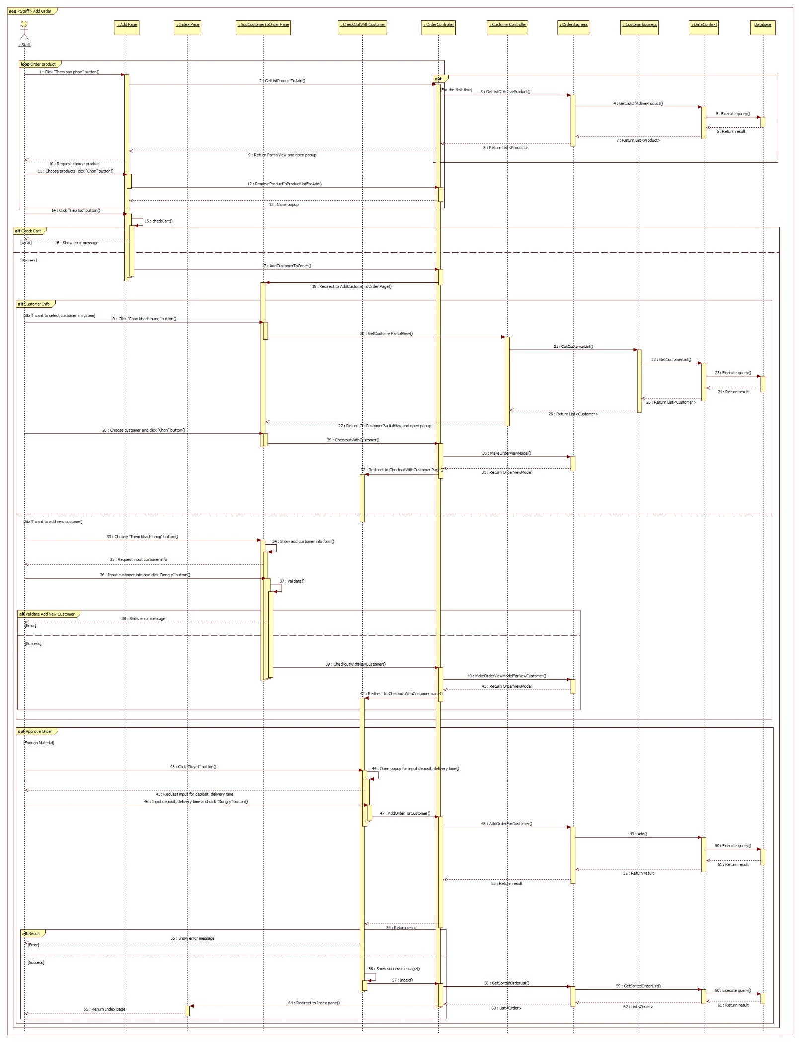

Figure 75 : Sequence diagram - <Staff> Add order

###### Cancel order

**Summary**: This diagram shows process of staff cancel the order.

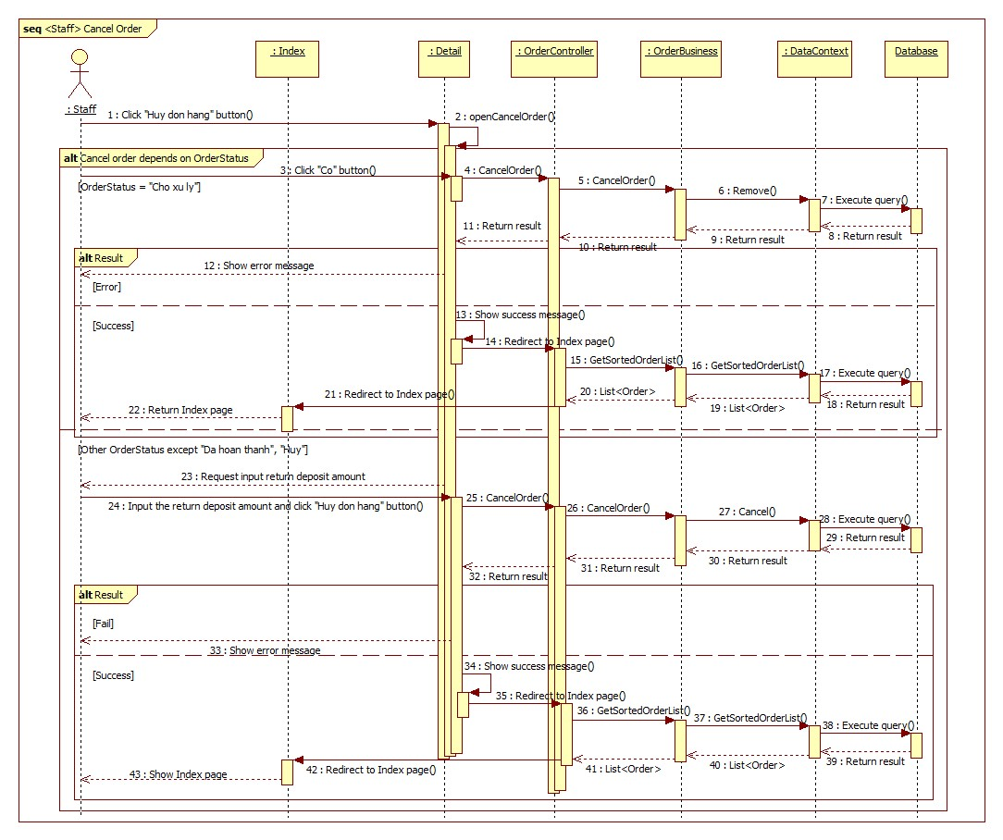

Figure 76 : Sequence diagram - <Staff> Cancel order

###### Edit order

**Summary**: This diagram shows process of staff edit the order.

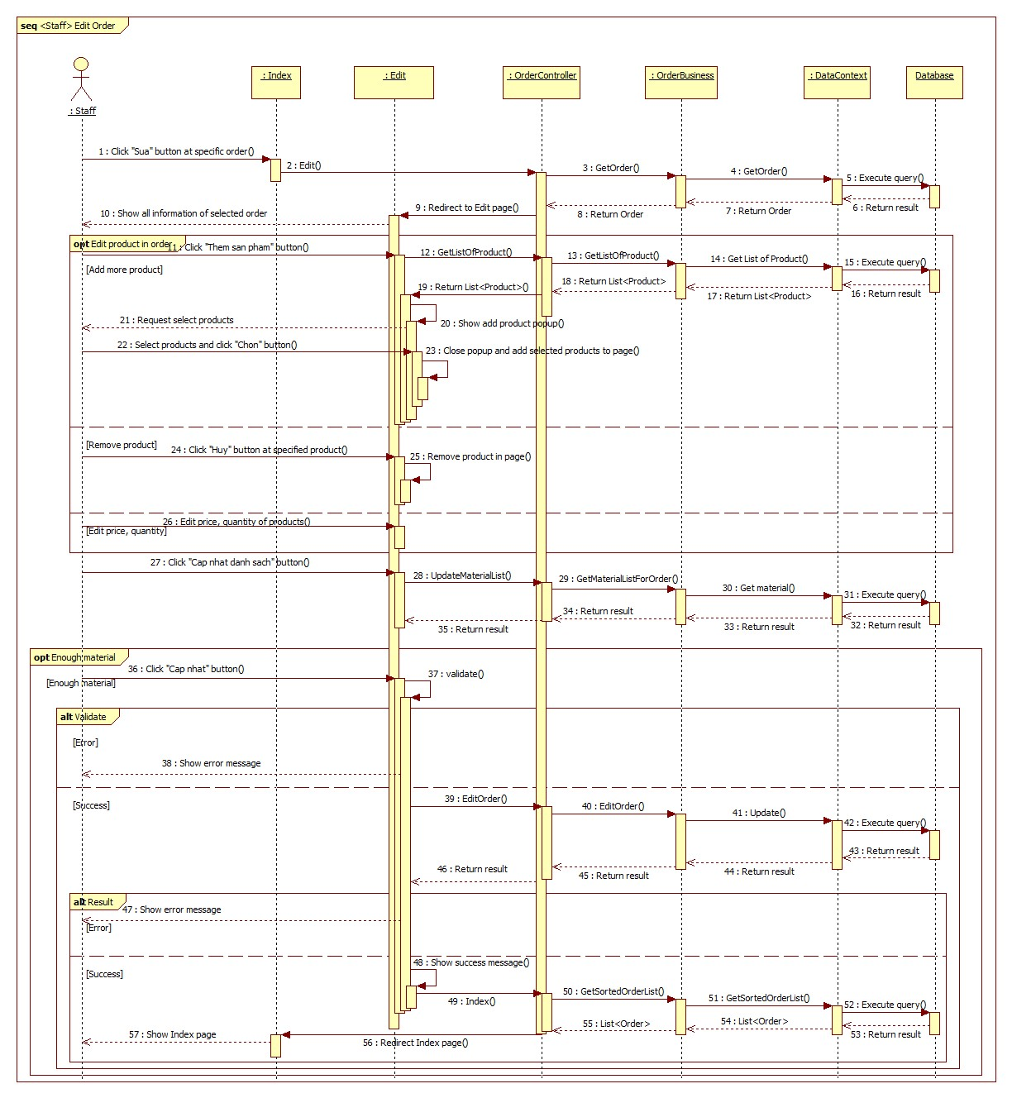

Figure 77 : Sequence diagram - <Staff> Edit order

###### Change order status

**Summary**: This diagram shows process of staff changing the order status.

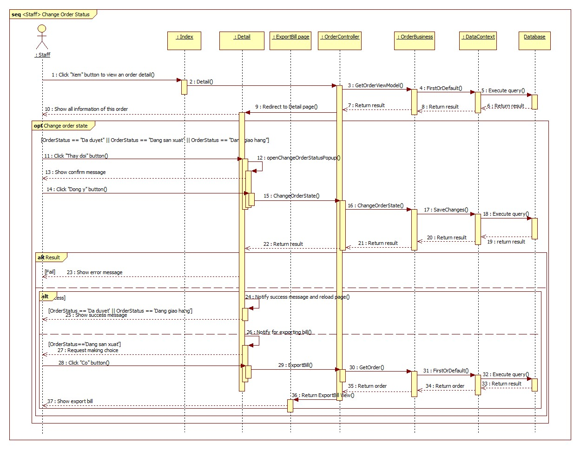

Figure 78 : Sequence diagram - <Staff> Change order status

###### Export Bill

**Summary**: This diagram shows process of staff export bill when order status is “Đang giao dịch”, “Đã hoàn thành”.

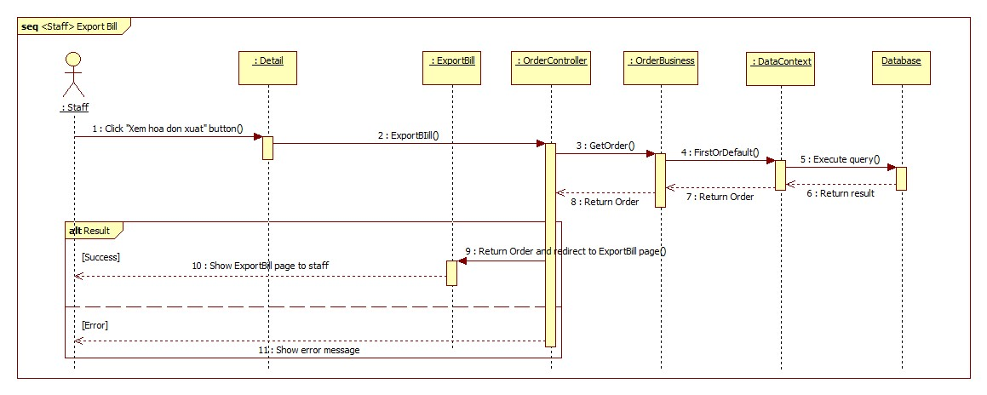

Figure 79 : Sequence diagram - <Staff> Export Bill

###### Export More Material For Order

**Summary**: This diagram shows process of staff export more material for order.

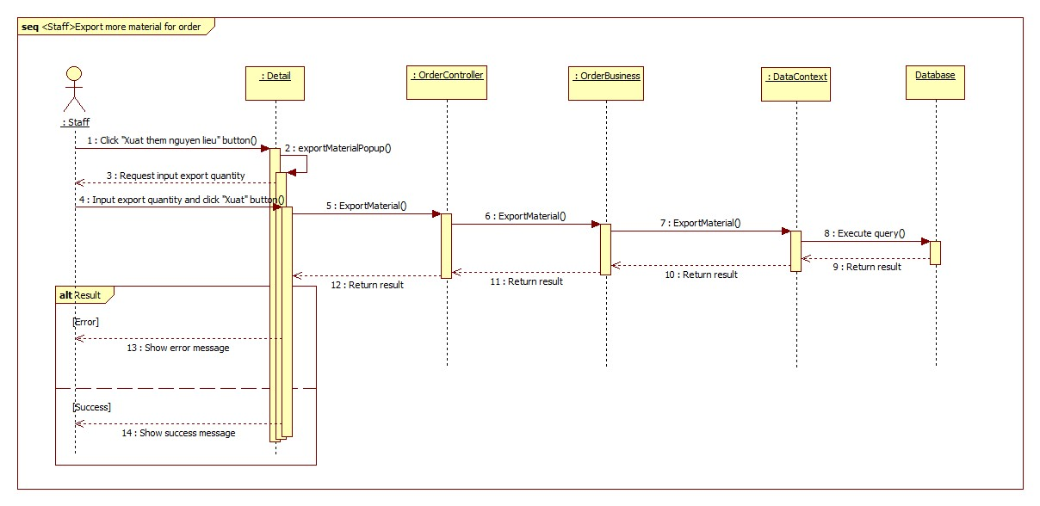

Figure 80 : Sequence diagram - <Staff> Export More Material For Order

###### Add input material

**Summary**: This diagram shows process of staff add input material.

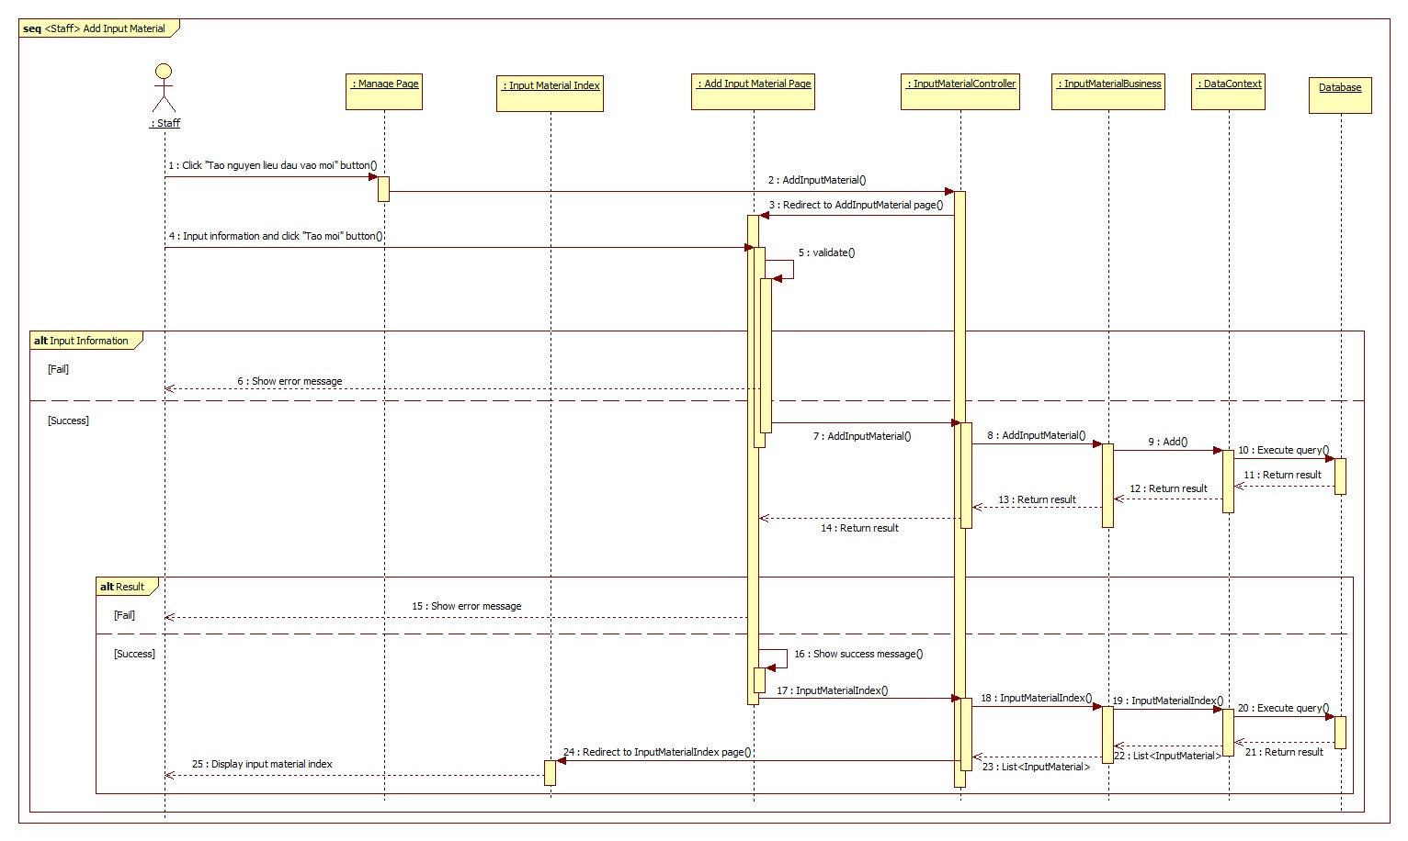

Figure 81 : Sequence diagram - <Staff> 4.3.1.3.8. Add input material

###### Edit input material

**Summary**: This diagram shows process of staff edit input material.

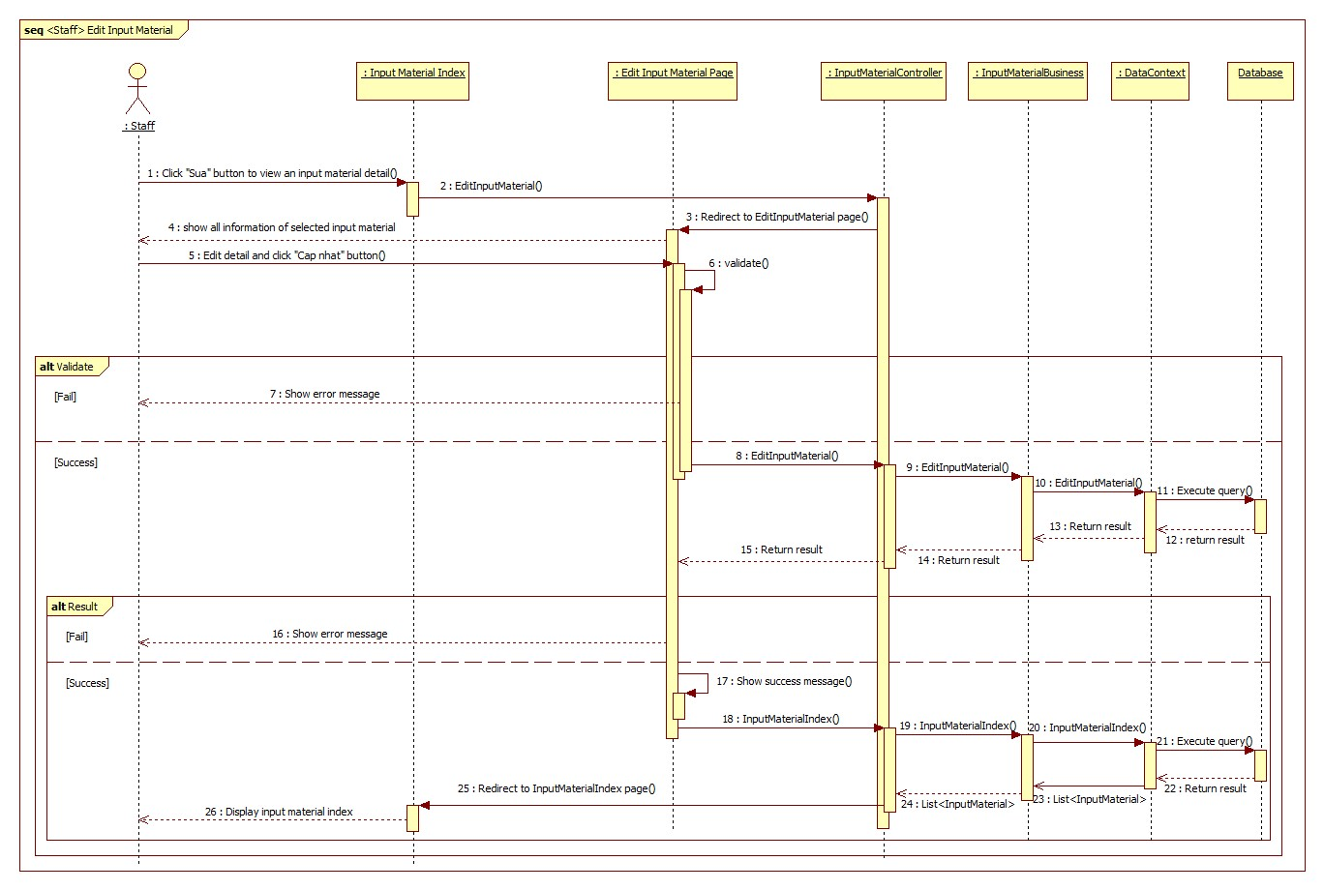

Figure 82 : Sequence diagram - <Staff> Edit input material

###### Discard input material

**Summary**: This diagram shows process of staff discard input material.

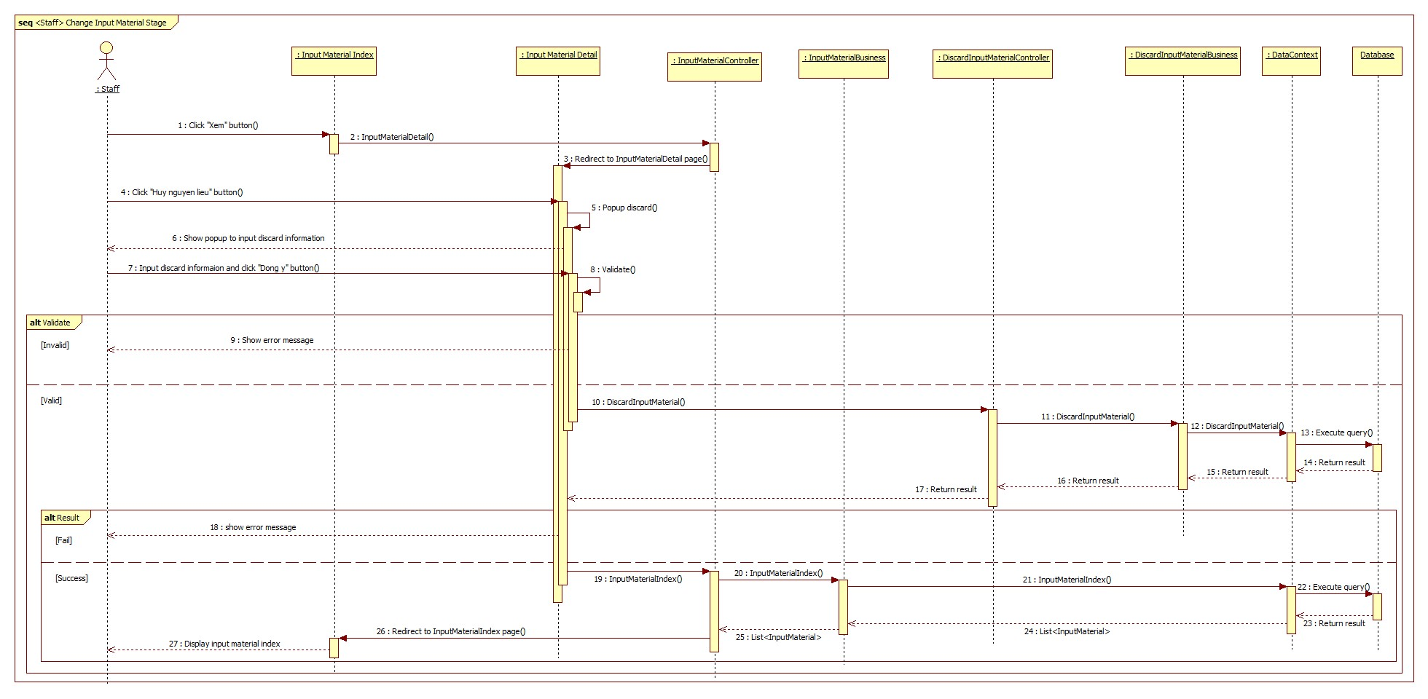

Figure 83 : Sequence diagram - <Staff> Discard input material

###### Add input bill

**Summary**: This diagram shows process of staff add input bill.

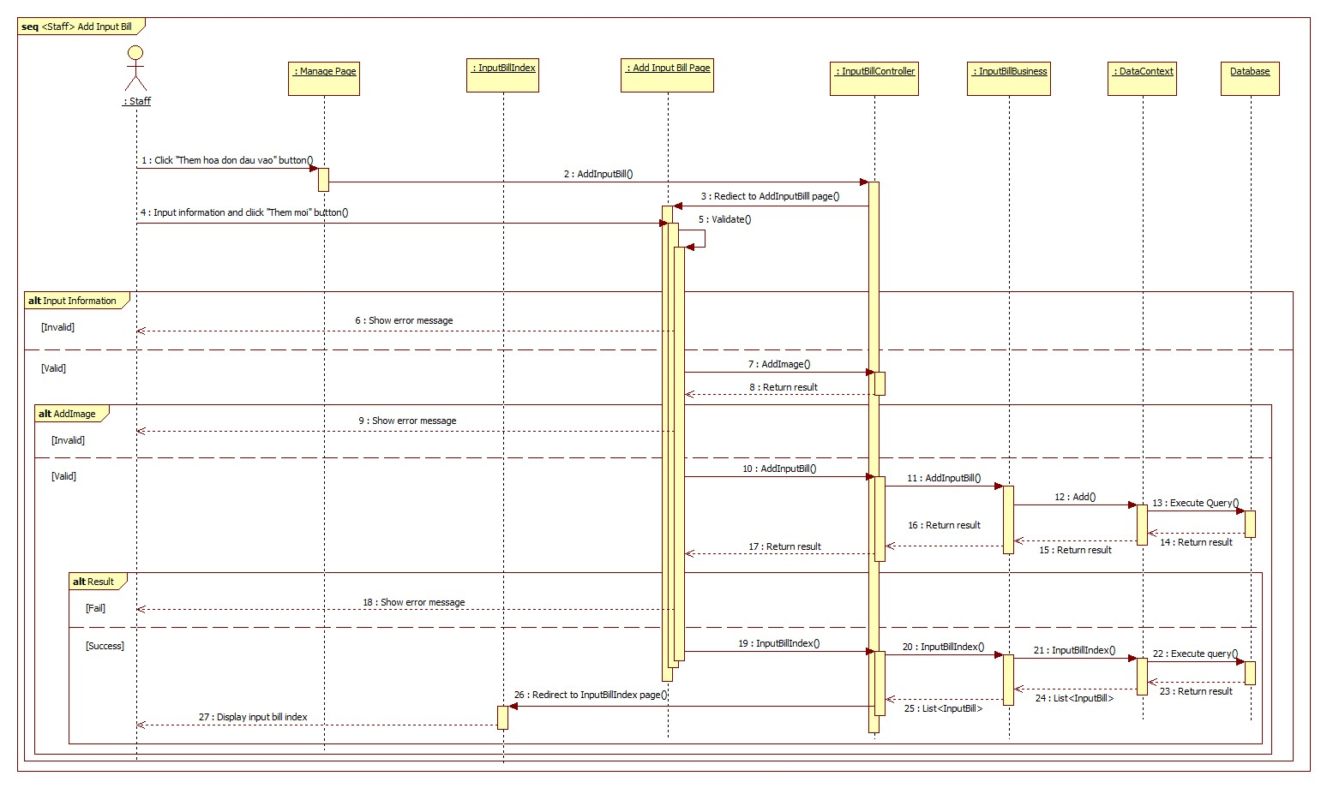

Figure 84 : Sequence diagram - <Staff> Add input bill

###### Edit input bill

**Summary**: This diagram shows process of staff edit input bill.

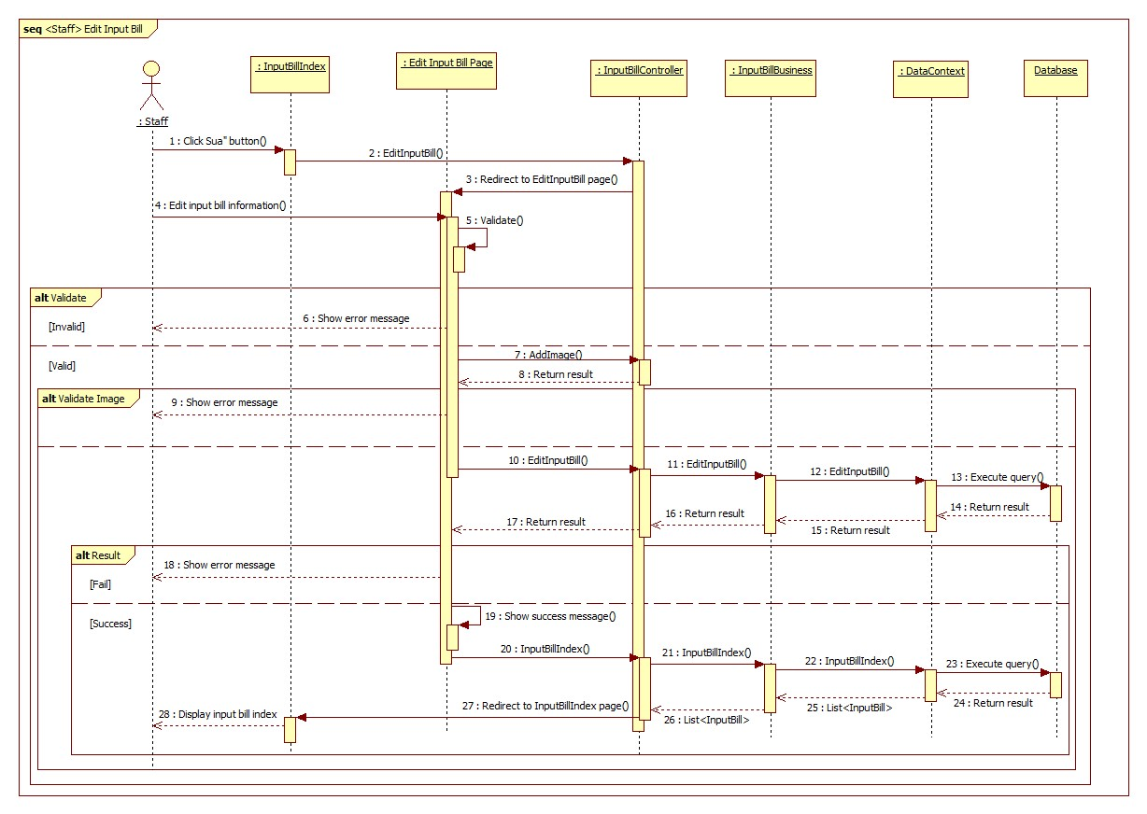

Figure 85 : Sequence diagram - <Staff> Edit input bill

###### Change material status

**Summary**: This diagram shows process of staff change material status.

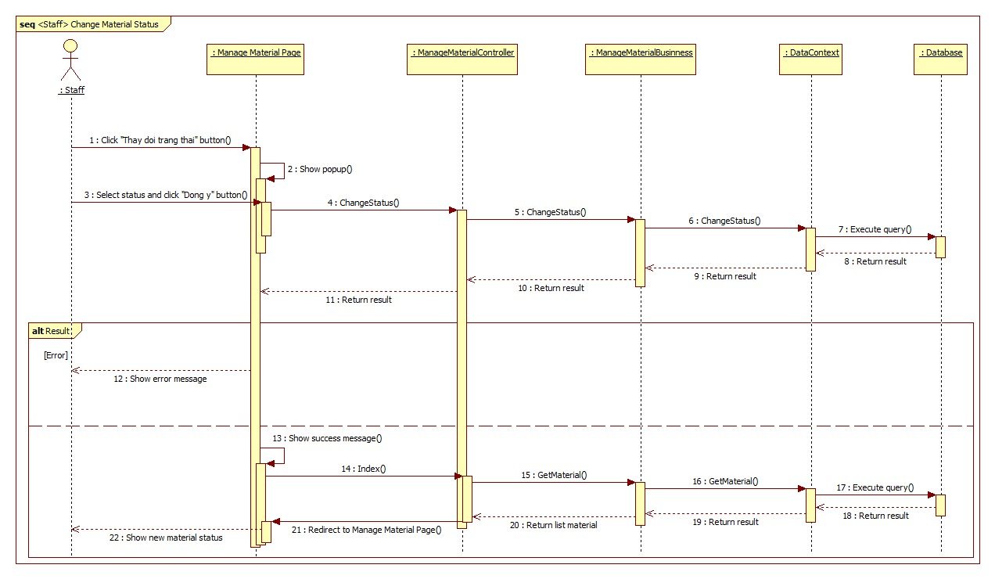

Figure 86 : Sequence diagram - <Staff> Change material status

###### Add material

**Summary**: This diagram shows process of staff add material.

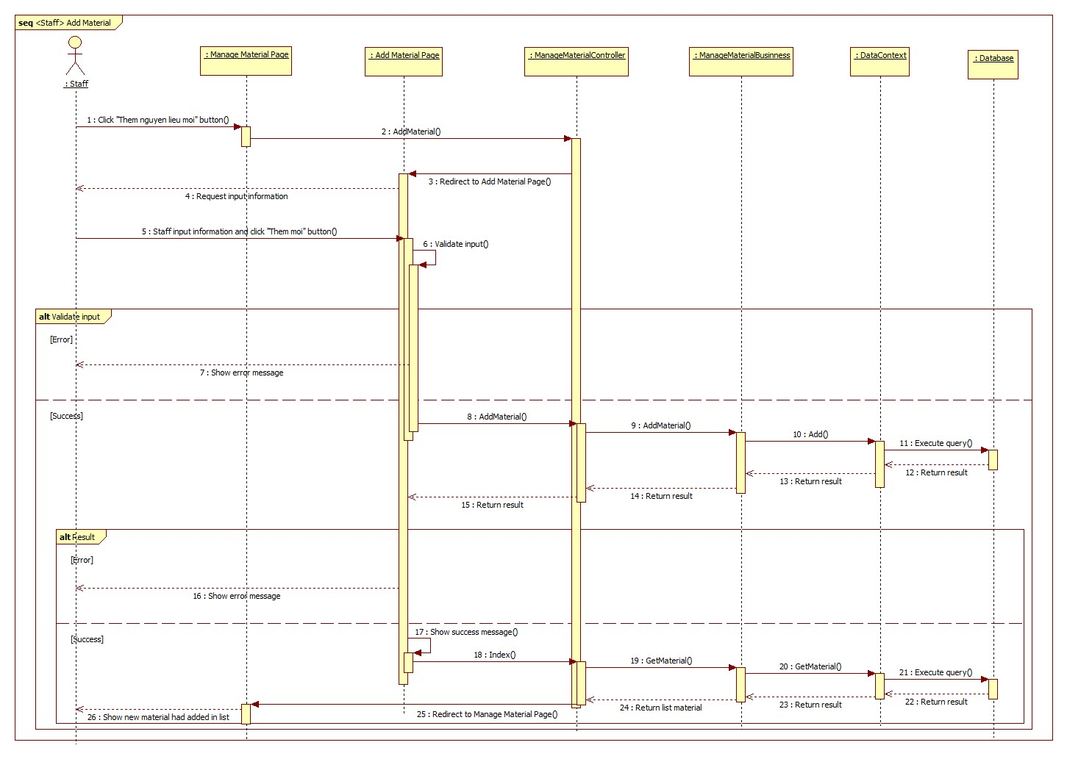

Figure 87 : Sequence diagram - <Staff> Add material

###### Edit material

**Summary**: This diagram shows process of staff edit material.

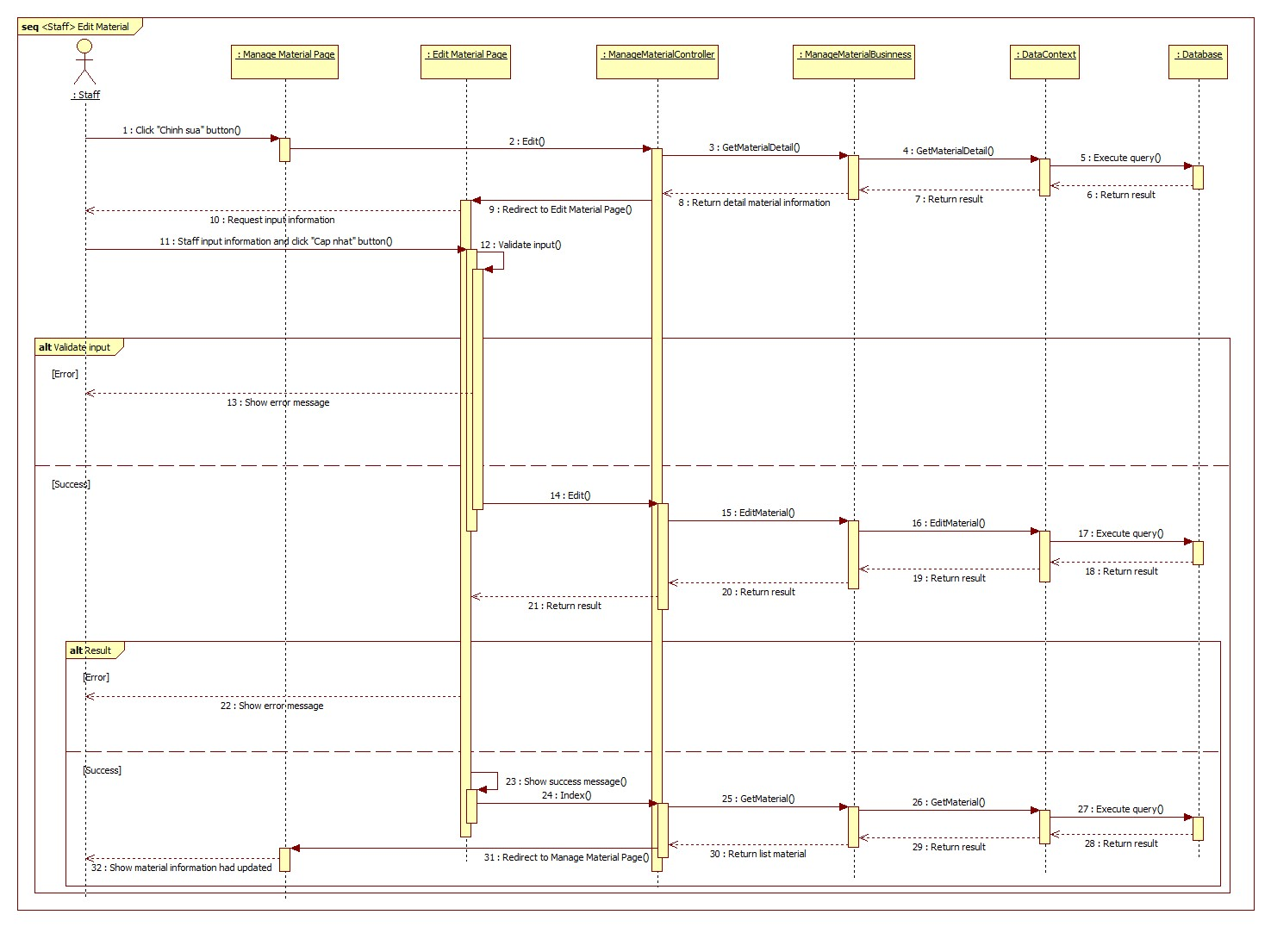

Figure 88 : Sequence diagram - <Staff> Edit material

###### Add product

**Summary**: This diagram shows process of staff add product.

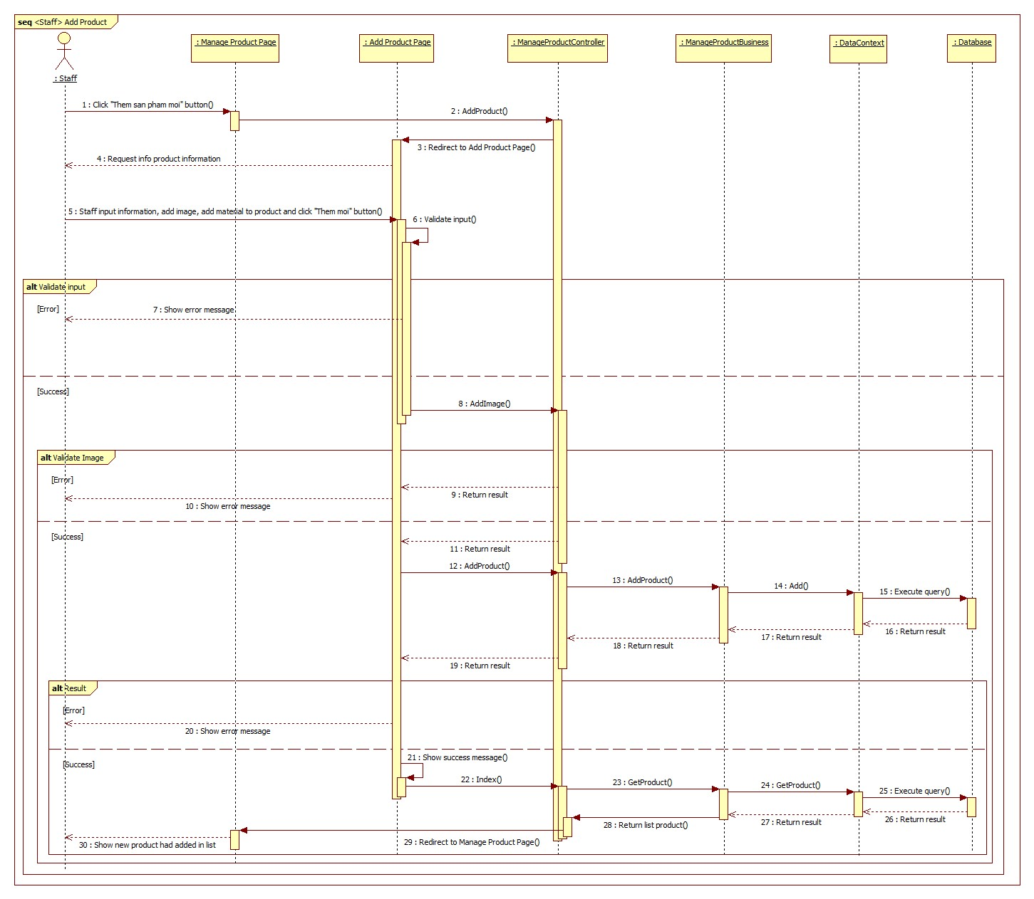

Figure 89 : Sequence diagram - <Staff> Add product

###### Edit product

**Summary**: This diagram shows process of staff edit product.

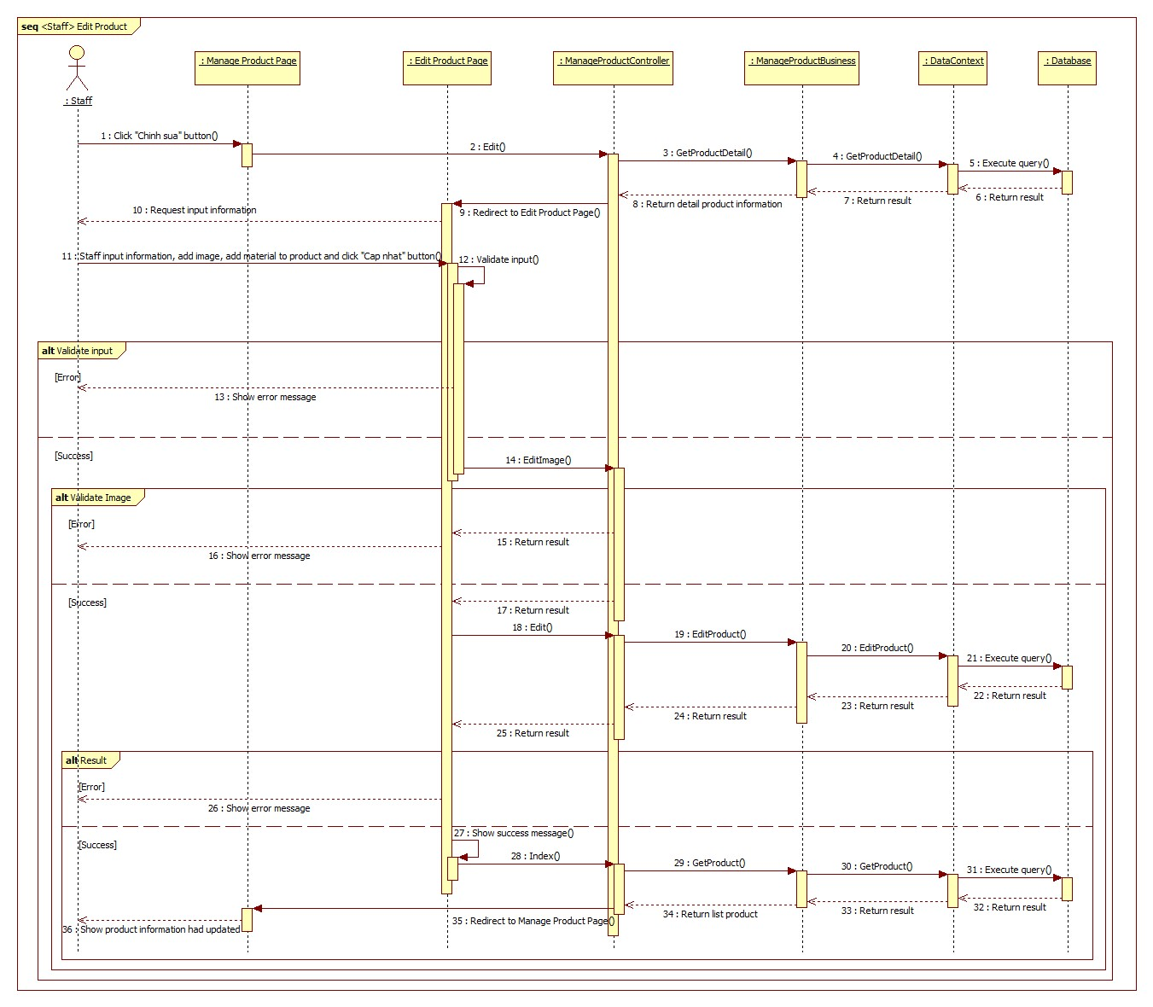

Figure 90 : Sequence diagram - <Staff> Edt product

###### Change product status

**Summary**: This diagram shows process of change product status.

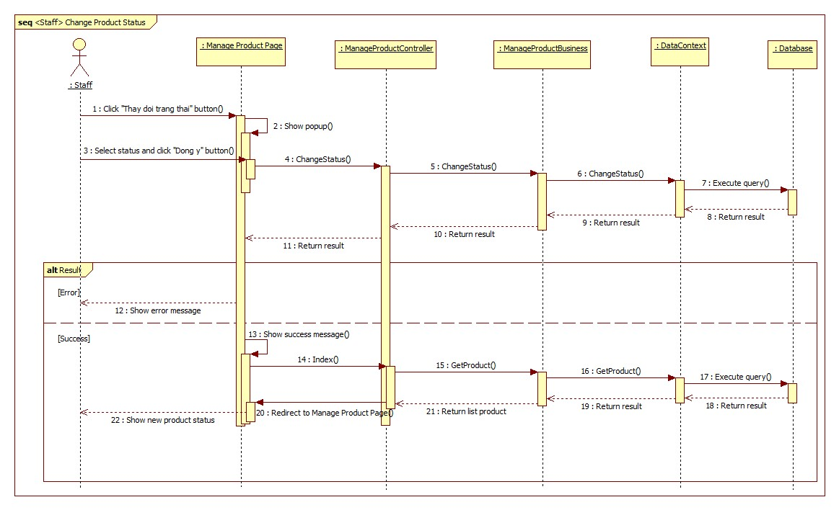

Figure 91 : Sequence diagram - <Staff> Change product status

##### Manager

###### Edit store information

**Summary**: This diagram shows process of manager edit store information.

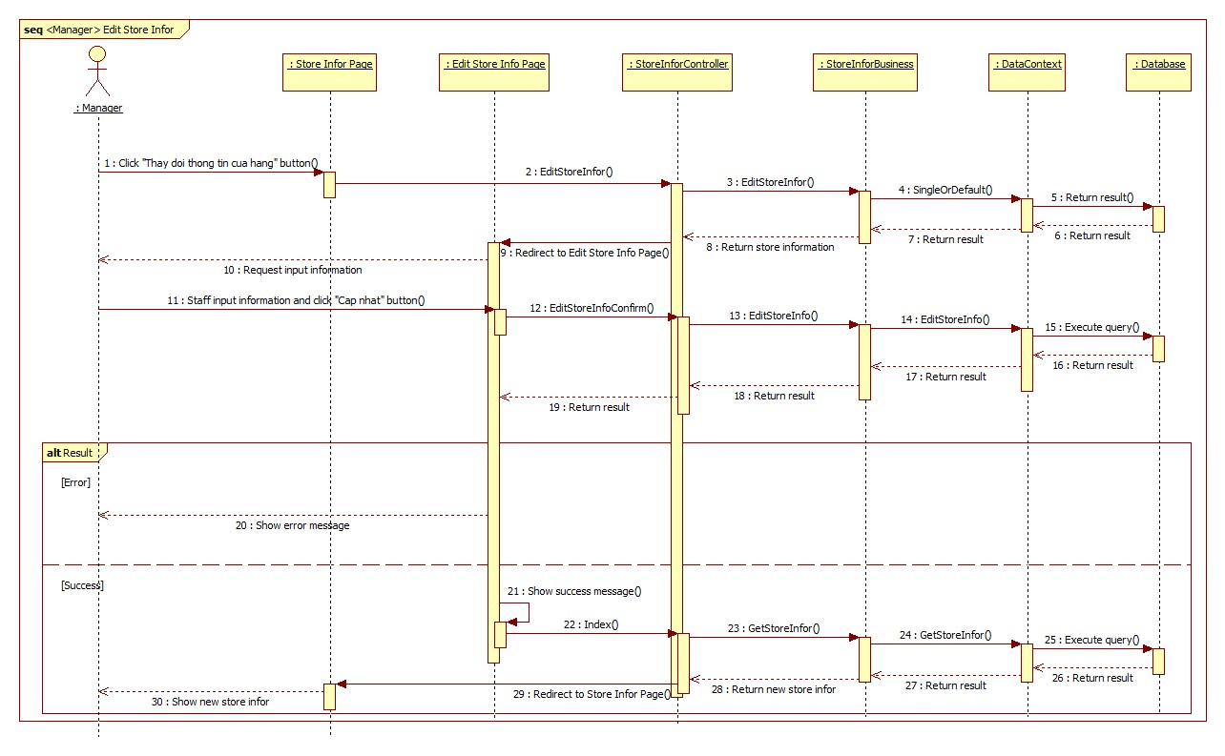

Figure 92 : Sequence diagram - <Manager> Edit store information

###### Edit store config

**Summary**: This diagram shows process of manager edit store config.

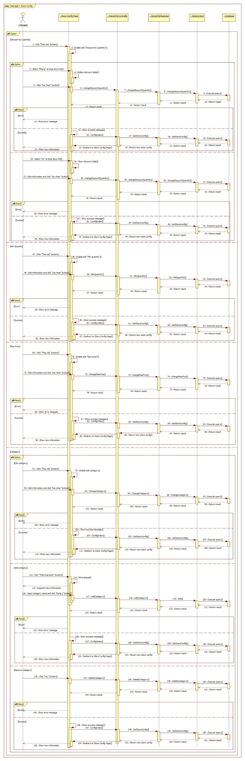

Figure 93 : Sequence diagram - <Manager> Edit store config

###### Add new staff

**Summary**: This diagram shows process of manager add new staff.

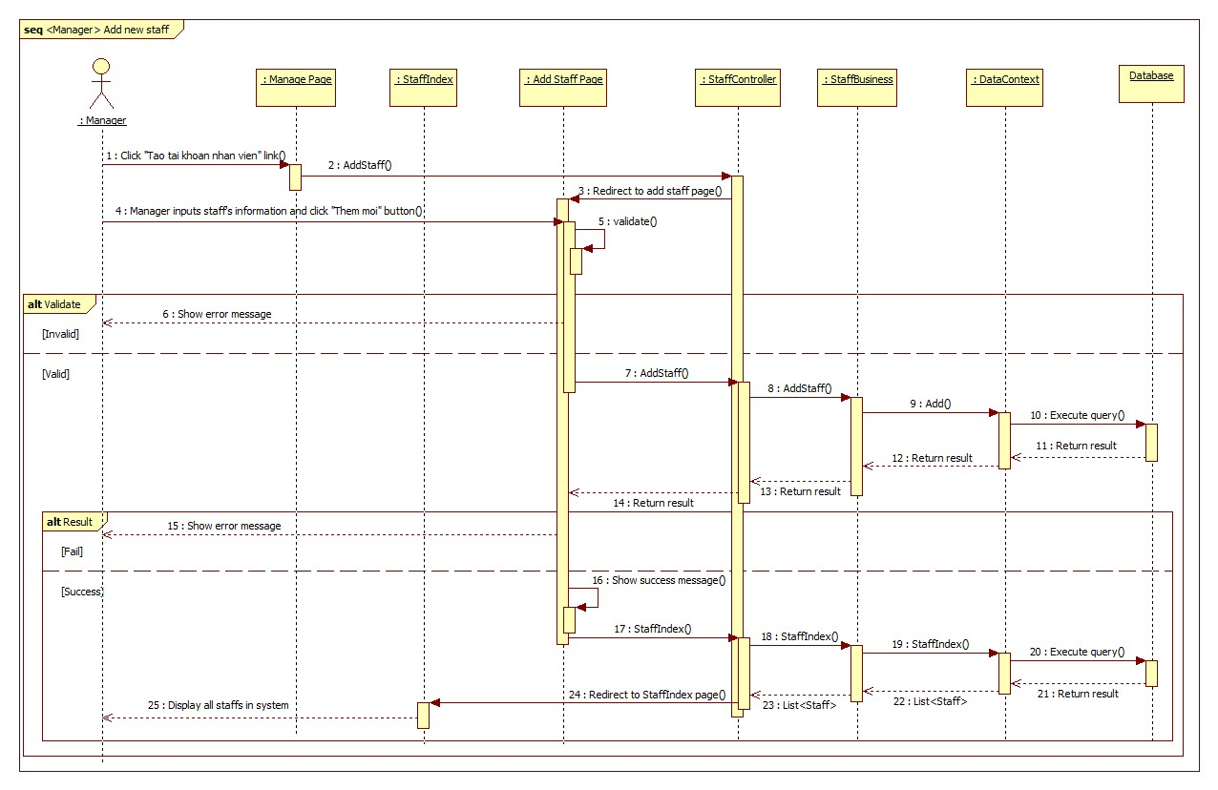

Figure 94 : Sequence diagram - <Manager> Add new staff

###### Change staff status

**Summary**: This diagram shows process of manager change staff status.

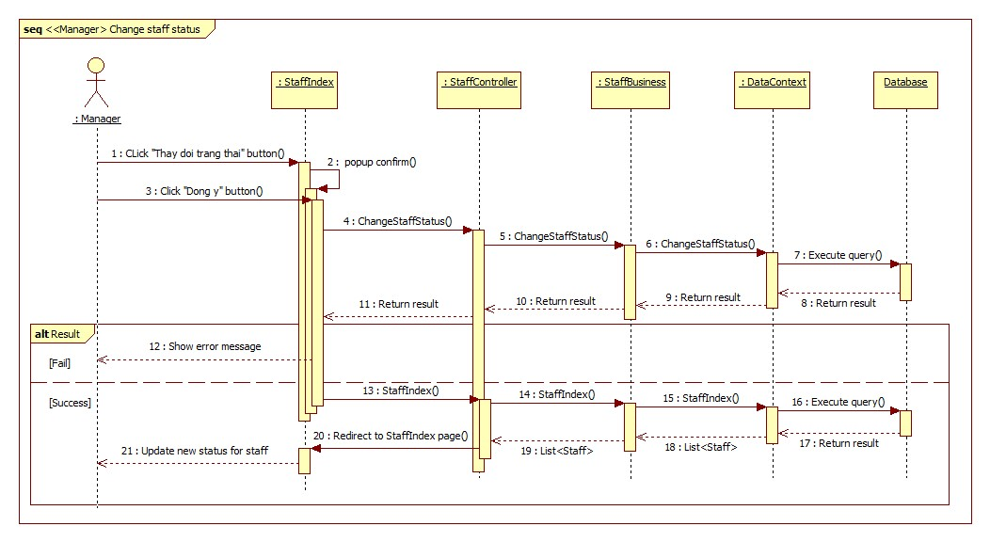

Figure 95 : Sequence diagram - <Manager> Change staff status

###### Change customer status

**Summary**: This diagram shows process of manager change customer status.

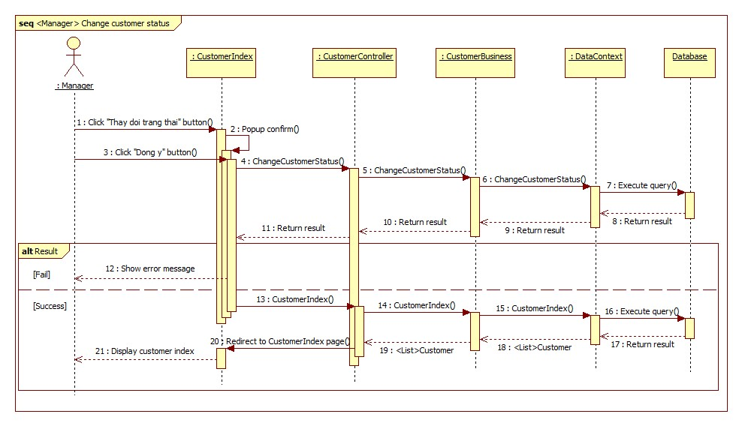

Figure 96 : Sequence diagram - <Manager> Change customer status

###### Change customer account to loyal

**Summary**: This diagram shows process of manager change customer account to loyal.

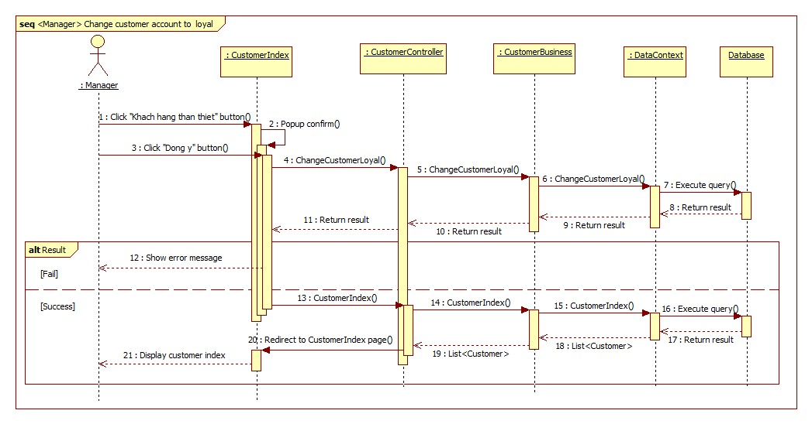

Figure 97 : Sequence diagram - <Manager> Change customer account to loyal

###### Add new supplier

**Summary**: This diagram shows process of manager add new supplier.

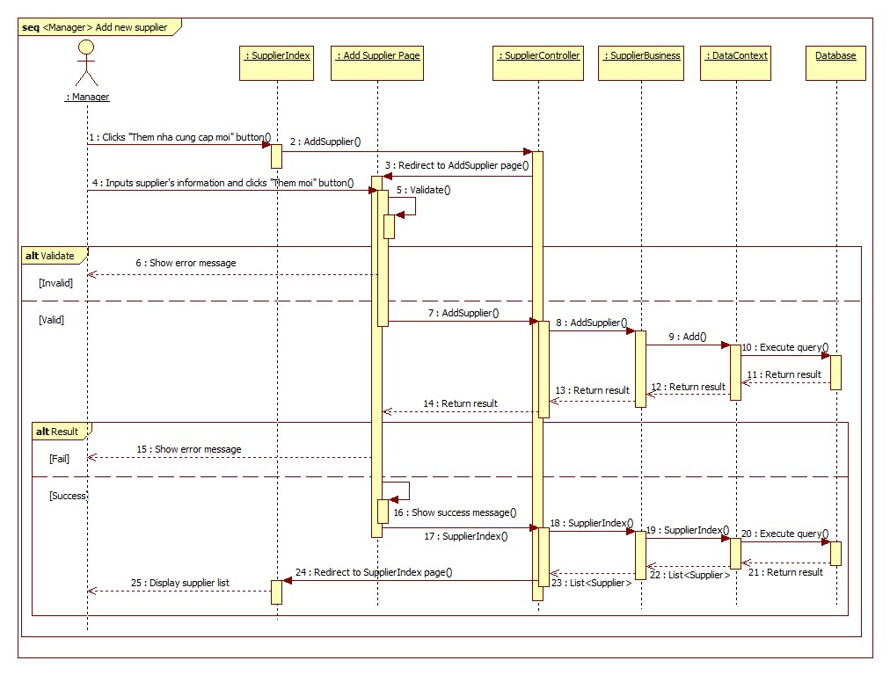

Figure 98 : Sequence diagram - <Manager> Add new supplier

###### Edit supplier information

**Summary**: This diagram shows process of manager edit supplier information.

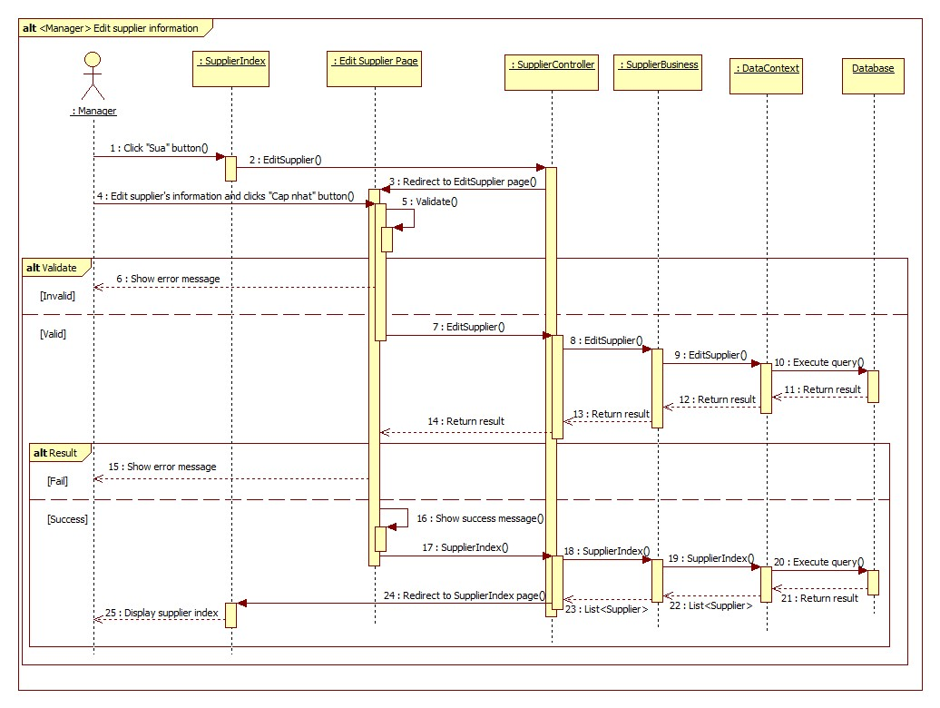

Figure 99 : Sequence diagram - <Manager> Edit supplier information

###### Change supplier status

**Summary**: This diagram shows process of manager change supplier status.

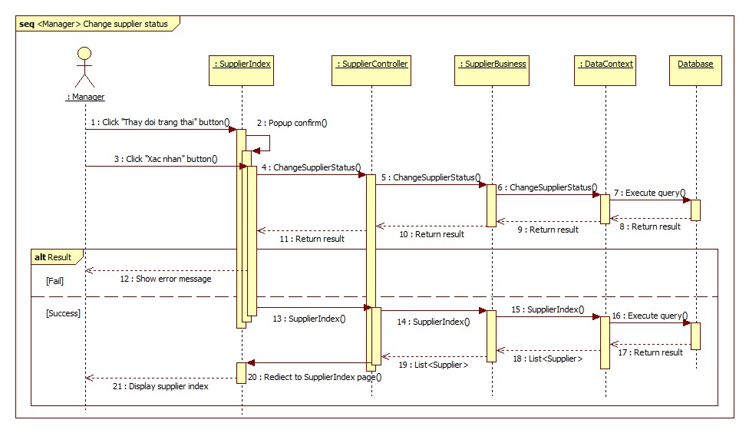

Figure 100 : Sequence diagram - <Manager> Change supplier status

###### Update VAT Tax Rate

**Summary**: This diagram shows process of manager update VAT Tax Rate.

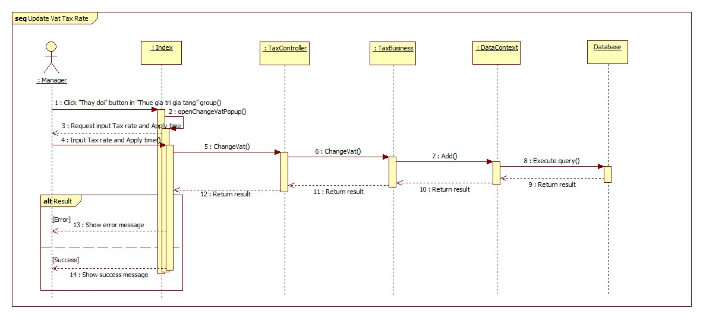

Figure 101 : Sequence diagram - <Manager> Update VAT Tax Rate

###### Update Excise Tax Rate

**Summary**: This diagram shows process of manager update Excise Tax Rate.

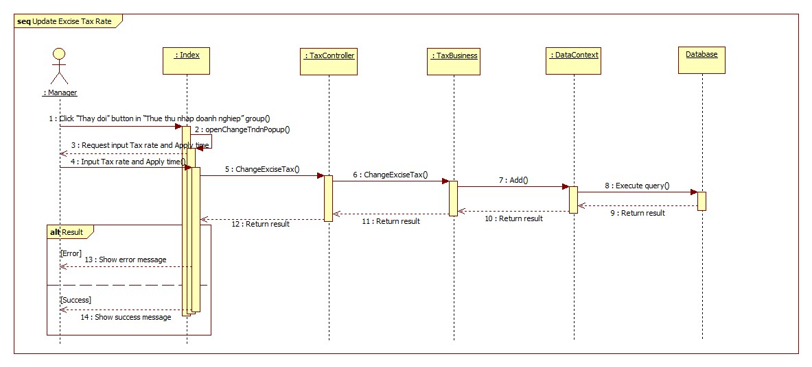

Figure 102 : Sequence diagram - <Manager> Update Excise Tax Rate

###### Review Income by Time

**Summary**: This diagram shows process of manager review income by time.

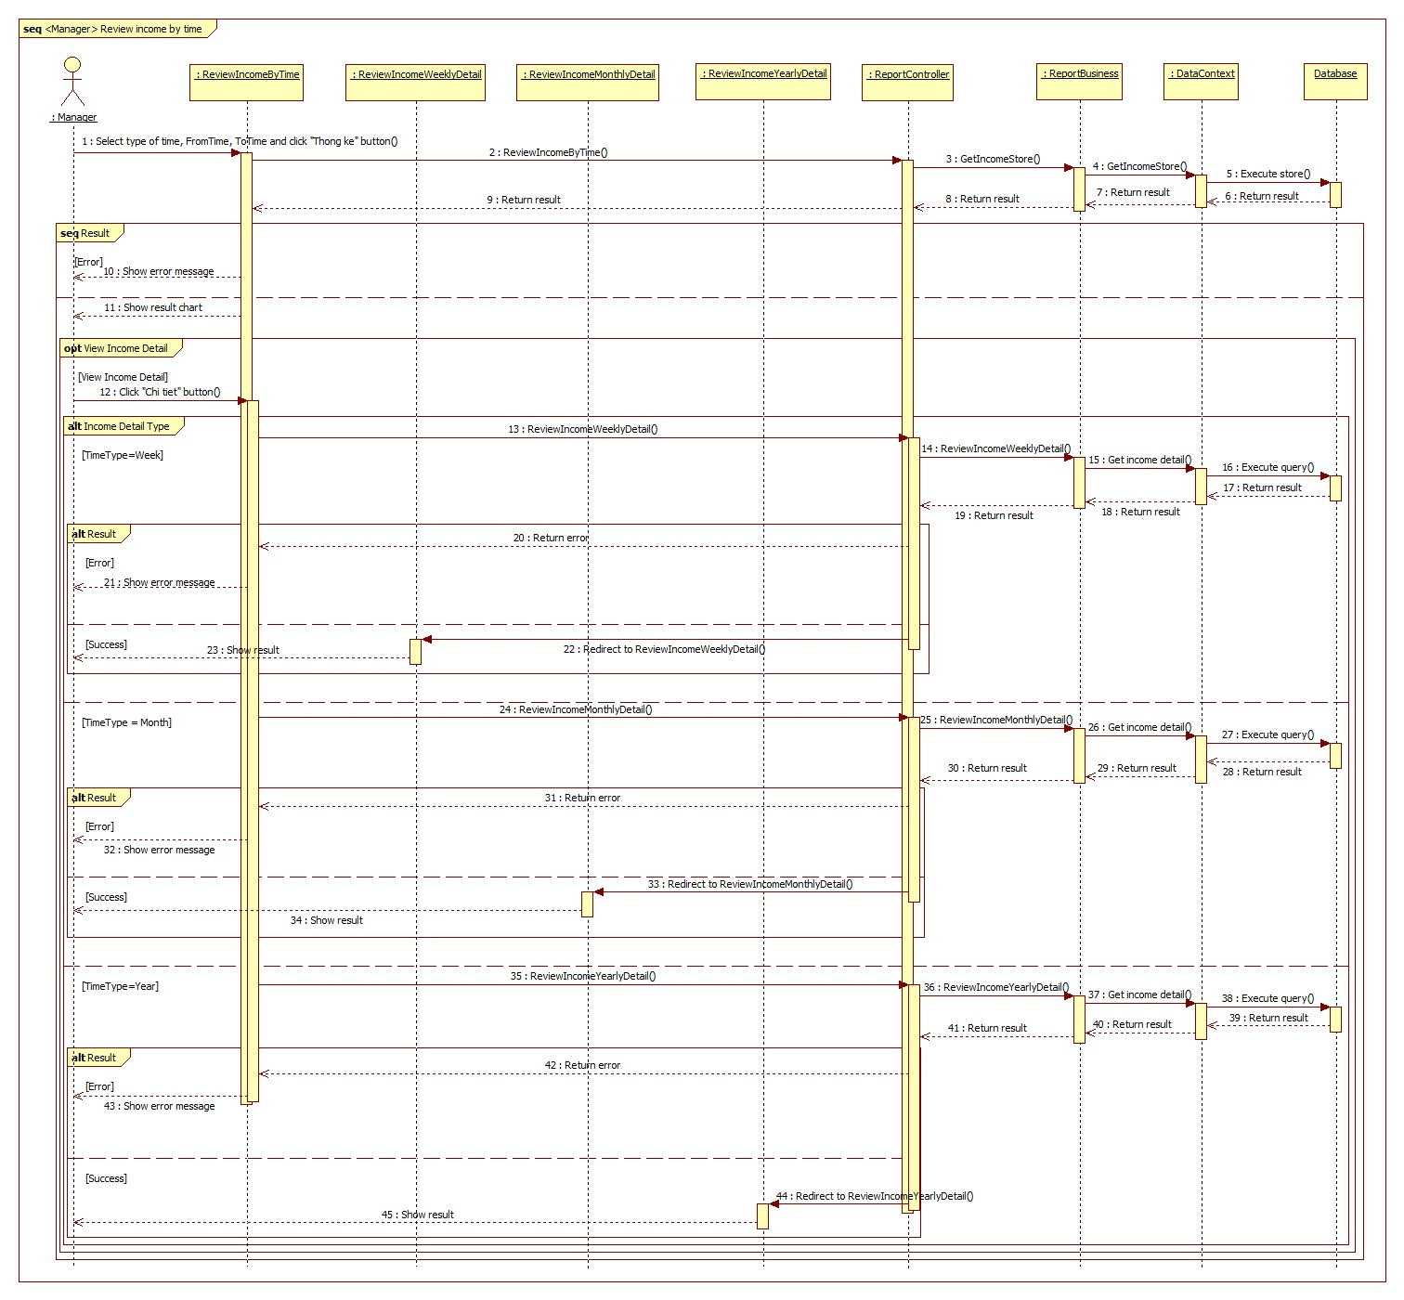

Figure 103 : Sequence diagram - <Manager> Review income by time

###### Review Income by Product

**Summary**: This diagram shows process of manager review income by product.

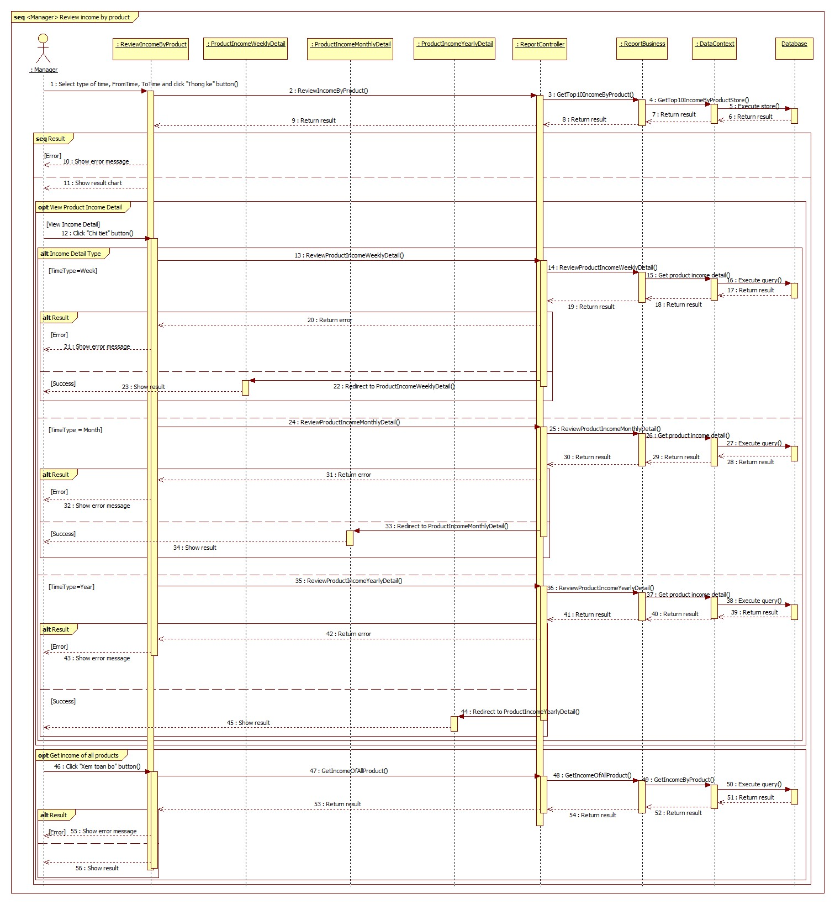

Figure 104 : Sequence diagram - <Manager> Review income by product

###### Review Revenue by Customer

**Summary**: This diagram shows process of manager review revenue by customer.

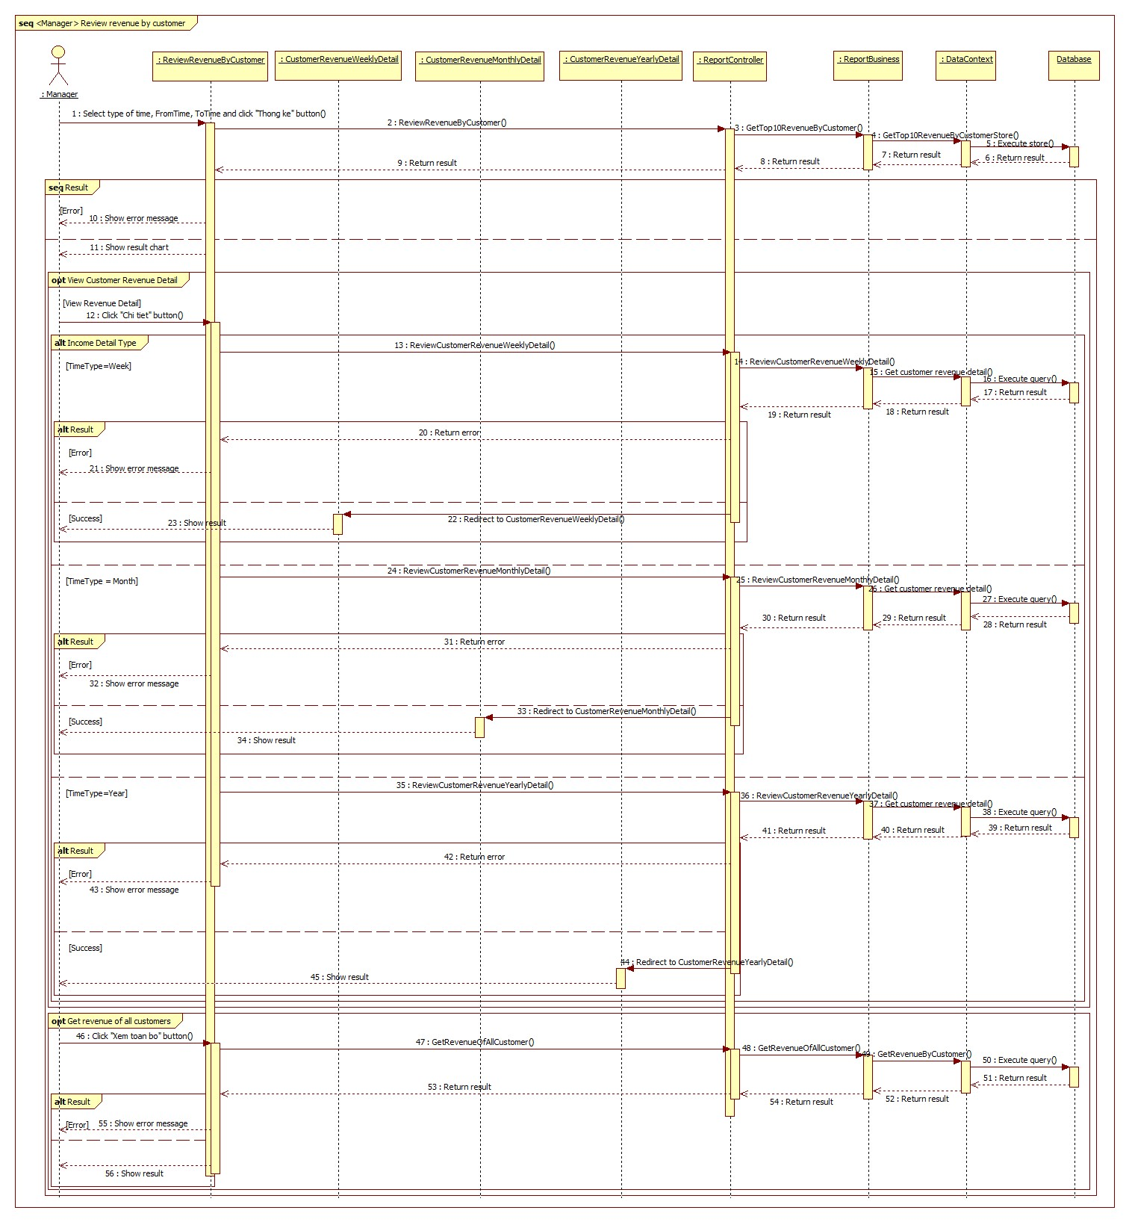

Figure 105 : Sequence diagram - <Manager> Review revenue by customer

###### Create VAT Tax Declaration

**Summary**: This diagram shows process of manager create VAT Tax Declaration.

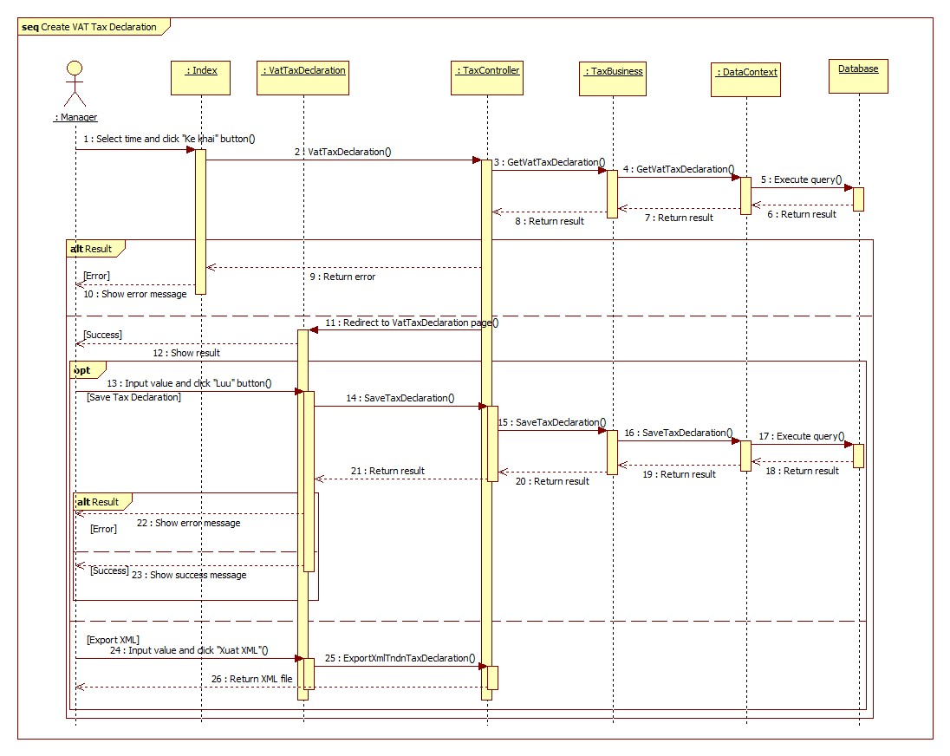

Figure 106 : Sequence diagram - <Manager> Create VAT Tax Declaration

###### Create Excise Tax Declaration

**Summary**: This diagram shows process of manager create Excise Tax Declaration.

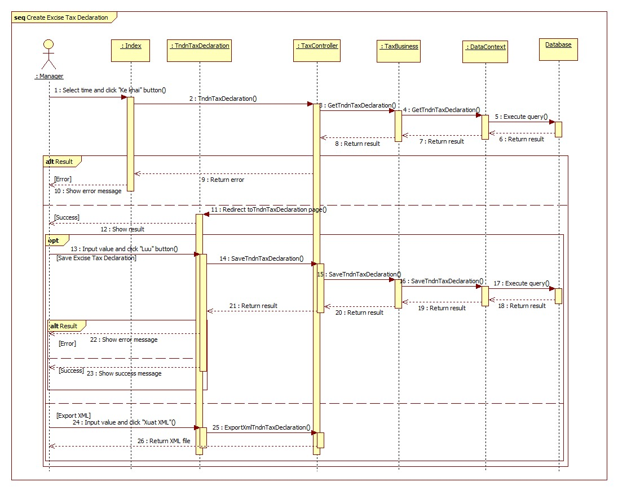

Figure 107 : Sequence diagram - <Manager> Create Excise Tax Declaration

## User Interface Design

### User Login

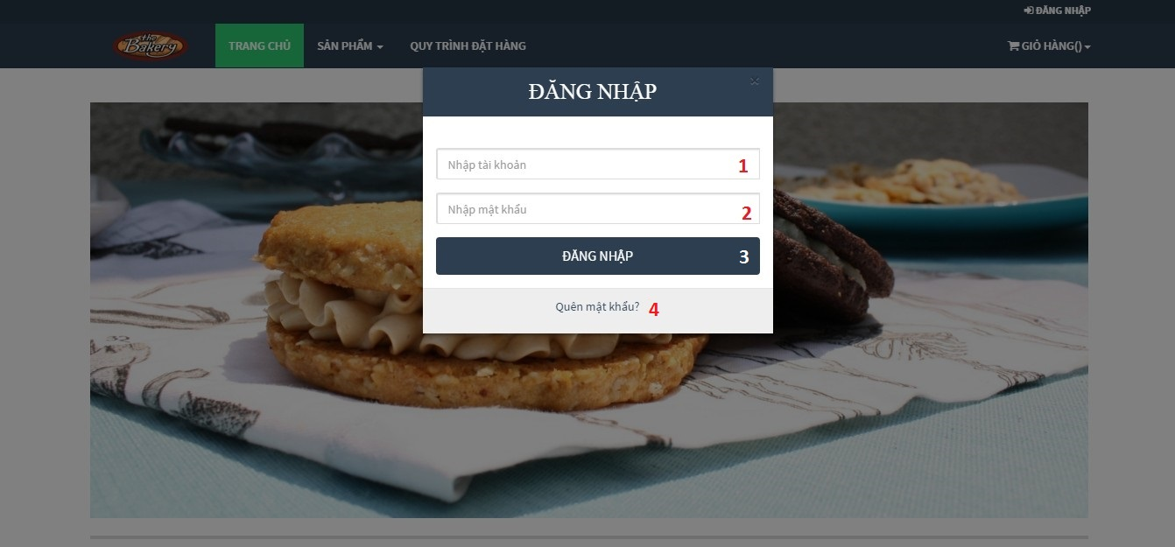

Figure 108: Login popup

**Fields**

|  |  |  |  |  |  |  |  |
| --- | --- | --- | --- | --- | --- | --- | --- |
| No. | Field name | Description | Read only | Mandatory | Control type | Data type | Length |
| 1 | Username | User enters Username | No | Yes | textbox | string | N/A |
| 2 | Password | User enters Password | No | Yes | textbox | string | N/A |

**Buttons/Hyperlinks**

|  |  |  |  |  |
| --- | --- | --- | --- | --- |
| No. | Function | Description | Validation | Outcome |
| 3 | Login | User press “Đăng nhập” button to login into system | N/A | Login to system |
| 4 | Forgot password | User click “Quên mật khẩu?” link if forgetting password | N/A | Navigate to forget password page. |

### Order A Product

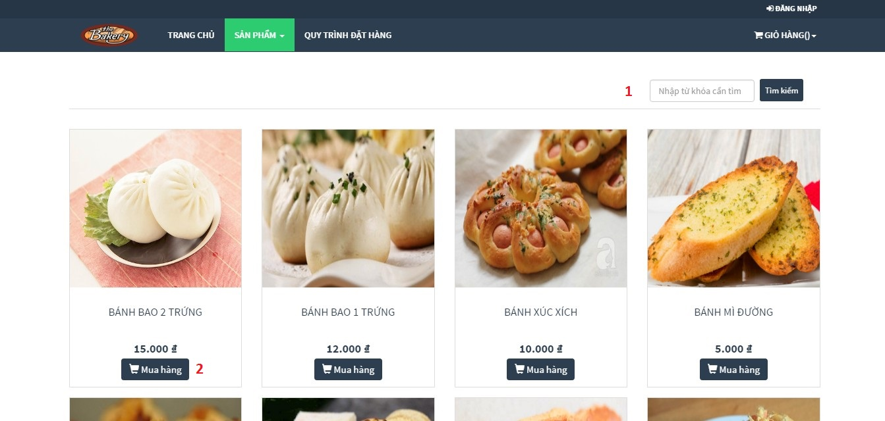

Figure 109: Order Product

**Buttons/ Hyperlinks**

|  |  |  |  |  |
| --- | --- | --- | --- | --- |
| No. | Function | Description | Validation | Outcome |
| 1 | Searching product | Searching product | N/A | List of product match with keyword |
| 2 | Add product to cart | User clicks “Mua hàng” button to order product | N/A | Popup add product to cart |

### Add to cart a product

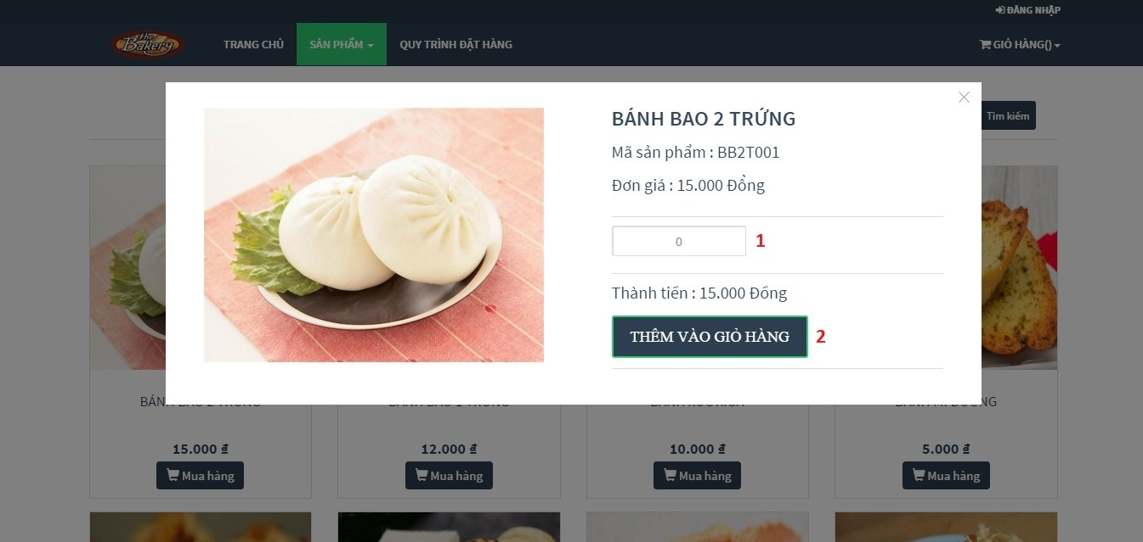

Figure 110: Add to cart a product

**Fields**:

|  |  |  |  |  |  |  |  |
| --- | --- | --- | --- | --- | --- | --- | --- |
| No. | Field name | Description | Read only | Mandatory | Control type | Data type | Length |
| 1 | Product quantity | Quantity of product that user want to order | No | Yes | textbox | number | N/A |

**Buttons/ Hyperlinks**

|  |  |  |  |  |
| --- | --- | --- | --- | --- |
| No. | Function | Description | Validation | Outcome |
| 2 | Add to cart | User click “Thêm vào giỏ hàng” button to add to cart this product | Product quantity must less than 5000 | Add this product to cart |

### Check cart

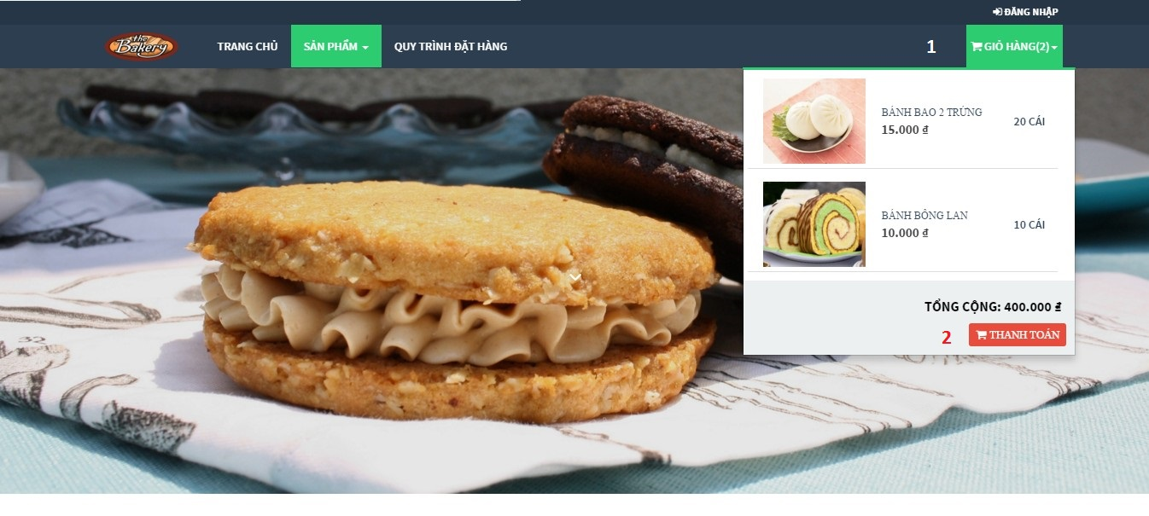

Figure 111: Check cart

**Buttons/ Hyperlinks**

|  |  |  |  |  |
| --- | --- | --- | --- | --- |
| Step | Function | Description | Validation | Outcome |
| 1 | View cart | Click “Giỏ hàng” button to view list of product in cart | N/A | List of products in cart |
| 2 | Cart information | User click “Thanh toán” button to view all of information in cart | N/A | View all of information in cart |

### View information in cart

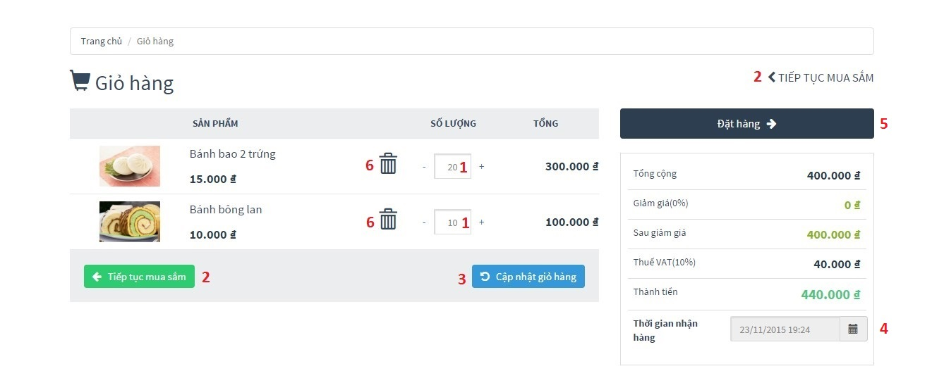

Figure 112: View information in cart

**Fields**:

|  |  |  |  |  |  |  |  |
| --- | --- | --- | --- | --- | --- | --- | --- |
| No. | Field name | Description | Read only | Mandatory | Control type | Data type | Length |
| 1 | Product quantity | Allow user can change quantity of product | No | Yes | textbox | number | N/A |
| 4 | Deliver date | User choose deliver date | Yes | Yes | textbox | Datetime | N/A |

**Buttons/Hyperlinks:**

|  |  |  |  |  |
| --- | --- | --- | --- | --- |
| No. | Function | Description | Validation | Outcome |
| 2 | Redirect to product index page | Come back to product page for user can continue order product | N/A | Redirect to product index page |
| 3 | Update cart | User click “Cập nhật giỏ hàng” button to update cart after edited | N/A | Update cart information after editing |
| 5 | Order | User click “Đặt hàng” button when wanting to finish order | Total number of products in cart must more than 20 and less than 10000 | Finish order, go to order information page |

### Confirm order

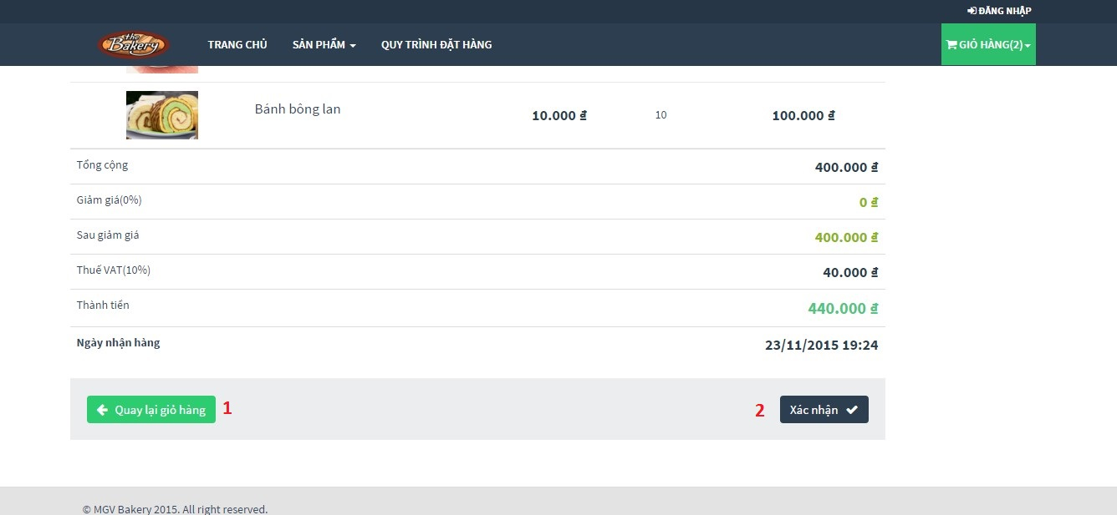

Figure 113: Confirm order

**Buttons/Hyperlinks**

|  |  |  |  |  |
| --- | --- | --- | --- | --- |
| No. | Function | Description | Validation | Outcome |
| 1 | Redirect to cart information page | Click “Quay lại giỏ hàng” button to come back to view information in cart | N/A | Redirect to cart information page |
| 2 | Customer/Guest confirms this order | Confirm order | N/A | If he/she had logged in to system by customer account, then go to order detail page. Else, go to add customer to order page |

### Add customer information to order

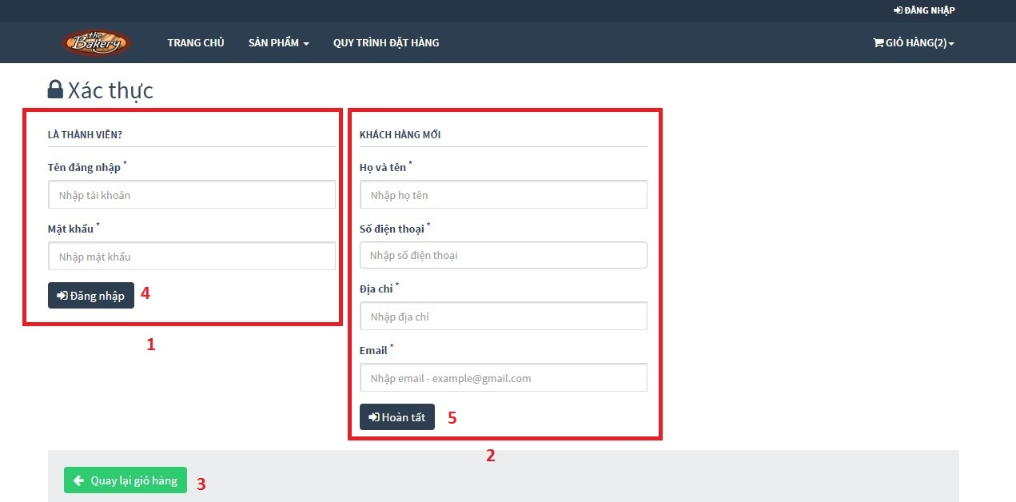

Figure 114: Add customer information to order

**Buttons/Hyperlinks**

|  |  |  |  |  |
| --- | --- | --- | --- | --- |
| No. | Function | Description | Validation | Outcome |
| 1 | Login form | Allow user can login here | N/A | Login to system |
| 2 | Guest adds information form | If user do not have account, he/she can enter personal information here | N/A | Create guest’s information successful |
| 3 | Redirect to product index page | User click “Quay lại giỏ hàng” button to come back confirm order page | N/A | Redirect to product index page |
| 4 | Login | After entering username and password, click “Đăng nhập” button to finish order | Check username and password in database | Login to system |
| 5 | Create guest’s information | After entering personal information, click “Hoàn tất” button to finish order | Check guest information | Create guest’s information successful |

### View order list

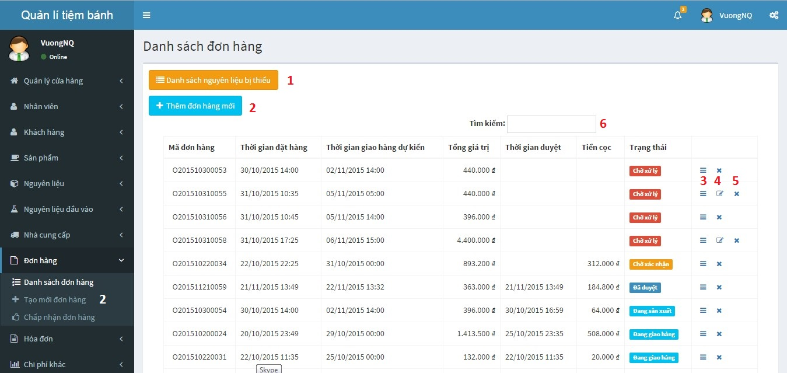

Figure 115: View order list

**Buttons/Hyperlinks**

|  |  |  |  |  |
| --- | --- | --- | --- | --- |
| No. | Function | Description | Validation | Outcome |
| 1 | List of materials are not enough in store | List of materials are not enough in store | N/A | Popup displays list of materials are not enough in store |
| 2 | Add new order | Create new order | N/A | Redirect to add new order page |
| 3 | View order detail | View order detail | N/A | Redirect to order detail page |
| 4 | Edit order | Edit order (when this order is created by customer) | N/A | Redirect to edit order page |
| 5 | Cancel order | Cancel order | N/A | Cancel order (with status “Chờ xử lí” only) |
| 6 | Search order | Search order | N/A | Show list of orders match with input keyword |

### Staff add product to order

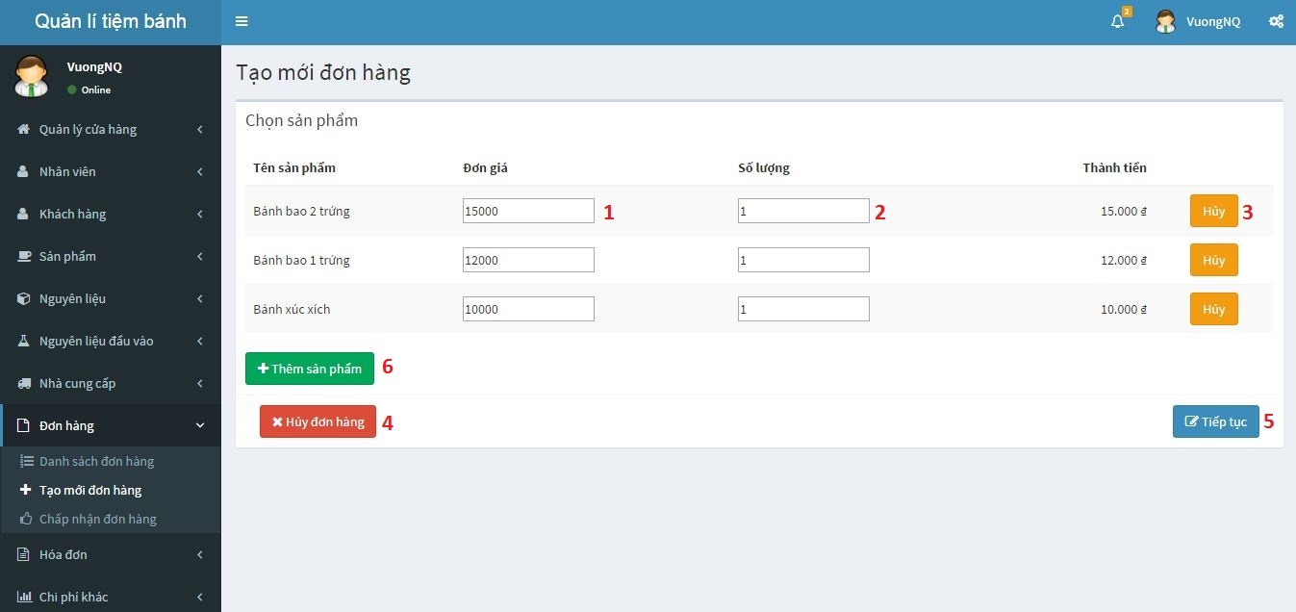

Figure 116: Staff add product to order

**Fields:**

|  |  |  |  |  |  |  |  |
| --- | --- | --- | --- | --- | --- | --- | --- |
| No. | Field name | Description | Read only | Mandatory | Control type | Data type | Length |
| 1 | Product price | Product unit price, allow editing | No | Yes | textbox | Number | N/A |
| 2 | Product quantity | Quantity of product | No | Yes | textbox | Number | N/A |

**Buttons/Hyperlinks:**

|  |  |  |  |  |
| --- | --- | --- | --- | --- |
| No. | Function | Description | Validation | Outcome |
| 3 | Delete product from cart | Delete product from list | N/A | Delete product from cart |
| 4 | Cancel to create order | Cancel to create order | N/A | Cancel to create order |
| 5 | Redirect to add customer to order | Continue order | N/A | Redirect to add customer to order |
| 6 | Add new product to order | Add new product to order |  | Popup display list of product |

### Add customer to order

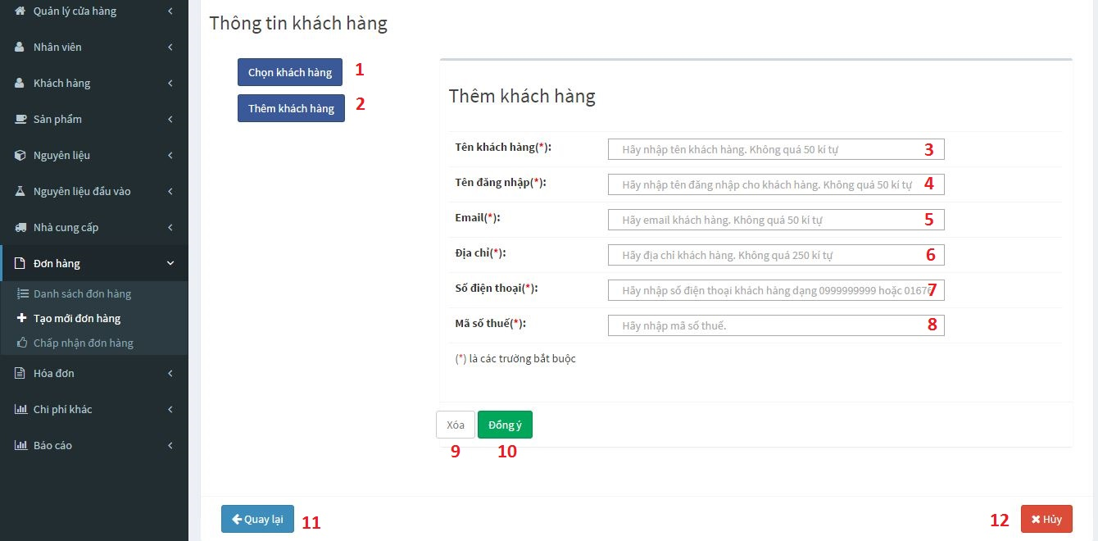

Figure 117: Add customer to order

**Field:**

|  |  |  |  |  |  |  |  |
| --- | --- | --- | --- | --- | --- | --- | --- |
| No. | Field name | Description | Read only | Mandatory | Control type | Data type | Length |
| 3 | Customer’s name | Customer’s name | No | Yes | textbox | string | N/A |
| 4 | Customer’s account name | Customer’s account name | No | Yes | textbox | string | N/A |
| 5 | Customer’s email | Customer’s email | No | Yes | textbox | string | N/A |
| 6 | Customer’s address | Customer’s address | No | Yes | textbox | string | N/A |
| 7 | Customer’s phone number | Customer’s phone number | No | Yes | textbox | number | From 10-11 number character |
| 8 | Customer’s tax code | Customer’s tax code | No | Yes | textbox | number | From 10-13 number character |

**Buttons/Hyperlinks:**

|  |  |  |  |  |
| --- | --- | --- | --- | --- |
| No. | Function | Description | Validation | Outcome |
| 1 | Add customer to order | Select to add customer to order (If this is order of customer had account in system) | N/A | Add this order for selected customer |
| 2 | Create new customer | Create customer account (If this is order of new customer) | N/A | Display add new customer form |
| 9 | Clear add new customer form | Clear data in add new customer form | N/A | Clear all fields in add new customer form |
| 10 | Add new customer | Create new customer and add this order to customer’s order history | Check customer information | Add new customer and redirect to check out with new customer page |
| 11 | Redirect to add product to order page | Redirect to add product to order page | N/A | Redirect to add product to order page |
| 12 | Cancel create order | Cancel create order | N/A | Cancel create order |

### Check out with new customer

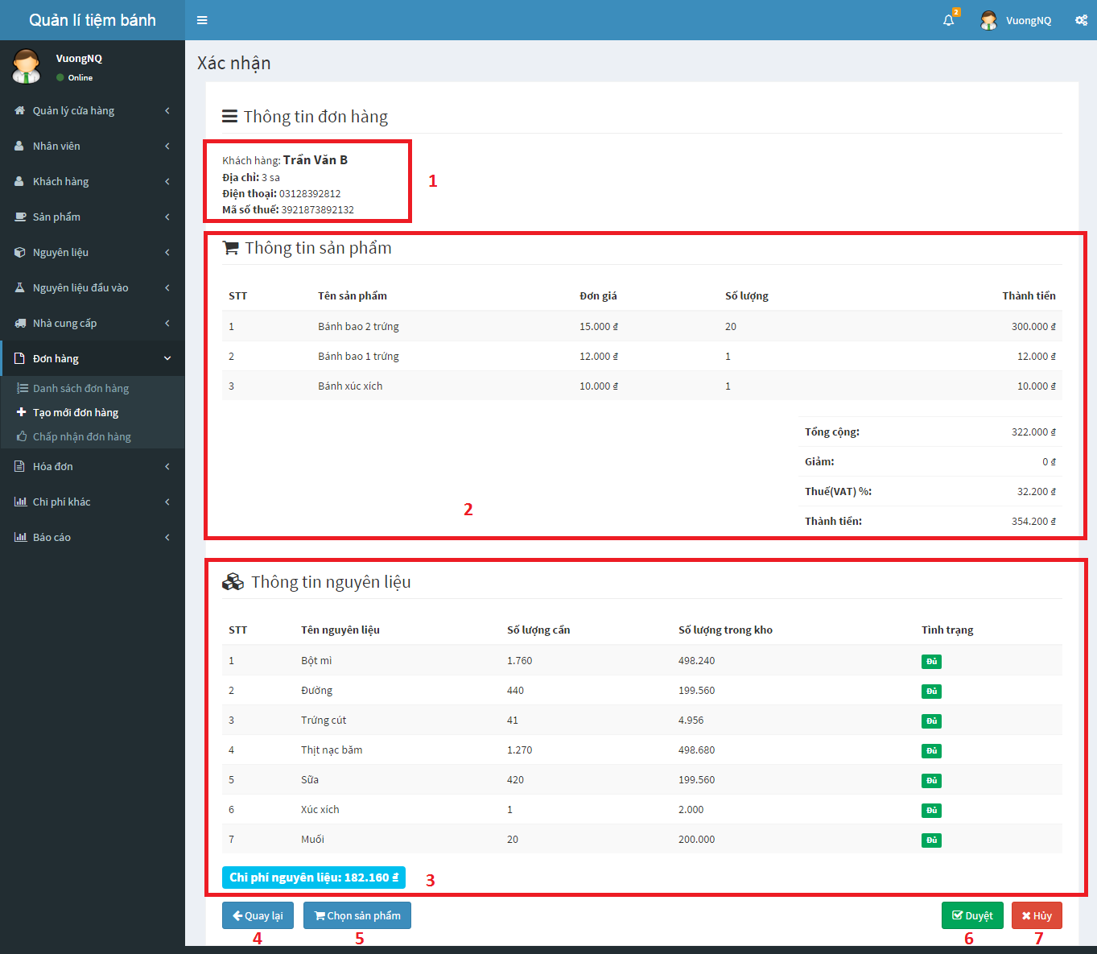

Figure 118: Check out with new customer

**Buttons/Hyperlinks:**

|  |  |  |  |  |
| --- | --- | --- | --- | --- |
| No. | Function | Description | Validation | Outcome |
| 1 | Get new customer information | New customer information | N/A | New customer information |
| 2 | Get order information | Order information | N/A | Order information |
| 3 | Get list of materials spend for this order | List of materials spend for this order | N/A | List of materials spend for this order |
| 4 | Redirect to add customer to order page | Come back to add customer to order page | N/A | Redirect to add customer to order page |
| 5 | Redirect to add product to order page | Come back to add product to order page | N/A | Redirect to add product to order page |
| 6 | Confirm order | Confirm this order | N/A | Confirm this order |
| 7 | Cancel add order | Cancel to create this order | N/A | Cancel to create this order |

### View input bill list

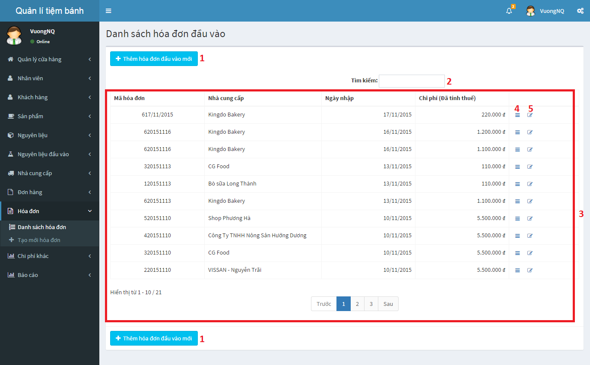

Figure 119: View input bill list

**Buttons/Hyperlinks:**

|  |  |  |  |  |
| --- | --- | --- | --- | --- |
| No. | Function | Description | Validation | Outcome |
| 1 | Add input bill | Add new input bill | N/A | Redirect to add input bill page |
| 2 | Search input bill | Search | N/A | Display list of input bills match with inputted keyword |
| 3 | Input bill index | List of all input bill in store | N/A | List of all input bill in store |
| 4 | Input bill detail | View input bill detail | N/A | Redirect to selected input bill detail page |
| 5 | Edit input bill | Edit input bill information | N/A | Redirect to selected input bill editing page |

### Add new input bill

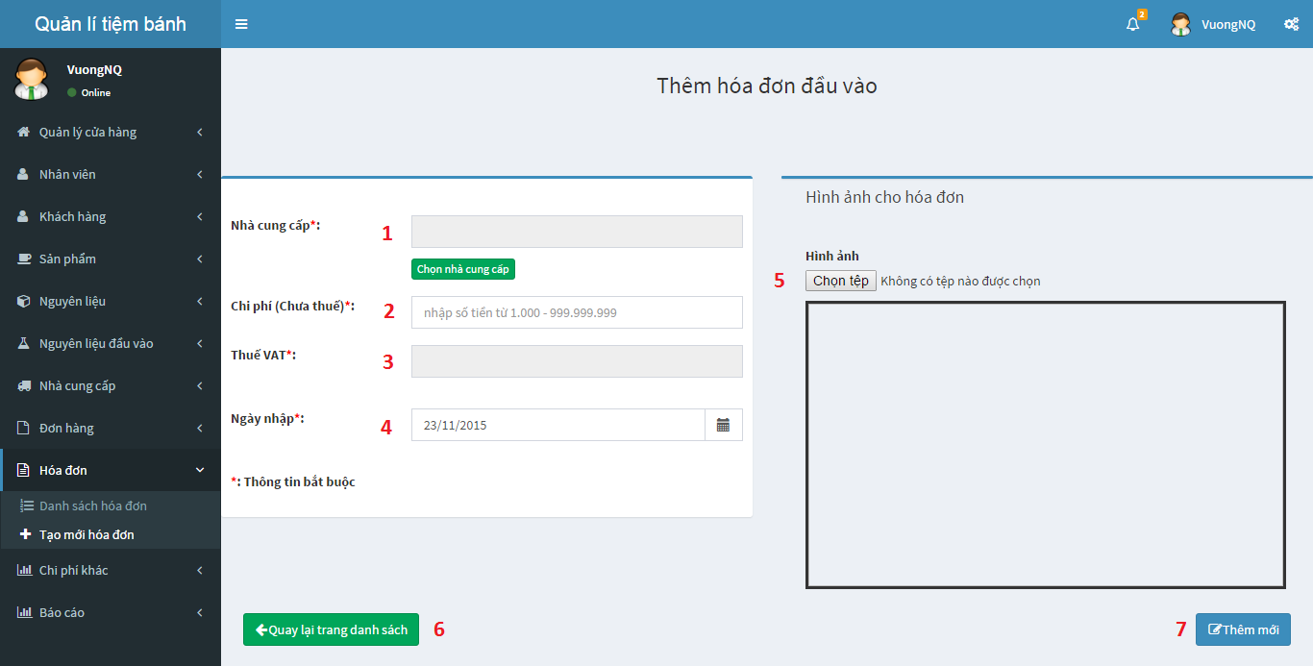

Figure 120: Add new input bill

**Fields:**

|  |  |  |  |  |  |  |  |
| --- | --- | --- | --- | --- | --- | --- | --- |
| No. | Field name | Description | Read only | Mandatory | Control type | Data type | Length |
| 1 | Supplier name | Select supplier name | Yes | Yes | textbox | string | N/A |
| 2 | Import cost | Cost in bill (not include VAT) | No | Yes | textbox | number | N/A |
| 3 | VAT cost | VAT cost (automatic render by cost in bill) | Yes | Yes | textbox | number | N/A |
| 4 | Import date | Import date | No | Yes | textbox | string | N/A |
| 5 | Input bill’s image | Input bill’s image | No | Yes | textbox | string | N/A |

**Buttons/Hyperlinks:**

|  |  |  |  |  |
| --- | --- | --- | --- | --- |
| No. | Function | Description | Validation | Outcome |
| 6 | Input bill index | Come back to input bill list | N/A | Redirect to Input Bill Index page |
| 7 | Add input bill | Add new input bill | N/A | Add new input bill |

### View input material list

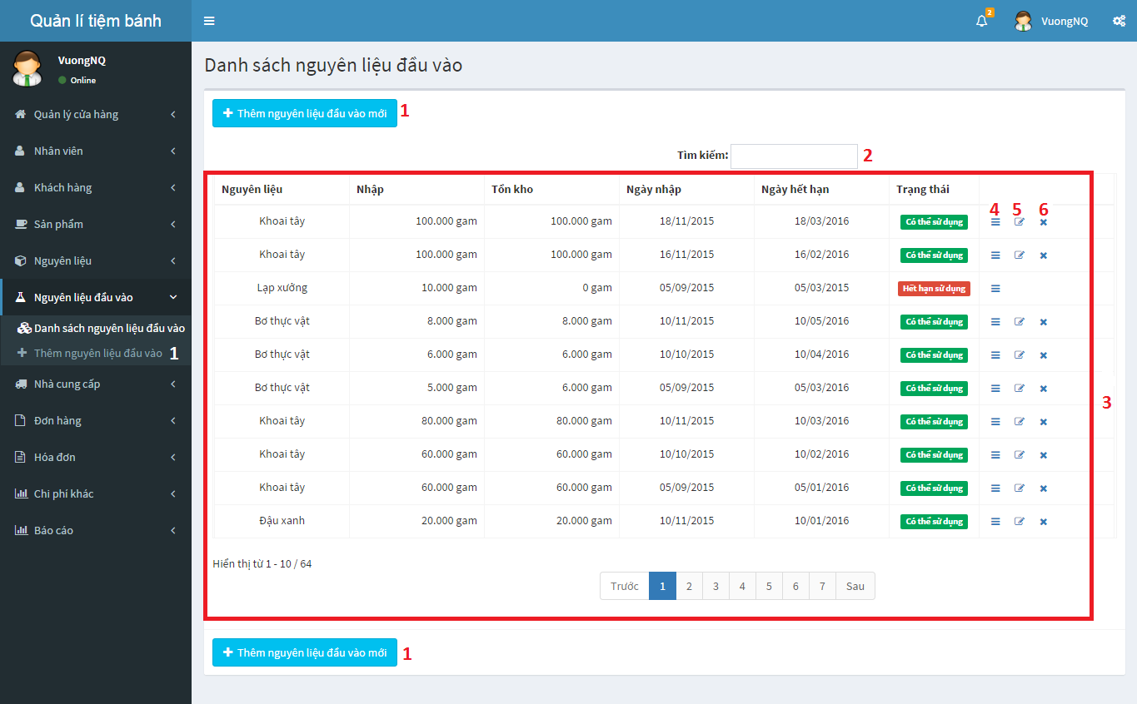

Figure 121: Input material list

**Buttons/Hyperlinks:**

|  |  |  |  |  |
| --- | --- | --- | --- | --- |
| No. | Function | Description | Validation | Outcome |
| 1 | Add input material | Add new input material | N/A | Redirect to add input material page |
| 2 | Search | Search | N/A | Display list of input materials match with inputted keyword |
| 3 | Input material index | List all of input materials in store | N/A | List all of input materials in store |
| 4 | Input material detail | View input material detail | N/A | View input material detail |
| 5 | Edit input material | Edit input material information | Only with input material that import quantity equal with remain quantity and status “Đang sử dụng” | Edit input material information |
| 6 | Discard input material | Discard input material | Only with input material that remain quantity is more than 0 and status is “Đang sử dụng” | Discard input material |

### View input material detail

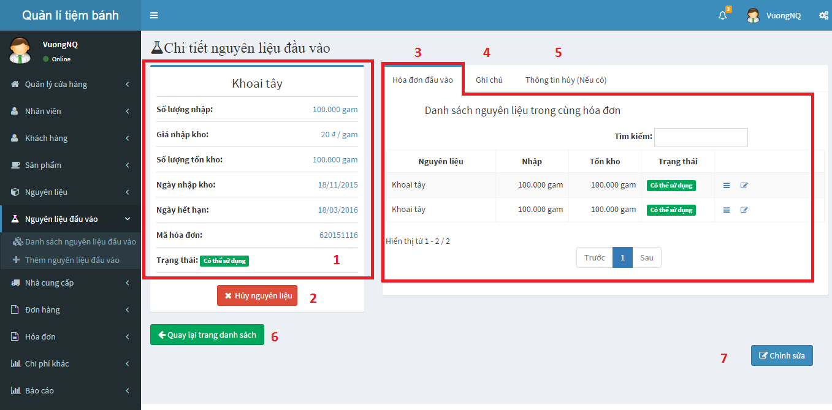

Figure 122: View input material detail

**Buttons/Hyperlinks:**

|  |  |  |  |  |
| --- | --- | --- | --- | --- |
| No. | Function | Description | Validation | Outcome |
| 1 | Input material information | Input material’s standard information | N/A | Input material’s standard information |
| 2 | Discard input material | Discard input material | Only with input material that remain quantity is more than 0 and status is “Đang sử dụng” | Discard input material |
| 3 | Input material index by input bill | List input materials in same input bill | N/A | List input materials in same input bill |
| 4 | Input material’s note | Input material’s note | N/A | Input material’s note |
| 5 | Discard input material detail | Discard input material’s detail list | N/A | Discard input material’s detail list |
| 6 | Input material index | Come back to input material list | N/A | Come back to input material list |
| 7 | Edit input material | Edit input material information | Only with input material that import quantity equal with remain quantity and status “Đang sử dụng | Edit input material information |

### Add new input material

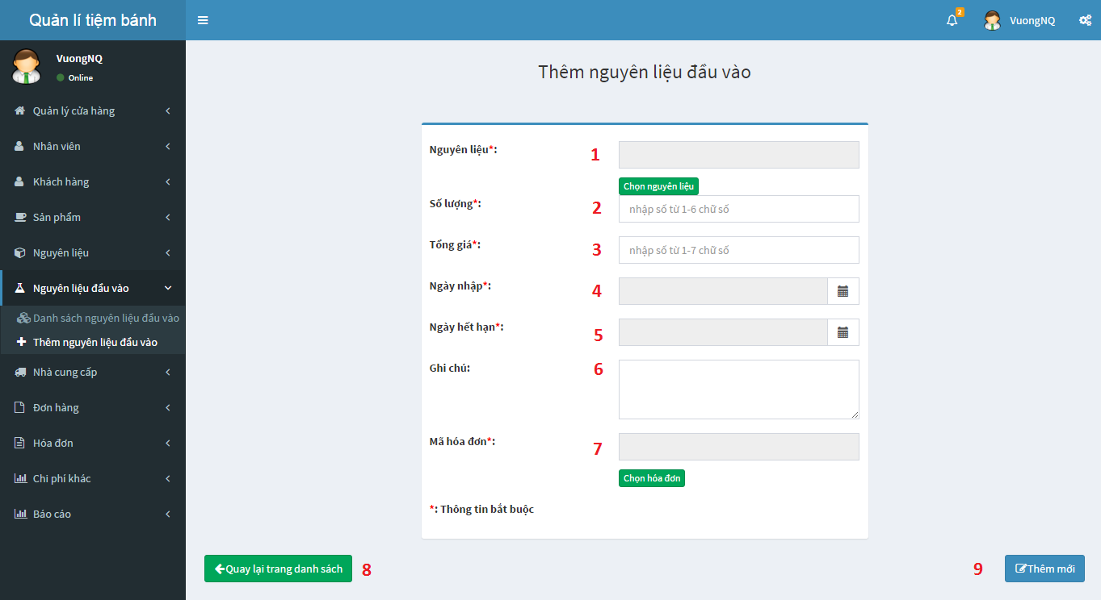

Figure 123: Add new input material

**Fields:**

|  |  |  |  |  |  |  |  |
| --- | --- | --- | --- | --- | --- | --- | --- |
| No. | Field name | Description | Read only | Mandatory | Control type | Data type | Length |
| 1 | Input material’s name | Input material’s name | Yes | Yes | textbox | string | N/A |
| 2 | Input material’s quantity | Input material’s quantity | No | Yes | textbox | string | N/A |
| 3 | Input material’s total price | Input material’s total price | No | Yes | textbox | number | N/A |
| 4 | Input material’s import date | Input material’s import date | No | Yes | textbox | number | N/A |
| 5 | Input material’s expire date | Input material’s expire date | No | Yes | textbox | string | N/A |
| 6 | Input material’s note | Input material’s note | No | Yes | textbox | string | N/A |
| 7 | Input material’s input bill code | Input material’s input bill code | Yes | Yes | textbox | string | N/A |

**Buttons/Hyperlinks:**

|  |  |  |  |  |
| --- | --- | --- | --- | --- |
| No. | Function | Description | Validation | Outcome |
| 8 | Input material index | Come back to input material list | N/A | Redirect to input material index |
| 9 | Add input bill | Add new input material | N/A | Add new input material |

### Review income by time

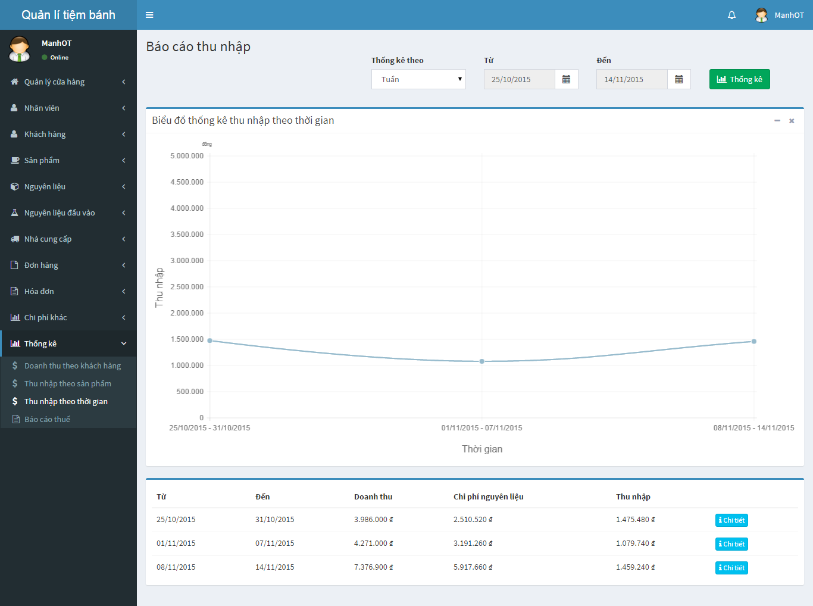

1

2

3

4

5

6

7

Figure 124: Review income by time

**Fields:**

|  |  |  |  |  |  |  |  |
| --- | --- | --- | --- | --- | --- | --- | --- |
| No. | Field name | Description | Read only | Mandatory | Control type | Data type | Length |
| 1 | Time type | Time type: week, month, year | Yes | Yes | Dropdown list | string | N/A |
| 2 | From Time | From time of chart | Yes | Yes | Datetimepicker | string | N/A |
| 3 | To Time | To time of chart | Yes | Yes | Datetimepicker | string | N/A |

**Buttons/Hyperlinks:**

|  |  |  |  |  |
| --- | --- | --- | --- | --- |
| No. | Function | Description | Validation | Outcome |
| 4 | Review income by time | Get review income by time | N/A | Show review income by time line chart |
| 5 | Get review income by time chart | Review income by time chart | N/A | Review income by time line chart |
| 6 | Get review income by time detail | Review income by time detail table | N/A | Review income by time detail table |
| 7 | Get detail of income of specified period | Get detail of income of specified period | N/A | Redirect to review income by time detail page |

### Review income weekly detail

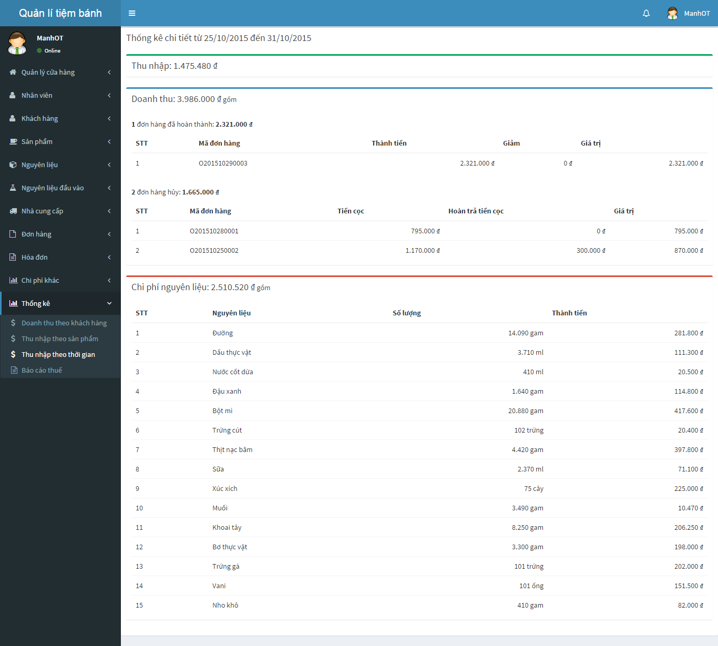

**3**

**2**

**1**

Figure 125: Review income weekly detail

**Buttons/Hyperlinks:**

|  |  |  |  |  |
| --- | --- | --- | --- | --- |
| No. | Function | Description | Validation | Outcome |
| 1 | Get income information of this period | Income information of this period | N/A | Show income information of this period |
| 2 | Get revenue information of this period | Revenue information of this period | N/A | Show revenue information of this period |
| 3 | Get material expense of this period | Material expense information of this period | N/A | Show material expense information of this period |

### VAT Tax Declaration – Appendix 1

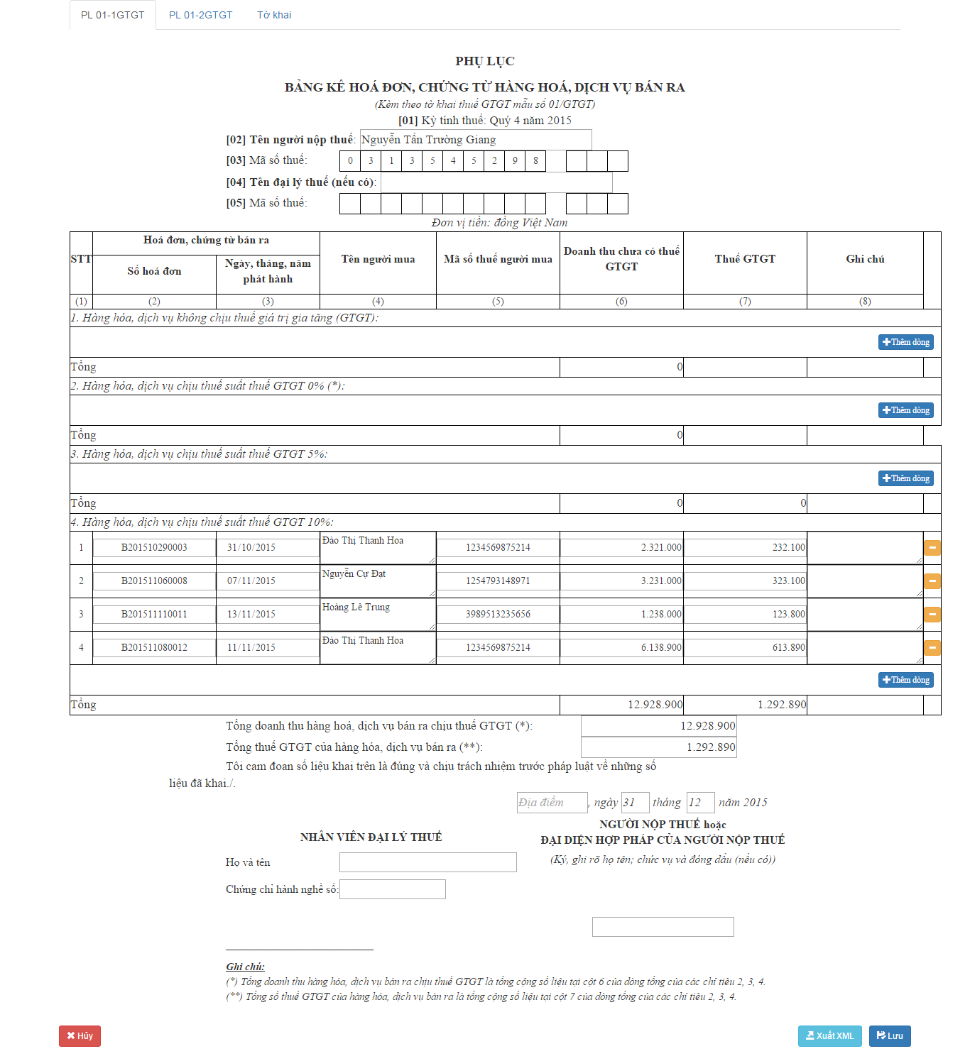

**27**

**26**

**25**

**24**

**23**

**22**

**21**

**20**

**19**

**18**

**17**

**15**

**16**

**14**

**13**

**12**

**11**

**10**

**9**

**8**

**7**

**6**

**5**

**4**

**2**

**3**

**1**

Figure 126: VAT Tax Declaration – Appendix 1

**Fields:**

|  |  |  |  |  |  |  |  |
| --- | --- | --- | --- | --- | --- | --- | --- |
| No. | Field name | Description | Read only | Mandatory | Control type | Data type | Length |
| 1 | Store owner name | Store owner name | No | Yes | Textbox | string | N/A |
| 2 | Store tax code | Store tax code | No | Yes | Number | string | 1letter/cell |
| 3 | Tax agent owner name | Tax agent owner name | No | No | Textbox | string | N/A |
| 4 | Tax agent tax code | Tax agent tax code | No | No | Number | string | 1letter/cell |
| 21 | Bill code | Bill code | No | No | Textbox | string | 15 |
| 22 | Bill date | Bill date | No | No | Date | string | 10 |
| 23 | Customer name | Customer name | No | No | Textbox | string | N/A |
| 24 | Customer tax code | Customer tax code | No | No | Textbox | string | 13 |
| 25 | Revenue | Revenue | No | No | Number | string | N/A |
| 26 | Tax amount | Tax amount | No | No | Number | string | N/A |
| 27 | Note | Note | No | No | Textbox | string | N/A |
| 10 | Total revenue | Total revenue | Yes | Yes | Number | string | N/A |
| 11 | Total tax amount | Total tax amount | Yes | Yes | Number | string | N/A |
| 12 | Create location | Create location | No | No | Textbox | string | N/A |
| 13 | Create day | Create day | No | No | Number | string | 2 |
| 14 | Create month | Create month | No | No | Number | string | 2 |
| 15 | Tax agent name | Tax agent name | No | No | Textbox | string | 30 |
| 16 | Tax agent certificate number | Tax agent certificate number | No | No | Textbox | string | 10 |
| 17 | Sign name | Sign name | No | No | Textbox | string | N/A |

**Buttons/Hyperlinks:**

|  |  |  |  |  |
| --- | --- | --- | --- | --- |
| No. | Function | Description | Validation | Outcome |
| 5 | Insert more row | Insert more row for products no VAT tax | N/A | Insert new row for products no VAT tax |
| 6 | Insert more row | Insert more row for products 0% VAT tax | N/A | Insert new row for products 0% VAT tax |
| 7 | Insert more row | Insert more row for products 5% VAT tax | N/A | Insert new row for products 5% VAT tax |
| 8 | Remove row | Remove the specified row | N/A | Remove the specified row |
| 9 | Insert more row | Insert more row for products 10% VAT tax | N/A | Insert new row for products 10% VAT tax |
| 18 | Cancel | Cancel this declaration | N/A | Cancel this declaration |
| 19 | Export XML file | Export XML file | N/A | Export XML file |
| 20 | Save the declaration | Save the declaration | N/A | Save the declaration |

## Database Design

### Entity relationship diagram

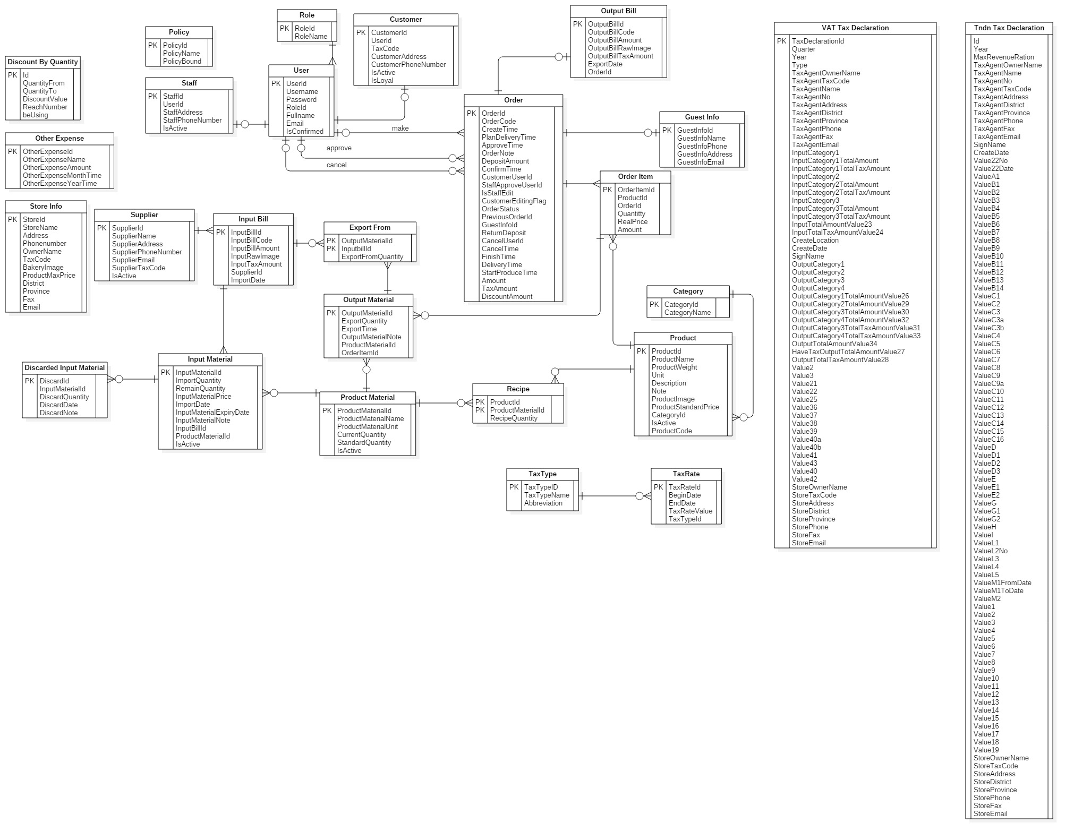

Figure 127 : Entity relationship diagram

### Entity Dictionary

|  |  |
| --- | --- |
| Entity Data Dictionary: describe content of all entities | |
| **Entity name** | **Description** |
| Discount By Quantity | Describe all discounts by quantity in the system |
| Other Expense | Describe all other expenses in the system |
| StoreInfo | Describe all information of store in the system |
| Policy | Describe all policies in the system |
| Role | Describe all roles in the system |
| User | Describe all users in the system |
| Customer | Describe all customers in the system |
| Staff | Describe all staffs in the system |
| Guest Info | Describe all guest information in the system |
| Orders | Describe all orders in the system |
| Output Bill | Describe all output bills in the system |
| Order Item | Describe all order items of an order in the system |
| Category | Describe all categories in the system |
| Product | Describe all products in the system |
| Supplier | Describe all suppliers in the system |
| Input Bill | Describe all input bills in the system |
| Discarded Input Material | Describe all discard information of an input material in the system |
| Input Material | Describe all input materials in the system |
| Export From | Describe all relationship information between output material and input bill |
| Product Material | Describe all product materials in the system |
| Output Material | Describe all output materials of an order item in the system |
| Recipe | Describe all of materials of each product in the system |
| Tax Rate | Describe all tax rates in the system |
| Tax Type | Describe all tax types in the system |
| VAT Tax Declaration | Describe all information in VAT tax declaration |
| Tndn Tax Declaration | Describe all information in Excise tax declaration |

Table 61 : Entity dictionary

|  |  |  |  |  |
| --- | --- | --- | --- | --- |
| **Entity name** | **Attribute** | **Description** | **Domain** | **Allow null** |
| **Discount By Quantity** | Id (PK) | Unique identifier of discount by quantity | int | No |
| QuantityFrom | Min quantity to get discount | int | No |
| QuantityTo | Max quantity to get discount | int | No |
| DiscountValue | Discount value | int | No |
| beUsing | Identifier for discount or not | int | No |
| **Other Expense** | OtherExpenseId (PK) | Unique identifier of other expense | int | No |
| OtherExpenseName | Other expense name | nvarchar(100) | No |
| OtherExpenseAmount | Other expense amount | int | No |
| OtherExpenseMonthTime | Other expense month | int | Yes |
| OtherExpenseYearTime | Other expense year | int | Yes |
| Type | Type of other expense | int | No |
| **StoreInfo** | StoreId (PK) | Unique identifier of store information | int | No |
| StoreName | Name of the store | nvarchar(50) | No |
| Address | Store address (include No, Street name) | nvarchar(200) | No |
| Phonenumber | Store phone number | nvarchar(20) | No |
| OwnerName | Store owner name | nvarchar(50) | No |
| TaxCode | Store tax code | varchar(20) |  |
| BakeryImage | Link of bakery’s logo | nvarchar(200) |  |
| District | Store address’s district | nvarchar(50) | No |
| Province | Store address’s province | nvarchar(50) | No |
| Fax | Store fax number | nvarchar(50) | Yes |
| Email | Store email | nvarchar(50) | Yes |
| **Policy** | PolicyId (PK) | Unique identifier of policy | int | No |
| PolicyName | Name of policy | nvarchar(50) | No |
| PolicyBound | Max value of policy | int | No |
| **Role** | RoleId (PK) | Unique identifier of role | int | No |
| Name | Role name | nvarchar(50) | No |
| **User** | UserId (PK) | Unique identifier of user | int | No |
| Username | User name in the system | nvarchar(50) | No |
| Password | User’s password | nvarchar(max) | Yes |
| RoleId (FK) | Foreign key, role identifier | int | No |
| Fullname | User’s fullname | nvarchar(50) | Yes |
| Email | User’s email | nvarchar(250) | Yes |
| IsConfirmed | Check the account is used or not | bit | No |
| **Customer** | CustomerId (PK) | Unique identifier of customer | int | No |
| UserId (FK) | Foreign key, user identifier | int | No |
| TaxCode | Customer’s tax code | nvarchar(20) | Yes |
| CustomerAddress | Customer’s address | nvarchar(200) | Yes |
| CustomerPhoneNumber | Customer’s phone number | nvarchar(20) | Yes |
| IsActive | Customer’s staus | bit | No |
| IsLoyal | Identifier for loyal customer | bit | No |
| **Staff** | StaffId (PK) | Unique identifier of staff | int | No |
| UserId (FK) | Foreign key, user identifier | int | No |
| StaffAddress | Staff’s address | nvarchar(200) | Yes |
| StaffPhoneNumber | Staff’s phone number | nvarchar(20) | Yes |
| IsActive | Staff’s status | bit | No |
| **Guest Info** | GuestInfoId (PK) | Unique identifier for guest information | int | No |
| GuestInfoName | Guest’s name | nvarchar(50) | No |
| GuestInfoPhone | Guest’s phone | nvarchar(20) | No |
| GuestInfoAddress | Guest’s address | nvarchar(200) | No |
| GuestInfoEmail | Guest’s email | nvarchar(200) | No |
| **Orders** | OrderId (PK) | Unique identifier for order | int | No |
| OrderCode | Order code | varchar(13) | No |
| CreateTime | Order create time | datetime | No |
| PlanDeliveryTime | Order plan delivery time | datetime | No |
| ApproveTime | Order approve time | datetime | Yes |
| OrderNote | Order note | nvarchar(200) | Yes |
| DepositAmount | Deposit amount | int | No |
| ConfirmTime | Order confirm time | datetime | Yes |
| CustomerUserId (FK) | Foreign key, customer user identifier | int | Yes |
| StaffApproveUserId (FK) | Foreign key, approved staff user identifier | int | Yes |
| IsStaffEdit | Check order staff edit or not | bit | No |
| CustomerEditingFlag | Check order customer edit or not | bit | No |
| OrderStatus | Order status | int | No |
| PreviousOrderId (FK) | The previous version of order before staff edit | int | Yes |
| GuestInfoId (FK) | Foreign key, guest identifier | int | Yes |
| ReturnDeposit | Return deposit when order is canceled | int | No |
| CancelUserId (FK) | Foreign key, canceled customer user identifier | int | Yes |
| CancelTime | Order’s cancel time | datetime | Yes |
| FinishTime | Order’s finish time | datetime | Yes |
| DeliveryTime | Order’s delivery time | datetime | Yes |
| StartProduceTime | Order’s start producing time | datetime | Yes |
| Amount | Order’s total amount | int | No |
| TaxAmount | Order’s total tax amount | int | No |
| DiscountAmount | Order’s discount amount | int | No |
| **Output Bill** | OutputBillId (PK) | Unique identifier for output bill | int | No |
| OutputBillCode | Output bill code | nvarchar(50) | No |
| OutputBillAmount | Output bill amount | float | No |
| OutputBillRawImage | Output bill raw image | nvarchar(200) | Yes |
| OutputBillTaxAmount | Output bill tax amount | float | No |
| ExportDate | Export date | date | No |
| OrderId (FK) | Foreign key, Order identifier | int | No |
| **Order Item** | OrderItemId (PK) | Unique identifier for order item | int | No |
| ProductId (FK) | Foreign key, product identifier | int | No |
| OrderId (FK) | Foreign key, order identifier | int | No |
| Quantity | Order item’s quantity | int | No |
| RealPrice | Order item’s real price | int | No |
| Amount | Order item’s total amount | int | No |
| **Category** | CategoryId (PK) | Unique identifier for category | int | No |
| CategoryName | Category name | nvarchar(200) | No |
| **Product** | ProductId (PK) | Unique identifier for product | int | No |
| ProductName | Product’s name | nvarchar(200) | No |
| ProductWeight | Product’s weight | float | No |
| Unit | Product’s unit | nvarchar(50) | No |
| Descriptions | Product’s description | nvarchar(500) | Yes |
| Note | Product’s note | nvarchar(500) | Yes |
| ProductImage | Product’s image | nvarchar(200) | Yes |
| ProductStandardPrice | Product’s standard price | int | No |
| CategoryId (FK) | Foreign key, category identifier | int | Yes |
| IsActive | Product’s status | bit | No |
| ProductCode | Product’s code | varchar(10) | No |
| **Supplier** | SupplierId (PK) | Unique identifier for supplier | int | No |
| SupplierName | Supplier’s name | nvarchar(200) | No |
| SupplierAddress | Supplier’s address | nvarchar(200) | No |
| SupplierPhoneNumber | Supplier’s phone number | char(12) | No |
| SupplierEmail | Supplier’s email | nvarchar(50) | No |
| SupplierTaxCode | Supplier’s tax code | char(20) | No |
| IsActive | Supplier’s status | bit | No |
| **Input Bill** | InputBillId (PK) | Unique identifier for input bill | int | No |
| InputBillCode | Input bill’s code | nvarchar(50) | No |
| InputBillAmount | Input bill’s amount | float | No |
| InputRawImage | Input bill’s raw image | nvarchar(200) | Yes |
| InputTaxAmount | Input bill’s tax amount | float | No |
| SupplierId (FK) | Foreign key, supplier identifier | int | No |
| ImportDate | Import date | date | No |
| **Discarded Input Material** | DiscardId (PK) | Unique identifier for discard input material | int | No |
| InputMaterialId (FK) | Foreign key, input material identifier | int | No |
| DiscardQuantity | Discard quantity | int | No |
| DiscardDate | Discard Date | date | No |
| DiscardNote | Discard’s Note | nvarchar(200) | No |
| **Input Material** | InputMaterialId (PK) | Unique identifier for input material | int | No |
| ImportQuantity | Import quantity | int | No |
| RemainQuantity | Remain quantity | int | No |
| InputMaterialPrice | Input material price per unit | float | No |
| ImportDate | Import Date | date | No |
| InputMaterialExpiryDate | Expiry Date | date | No |
| InputMaterialNote | Input material’s nore | nvarchar(500) | Yes |
| InputBillId (FK) | Foreign key, input bill identifier | int | No |
| ProductMaterialId (FK) | Foreign key, product material identifier | int | No |
| IsActive | Input materil’s status | bit | No |
| **Export From** | OutputMaterialId (PK,FK) | One member of composite primary key  Foreign key, output material identifier | int | No |
| InputbillId (PK,FK) | One member of composite primary key  Foreign key, input bill identifier | int | No |
| ExportFromQuantity | Export quantity | int | No |
| **Product Material** | ProductMaterialId (PK) | Unique identifier for product material | int | No |
| ProductMaterialName | Product material’s name | nvarchar(100) | No |
| ProductMaterialUnit | Product material’s unit | nvarchar(50) | No |
| CurrentQuantity | Current quantity | int | No |
| StandardQuantity | Standard quantity | int | Yes |
| IsActive | Product material’s status | bit | No |
| **Output Material** | OutputMaterialId (PK) | Unique identifier for output material | int | No |
| ExportQuantity | Export quantity | int | No |
| ExportTime | Export time | datetime | Yes |
| OutputMaterialNote | Output material’s note | nvarchar(500) | Yes |
| ProductMaterialId (FK) | Foreign key, product material identifier | int | No |
| OrderItemId (FK) | Foreign key, order item identifier | int | No |
| **Recipe** | ProductId (PK,FK) | One member of composite primary key  Foreign key, product identifier | int | No |
| ProductMaterialId (PK,FK) | One member of composite primary key  Foreign key, product material identifier | int | No |
| RecipeQuantity | Quantity | float | No |
| **Tax Rate** | TaxRateId (PK) | Unique identifier for tax rate | int | No |
| BeginDate | Valid begin date | date | No |
| EndDate | Valid end date | date | Yes |
| TaxRateValue | Tax rate value | int | No |
| TaxTypeId (FK) | Foreign key, tax type identifier | int | No |
| **Tax Type** | TaxTypeID (PK) | Unique identifier for tax type | int | No |
| TaxTypeName | Tax type’s name | nvarchar(200) | No |
| Abbreviation | Short name of tax type | varchar(10) | Yes |
| **VAT Tax Declaration** | TaxDeclarationId | Unique identifier for VAT Tax Declaration | int | No |
| Quarter | VAT Tax Declaration’s quarter | int | No |
| Year | VAT Tax Declaration’s year | int | No |
| Type | VAT Tax Declaration’s type | int | No |
| TaxAgentOwnerName | Tax agent owner name | nvarchar(50) | No |
| TaxAgentTaxCode | Tax agent tax code | varchar(15) | No |
| TaxAgentName | Tax agent name | nvarchar(50) | No |
| TaxAgentNo | Tax agent certificate number | varchar(15) | No |
| InputCategory1 | Category 1 in appendix 1 tax declaration | nvarchar(max) | Yes |
| InputCategory1TotalAmount | Category 1 in appendix 1 tax declaration total amount | int | Yes |
| InputCategory1TotalTaxAmount | Category 1 in appendix 1 tax declaration total tax amount | int | Yes |
| InputCategory2 | Category 2 in appendix 1 tax declaration | nvarchar(max) | Yes |
| InputCategory2TotalAmount | Category 2 in appendix 1 tax declaration total amount | int | Yes |
| InputCategory2TotalTaxAmount | Category 2 in appendix 1 tax declaration total tax amount | int | Yes |
| InputCategory3 | Category 3 in appendix 1 tax declaration | nvarchar(max) | Yes |
| InputCategory3TotalAmount | Category 3 in appendix 1 tax declaration total amount | int | Yes |
| InputCategory3TotalTaxAmount | Category 3 in appendix 1 tax declaration total tax amount | int | Yes |
| InputTotalAmountValue23 | Total value in appendix 1 | int | No |
| InputTotalTaxAmountValue24 | Total tax value in appendix 1 | int | No |
| CreateLocation | Create Location | nvarchar(50) | No |
| CreateDate | Create Date | date | No |
| SignName | Sign name | nvarchar(50) | No |
| OutputCategory1 | Category 1 in appendix 2 tax declaration | nvarchar(max) | Yes |
| OutputCategory2 | Category 2 in appendix 2 tax declaration | nvarchar(max) | Yes |
| OutputCategory3 | Category 3 in appendix 2 tax declaration | nvarchar(max) | Yes |
| OutputCategory4 | Category 4 in appendix 2 tax declaration | nvarchar(max) | Yes |
| OutputCategory1TotalAmountValue26 | Category 1 in appendix 2 tax declaration Total Amount | int | Yes |
| OutputCategory2TotalAmountValue29 | Category 2 in appendix 2 tax declaration Total Amount | int | Yes |
| OutputCategory3TotalAmountValue30 | Category 3 in appendix 2 tax declaration Total Amount | int | Yes |
| OutputCategory4TotalAmountValue32 | Category 4 in appendix 2 tax declaration Total Amount | int | Yes |
| OutputCategory3TotalTaxAmountValue31 | Category 3 in appendix 2 tax declaration Total Tax Amount | int | Yes |
| OutputCategory4TotalTaxAmountValue33 | Category 4 in appendix 2 tax declaration Total Tax Amount | int | Yes |
| OutputTotalAmountValue34 | Total value in appendix 2 | int | Yes |
| HaveTaxOutputTotalAmountValue27 | Total value which have tax in appendix 2 | int | No |
| OutputTotalTaxAmountValue28 | Total tax value in appendix 2 | int | No |
| Value2 | Value 2 in VAT tax declaration | bit | Yes |
| Value3 | Value3 in VAT tax declaration | int | Yes |
| Value21 | Value 21 in VAT tax declaration | bit | Yes |
| Value22 | Value 22 in VAT tax declaration | int | Yes |
| Value25 | Value 25 in VAT tax declaration | int | Yes |
| Value36 | Value 36 in VAT tax declaration | int | Yes |
| Value37 | Value 37 in VAT tax declaration | int | Yes |
| Value38 | Value 38 in VAT tax declaration | int | Yes |
| Value39 | Value 39 in VAT tax declaration | int | Yes |
| Value40a | Value 40a in VAT tax declaration | int | Yes |
| Value40b | Value 40b in VAT tax declaration | int | Yes |
| Value41 | Value 41 in VAT tax declaration | int | Yes |
| Value43 | Value 43 in VAT tax declaration | int | Yes |
| TaxAgentAddress | Tax agent address | nvarchar(200) | Yes |
| TaxAgentDistrict | Tax agent district | nvarchar(50) | Yes |
| TaxAgentProvince | Tax Agent Province | nvarchar(50) | Yes |
| TaxAgentPhone | Tax Agent Phone | varchar(20) | Yes |
| TaxAgentFax | Tax Agent Fax | varchar(20) | Yes |
| TaxAgentEmail | Tax Agent Email | varchar(50) | Yes |
| Value40 | Value 40 in VAT tax declaration | int | Yes |
| Value42 | Value 42 in VAT tax declaration | int | Yes |
| StoreOwnerName | Store owner name | nvarchar(50) | No |
| StoreTaxCode | Store tax code | varchar(15) | No |
| StoreAddress | Store address | nvarchar(200) | No |
| StoreDistrict | Store district | nvarchar(50) | No |
| StoreProvince | Store province | nvarchar(50) | No |
| StorePhone | Store phone | varchar(15) | No |
| StoreFax | Store fax | varchar(15) | Yes |
| StoreEmail | Store email | nvarchar(200) | No |
| **Tndn Tax Declaration** | Id | Unique identifier for Excise tax declaration | int | No |
| Year | Excise tax declaration’s year | int | No |
| MaxRevenueRatio | Max Revenue Ratio | int | Yes |
| TaxAgentOwnerName | Tax agent owner name | nvarchar(50) | Yes |
| TaxAgentName | Tax agent name | nvarchar(50) | Yes |
| TaxAgentNo | Tax agent certificate number | varchar(15) | Yes |
| TaxAgentTaxCode | Tax agent tax code | varchar(15) | Yes |
| TaxAgentAddress | Tax agent address | nvarchar(200) | Yes |
| TaxAgentDistrict | Tax agent district | nvarchar(50) | Yes |
| TaxAgentProvince | Tax Agent Province | nvarchar(50) | Yes |
| TaxAgentPhone | Tax Agent Phone | varchar(15) | Yes |
| TaxAgentFax | Tax Agent Fax | varchar(15) | Yes |
| TaxAgentEmail | Tax Agent Email | nvarchar(50) | Yes |
| SignName | Sign name | nvarchar(50) | Yes |
| CreateDate | Create Date | date | Yes |
| Value22No |  | int | Yes |
| Value22Date |  | date | Yes |
| ValueA1 | Value A1 in tax declaration | int | Yes |
| ValueB1 | Value B1 in tax declaration | int | Yes |
| ValueB2 | Value B2 in tax declaration | int | Yes |
| ValueB3 | Value B3 in tax declaration | int | Yes |
| ValueB4 | Value B4 in tax declaration | int | Yes |
| ValueB5 | Value B5 in tax declaration | int | Yes |
| ValueB6 | Value B6 in tax declaration | int | Yes |
| ValueB7 | Value B7 in tax declaration | int | Yes |
| ValueB8 | Value B8 in tax declaration | int | Yes |
| ValueB9 | Value B9 in tax declaration | int | Yes |
| ValueB10 | Value B10 in tax declaration | int | Yes |
| ValueB11 | Value B11 in tax declaration | int | Yes |
| ValueB12 | Value B12 in tax declaration | int | Yes |
| ValueB13 | Value B13 in tax declaration | int | Yes |
| ValueB14 | Value B14 in tax declaration | int | Yes |
| ValueC1 | Value C1 in tax declaration | int | Yes |
| ValueC2 | Value C2 in tax declaration | int | Yes |
| ValueC3 | Value C3 in tax declaration | int | Yes |
| ValueC3a | Value C3a in tax declaration | int | Yes |
| ValueC3b | Value C3b in tax declaration | int | Yes |
| ValueC4 | Value C4 in tax declaration | int | Yes |
| ValueC5 | Value C5 in tax declaration | int | Yes |
| ValueC6 | Value C6 in tax declaration | int | Yes |
| ValueC7 | Value C7 in tax declaration | int | Yes |
| ValueC8 | Value C8 in tax declaration | int | Yes |
| ValueC9 | Value C9 in tax declaration | int | Yes |
| ValueC9a | Value C9a in tax declaration | int | Yes |
| ValueC10 | Value C10 in tax declaration | int | Yes |
| ValueC11 | Value C11 in tax declaration | int | Yes |
| ValueC12 | Value C12 in tax declaration | int | Yes |
| ValueC13 | Value C13 in tax declaration | int | Yes |
| ValueC14 | Value C14 in tax declaration | int | Yes |
| ValueC15 | Value C15 in tax declaration | int | Yes |
| ValueC16 | Value C16 in tax declaration | int | Yes |
| ValueD | Value D in tax declaration | int | Yes |
| ValueD1 | Value D1 in tax declaration | int | Yes |
| ValueD2 | Value D2 in tax declaration | int | Yes |
| ValueD3 | Value D3 in tax declaration | int | Yes |
| ValueE | Value E in tax declaration | int | Yes |
| ValueE1 | Value E1 in tax declaration | int | Yes |
| ValueE2 | Value E2 in tax declaration | int | Yes |
| ValueE3 | Value E3 in tax declaration | int | Yes |
| ValueG | Value G in tax declaration | int | Yes |
| ValueG1 | Value G1 in tax declaration | int | Yes |
| ValueG2 | Value G2 in tax declaration | int | Yes |
| ValueG3 | Value G3 in tax declaration | int | Yes |
| ValueH | Value H in tax declaration | int | Yes |
| ValueI | Value I in tax declaration | int | Yes |
| ValueL1 | Value L1 in tax declaration | int | Yes |
| ValueL2 | Value L2 in tax declaration | int | Yes |
| ValueL3 | Value L3 in tax declaration | int | Yes |
| ValueL4 | Value L4 in tax declaration | int | Yes |
| ValueL5 | Value L5 in tax declaration | int | Yes |
| ValueM1FromDate | Value M1 From Date in tax declaration | date | Yes |
| ValueM1ToDate | Value M1 To Date in tax declaration | date | Yes |
| Value M2 | Value M2 in tax declaration | int | Yes |
| Value1 | Value1 in appendix | int | Yes |
| Value2 | Value 2 in appendix | int | Yes |
| Value3 | Value 3 in appendix | int | Yes |
| Value4 | Value 4 in appendix | int | Yes |
| Value5 | Value 5 in appendix | int | Yes |
| Value6 | Value 6 in appendix | int | Yes |
| Value7 | Value 7 in appendix | int | Yes |
| Value8 | Value 8 in appendix | int | Yes |
| Value9 | Value 9 in appendix | int | Yes |
| Value10 | Value 10 in appendix | int | Yes |
| Value11 | Value 11 in appendix | int | Yes |
| Value12 | Value 12 in appendix | int | Yes |
| Value13 | Value 13 in appendix | int | Yes |
| Value14 | Value 14 in appendix | int | Yes |
| Value15 | Value 15 in appendix | int | Yes |
| Value16 | Value 16 in appendix | int | Yes |
| Value17 | Value 17 in appendix | int | Yes |
| Value18 | Value 18 in appendix | int | Yes |
| Value19 | Value 19 in appendix | int | Yes |
| StoreOwnerName | Store owner name | nvarchar(50) | No |
| StoreTaxCode | Store tax code | varchar(15) | No |
| StoreAddress | Store address | nvarchar(200) | No |
| StoreDistrict | Store district | nvarchar(50) | No |
| StoreProvince | Store province | nvarchar(50) | No |
| StorePhone | Store phone | varchar(15) | No |
| StoreFax | Store fax | varchar(15) | Yes |
| StoreEmail | Store email | nvarchar(200) | No |

Table 62 : Detail data dictionary

* Business integrity constrains

Each user can only be in one single role and has his/her single profile. (If “member” is a username exist in Customer, it can not exist in Manager or Staff).

Each order can only has either customer information or guest information.

## Algorithms

### Order State

The orders in BMA system is complex and can be managed differently during the operation. The state chart below describes all the state of a order.

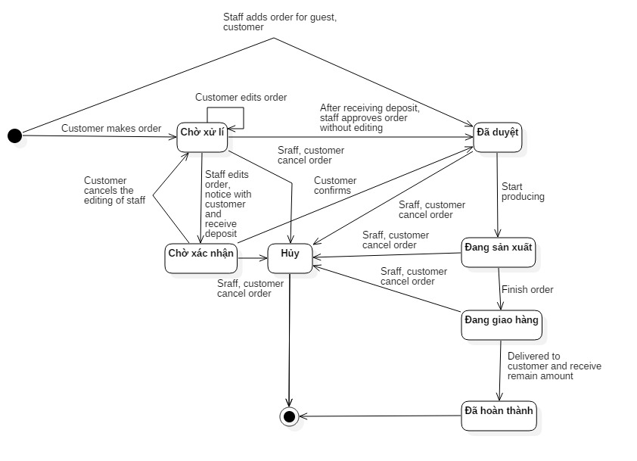

Figure 128: Order State Chart

|  |  |
| --- | --- |
| SStimulusion﷽﷽﷽﷽﷽> ERDquence numberecution bar em and database.tate | Description |
| Chờ xử lý | Order is made by customer and waiting for approve from the system. |
| Chờ xác nhận | Order is editted by staff and waiting for confirm from the customer. |
| Đã duyệt | Order is approved by staff or confirmed by customer. |
| Đang sản xuất | Order is producing. |
| Đang giao hàng | Order is delivering. |
| Đã hoàn thành | Order is finished after receiving money. |
| Hủy | Order is cancelled. |

Table 63: Contract State Dictionary

# 番５のレポート。システムの展開とテスト

## はじめに

### 概要

本節、物理データベースの詳細とその記述は表れています。その上、BMAのテストの方法やテストプランやテストケースも記載されています。

### テストアプローチ

* ゴール: 要求を満たすため、すべてのシステムが正常に実行されていること。
* 方法: システムテスト, ブラックボックステスト。

## データベース関係ダイアグラム

### ウェブアプリケーション物理的なダイアグラム

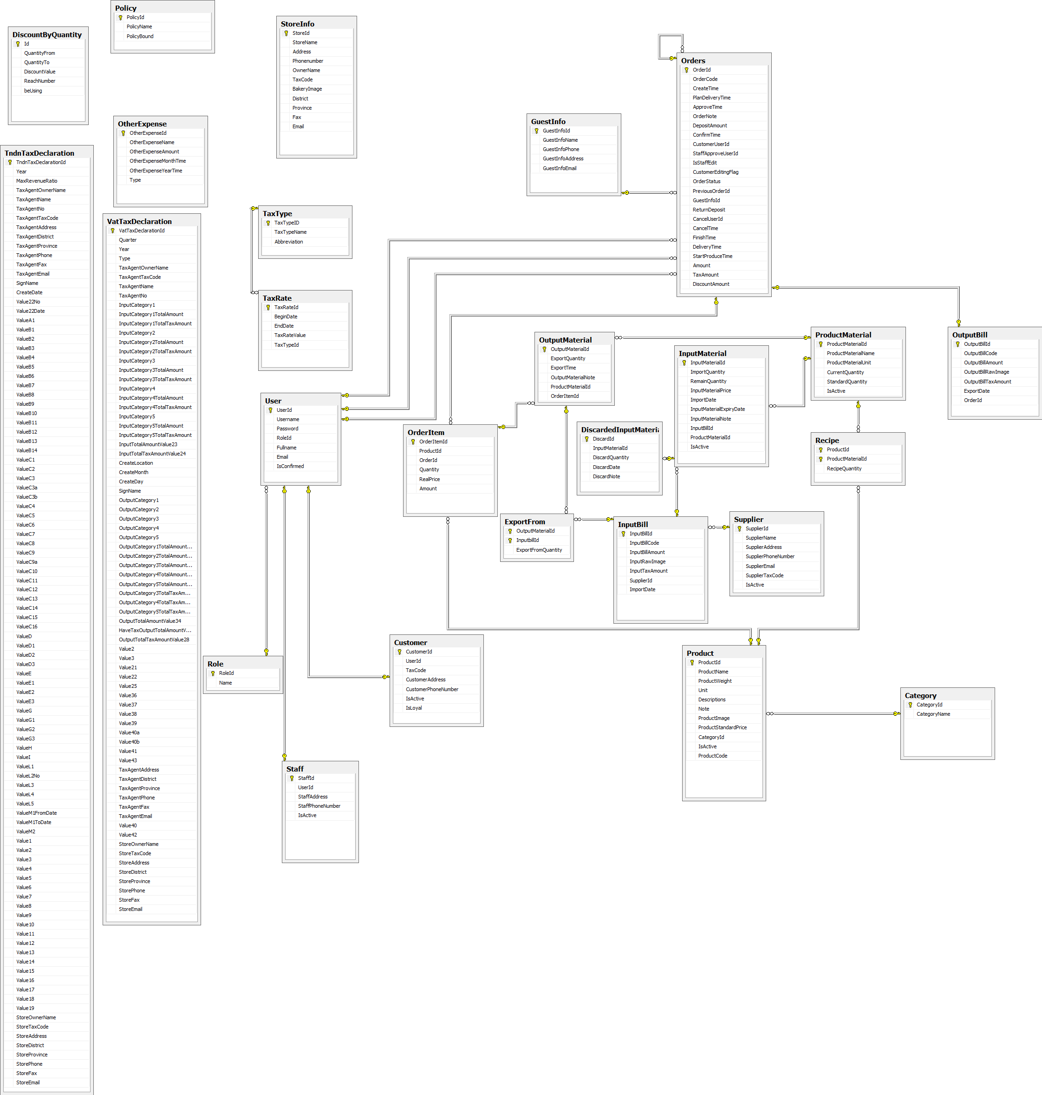

Figure 129: ウェブサイトアプリケーション物理的なダイアグラム

### 2.2 ウェブアプリケーションデータ辞書

|  |  |  |
| --- | --- | --- |
|  | Entity Data Dictionary: describe content of all entities | |
| 数字 | **実体名** | **記述** |
| 01 | Discount By Quantity | システムで分量で安売りを含有しています |
| 02 | Other Expense | システムで外の費を含有しています |
| 03 | StoreInfo | システムで店の見聞を含有しています |
| 04 | Policy | システムで政策を含有しています |
| 05 | Role | システムで役を含有しています |
| 06 | User | システムで利用者を含有しています |
| 07 | Customer | システムでメンバーを含有しています |
| 08 | Staff | システムで職員を含有しています |
| 09 | Guest Info | システムでお客員の見聞を含有しています |
| 10 | Orders | システムで注文を含有しています |
| 11 | Output Bill | システムで出力法案を含有しています |
| 12 | Order Item | システムで注文の項目を含有しています |
| 13 | Category | システムで種類を含有しています |
| 14 | Product | システムで製品を含有しています |
| 15 | Supplier | システムでサプライヤーを含有しています |
| 16 | Input Bill | システムで入力法案を含有しています |
| 17 | Discarded Input Material | システムで投入原料を捨てるのことを含有しています |
| 18 | Input Material | システムで投入原料を含有しています |
| 19 | Export From | システムで投入原料の注文の見聞を含有しています |
| 20 | Product Material | システムで製品の原料を含有しています |
| 21 | Output Material | システムで出力材料を含有しています |
| 22 | Recipe | システムで料理法を含有しています |
| 23 | Tax Rate | システムで税率を含有しています |
| 24 | Tax Type | システムで税金のタイプを含有しています |
| 25 | VAT Tax Declaration | システムでVATの税金申告を含有しています |

Table 64 : ウェブデータ•ディクショナリ

|  |  |  |  |  |
| --- | --- | --- | --- | --- |
| エンティティ名 | 属性 | 記述 | ドメイン | ヌル |
| **Discount By Quantity** | Id (PK) | 各安売りの唯一の識別子、量で安売りテーブルから自動インクリメント | int | No |
| QuantityFrom | 量で安売りから | int | No |
| QuantityTo | 量で安売りまで | int | No |
| DiscountValue | 量で安売りの値 | int | No |
| beUsing | 各量で安売りが使われるかどうかのステータス。 | int | No |
| **Other Expense** | OtherExpenseId (PK) | 各外の費の唯一の識別子、外の費テーブルから自動インクリメント | int | No |
| OtherExpenseName | 外の費の名 | nvarchar(100) | No |
| OtherExpenseAmount | 外の費の分量 | int | No |
| OtherExpenseMonthTime | 外の費の月 | int | Yes |
| OtherExpenseYearTime | 外の費の年 | int | Yes |
| **StoreInfo** | StoreId | 各店の唯一の識別子、店の見聞テーブルから自動インクリメント | int | No |
| StoreName | 店の名 | nvarchar(50) | No |
| Address | 店の住所 | nvarchar(200) | No |
| Phonenumber | 店の電話番号 | nvarchar(20) | No |
| OwnerName | 店の主の名前 | nvarchar(50) | No |
| TaxCode | 店の税金のコード | varchar(20) |  |
| BakeryImage | 店のケーキの映像 | nvarchar(200) |  |
| ProductMaxPrice | 店の最高の製品の値段 | int | Yes |
| District | 店の郡 | nvarchar(50) | No |
| Province | 店の州 | nvarchar(50) | No |
| Fax | 店のファクス | nvarchar(50) | Yes |
| Email | 店の電子メール | nvarchar(50) | Yes |
| **Policy** | PolicyId (PK) | 各政策の唯一の識別子、政策テーブルから自動インクリメント | int | No |
| PolicyName | 政策の名 | nvarchar(50) | No |
| PolicyBound | 政策の限界 | int | No |
| **Role** | RoleId (PK) | 各役の唯一の識別子、役テーブルから自動インクリメント | int | No |
| Name | 役の名 | nvarchar(50) | No |
| **User** | UserId (PK) | 各利用者の唯一の識別子、利用者テーブルから自動インクリメント | int | No |
| Username | 利用者のユーザ名 | nvarchar(50) | No |
| Password | 利用者のパスワード | nvarchar(max) | Yes |
| RoleId (FK) | 役のID | int | No |
| Fullname | 利用者の名前 | nvarchar(50) | Yes |
| Email | 利用者の電子メール | nvarchar(250) | Yes |
| IsConfirmed | 各量で役が確認されたかどうかのステータス。 | bit | No |
| **Customer** | CustomerId (PK) | 各メンバーの唯一の識別子、メンバーテーブルから自動インクリメント | int | No |
| UserId (FK) | 役のID | int | No |
| TaxCode | メンバーの税金のコード | nvarchar(20) | Yes |
| CustomerAddress | メンバーの住所 | nvarchar(200) | Yes |
| CustomerPhoneNumber | メンバーの電話番後 | nvarchar(20) | Yes |
| IsActive | 各量でメンバーがアクティブされたかどうかのステータス。 | bit | No |
| IsLoyal | 各量でメンバーがロイヤルかどうかのステータス。 | bit | No |
| **Staff** | StaffId (PK) | 各職員の唯一の識別子、職員テーブルから自動インクリメント | int | No |
| UserId (FK) | 役のID | int | No |
| StaffAddress | 職員の住所 | nvarchar(200) | Yes |
| StaffPhoneNumber | 職員の電話番後 | nvarchar(20) | Yes |
| IsActive | 各量で職員がアクティブされたかどうかのステータス。 | bit | No |
| **Guest Info** | GuestInfoId (PK) | 各お客員の唯一の識別子、お客員の見聞テーブルから自動インクリメント | int | No |
| GuestInfoName | お客員の名前 | nvarchar(50) | No |
| GuestInfoPhone | お客員の電話番後 | nvarchar(20) | No |
| GuestInfoAddress | お客員の住所 | nvarchar(200) | No |
| GuestInfoEmail | お客員の電子メール | nvarchar(200) | No |
| **Orders** | OrderId (PK) | 各注文の唯一の識別子、注文テーブルから自動インクリメント | int | No |
| OrderCode | 注文のコード | varchar(13) | No |
| CreateTime | 注文の作ったの時 | datetime | No |
| PlanDeliveryTime | 注文の配信の時の予定 | datetime | No |
| ApproveTime | 注文の認めたの時 | datetime | Yes |
| OrderNote | 注文のノート | nvarchar(200) | Yes |
| DepositAmount | 注文の分量 | int | No |
| ConfirmTime | 注文の確認の時 | datetime | Yes |
| CustomerUserId (FK) | メンバーのID | int | Yes |
| StaffApproveUserId (FK) | 認可されていた職員のID | int | Yes |
| IsStaffEdit | 各量で職員がエディトしているかどうかのステータス。 | bit | No |
| CustomerEditingFlag | 各量でメンバーがエディトしているかどうかのステータス | bit | No |
| OrderStatus | 注文のステータス | int | No |
| PreviousOrderId (FK) | 前の注文のID | int | Yes |
| GuestInfoId (FK) | お客員のID | int | Yes |
| ReturnDeposit | 注文の回帰の預金 | int | No |
| CancelUserId (FK) | 注文をキャンセルした役のID | int | Yes |
| CancelTime | 注文をキャンセルする時 | datetime | Yes |
| FinishTime | 注文の終わりの時 | datetime | Yes |
| DeliveryTime | 注文の配信の時 | datetime | Yes |
| StartProduceTime | 初めに注文の作る時 | datetime | Yes |
| Amount | 注文の分量 | int | No |
| TaxAmount | 注文の税金の分量 | int | No |
| DiscountAmount | 注文の割引の分量 | int | No |
| **Output Bill** | OutputBillId (PK) | 各出力法案の唯一の識別子、出力法案テーブルから自動インクリメント | int | No |
| OutputBillCode | 出力法案のコード | nvarchar(50) | No |
| OutputBillAmount | 出力法案の分量 | float | No |
| OutputBillRawImage | 出力法案の映像 | nvarchar(200) | Yes |
| OutputBillTaxAmount | 出力法案の税金の分量 | float | No |
| ExportDate | 出力法案の輸出の日 | date | No |
| FormNo | 出力法案の用紙のID | varchar(50) | No |
| Serial | 出力法案のシリアル | varchar(50) | No |
| OrderId (FK) | 注文のID | int | No |
| **Order Item** | OrderItemId (PK) | 各注文の項目の唯一の識別子、注文の項目テーブルから自動インクリメント | int | No |
| ProductId (FK) | 製品のID | int | No |
| OrderId (FK) | 注文のID | int | No |
| Quantity | 注文の項目量 | int | No |
| RealPrice | 注文の項目のリアル値段 | int | No |
| Amount | 注文の項目の分量 | int | No |
| **Category** | CategoryId (PK) | 各種類の唯一の識別子、種類テーブルから自動インクリメント | int | No |
| CategoryName | 種類の名 | nvarchar(200) | No |
| **Product** | ProductId (PK) | 各製品の唯一の識別子、製品テーブルから自動インクリメント | int | No |
| ProductName | 製品の名 | nvarchar(200) | No |
| ProductWeight | 製品の重さ | float | No |
| Unit | 製品のユニット | nvarchar(50) | No |
| Descriptions | 製品の記述 | nvarchar(500) | Yes |
| Note | 製品のノート | nvarchar(500) | Yes |
| ProductImage | 製品のの映像 | nvarchar(200) | Yes |
| ProductStandardPrice | 製品の標準価格 | int | No |
| CategoryId (FK) | 種類のID | int | Yes |
| IsActive | 各量で製品がアクティブされたかどうかのステータス。 | bit | No |
| ProductCode | 製品のコード | varchar(10) | No |
| **Supplier** | SupplierId (PK) | 各サプライヤーの唯一の識別子、サプライヤーテーブルから自動インクリメント | int | No |
| SupplierName | サプライヤーの名 | nvarchar(200) | No |
| SupplierAddress | サプライヤーの住所 | nvarchar(200) | No |
| SupplierPhoneNumber | サプライヤーの電話番後 | char(12) | No |
| SupplierEmail | サプライヤーの電子メール | nvarchar(50) | No |
| SupplierTaxCode | サプライヤーの税金のコード | char(20) | No |
| IsActive | 各量でサプライヤーがアクティブされたかどうかのステータス。 | bit | No |
| **Input Bill** | InputBillId (PK) | 各入力法案の唯一の識別子、入力法案テーブルから自動インクリメント | int | No |
| InputBillCode | 入力法案のコード | nvarchar(50) | No |
| InputBillAmount | 入力法案の分量 | float | No |
| InputRawImage | 入力法案の映像 | nvarchar(200) | Yes |
| InputTaxAmount | 入力法案の税金の分量 | float | No |
| SupplierId (FK) | サプライヤーのID | int | No |
| ImportDate | 入力法案の輸入の日 | date | No |
| FormNo | 入力法案の用紙のID | varchar(50) | No |
| Serial | 入力法案のシリアル | varchar(50) | No |
| **Discarded Input Material** | DiscardId (PK) | 各投入原料を捨てるのことの唯一の識別子、投入原料を捨てるのことテーブルから自動インクリメント | int | No |
| InputMaterialId (FK) | 投入原料を捨てるのことのID | int | No |
| DiscardQuantity | 投入原料を捨てるのことの量 | int | No |
| DiscardDate | 投入原料を捨てるのことの日 | date | No |
| DiscardNote | 投入原料を捨てるのことのノート | nvarchar(200) | No |
| **Input Material** | InputMaterialId (PK) | 各投入原料の唯一の識別子、投入原料テーブルから自動インクリメント | int | No |
| ImportQuantity | 投入原料の量 | int | No |
| RemainQuantity | 在留原料の量 | int | No |
| InputMaterialPrice | 在留原料の値段 | float | No |
| ImportDate | 在留原料の輸入の日 | date | No |
| InputMaterialExpiryDate | 在留原料の消費期限 | date | No |
| InputMaterialNote | 在留原料のノート | nvarchar(500) | Yes |
| InputBillId (FK) | 入力法案のID | int | No |
| ProductMaterialId (FK) | 製品の原料のID | int | No |
| IsActive | 各量で在留原料がアクティブされたかどうかのステータス。 | bit | No |
| **Export From** | OutputMaterialId (PK) | 出力材料のID | int | No |
| InputbillId (PK) | 入力法案のID | int | No |
| ExportFromQuantity | 入力法案の量 | int | No |
| **Product Material** | ProductMaterialId (PK) | 各製品の原料の唯一の識別子、製品の原料テーブルから自動インクリメント | int | No |
| ProductMaterialName | 製品の原料の名 | nvarchar(100) | No |
| ProductMaterialUnit | 製品の原料のユニット | nvarchar(50) | No |
| CurrentQuantity | 製品の原料の在留原料量 | int | No |
| StandardQuantity | 製品の原料の標準量 | int | Yes |
| IsActive | 各量で製品の原料がアクティブされたかどうかのステータス。 | bit | No |
| **Output Material** | OutputMaterialId (PK) | 各出力材料の唯一の識別子、出力材料テーブルから自動インクリメント | int | No |
| ExportQuantity | 出力材料の輸出量 | int | No |
| ExportTime | 出力材料の輸出の時 | datetime | Yes |
| OutputMaterialNote | 出力材料のノート | nvarchar(500) | Yes |
| ProductMaterialId (FK) | 製品の原料のID | int | No |
| OrderItemId (FK) | 注文の項目のID | int | No |
| **Recipe** | ProductId (PK) | 製品のID | int | No |
| ProductMaterialId (PK) | 製品の原料のID | int | No |
| RecipeQuantity | 料理法量 | float | No |
| **Tax Rate** | TaxRateId (PK) | 各税率の唯一の識別子、税率テーブルから自動インクリメント | int | No |
| BeginDate | 税率の初めの日 | date | No |
| EndDate | 税率の終わりの日 | date | Yes |
| TaxRateValue | 税率の値 | int | No |
| TaxTypeId (FK) | 税金のID | int | No |
| **Tax Type** | TaxTypeID (PK) | 各税金の唯一の識別子、税金テーブルから自動インクリメント | int | No |
| TaxTypeName | 税金の名 | nvarchar(200) | No |
| Abbreviation | 税金テーブルの省略形 | varchar(10) | Yes |
| **VAT Tax Declaration** | TaxDeclarationId | 消費税申告の唯一の識別子、消費税申告テーブルから自動インクリメント | int | No |
| Quarter | 消費税申告の季 | int | No |
| Year | 消費税申告の年 | int | No |
| Type | 消費税申告のタイプ | int | No |
| TaxAgentOwnerName | 代理人の組合の名前 | nvarchar(50) | No |
| TaxAgentTaxCode | 代理人の税法 | varchar(15) | No |
| TaxAgentName | 代理人の名前 | nvarchar(50) | No |
| TaxAgentNo | 代理人の許可番号 | varchar(15) | No |
| InputCategory1 | 消費税申告の付録1の種類1 | nvarchar(max) | Yes |
| InputCategory1TotalAmount | 消費税申告の付録1の種類1の金額 | int | Yes |
| InputCategory1TotalTaxAmount | 消費税申告の付録1の種類1の税金 | int | Yes |
| InputCategory2 | 消費税申告の付録1の種類2 | nvarchar(max) | Yes |
| InputCategory2TotalAmount | 消費税申告の付録1の種類2の金額 | int | Yes |
| InputCategory2TotalTaxAmount | 消費税申告の付録1の種類2の税金 | int | Yes |
| InputCategory3 | 消費税申告の付録1の種類3 | nvarchar(max) | Yes |
| InputCategory3TotalAmount | 消費税申告の付録1の種類3の金額 | int | Yes |
| InputCategory3TotalTaxAmount | 消費税申告の付録1の種類3の税金 | int | Yes |
| InputTotalAmountValue23 | 付録1の金額 | int | No |
| InputTotalTaxAmountValue24 | 付録1の税金 | int | No |
| CreateLocation | 作成する場所 | nvarchar(50) | No |
| CreateDate | 作成する日付 | date | No |
| SignName | サイン | nvarchar(50) | No |
| OutputCategory1 | 消費税申告の付録2の種類1 | nvarchar(max) | Yes |
| OutputCategory2 | 消費税申告の付録2の種類2 | nvarchar(max) | Yes |
| OutputCategory3 | 消費税申告の付録2の種類3 | nvarchar(max) | Yes |
| OutputCategory4 | 消費税申告の付録2の種類4 | nvarchar(max) | Yes |
| OutputCategory1TotalAmountValue26 | 消費税申告の付録2の種類1の金額 | int | Yes |
| OutputCategory2TotalAmountValue29 | 消費税申告の付録2の種類2の金額 | int | Yes |
| OutputCategory3TotalAmountValue30 | 消費税申告の付録2の種類3の金額 | int | Yes |
| OutputCategory4TotalAmountValue32 | 消費税申告の付録2の種類4の金額 | int | Yes |
| OutputCategory3TotalTaxAmountValue31 | 消費税申告の付録2の種類3の税金 | int | Yes |
| OutputCategory4TotalTaxAmountValue33 | 消費税申告の付録2の種類4の税金 | int | Yes |
| OutputTotalAmountValue34 | 付録2の金額 | int | Yes |
| HaveTaxOutputTotalAmountValue27 | 税金がある付録2の金額 | int | No |
| OutputTotalTaxAmountValue28 | 付録2の税金 | int | No |
| Value2 | 消費税申告のバリュー2 | bit | Yes |
| Value3 | 消費税申告のバリュー3 | int | Yes |
| Value21 | 消費税申告のバリュー21 | bit | Yes |
| Value22 | 消費税申告のバリュー22 | int | Yes |
| Value25 | 消費税申告のバリュー25 | int | Yes |
| Value36 | 消費税申告のバリュー36 | int | Yes |
| Value37 | 消費税申告のバリュー37 | int | Yes |
| Value38 | 消費税申告のバリュー38 | int | Yes |
| Value39 | 消費税申告のバリュー39 | int | Yes |
| Value40a | 消費税申告のバリュー40a | int | Yes |
| Value40b | 消費税申告のバリュー40b | int | Yes |
| Value41 | 消費税申告のバリュー41 | int | Yes |
| Value43 | 消費税申告のバリュー43 | int | Yes |
| TaxAgentAddress | 代理人の住所 | nvarchar(200) | Yes |
| TaxAgentDistrict | 代理人の地区 | nvarchar(50) | Yes |
| TaxAgentProvince | 代理人の県 | nvarchar(50) | Yes |
| TaxAgentPhone | 代理人の電話番号 | varchar(20) | Yes |
| TaxAgentFax | 代理人のファクス番号 | varchar(20) | Yes |
| TaxAgentEmail | 代理人のイー‐メール | varchar(50) | Yes |
| Value40 | 消費税申告のバリュー40 | int | Yes |
| Value42 | 消費税申告のバリュー42 | int | Yes |
| StoreOwnerName | オーナーの名前 | nvarchar(50) | No |
| StoreTaxCode | オーナーの税法 | varchar(15) | No |
| StoreAddress | オーナーの住所 | nvarchar(200) | No |
| StoreDistrict | オーナーの地区 | nvarchar(50) | No |
| StoreProvince | オーナーの県 | nvarchar(50) | No |
| StorePhone | オーナーの電話番号 | varchar(15) | No |
| StoreFax | オーナーのファクス番号 | varchar(15) | Yes |
| StoreEmail | オーナーのイー‐メール | nvarchar(200) | No |
| **Tndn Tax Declaration** | Id | 免許税申告の唯一の識別子、免許税申告テーブルから自動インクリメント | int | No |
| Year | 免許税申告の年 | int | No |
| MaxRevenueRatio | 最大歳入の比率 | int | Yes |
| TaxAgentOwnerName | 代理人の組合の名前 | nvarchar(50) | Yes |
| TaxAgentName | 代理人の名前 | nvarchar(50) | Yes |
| TaxAgentNo | 代理人の許可番号 | varchar(15) | Yes |
| TaxAgentTaxCode | 代理人の税法 | varchar(15) | Yes |
| TaxAgentAddress | 代理人の住所 | nvarchar(200) | Yes |
| TaxAgentDistrict | 代理人の地区 | nvarchar(50) | Yes |
| TaxAgentProvince | 代理人の県 | nvarchar(50) | Yes |
| TaxAgentPhone | 代理人の電話番号 | varchar(15) | Yes |
| TaxAgentFax | 代理人のファクス番号 | varchar(15) | Yes |
| TaxAgentEmail | 代理人のイー‐メール | nvarchar(50) | Yes |
| SignName | サイン | nvarchar(50) | Yes |
| CreateDate | 作成する日付 | date | Yes |
| Value22No | 免許税申告のバリュー22番号 | int | Yes |
| Value22Date | 免許税申告のバリュー22日付 | date | Yes |
| ValueA1 | 免許税申告のバリューA1 | int | Yes |
| ValueB1 | 免許税申告のバリューB1 | int | Yes |
| ValueB2 | 免許税申告のバリューB2 | int | Yes |
| ValueB3 | 免許税申告のバリューB3 | int | Yes |
| ValueB4 | 免許税申告のバリューB4 | int | Yes |
| ValueB5 | 免許税申告のバリューB5 | int | Yes |
| ValueB6 | 免許税申告のバリューB6 | int | Yes |
| ValueB7 | 免許税申告のバリューB7 | int | Yes |
| ValueB8 | 免許税申告のバリューB8 | int | Yes |
| ValueB9 | 免許税申告のバリューB9 | int | Yes |
| ValueB10 | 免許税申告のバリューB10 | int | Yes |
| ValueB11 | 免許税申告のバリューB11 | int | Yes |
| ValueB12 | 免許税申告のバリューB12 | int | Yes |
| ValueB13 | 免許税申告のバリューB13 | int | Yes |
| ValueB14 | 免許税申告のバリューB14 | int | Yes |
| ValueC1 | 免許税申告のバリューC1 | int | Yes |
| ValueC2 | 免許税申告のバリューC2 | int | Yes |
| ValueC3 | 免許税申告のバリューC3 | int | Yes |
| ValueC3a | 免許税申告のバリューC3a | int | Yes |
| ValueC3b | 免許税申告のバリューC3ｂ | int | Yes |
| ValueC4 | 免許税申告のバリューC4 | int | Yes |
| ValueC5 | 免許税申告のバリューC5 | int | Yes |
| ValueC6 | 免許税申告のバリューC6 | int | Yes |
| ValueC7 | 免許税申告のバリューC7 | int | Yes |
| ValueC8 | 免許税申告のバリューC8 | int | Yes |
| ValueC9 | 免許税申告のバリューC9 | int | Yes |
| ValueC9a | 免許税申告のバリューC9a | int | Yes |
| ValueC10 | 免許税申告のバリューC10 | int | Yes |
| ValueC11 | 免許税申告のバリューC11 | int | Yes |
| ValueC12 | 免許税申告のバリューC12 | int | Yes |
| ValueC13 | 免許税申告のバリューC13 | int | Yes |
| ValueC14 | 免許税申告のバリューC14 | int | Yes |
| ValueC15 | 免許税申告のバリューC15 | int | Yes |
| ValueC16 | 免許税申告のバリューC16 | int | Yes |
| ValueD | 免許税申告のバリューD | int | Yes |
| ValueD1 | 免許税申告のバリューD1 | int | Yes |
| ValueD2 | 免許税申告のバリューD2 | int | Yes |
| ValueD3 | 免許税申告のバリューD3 | int | Yes |
| ValueE | 免許税申告のバリューE | int | Yes |
| ValueE1 | 免許税申告のバリューE1 | int | Yes |
| ValueE2 | 免許税申告のバリューE2 | int | Yes |
| ValueE3 | 免許税申告のバリューE3 | int | Yes |
| ValueG | 免許税申告のバリューG | int | Yes |
| ValueG1 | 免許税申告のバリューG1 | int | Yes |
| ValueG2 | 免許税申告のバリューG2 | int | Yes |
| ValueG3 | 免許税申告のバリューG3 | int | Yes |
| ValueH | 免許税申告のバリューH | int | Yes |
| ValueI | 免許税申告のバリューI | int | Yes |
| ValueL1 | 免許税申告のバリューL1 | int | Yes |
| ValueL2 | 免許税申告のバリューL2 | int | Yes |
| ValueL3 | 免許税申告のバリューL3 | int | Yes |
| ValueL4 | 免許税申告のバリューL4 | int | Yes |
| ValueL5 | 免許税申告のバリューL5 | int | Yes |
| ValueM1FromDate | 免許税申告のバリューM1開始日 | date | Yes |
| ValueM1ToDate | 免許税申告のバリューM1終了日 | date | Yes |
| Value M2 | 免許税申告のバリューM2 | int | Yes |
| Value1 | 免許税申告のバリュー1 | int | Yes |
| Value2 | 免許税申告のバリュー2 | int | Yes |
| Value3 | 免許税申告のバリュー3 | int | Yes |
| Value4 | 免許税申告のバリュー4 | int | Yes |
| Value5 | 免許税申告のバリュー5 | int | Yes |
| Value6 | 免許税申告のバリュー6 | int | Yes |
| Value7 | 免許税申告のバリュー7 | int | Yes |
| Value8 | 免許税申告のバリュー8 | int | Yes |
| Value9 | 免許税申告のバリュー9 | int | Yes |
| Value10 | 免許税申告のバリュー10 | int | Yes |
| Value11 | 免許税申告のバリュー11 | int | Yes |
| Value12 | 免許税申告のバリュー12 | int | Yes |
| Value13 | 免許税申告のバリュー13 | int | Yes |
| Value14 | 免許税申告のバリュー14 | int | Yes |
| Value15 | 免許税申告のバリュー15 | int | Yes |
| Value16 | 免許税申告のバリュー16 | int | Yes |
| Value17 | 免許税申告のバリュー17 | int | Yes |
| Value18 | 免許税申告のバリュー18 | int | Yes |
| Value19 | 免許税申告のバリュー19 | int | Yes |
| StoreOwnerName | オーナーの名前 | nvarchar(50) | No |
| StoreTaxCode | オーナーの税法 | varchar(15) | No |
| StoreAddress | オーナーの住所 | nvarchar(200) | No |
| StoreDistrict | オーナーの地区 | nvarchar(50) | No |
| StoreProvince | オーナーの県 | nvarchar(50) | No |
| StorePhone | オーナーの電話番号 | varchar(15) | No |
| StoreFax | オーナーのファクス番号 | varchar(15) | Yes |
| StoreEmail | オーナーのイー‐メール | nvarchar(200) | No |

Table 65: ウェブ属性データディクショナリ

## パフォーマンス対策

パフォーマンスを測定するために、デプロイとともにazure ホスティングでテストして、予測を行いました。

### 製品検索、メンバーのパフォーマンス

一般的に、結果はユーザが検索フォームを提出した後、5秒未満を現されます。

### 送り状リストが展示されるパフォーマンス

一般的には、ユーザーが「送り状リスト」のリンクをクリックすると、注文リストはより5秒以内に展示されます。

### 収入統計など展示されるパフォーマンス

一般的に、時間を選んで、「統計」というボタンをクリックすると、10秒以内で収入統計など展示されます。

## テスト計画

### テストする機能

システムテストはコアワークフローに基づいて行うことになります。

テストする機能:

* ユーザログイン
* ゲスト：
  + 製品を注文します
* 顧客：
  + 製品を注文します
  + 送り状を確認します
* 人員
  + 送り状を造ります
  + 送り状を承認します
  + 送り状の状態を変化します
  + 送り状を編集します
  + 入力原料を付加します
  + 入力原料を捨てます
  + 入力法案を付加します
* 管理
  + 収入統計
  + 製品別収益
  + お客様による純益統計
  + 消費税申告
  + 免許税申告

### テストされない機能

* ログ‐アウト
* プロフィールを編集
* 消費税申告
* 免許税申告
* 顧客管理
* 人員管理

## システムテストのテストケース

### ウェブシステムのテストケース

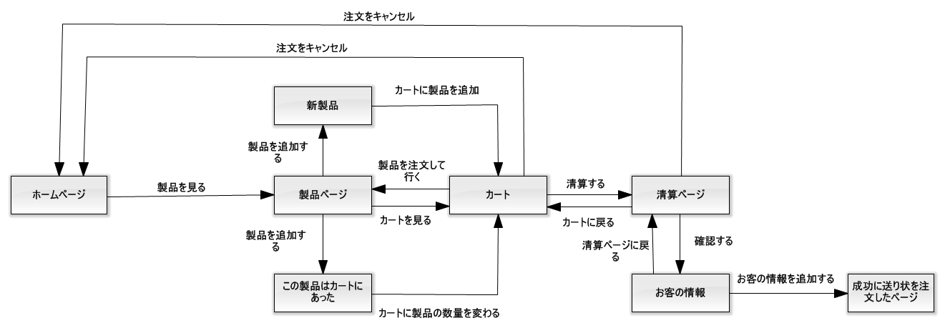

Figure 130: 「ゲスト」製品を注文すること

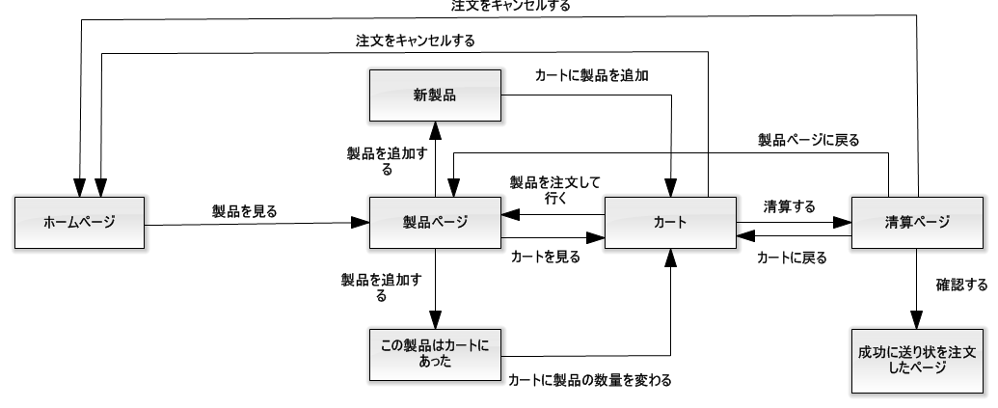

Figure 131: 「顧客」製品を注文すること

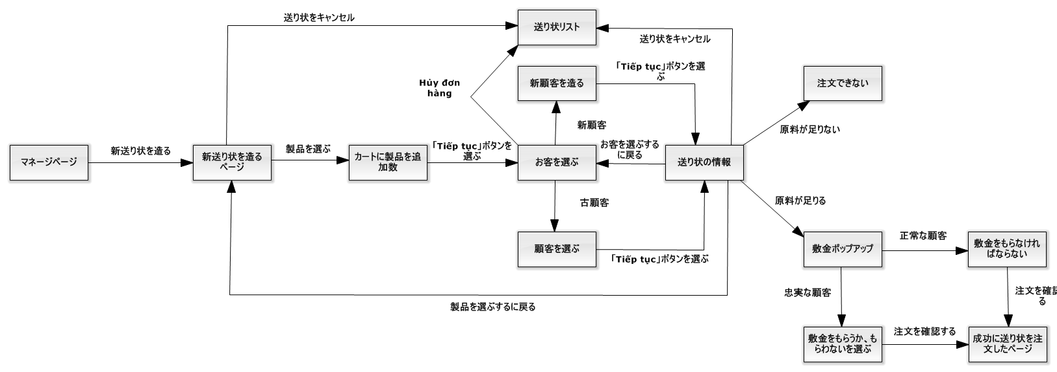

Figure 132: 「人員」送り状を造ること

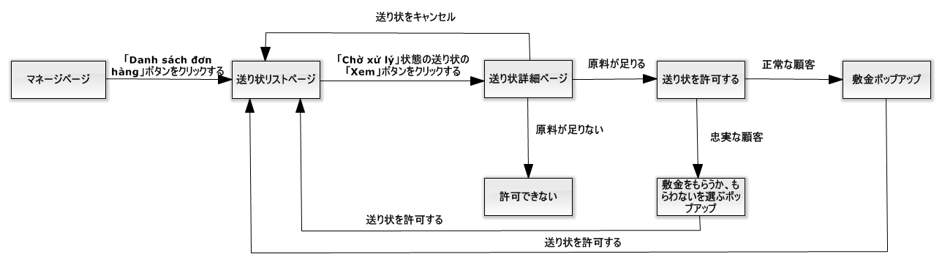

Figure 133: 「人員」送り状を造ること

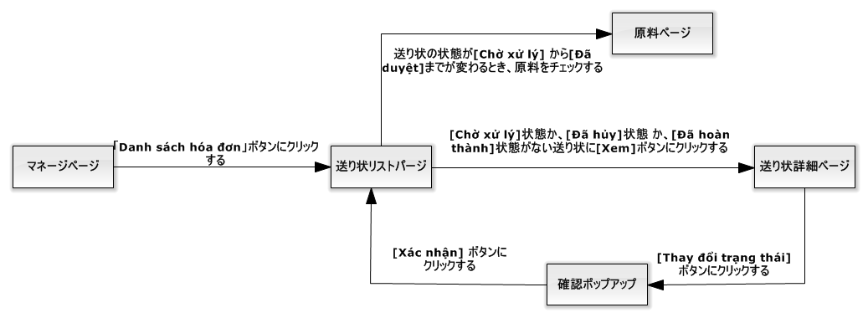

Figure 134: 「人員」送り状の状態を変化すること

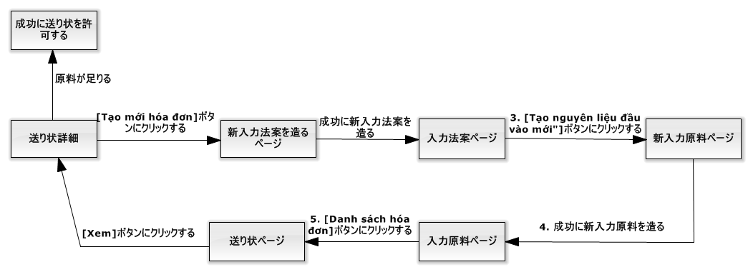

Figure 135: 「人員」入力原料を付加すること

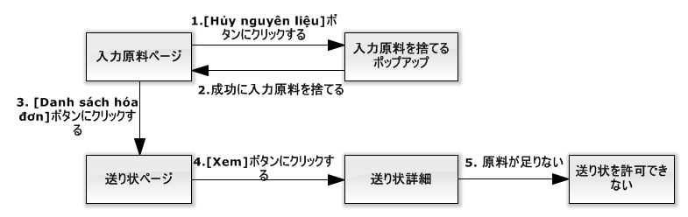

Figure 136: 「人員」入力原料を捨てること

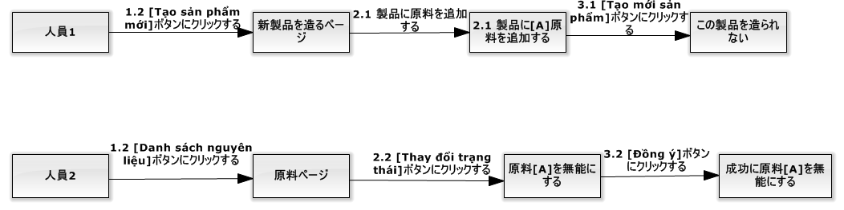

Figure 137: 「人員」新製品を造る前に、この製品の原料が無能にすること

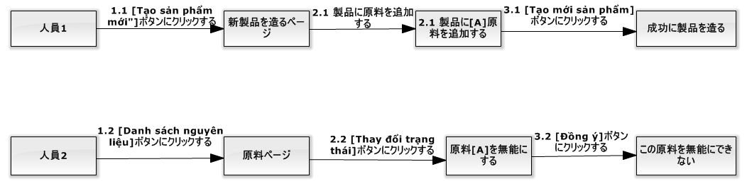

Figure 138: 「人員」新製品を造ったら、この製品の原料が無能にすること

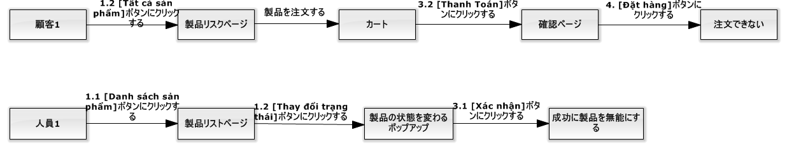

Figure 139: 「人員」注文することが終了する前に、この注文の製品が無能にすること

#### ユーザログイン

|  |  |  |  |  |  |  |  |
| --- | --- | --- | --- | --- | --- | --- | --- |
| **ID** | **説明** | **テストケース順序** | **出力** | **インターテストケース依存性** | **結果** | **テスト期日** | **注釈** |
| UL01 | ユーザ名が違う | １．ユーザは「Đăng nhập」ブタンをクリークする。  ２．ユーザ名：Hoadt  　　パスワード：123456  ３．ユーザは「Đăng nhập」ブタンをクリークする。 | ステップ３には、誤差「Tên đăng nhập hoặc mật khẩu không đúng」を通知する | なし | 合格 | 22/11/2015 | なし |
| UL02 | パスワードが違う | １．ユーザは「Đăng nhập」ブタンをクリークする。  ２．ユーザ名：Hoadtt  　　パスワード：1234  ３．ユーザは「Đăng nhập」ブタンをクリークする。 | ステップ３には、誤差「Tên đăng nhập hoặc mật khẩu không đúng」を通知する | なし | 合格 | 22/11/2015 | なし |
| UL03 | メンバーはログインする | １．ユーザは「Đăng nhập」ブタンをクリークする。  ２．ユーザ名：Hoadtt  　　パスワード：123456  ３．ユーザは「Đăng nhập」ブタンをクリークする。 | ステップ３には、システムにメンバー同上のユーザ名をログインする。 | なし | 合格 | 22/11/2015 | なし |
| UL04 | 職員はログインする | １．ユーザは「Đăng nhập」ブタンをクリークする。  ２．ユーザ名：VuongNQ  　　パスワード：123456  ３．ユーザは「Đăng nhập」ブタンをクリークする。 | ステップ３には、システムに職員同上のユーザ名をログインする。 | なし | 合格 | 22/11/2015 | なし |
| UL05 | 社長はログインする | １．ユーザは「Đăng nhập」ブタンをクリークする。  ２．ユーザ名：ManhOT  　　パスワード：123456  ３．ユーザは「Đăng nhập」ブタンをクリークする。 | ステップ３には、システムに社長のユーザ名をログインする。 | なし | 合格 | 22/11/2015 | なし |

#### 「顧客」製品を注文すること

|  |  |  |  |  |  |  |  |
| --- | --- | --- | --- | --- | --- | --- | --- |
| **ID** | **説明** | **テストケース順序** | **出力** | **インターテストケース依存性** | **結果** | **テスト期日** | **注釈** |
| COP01 | 製品の数量は数ではない | １．「Đặt hàng」ボタンをクリックして  ２．数量：eee  ３．「Thêm vào giỏ hàng」ボタンをクリックする | ステップ３には、誤差「Số lượng sản phẩm phải là số」を通知する | UL03 | 合格 | 22/11/2015 | なし |
| COP02 | 製品の数量は空白 | １．「Đặt hàng」ボタンをクリックして、「Bánh bao 2 trứng」製品を注文する  ２．数量：  ３．「Thêm vào giỏ hàng」ボタンをクリックする | ステップ３には、誤差「Số lượng sản phẩm không được trống」を通知する | UL03 | 合格 | 22/11/2015 | なし |
| COP03 | 製品の数量は０同等や０以下場合 | １．「Đặt hàng」ボタンをクリックして、「Bánh bao １ trứng」製品を注文する  ２．数量：－１００  ３．「Thêm vào giỏ hàng」ボタンをクリックする | ステップ３には、誤差「Số lượng sản phẩm không được nhỏ hơn 0」を通知する | UL03 | 合格 | 22/11/2015 | なし |
| COP04 | 製品の総量は足らない | １．「Đặt hàng」ボタンをクリックして、「Bánh bao 2 trứng」製品を注文する  ２．数量：１９  標準：「Min quantity-5000」  ３．「Thêm vào giỏ hàng」ボタンをクリックする  ４．「Giỏ hàng」ボタンをクリックして  ５．「Thanh toán」ボタンをクリックして  ６．「Xác nhận」ボタンをクリックして | ステップ6には、誤差「Số lượng sản phẩm trong đơn hàng không được nhỏ hơn “Min quantity”」を通知する | UL03 | 合格 | 22/11/2015 | なし |
| COP05 | 製品の総量は５０００オーバー | １．「Đặt hàng」ボタンをクリックして、「Bánh bao 2 trứng」製品を注文する  ２．数量：５００１  標準：「Min quantity-5000」  ３．「Thêm vào giỏ hàng」ボタンをクリックする  ４．「Giỏ hàng」ボタンをクリックして  ５．「Thanh toán」ボタンをクリックして  ６．「Xác nhận」ボタンをクリックして | ステップ6には、この製品の数量は５０００になります | UL03 | 合格 | 22/11/2015 | なし |
| COP06 | 顧客はカートにある製品を付加する | １．「Đặt hàng」ボタンをクリックして、「Bánh bao 2 trứng」製品を注文する | 「Add to Cart」ポープアップにはこの製品の数量を通知しなければならない | UL03 | 合格 | 22/11/2015 | なし |
| COP07 | カートは空白 | １．「Xác nhận」ボタンをクリックして | 製品のページをリダイレクトする | UL03 | 合格 | 22/11/2015 | なし |
| COP08 | カートに無効製品があるとき、「Xác nhận」ボタンをクリックして | １．「Đặt hàng」ボタンをクリックして、「Bánh bao 2 trứng」製品を注文する  ２．数量：１００  ３．「Thêm vào giỏ hàng」ボタンをクリックする  ４．「Thanh toán」ボタンをクリックして  ５．「Xác nhận」ボタンをクリックして  ６．人員は「Bánh bao 2 trứng」の状態を「Ngừng sử dụng」に変化する  ７．「Xác nhận」ボタンをクリックして | ステップ７には、誤差「Xin lỗi quý khách, sản phẩm ‘Bánh bao 2 trứng’ đã ngừng sản xuất. Qúy khách vui lòng gỡ khỏi giỏ hàng」を通知する | UL03 | 合格 | 22/11/2015 | なし |
| COP09 | 「Xác nhận」ボタンをクリックしたら、「人員」が製品の状態を「Ngừng sử dụng」に変化する | １．「Đặt hàng」ボタンをクリックして、「Bánh bao 2 trứng」製品を注文する  ２．数量：１００  ３．「Thêm vào giỏ hàng」ボタンをクリックする  ４．「Thanh toán」ボタンをクリックして  ５．「Xác nhận」ボタンをクリックして  ６．「Xác nhận」ボタンをクリックして  ７．人員は「Bánh bao 2 trứng」の状態を「Ngừng sử dụng」に変化する | ステップ７には、この送り状は注文したが、「Bánh bao 2 trứng」製品は製品ページに表示されない | UL03 | 合格 | 22/11/2015 | なし |

#### 「ゲスト」製品を注文すること

|  |  |  |  |  |  |  |  |
| --- | --- | --- | --- | --- | --- | --- | --- |
| **ID** | **説明** | **テストケース順序** | **出力** | **インターテストケース依存性** | **結果** | **テスト期日** | **注釈** |
| GOP01 | 製品の数量は数ではない | １．「Đặt hàng」ボタンをクリックして  ２．数量：eee  ３．「Thêm vào giỏ hàng」ボタンをクリックする | ステップ３には、誤差「Số lượng sản phẩm phải là số」を通知する | なし | 合格 | 22/11/2015 | なし |
| GOP02 | 製品の数量は空白 | １．「Đặt hàng」ボタンをクリックして、「Bánh bao 2 trứng」製品を注文する  ２．数量：  ３．「Thêm vào giỏ hàng」ボタンをクリックする | ステップ３には、誤差「Số lượng sản phẩm không được trống」を通知する | なし | 合格 | 22/11/2015 | なし |
| GOP03 | 製品の数量は０同等や０以下場合 | １．「Đặt hàng」ボタンをクリックして、「Bánh bao １ trứng」製品を注文する  ２．数量：－１００  ３．「Thêm vào giỏ hàng」ボタンをクリックする | ステップ３には、誤差「Số lượng sản phẩm không được nhỏ hơn 0」を通知する | なし | 合格 | 22/11/2015 | なし |
| GOP04 | ゲストの名前は空白 | １．「Đặt hàng」ボタンをクリックして、「Bánh bao 2 trứng」製品を注文する  ２．数量：２５０  ３．「Thêm vào giỏ hàng」ボタンをクリックする  ４．「Thanh toán」ボタンをクリックして  ５．「Xác nhận」ボタンをクリックして  ６．「Xác nhận」ボタンをクリックして  ７．  ゲストの名前：  ゲストの電話番号：０９０１２３１２３１  ゲストの住所：１０５０ Quang Trung, Gò Vấp  ゲストのメール：test@gmail.com  ８．「Hoàn tất」ボタンをクリックして | ステップ８には、誤差「Họ tên không được trống」を通知する | なし | 合格 | 22/11/2015 | なし |
| GOP05 | ゲストの電話番号は空白 | １．「Đặt hàng」ボタンをクリックして、「Bánh bao 2 trứng」製品を注文する  ２．数量：２５０  ３．「Thêm vào giỏ hàng」ボタンをクリックする  ４．「Thanh toán」ボタンをクリックして  ５．「Xác nhận」ボタンをクリックして  ６．「Xác nhận」ボタンをクリックして  ７．  ゲストの名前：Trà Văn Ân  ゲストの電話番号：  ゲストの住所：１０５０ Quang Trung, Gò Vấp  ゲストのメール：test@gmail.com  ８．「Hoàn tất」ボタンをクリックして | ステップ８には、誤差「Số điện thoại không được để trống」を通知する | なし | 合格 | 22/11/2015 | なし |
| GOP06 | ゲストの電話番号は８字より少ないや、１２時より多い | １．「Đặt hàng」ボタンをクリックして、「Bánh bao 2 trứng」製品を注文する  ２．数量：２５０  ３．「Thêm vào giỏ hàng」ボタンをクリックする  ４．「Thanh toán」ボタンをクリックして  ５．「Xác nhận」ボタンをクリックして  ６．「Xác nhận」ボタンをクリックして  ７．  ゲストの名前：Trà Văn Ân  ゲストの電話番号：01234  ゲストの住所：１０５０ Quang Trung, Gò Vấp  ゲストのメール：test@gmail.com  ８．「Hoàn tất」ボタンをクリックして | ステップ８には、誤差「Số điện thoại có độ dài từ 8 đến 12 kí tự」を通知する | なし | 合格 | 22/11/2015 | なし |
| GOP07 | ゲストの住所は空白 | １．「Đặt hàng」ボタンをクリックして、「Bánh bao 2 trứng」製品を注文する  ２．数量：２５０  ３．「Thêm vào giỏ hàng」ボタンをクリックする  ４．「Thanh toán」ボタンをクリックして  ５．「Xác nhận」ボタンをクリックして  ６．「Xác nhận」ボタンをクリックして  ７．  ゲストの名前：Trà Văn Ân  ゲストの電話番号：０９０１２３１２３１  ゲストの住所：  ゲストのメール：test@gmail.com  ８．「Hoàn tất」ボタンをクリックして | ステップ８には、誤差「Địa chỉ không được để trống」を通知する | なし | 合格 | 22/11/2015 | なし |
| GOP08 | ゲストのメールは空白 | １．「Đặt hàng」ボタンをクリックして、「Bánh bao 2 trứng」製品を注文する  ２．数量：２５０  ３．「Thêm vào giỏ hàng」ボタンをクリックする  ４．「Thanh toán」ボタンをクリックして  ５．「Xác nhận」ボタンをクリックして  ６．「Xác nhận」ボタンをクリックして  ７．  ゲストの名前：Trà Văn Ân  ゲストの電話番号：０９０１２３１２３１  ゲストの住所：１０５０ Quang Trung, Gò Vấp  ゲストのメール：８．「Hoàn tất」ボタンをクリックして | ステップ８には、誤差「Email không được để trống」を通知する | なし | 合格 | 22/11/2015 | なし |
| GOP09 | ゲストのメールは正しくない | １．「Đặt hàng」ボタンをクリックして、「Bánh bao 2 trứng」製品を注文する  ２．数量：２５０  ３．「Thêm vào giỏ hàng」ボタンをクリックする  ４．「Thanh toán」ボタンをクリックして  ５．「Xác nhận」ボタンをクリックして  ６．「Xác nhận」ボタンをクリックして  ７．  ゲストの名前：Trà Văn Ân  ゲストの電話番号：０９０１２３１２３１  ゲストの住所：１０５０ Quang Trung, Gò Vấp  ゲストのメール：test@mot  ８．「Hoàn tất」ボタンをクリックして | ステップ８には、誤差「Email không đúng định dạng – example@gmail.com」を通知する | なし | 合格 | 22/11/2015 | なし |
| GOP10 | 製品の総量は足らない | １．「Đặt hàng」ボタンをクリックして、「Bánh bao 2 trứng」製品を注文する  ２．数量：１９  標準：「Min quantity-5000」  ３．「Thêm vào giỏ hàng」ボタンをクリックする  ４．「Giỏ hàng」ボタンをクリックして  ５．「Thanh toán」ボタンをクリックして  ６．「Xác nhận」ボタンをクリックして | ステップ6には、誤差「Số lượng sản phẩm trong đơn hàng không được nhỏ hơn “Min quantity”」を通知する | なし | 合格 | 22/11/2015 | なし |
| GOP11 | 製品の総量は５０００オーバー | １．「Đặt hàng」ボタンをクリックして、「Bánh bao 2 trứng」製品を注文する  ２．数量：５００１  標準：「Min quantity-5000」  ３．「Thêm vào giỏ hàng」ボタンをクリックする  ４．「Giỏ hàng」ボタンをクリックして  ５．「Thanh toán」ボタンをクリックして  ６．「Xác nhận」ボタンをクリックして | ステップ6には、この製品の数量は５０００になります | なし | 合格 | 22/11/2015 | なし |
| GOP12 | 顧客はカートにある製品を付加する | １．「Đặt hàng」ボタンをクリックして、「Bánh bao 2 trứng」製品を注文する | 「Add to Cart」ポープアップにはこの製品の数量を通知しなければならない | なし | 合格 | 22/11/2015 | なし |
| GOP13 | カートは空白 | １．「Xác nhận」ボタンをクリックして | 製品のページをリダイレクトする | なし | 合格 | 22/11/2015 | なし |

#### 「人員」送り状を造ること

|  |  |  |  |  |  |  |  |
| --- | --- | --- | --- | --- | --- | --- | --- |
| **ID** | **説明** | **テストケース順序** | **出力** | **インターテストケース依存性** | **結果** | **テスト期日** | **注釈** |
| SAO01 | ショッピングカートの中で、製品がない | １．「Tạo mới đơn hàng」ボタンをクリックして  ２．「Tiếp tục」ボタンをクリックして | ステップ２には、誤差「Vui lòng chọn ít nhất 1 sản phẩm」を通知する | UL04 | 合格 | 22/11/2015 | なし |
| SAO02 | ショッピングカートの中で、製品が足れない | １．「Tạo mới đơn hàng」ボタンをクリックして  ２．「Thêm sản phẩm」ボタンをクリックして、「Bánh bao 2 trứng」製品を注文する  ３．「Tiếp tục」ボタンをクリックして | ステップ３には、誤差「Số lượng sản phẩm phải lớn hơn 20」を通知する | UL04 | 合格 | 22/11/2015 | なし |
| SAO03 | 注文のお客がいない | １．「Tạo mới đơn hàng」ボタンをクリックして  ２．「Thêm sản phẩm」ボタンをクリックして、「Bánh bao 2 trứng」製品を注文する  　　数量：２０  ３．「Tiếp tục」ボタンをクリックして  ４．「Chọn khách hàng」ボタンをクリックして  ５．「Chọn」ボタンをクリックして | ステップ5には、誤差「Vui lòng chọn khách hàng」を通知する | UL04 | 合格 | 22/11/2015 | なし |
| SAO04 | 新しいお客のアカウントを作って、お客の名前が空白 | １．「Tạo mới đơn hàng」ボタンをクリックして  ２．「Thêm sản phẩm」ボタンをクリックして、「Bánh bao 2 trứng」製品を注文する  　　数量：２０  ３．「Tiếp tục」ボタンをクリックして  ４．「Thêm khách hàng」ボタンをクリックして  　名前：「」  　ユーザ名：atv1  　電子メール：[atv1@gmail.com](mailto:atv1@gmail.com)  　住所：「1050 Quang Trung, Gò Vấp, TPHCM」  　電話番後：  0901231231  　税金のコード：091238213910  ５．「Đồng ý」ボタンをクリックして | ステップ5には、誤差「Tên khách hàng không được trống」を通知する | UL04 | 合格 | 22/11/2015 | なし |
| SAO05 | システムの中でユーザ名がある | １．「Tạo mới đơn hàng」ボタンをクリックして  ２．「Thêm sản phẩm」ボタンをクリックして、「Bánh bao 2 trứng」製品を注文する  　　数量：２０  ３．「Tiếp tục」ボタンをクリックして  ４．「Thêm khách hàng」ボタンをクリックして  　名前：「Trần văn A」  　ユーザ名：hoadtt  　電子メール：[atv1@gmail.com](mailto:atv1@gmail.com)  　住所：「1050 Quang Trung, Gò Vấp, TPHCM」  　電話番後：  0901231231  　税金のコード：091238213910  ５．「Đồng ý」ボタンをクリックして | ステップ5には、誤差「Tên tài khoản này đã có trong hệ thống」を通知する | UL04 | 合格 | 22/11/2015 | なし |
| SAO06 | システムの中で電話番後がある | １．「Tạo mới đơn hàng」ボタンをクリックして  ２．「Thêm sản phẩm」ボタンをクリックして、「Bánh bao 2 trứng」製品を注文する  　　数量：２０  ３．「Tiếp tục」ボタンをクリックして  ４．「Thêm khách hàng」ボタンをクリックして  　名前：「Trần văn A」  　ユーザ名：atv1  　電子メール：[atv1@gmail.com](mailto:atv1@gmail.com)  　住所：「1050 Quang Trung, Gò Vấp, TPHCM」  　電話番後：  0951236977  　税金のコード：091238213910  ５．「Đồng ý」ボタンをクリックして | ステップ5には、誤差「Số điện thoại này đã có trong hệ thống」を通知する | UL04 | 合格 | 22/11/2015 | なし |
| SAO07 | 電話番後が空白 | １．「Tạo mới đơn hàng」ボタンをクリックして  ２．「Thêm sản phẩm」ボタンをクリックして、「Bánh bao 2 trứng」製品を注文する  　　数量：２０  ３．「Tiếp tục」ボタンをクリックして  ４．「Thêm khách hàng」ボタンをクリックして  　名前：「Trần văn A」  　ユーザ名：atv1  　電子メール：[atv1@gmail.com](mailto:atv1@gmail.com)  　住所：「1050 Quang Trung, Gò Vấp, TPHCM」  　電話番後：「」  　税金のコード：091238213910  ５．「Đồng ý」ボタンをクリックして | ステップ5には、誤差「Số điện thoại không được trống」を通知する | UL04 | 合格 | 22/11/2015 | なし |
| SAO08 | 電話番後の書き方が違う | １．「Tạo mới đơn hàng」ボタンをクリックして  ２．「Thêm sản phẩm」ボタンをクリックして、「Bánh bao 2 trứng」製品を注文する  　　数量：２０  ３．「Tiếp tục」ボタンをクリックして  ４．「Thêm khách hàng」ボタンをクリックして  　名前：「Trần văn A」  　ユーザ名：atv1  　電子メール：[atv1@gmail.com](mailto:atv1@gmail.com)  　住所：「1050 Quang Trung, Gò Vấp, TPHCM」  　電話番後：  095  　税金のコード：091238213910  ５．「Đồng ý」ボタンをクリックして | ステップ5には、誤差「Vui lòng nhập số điện thoại đúng」を通知する | UL04 | 合格 | 22/11/2015 | なし |
| SAO09 | 住所が空白 | １．「Tạo mới đơn hàng」ボタンをクリックして  ２．「Thêm sản phẩm」ボタンをクリックして、「Bánh bao 2 trứng」製品を注文する  　　数量：２０  ３．「Tiếp tục」ボタンをクリックして  ４．「Thêm khách hàng」ボタンをクリックして  　名前：「Trần văn A」  　ユーザ名：atv1  　電子メール：[atv1@gmail.com](mailto:atv1@gmail.com)  　住所「」  　電話番後：  0951236977  　税金のコード：091238213910  ５．「Đồng ý」ボタンをクリックして | ステップ5には、誤差「Địa chỉ khách hàng không được trống」を通知する | UL04 | 合格 | 22/11/2015 | なし |
| SAO10 | 税金のコードが空白 | １．「Tạo mới đơn hàng」ボタンをクリックして  ２．「Thêm sản phẩm」ボタンをクリックして、「Bánh bao 2 trứng」製品を注文する  　　数量：２０  ３．「Tiếp tục」ボタンをクリックして  ４．「Thêm khách hàng」ボタンをクリックして  　名前：「Trần văn A」  　ユーザ名：atv1  　電子メール：[atv1@gmail.com](mailto:atv1@gmail.com)  　住所：「1050 Quang Trung, Gò Vấp, TPHCM」  　電話番後：  0951236977  　税金のコード：091238213910  ５．「Đồng ý」ボタンをクリックして | ステップ5には、誤差「Mã số thuế không được trống」を通知する | UL04 | 合格 | 22/11/2015 | なし |
| SAO11 | システムの中で税金のコードがある | １．「Tạo mới đơn hàng」ボタンをクリックして  ２．「Thêm sản phẩm」ボタンをクリックして、「Bánh bao 2 trứng」製品を注文する  　　数量：２０  ３．「Tiếp tục」ボタンをクリックして  ４．「Thêm khách hàng」ボタンをクリックして  　名前：「Trần văn A」  　ユーザ名：atv1  　電子メール：atv1@gmail.com  　住所：「1050 Quang Trung, Gò Vấp, TPHCM」  　電話番後：0951236977  　税金のコード：1234569875214  ５．「Đồng ý」ボタンをクリックして | ステップ5には、誤差「Mã số thuế này đã có trong hệ thống」を通知する | UL04 | 合格 | 22/11/2015 | なし |
| SAO12 | 税金のコードの書き方が違う | １．「Tạo mới đơn hàng」ボタンをクリックして  ２．「Thêm sản phẩm」ボタンをクリックして、「Bánh bao 2 trứng」製品を注文する  　　数量：２０  ３．「Tiếp tục」ボタンをクリックして  ４．「Thêm khách hàng」ボタンをクリックして  　名前：「Trần văn A」  　ユーザ名：atv1  　電子メール：atv1@gmail.com  　住所：「1050 Quang Trung, Gò Vấp, TPHCM」  　電話番後：0951236977  　税金のコード：09123  ５．「Đồng ý」ボタンをクリックして | ステップ5には、誤差「Vui lòng nhập mã số thuế đúng」を通知する | UL04 | 合格 | 22/11/2015 | なし |
| SAO13 | 確認のページの中で、他のお客を選んでほしいです。 | １．「Tạo mới đơn hàng」ボタンをクリックして  ２．「Thêm sản phẩm」ボタンをクリックして、「Bánh bao 2 trứng」製品を注文する  　　数量：２０  ３．具全の**メンバーをえらぶ**  ４．「Chọn」ボタンをクリックして  ５．「Quay lại」ボタンをクリックして | ステップ5には、選んだお客の名前を見所です。 | UL04 | 合格 | 22/11/2015 | なし |
| SAO14 | 確認のページの中で、お客の個人情報を改めてほしいです。 | １．「Tạo mới đơn hàng」ボタンをクリックして  ２．「Thêm sản phẩm」ボタンをクリックして、「Bánh bao 2 trứng」製品を注文する  　　数量：２０  ３．「Tiếp tục」ボタンをクリックして  ４．「Thêm khách hàng」ボタンをクリックして  　名前：「Trần văn A」  　ユーザ名：atv1  　電子メール：atv1@gmail.com  　住所：「1050 Quang Trung, Gò Vấp, TPHCM」  　電話番後：0951236977  　税金のコード：091238213910  ５．「Đồng ý」ボタンをクリックして  ６．「Quay lại」ボタンをクリックして | ステップ６には、入力した個人情報を見せて、改められる。 | UL04 | 合格 | 22/11/2015 | なし |
| SAO15 | 確認のページの中で、投入原料を足りない | １．「Tạo mới đơn hàng」ボタンをクリックして  ２．「Thêm sản phẩm」ボタンをクリックして、「Bánh bao 2 trứng」製品を注文する  　　数量：２００  ３．具全のメンバーをえらぶ  ４．「Chọn」ボタンをクリックして | ステップ4には、「Duyệt」ボタンを見せない | UL04 | 合格 | 22/11/2015 | なし |
| SAO16 | 確認のページの中で、届ける日は過去です。 | １．「Tạo mới đơn hàng」ボタンをクリックして  ２．「Thêm sản phẩm」ボタンをクリックして、「Bánh bao 2 trứng」製品を注文する  　　数量：２０  ３．具全のメンバーをえらぶ  ４．「Chọn」ボタンをクリックして  ５．「Duyệt」ボタンをクリックして | ステップ5には、最小の届ける日は明日です。 | UL04 | 合格 | 22/11/2015 | なし |
| SAO17 | 確認のページの中で、えらんだメンバーはロイヤルではない時、いつも入金を受ける | １．「Tạo mới đơn hàng」ボタンをクリックして  ２．「Thêm sản phẩm」ボタンをクリックして、「Bánh bao 2 trứng」製品を注文する  　　数量：２０  ３．具全のロイヤルではないメンバーをえらぶ  ４．「Chọn」ボタンをクリックして  ５．「Duyệt」ボタンをクリックして | ステップ5には、確認のポップアップで最小の入金は投入原料の費用です。 | UL04 | 合格 | 22/11/2015 | なし |
| SAO18 | 確認のページの中で、えらんだメンバーはロイヤルの時、職員は入金を受けないとか入金を受けるとか選べる | １．「Tạo mới đơn hàng」ボタンをクリックして  ２．「Thêm sản phẩm」ボタンをクリックして、「Bánh bao 2 trứng」製品を注文する  　　数量：２０  ３．具全のロイヤルでなメンバーをえらぶ  ４．「Chọn」ボタンをクリックして  ５．「Duyệt」ボタンをクリックして | ステップ5には、確認のポップアップで職員は入金を受けないとか入金を受けるとか選べる。最小の入金は投入原料の費用です | UL04 | 合格 | 22/11/2015 | なし |
| SAO19 | 確認のページの中で、これは新しいメンバーの時、いつも入金を受ける | １．「Tạo mới đơn hàng」ボタンをクリックして  ２．「Thêm sản phẩm」ボタンをクリックして、「Bánh bao 2 trứng」製品を注文する  　　数量：２０  ３．「Tiếp tục」ボタンをクリックして  ４．「Thêm khách hàng」ボタンをクリックして  　名前：「Trần văn A」  　ユーザ名：atv1  　電子メール：atv1@gmail.com  　住所：「1050 Quang Trung, Gò Vấp, TPHCM」  　電話番後：0951236977  　税金のコード：091238213910  ５．「Đồng ý」ボタンをクリックして  ６．「Duyệt」ボタンをクリックして | ステップ６には、確認のポップアップで最小の入金は投入原料の費用です。 | UL04 | 合格 | 22/11/2015 | なし |
| SAO20 | 注文を確認したあとで、この注文のステータスは「Đã duyệt」だし、製品の原料を減少する。 | １．「Tạo mới đơn hàng」ボタンをクリックして  ２．「Thêm sản phẩm」ボタンをクリックして、「Bánh bao 2 trứng」製品を注文する  　　数量：２０  ３．具全のメンバーをえらぶ  ４．「Chọn」ボタンをクリックして  ５．「Duyệt」ボタンをクリックして  ６．「Xác nhận」ボタンをクリックする。 | ステップ６には、この注文のステータスは「Đã duyệt」だし、製品の原料を減少する。 | UL04 | 合格 | 22/11/2015 | なし |
| SAO21 | 注文を確認したあとで、この注文のステータスは「Đã duyệt」だし、新しいメンバーのステータスは「Đang hoạt động」だし、製品の原料を減少する。 | １．「Tạo mới đơn hàng」ボタンをクリックして  ２．「Thêm sản phẩm」ボタンをクリックして、「Bánh bao 2 trứng」製品を注文する  　　数量：２０  ３．「Tiếp tục」ボタンをクリックして  ４．「Thêm khách hàng」ボタンをクリックして  　名前：「Trần văn A」  　ユーザ名：atv1  　電子メール：atv1@gmail.com  　住所：「1050 Quang Trung, Gò Vấp, TPHCM」  　電話番後：0951236977  　税金のコード：091238213910  ５．「Đồng ý」ボタンをクリックして  ６．「Duyệt」ボタンをクリックして  ７．「Xác nhận」ボタンをクリックする。 | ステップ６には、この注文のステータスは「Đã duyệt」だし、新しいメンバーのステータスは「Đang hoạt động」だし、製品の原料を減少する。 | UL04 | 合格 | 22/11/2015 | なし |

#### 「人員」送り状を承認すること

|  |  |  |  |  |  |  |  |
| --- | --- | --- | --- | --- | --- | --- | --- |
| **ID** | **説明** | **テストケース順序** | **出力** | **インターテストケース依存性** | **結果** | **テスト期日** | **注釈** |
| SapO01 | 注文のステータスが「Chờ xác nhận」の時は見とれられる。 | １．職員は「Danh sách đơn hàng」ボタンをクリックして  ２．注文のステータスが「Chờ xác nhận」で、職員は「Xem」ボタンをクリックする。 | ステップ２には、「Duyệt」ボタンを見せない | UL04 | 合格 | 22/11/2015 | なし |
| SapO02 | 注文のステータスが「Đã duyệt」の時は見とれられる。 | １．職員は「Danh sách đơn hàng」ボタンをクリックして  ２．注文のステータスが「Đã duyệt」で、職員は「Xem」ボタンをクリックする。 | ステップ２には、「Duyệt」ボタンを見せない | UL04 | 合格 | 22/11/2015 | なし |
| SapO03 | 注文のステータスが「Đang sản xuất」の時は見とれられる。 | １．職員は「Danh sách đơn hàng」ボタンをクリックして  ２．注文のステータスが「Chờ xác nhận」で、職員は「Xem」ボタンをクリックする。 | ステップ２には、「Duyệt」ボタンを見せない | UL04 | 合格 | 22/11/2015 | なし |
| SapO04 | 注文のステータスが「Đang giao hàng」の時は見とれられる。 | １．職員は「Danh sách đơn hàng」ボタンをクリックして  ２．注文のステータスが「Chờ xác nhận」で、職員は「Xem」ボタンをクリックする。 | ステップ２には、「Duyệt」ボタンを見せない | UL04 | 合格 | 22/11/2015 | なし |
| SapO05 | 注文のステータスが「Đã hoàn thành」の時は見とれられる。 | １．職員は「Danh sách đơn hàng」ボタンをクリックして  ２．注文のステータスが「Chờ xác nhận」で、職員は「Xem」ボタンをクリックする。 | ステップ２には、「Duyệt」ボタンを見せない | UL04 | 合格 | 22/11/2015 | なし |
| SapO07 | メンバーが注文をエディトする時、職員は注文を見とれる。 | １．職員は「Danh sách đơn hàng」ボタンをクリックして  ２．注文のステータスが「Chờ xử lí」で、職員は「Xem」ボタンをクリックする。  ３．メンバーはこの注文をエディトしている。  ４．職員は「Duyệt」ボタンをクリックして | ステップ３には、誤差「Đơn hàng đang được sửa, không thể duyệt」を通知する | UL04 | 合格 | 22/11/2015 | なし |

#### 「人員」送り状の状態を変化すること

|  |  |  |  |  |  |  |  |
| --- | --- | --- | --- | --- | --- | --- | --- |
| **ID** | **説明** | **テストケース順序** | **出力** | **インターテストケース依存性** | **結果** | **テスト期日** | **注釈** |
| SCOS01 | 注文のステータスが「Chờ xác nhận」です。 | 注文のステータスが「Chờ xác nhận」で、職員は「Xem」ボタンをクリックする。 | 「Thay đổi trạng thái」ボタンを見せない | UL04 | 合格 | 22/11/2015 | なし |
| SCOS02 | 注文のステータスが「Đã hủy」です。 | 注文のステータスが「Đã hủy」で、職員は「Xem」ボタンをクリックする。 | 「Thay đổi trạng thái」ボタンを見せない | UL04 | 合格 | 22/11/2015 | なし |
| SCOS03 | 注文のステータスが「Đã hoàn thành」です。 | 注文のステータスが「Đã hoàn thành」で、職員は「Xem」ボタンをクリックする。 | 「Thay đổi trạng thái」ボタンを見せない | UL04 | 合格 | 22/11/2015 | なし |
| SCOS04 | 注文のステータスが「Đã duyệt」から「Đang sản xuất」まで変化する | １．注文のステータスが「Đã duyệt」で、職員は「Xem」ボタンをクリックする。  ２．「Thay đổi trạng thái」ボタンをクリックする | ステップ２には、注文のステータスが「Đã duyệt」から「Đang sản xuất」まで変化する | UL04 | 合格 | 22/11/2015 | なし |
| SCOS05 | 注文のステータスが「Đang sản xuất」から「Đang giao hàng」まで変化する | １．注文のステータスが「Đang sản xuất」で、職員は「Xem」ボタンをクリックする。  ２．「Thay đổi trạng thái」ボタンをクリックする | ステップ２には、注文のステータスが「Đang sản xuất」から「Đang giao hàng」まで変化する | UL04 | 合格 | 22/11/2015 | なし |
| SCOS06 | 注文のステータスが「Đang giao hàng」から「Đã hoàn thành」まで変化する | １．注文のステータスが「Đang giao hàng」で、職員は「Xem」ボタンをクリックする。  ２．「Thay đổi trạng thái」ボタンをクリックする | ステップ２には、注文のステータスが「Đang giao hàng」から「Đã hoàn thành」まで変化する | UL04 | 合格 | 22/11/2015 | なし |

#### 「人員」入力原料を付加すること

|  |  |  |  |  |  |  |  |
| --- | --- | --- | --- | --- | --- | --- | --- |
| **ID** | **説明** | **テストケース順序** | **出力** | **インターテストケース依存性** | **結果** | **テスト期日** | **注釈** |
| SAIM01 | 投入原料の名は空白 | １．「Thêm nguyên liệu đầu vào」リンクをクリックして  ２．投入原料の名：「」  　　投入原料の量：10000  　　全部の値段：400000  　　輸入の日：「21/11/2015」  　　消費期限：「21/11/2016」  　　ノート：「Thơm ngon」  　　入力法案のコード：「111092015」  ３．職員は「Thêm mới」ボタンをクリックする。 | ステップ３には、誤差「Tên nguyên liệu đầu vào không được trống」を通知する | UL04 | 合格 | 22/11/2015 | なし |
| SAIM02 | 投入原料の量は空白 | １．「Thêm nguyên liệu đầu vào」リンクをクリックして  ２．投入原料の名：「Bột」  　　投入原料の量：  　　全部の値段：400000  　　輸入の日：「21/11/2015」  　　消費期限：「21/11/2016」  　　ノート：「Thơm ngon」  　　入力法案のコード：「111092015」  ３．職員は「Thêm mới」ボタンをクリックする。 | ステップ３には、誤差「số lượng nguyên liệu không được trống」を通知する | UL04 | 合格 | 22/11/2015 | なし |
| SAIM03 | 投入原料の量は数ではない | １．「Thêm nguyên liệu đầu vào」リンクをクリックして  ２．投入原料の名：「Bột」  　　投入原料の量：eee  　　全部の値段：400000  　　輸入の日：「21/11/2015」  　　消費期限：「21/11/2016」  　　ノート：「Thơm ngon」  　　入力法案のコード：「111092015」  ３．職員は「Thêm mới」ボタンをクリックする。 | ステップ３には、誤差「số lượng nguyên liệu phải là số」を通知する | UL04 | 合格 | 22/11/2015 | なし |
| SAIM04 | 全部の在留原料の値段が空白 | １．「Thêm nguyên liệu đầu vào」リンクをクリックして  ２．投入原料の名：「Bột」  　　投入原料の量：10000  　　全部の値段：  　　輸入の日：「21/11/2015」  　　消費期限：「21/11/2016」  　　ノート：「Thơm ngon」  　　入力法案のコード：「111092015」  ３．職員は「Thêm mới」ボタンをクリックする。 | ステップ３には、誤差「Tổng giá nguyên liệu không được trống」を通知する | UL04 | 合格 | 22/11/2015 | なし |
| SAIM05 | 全部の在留原料の値段が数ではない | １．「Thêm nguyên liệu đầu vào」リンクをクリックして  ２．投入原料の名：「Bột」  　　投入原料の量：10000  　　全部の値段：eee  　　輸入の日：「21/11/2015」  　　消費期限：「21/11/2016」  　　ノート：「Thơm ngon」  　　入力法案のコード：「111092015」  ３．職員は「Thêm mới」ボタンをクリックする。 | ステップ３には、誤差「Tổng giá nguyên liệu phải là số」を通知する | UL04 | 合格 | 22/11/2015 | なし |
| SAIM06 | 消費期限は輸入の日の前です。 | １．「Thêm nguyên liệu đầu vào」リンクをクリックして  ２．投入原料の名：「Bột」  　　投入原料の量：10000  　　全部の値段：400000  　　輸入の日：「21/11/2015」  　　消費期限：「21/10/2015」  　　ノート：「Thơm ngon」  　　入力法案のコード：「111092015」  ３．職員は「Thêm mới」ボタンをクリックする。 | ステップ３には、誤差「Ngày hết hạn không được trước ngày nhập vào」を通知する | UL04 | 合格 | 22/11/2015 | なし |
| SAIM07 | 入力法案のコードは空白 | １．「Thêm nguyên liệu đầu vào」リンクをクリックして  ２．投入原料の名：「Bột」  　　投入原料の量：10000  　　全部の値段：400000  　　輸入の日：「21/11/2015」  　　消費期限：「21/11/2016」  　　ノート：「Thơm ngon」  　　入力法案のコード：「」  ３．職員は「Thêm mới」ボタンをクリックする。 | ステップ３には、誤差「số lượng nguyên liệu phải là số」を通知する | UL04 | 合格 | 22/11/2015 | なし |
| SAIM08 | 投入原料を輸入するあとで、製品の原料を増える。 | １．「Thêm nguyên liệu đầu vào」リンクをクリックして  ２．投入原料の名：「Bột」  　　投入原料の量：10000  　　全部の値段：400000  　　輸入の日：「21/11/2015」  　　消費期限：「21/11/2016」  　　ノート：「Thơm ngon」  　　入力法案のコード：「111092015」  ３．職員は「Thêm mới」ボタンをクリックする。  ４．「Danh sách nguyên liệu」リンクをクリックする。 | ステップ４には、誤差「số lượng nguyên liệu phải là số」を通知する | UL04 | 合格 | 22/11/2015 | なし |
| SAIM09 | 製品の原料のステータスが「Ngừng sử dụng」が見られない。 | 「Thêm nguyên liệu đầu vào」リンクをクリックして | 製品の原料のステータスが「Ngừng sử dụng」が見られない。 | UL04 | 合格 | 22/11/2015 | なし |

#### 「人員」入力原料を捨てること

|  |  |  |  |  |  |  |  |
| --- | --- | --- | --- | --- | --- | --- | --- |
| **ID** | **説明** | **テストケース順序** | **出力** | **インターテストケース依存性** | **結果** | **テスト期日** | **注釈** |
| DIM01 | 製品の数量は数ではない | １．「Hủy nguyên liệu」ボタンをクリックして  ２．投入原料を捨てるのことの量：「」  　　ノート：「Hư hỏng trong quá trình bảo quản」  ３．「Xác nhận」ボタンをクリックして | ステップ３には、誤差「Số lượng hủy không được trống」を通知する | UL04 | 合格 | 22/11/2015 | なし |
| DIM02 | 投入原料を捨てるのことは在留原料が量多い | １．「Hủy nguyên liệu」ボタンをクリックして  ２．投入原料を捨てるのことの量：「１００００」  　　ノート：「Hư hỏng trong quá trình bảo quản」  在留原料の量：８０００  ３．「Xác nhận」ボタンをクリックして | ステップ３には、誤差「Số lượng hủy không được lớn hơn số lượng tồn kho」を通知する | UL04 | 合格 | 22/11/2015 | なし |
| DIM03 | 製品の数量は数ではない | １．「Hủy nguyên liệu」ボタンをクリックして  ２．投入原料を捨てるのことの量：「eee」  　　ノート：「Hư hỏng trong quá trình bảo quản」  ３．「Xác nhận」ボタンをクリックして | ステップ３には、誤差「Số lượng hủy phải là số」を通知する | UL04 | 合格 | 22/11/2015 | なし |
| DIM04 | 投入原料を捨てるのことの量はゼロ以内です | １．「Hủy nguyên liệu」ボタンをクリックして  ２．投入原料を捨てるのことの量：「－１００」  　　ノート：「Hư hỏng trong quá trình bảo quản」  ３．「Xác nhận」ボタンをクリックして | ステップ３には、誤差「Số lượng hủy phải lớn hơn 0」を通知する | UL04 | 合格 | 22/11/2015 | なし |
| DIM05 | 投入原料を捨てるのことのノットは空白 | １．「Hủy nguyên liệu」ボタンをクリックして  ２．投入原料を捨てるのことの量：「１００」  　　ノート：「」  ３．「Xác nhận」ボタンをクリックして | ステップ３には、誤差「Ghi chú không được trống」を通知する | UL04 | 合格 | 22/11/2015 | なし |

#### 「人員」入力法案を付加すること

|  |  |  |  |  |  |  |  |
| --- | --- | --- | --- | --- | --- | --- | --- |
| **ID** | **説明** | **テストケース順序** | **出力** | **インターテストケース依存性** | **結果** | **テスト期日** | **注釈** |
| SAIB01 | サプライヤーのステータスが「Ngừng hoạt động」が見られない。 | 「Tạo hóa đơn đẩu vào mới」リンクをクリックして | サプライヤーのステータスが「Ngừng hoạt động」が見られない。 | UL04 | 合格 | 22/11/2015 | なし |
| SAIB02 | サプライヤーの名は空白 | １．「Tạo hóa đơn đẩu vào mới」リンクをクリックして  ２．サプライヤーの名：「」  　　入力法案の分量：1000000  　　入力法案の税金の分量：100000  　　入力法案の輸入の日：「21/11/2015」  　　入力法案の映像：「InputBillDemo.jpg」  ３．「Tạo hóa đơn đẩu vào mới」ボタンをクリックして | ステップ3には、誤差「Tên nhà cung cấp không được trống」を通知する | UL04 | 合格 | 22/11/2015 | なし |
| SAIB03 | 入力法案の分量は空白 | １．「Tạo hóa đơn đẩu vào mới」リンクをクリックして  ２．サプライヤーの名：「Bò sữa long thành」  　　入力法案の分量：  　　入力法案の税金の分量：  　　入力法案の輸入の日：「21/11/2015」  　　入力法案の映像：「InputBillDemo.jpg」  ３．「Tạo hóa đơn đẩu vào mới」ボタンをクリックして | ステップ3には、誤差「Giá trị hóa đơn đầu vào không được trống」を通知する | UL04 | 合格 | 22/11/2015 | なし |
| SAIB04 | 入力法案の税金の分量は入力法案の分量から自動的に作られる。 | １．「Tạo hóa đơn đẩu vào mới」リンクをクリックして  ２．サプライヤーの名：「Bò sữa long thành」  　　入力法案の分量：1000000  　　入力法案の税金の分量：100000  　　入力法案の輸入の日：「21/11/2015」  　　入力法案の映像：「InputBillDemo.jpg」  ３．「Tạo hóa đơn đẩu vào mới」ボタンをクリックして | ステップ3には、合格「Thêm hóa đơn thành công」を通知する | UL04 | 合格 | 22/11/2015 | なし |
| SAIB05 | 入力法案の映像は空白 | １．「Tạo hóa đơn đẩu vào mới」リンクをクリックして  ２．サプライヤーの名：「Bò sữa long thành」  　　入力法案の分量：1000000  　　入力法案の税金の分量：100000  　　入力法案の輸入の日：「21/11/2015」  　　入力法案の映像：「」  ３．「Tạo hóa đơn đẩu vào mới」ボタンをクリックして | ステップ3には、誤差「Hình ảnh hóa đơn đầu vào không được trống」を通知する | UL04 | 合格 | 22/11/2015 | なし |
| SAIB06 | 入力法案を輸入したあとで、新しい投入原料を輸入する時、この入力法案を見られる。 | １．「Tạo hóa đơn đẩu vào mới」リンクをクリックして  ２．サプライヤーの名：「Bò sữa long thành」  　　入力法案の分量：1000000  　　入力法案の税金の分量：100000  　　入力法案の輸入の日：「21/11/2015」  　　入力法案の映像：「InputBillDemo.jpg」  ３．「Tạo hóa đơn đẩu vào mới」ボタンをクリックする。  ４．「Thêm nguyên liệu đầu vào mới」リンクをクリックして | ステップ4には、入力法案を輸入したあとで、新しい投入原料を輸入する時、この入力法案を見られる。 | UL04 | 合格 | 22/11/2015 | なし |

# 番６のレポート。ソフトウェアユーザーズマニュアル

## インストレーションガイド

### サーパ側の環境を設定

#### ハードウェア要件

**スムーズにウェブサイトを実行するてめには、以下の要件を備えたコンピュータが必要になります:**

* オペレーティングシステム: ウィンドウXPまたはウィンドウのそれ以降のバージョン。
* プロセッサ：１GHｚ以上。
* メモリ：2GB以上。
* ハードウェア：2GB以上のハードドライブスペース。
* Wifi インターネット(> 2Mbps)。

#### ソフトウェア要件

* + - ウェブサーバー ：Internet information system – IIS 8 With MVC5 enable
    - Microsoft Windows Server 2008 R2 Enterprise (Server Pack 1 64 bit): オペレイティングシ
    - .Net Framework 4.5.1
    - SQL Server 2008 R2

### サーパ側で展開

#### 展開パッケージの準備

* データベース　ファイル： BMA.mdf
* サーパーでのフォルダにソースコードファイル（BMA）をコピーする。
  + 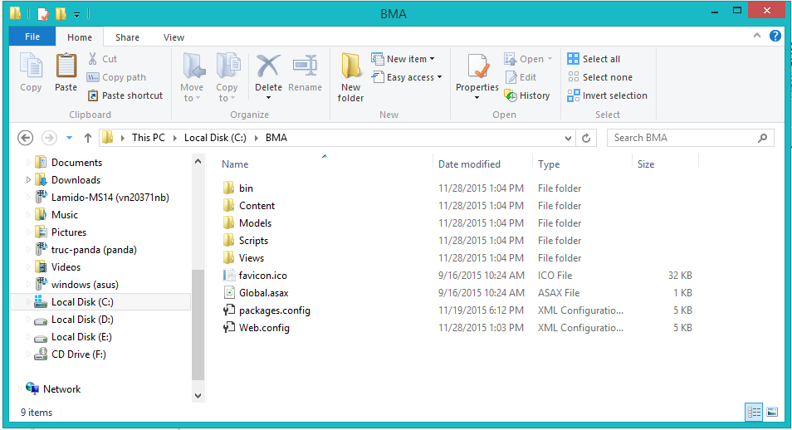例えば：C:\BMA

#### サーパーの構成前に展開

* **データベースの構成：**

<connectionString>

<add name = “DefaultConnection”

connectionString =”Datasource:(local);Initial Catalog=BMA;Persist Security Info = True;user id=sa;password=123456789” providerName = “System.Data.SqlClient” />

<add name = “BMAChangeDB”

connectionString =”Datasource:(local);Initial Catalog=BMA;Persist Security Info = True;user id=sa;password=123456789” providerName = “System.Data.SqlClient” />

</connectionString>

* Catalog : データベース名。
* User id :ユーザ名データベース。
* Password :パスワード

#### サーパ側でWebアプリケーションの展開

* **データベース展開：**
* ＳＱＬ Server 2008 R2 にBMA.mdfをアタックしてください。
* **ソースコードの展開：**
* オーペンIISマネージャ
* 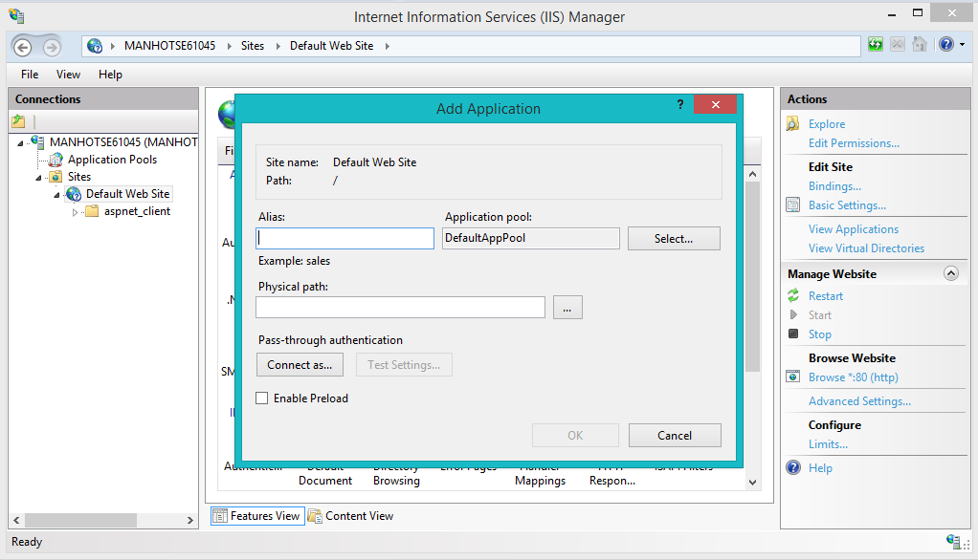“Default Web Site”にマウスを右クリックします。“Add Application”を選びます。
  + Alias : Aliasを入力してください。例えば：ＢMA
  + Application pool : ASP.NET v4.0 を選んでください
  + Physical path:サーパーのソースコードファイルを選んでください（C:\BMA）
* 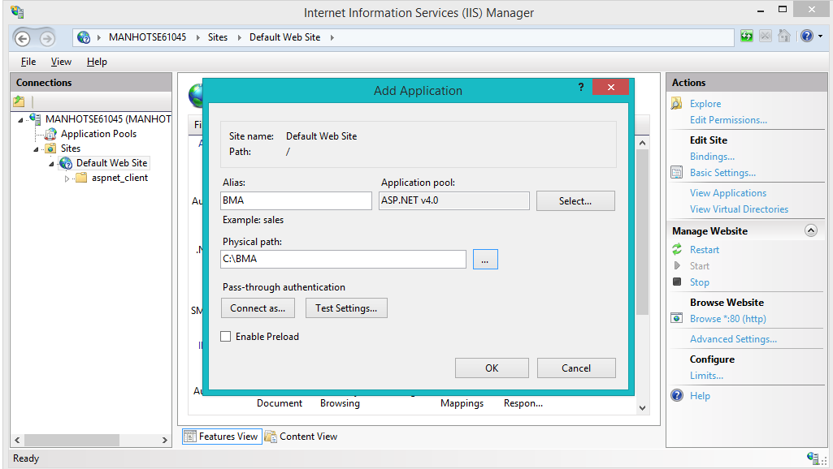“OK”ボタンをクリックしてください。
* 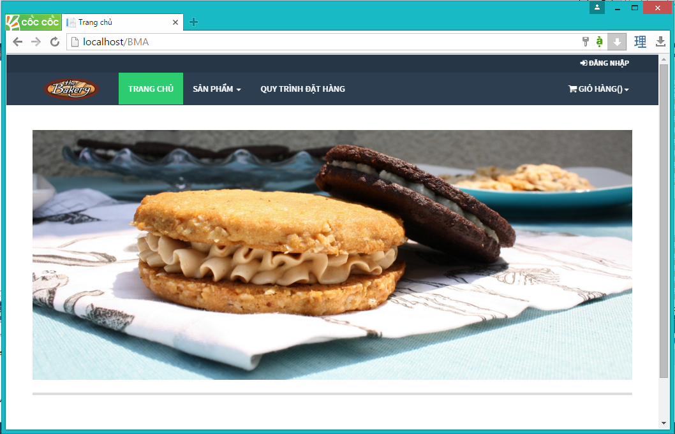オーペン：<http://localhost/BMA>

### クライアント側の環境の設定

#### コンピュータのための設定

* クライアントデバイスは、ウェブサイトを起動するには、以下のブラウザのいずれかを持っている必要があります：
  + Google Chrome(ダウンロードリンク):
    - <http://www.google.com/Chrome>
  + Coc Coc（コックコック）：
    - <http://www.coccoc.com/>

## ユーザーガイド

### ログイン



図面140: ログインポップアップ

|  |  |
| --- | --- |
| ステップ | 説明 |
| **1** | 口座を入力して |
| **2** | パスワードを入力して |
| **3** | 「Đăng nhập」ボタンをリックして |
| **4** | パスワードを忘れたら、「Quên mật khẩu」ボタンをリックして |

テーブル66: ログインポップアップ

### 製品を注文すること



図面 141:製品を注文すること

|  |  |
| --- | --- |
| ステップ | 説明 |
| **1** | 製品を探す |
| **2** | 「Mua hàng」 ボタンをクリックして、 製品を注文する |

テーブル 67:　製品を注文する

### カートに製品を追加すること



図面 142: カートに製品を追加すること

|  |  |
| --- | --- |
| ステップ | 説明 |
| **1** | この製品の数量 |
| **2** | 「Thêm vào giỏ hàng 」 ボタンをくりっくして、カートに製品を追加する |

テーブル 68: カートに製品を追加する

### かーとをチェックすること



図面 143: かーとをチェックすること

|  |  |
| --- | --- |
| Step | 説明 |
| **1** | 「Giỏ hàng 」 ボタン をクリックして、製品のリストが見える |
| **2** | 「Thanh toán 」 ボタン をクリックして、カートの精細を見える |

テーブル 69: かーとをチェックすること

### カーとの精細



図面 144: カートの精細

|  |  |
| --- | --- |
| ステップ | 説明 |
| **1** | 製品の数量を変われる |
| **2** | 製品のリストを戻って、製品を注文して行く |
| **3** | 「Cập nhật giỏ hàng 」 ボタンをクリックして、 カートを更新する |
| **4** | 配送日をセレクトする |
| **5** | 「Đặt hàng 」ボタン をクリックして、注文を完成する |

テーブル 70: カートの精細

### 送り状を確認すること



図面 145: 送り状を確認すること

|  |  |
| --- | --- |
| ステップ | 説明 |
| **1** | カートの精細を戻れば、「Quay lại giỏ hàng 」 ボタン をクリックする |
| **2** | 送り状の確認のボタン |

テーブル 71: 送り状を確認すること

### 送り状に顧客の情報を充実すること



図面 146: 送り状に顧客の情報を充実すること

|  |  |
| --- | --- |
| ステップ | 説明 |
| **1** | これに成員をログインする |
| **2** | 成員なければ、情報を充実するところ |
| **3** | 「Quay lại giỏ hàng 」 ボタン をクリックして、送り状の確認ページを戻る |
| **4** | 口座とパスワードを入力して,「Đăng nhập 」ボタンをクリックして、送り状を完成する |
| **5** | 顧客の情報を入力して,「Hoàn tất 」 ボタンをクリックして、送り状を完成する |

テーブル 72: 送り状に顧客の情報を充実すること

### 送り状のリストを見ること



図面 147: 送り状のリストを見ること

|  |  |
| --- | --- |
| ステップ | 説明 |
| **1** | 不足の原料のリスト |
| **2** | 新し送り状を造る |
| **3** | 送り状の精細 |
| **4** | 送り状を変わる |
| **5** | 送り状を取り消す |
| **6** | 探す |

テーブル 73: 送り状のリストを見ること

### 「人員」送り状を造ること



図面 148: 「人員」送り状を造ること

|  |  |
| --- | --- |
| ステップ | 説明 |
| **1** | 製品 の単価 |
| **2** | 製品の数量 |
| **3** | 送り状に製品をテーキオフする |
| **4** | 送り状をキャンセルこと |
| **5** | 送り状を続く |
| **6** | 送り状に製品を追加する |

テーブル 74: 「人員」送り状を造ること

### 送り状に顧客を追加すること



図面 149: 送り状に顧客を追加すること

|  |  |
| --- | --- |
| ステップ | 説明 |
| **1** | 顧客をセレクトする |
| **2** | 顧客なければ、口座を造る |
| **3** | お客さんの名前 |
| **4** | お客さんの口座 |
| **5** | お客さんのメール |
| **6** | お客さんの住所 |
| **7** | お客さんの電話番号 |
| **8** | お客さんの税額 |
| **9** | 入力をすべてリセット |
| **10** | 口座を造って、この口座にその送り状を追加する |
| **11** | 送り状を造るのページを戻る |
| **12** | 送り状をキャンセルする |

テーブル 75: 送り状に顧客を追加すること

### 新い顧客の口座で送り状をチェックアウト



図面 150: 新顧客の口座で送り状をチェックアウト

|  |  |
| --- | --- |
| ステップ | 説明 |
| **1** | 新顧客の情報 |
| **2** | 送り状の情報 |
| **3** | この送り状に原料数量 を過ごす |
| **4** | 送り状にお客さんを追加する ページを戻る |
| **5** | 送り状を造るのページを戻る |
| **6** | この送り状を確認する |
| **7** | この送り状をキャンセルする |

テーブル 76: 新顧客の口座で送り状をチェックアウト

### 入力法案 リスク



図面 151: 入力法案 リスク

|  |  |
| --- | --- |
| ステップ | 説明 |
| **1** | 新入力法案を造る |
| **2** | 探す |
| **3** | 入力法案 リスク |
| **4** | 入力法案 の精細を見る |
| **5** | 入力法案 の情報を変わる |

テーブル 77:入力法案 リスク

### 新入力法案を造ること



図面 152: 新入力法案を造ること

|  |  |
| --- | --- |
| ステップ | 説明 |
| **1** | サプライヤー をセレクトする |
| **2** | この入力法案料(VATがない) |
| **3** | VAT の料金 |
| **4** | 輸入日 |
| **5** | 入力法案の写真 |
| **6** | 入力法案 陸とを戻る |
| **7** | 新入力法案を造る |

テーブル 78: 新入力法案を造ること

### 入力原料 リスクを見る



図面 153: 入力原料 リスク

|  |  |
| --- | --- |
| ステップ | 説明 |
| **1** | 新入力原料を造ること |
| **2** | 探す |
| **3** | 入力原料 リスク |
| **4** | 入力原料 精細 |
| **5** | 入力原料 の情報を変わる |
| **6** | 入力原料をデリーとする |

テーブル 79: 入力原料リスク

### 入力原料 の精細を見ること



図面 154:入力原料 の精細を見ること

|  |  |
| --- | --- |
| ステップ | 説明 |
| **1** | 入力原料の情報 |
| **2** | 入力原料をデリートする |
| **3** | 同じ入力法案の入力原料リスク |
| **4** | 入力原料の脚注 |
| **5** | 入力原料デリーとの情報 |
| **6** | 入力原料 リスクを戻る |
| **7** | 入力原料 の情報を更新する |

テーブル 80:入力原料の精細を見ること

### 新入力原料を造ること



図面 155: 新入力原料を造ること

|  |  |
| --- | --- |
| ステップ | 説明 |
| **1** | 入力原料名 |
| **2** | 入力原料の数量 |
| **3** | 入力原料の総価格 |
| **4** | 入力原料の輸入日 |
| **5** | 入力原料の有効期限 |
| **6** | 入力原料の脚注 |
| **7** | 入力原料の 入力法案 のコード |
| **8** | 入力原料 リスクを戻る |
| **9** | 入力原料を造る |

テーブル 81:入力原料を造ること

# Appendix

1. How to get real time notification – Microsoft:

<http://www.asp.net/signalr/overview/getting-started>

1. Sashimi – Modified Waterfall Model:

<http://www.waterfall-model.com/sashimi-waterfall-model>

1. UML for drawing diagram (2.0 standard)

<http://www.omg.org/spec/UML/2.0>

1. Circular No. 119/2014/TT-BTC dated August 25, 2014, amendments to Circular No. 156/2013/TT-BTC, Circular No. 111/2013/TT-BTC, Circular No. 219/2013/TT-BTC, Circular No. 08/2013/TT-BTC, Circular No. 85/2011/TT-BTC, Circular No. 39/2014/TT-BTC and Circular No. 78/2014/TT-BTC in order to simplify tax formalities

<http://thuvienphapluat.vn/van-ban/Thue-Phi-Le-Phi/Circular-No-119-2014-TT-BTC-amendments-to-Circular-in-order-to-simplify-tax-formalities-247891.aspx?tab=1>

1. Circular No. 151/2014/TT-BTC dated October 10, 2014, on providing guidance on Decree No. 91/2014/ND-CP on amendments to Decrees on taxation

<http://thuvienphapluat.vn/van-ban/Doanh-nghiep/Circular-No-151-2014-TT-BTC-on-providing-guidance-No-91-2014-ND-CP-amendments-to-Decrees-on-taxation-258054.aspx?tab=1>